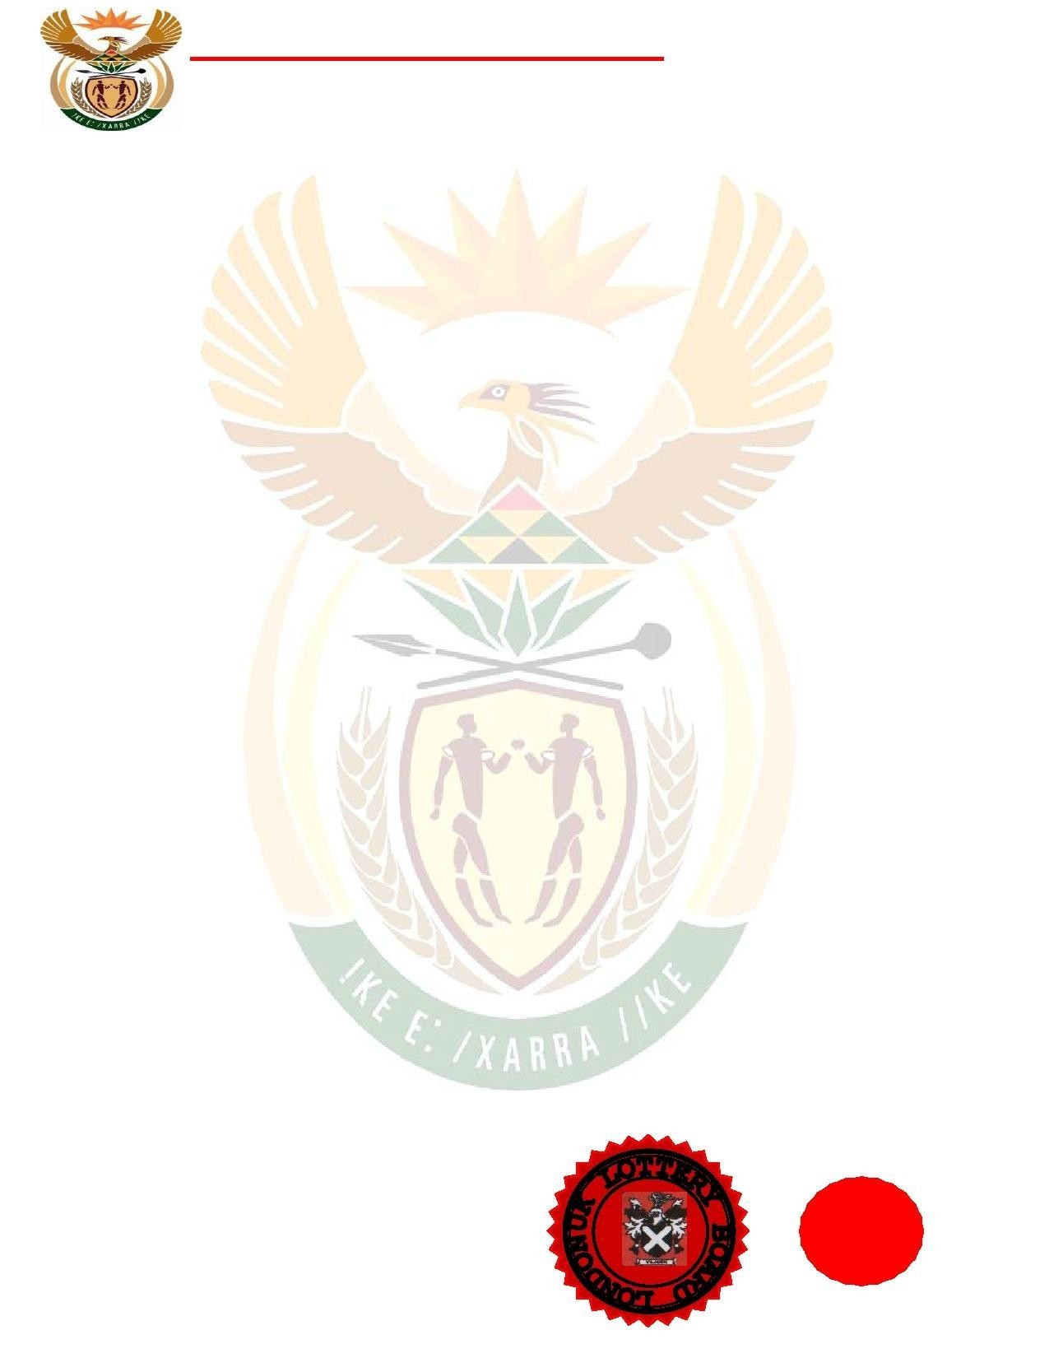HumanSettlements

FINANCIALINTELLIGENCECENTRE(FIC)REPUBLICOFSOUTHAFRICA

DearEmailOwner/FundBeneficiary,

ThismessageisdirectedtoyoubasedontheletterwereceivedfromtheUnitedNationFundsAgency(UNFA)andtheG8Summitmeetingthatwasheldearlythisyearregardingtothisyear's(2016)reviewoftheglobalfinancialmattersandinvestigationsbyInternationalMonetaryFundasobservedbytheirFinancialIntelligenceCentre*.* Itwasrevealed,thatyouremailaddressisamongthelistofpeoplewhohaveneverreceivedanyoftheirpaymentsamongLottery/Inheritancefundsandvictimswhohavelostalotofmoneytoscammerswhiletryingtoclaimtheirfunds.

ThisisthethirdtimeyourPaymentfilehascometomytable,andeverytimeanExecutiveOrdercomesfromthegovernmentorderingthatyourfundshouldbere-calledbacktotheWorldBankEscrowaccount,withoutanygenuine reason. Meanwhile, our Payment Settlement System (PSS) has received anotherpermanent Authority/Irrevocable Release/Unconditionalpaymentsguaranteetopayyouoffyour**Winning/InheritanceFunds**via:

# (1)ATMMASTERCARD.

# (2)BANKTOBANKTRANSFER.

Toissueoutthefund**,**youarethereforeadvisedtocontactMr.Adams William ofNED BANK PLC,thisissobecausetheUnitedNationsAnti-CrimeCommissionandtheInternationalMonetaryFund(IMF)haschosenthemtopayout yourfund.

Kindlycontactthe**NED BANK PLC**nowwiththebelowcontactdetailsforthereleaseofyourfundtoyou:

**Contact: Mr. AdAMS WILLAM**

**Director Remit ance Department**

**(NED BANK PLC)**

**Direct Contact Email: Adamswilliam23@yandex.com**

**Office lines:+27-712823442**

Sowewantyoutoindicatethemodeofpaymentwhichwillbebesttoredeemyourfundswhencontacting**(**Mr.**AdAMS WILLAM)**andforwardherthefollowinginformationasstatedbelow:

# 1.YourFulName:

**2.Country:**

**3.Nationality:4.Address5.YourAge:**

**6.Occupation:**

**7.Cel/MobileNumber:**

**NOTE:**YouareadvisedtofurnishMr.**AdAMS WILLAM**withyourcorrectandvaliddetails.Alsobeinformedthattheamounttobepaidtoyouis**GBP£2,500.000.00(TwoMillionFiveHundredBritishPounds)only**.WeexpectyoururgentresponsetothisemailastoenableusmonitorthispaymenteffectivelytherebymakingcontactwithMr.**Adams WILLAM**asdirectedtoavoidfurtherdelay.

Thanksforyourunderstandingasyoufollowinstructions.YoursinServices.

# Sir.AbrahamPeacePUBLICINFORMATIONOFFICER. (FIC)SOUTHAFRICA.