Patterns of performance degradation during sleep restriction of long distance truck drivers

## Presentation of the case study

We are analysing the effect of sleep deprivation on reaction time of long distance truck drivers. There are 18 subjects in the dataset and for each subject, the reaction time was measured for 10 days. The subjects were allowed only a limited amount of sleep for these 10 subsequent days. Each subject’s reaction time was measured several times on each day of the trial and an average was taken.

Reaction time is measured with a psychomotor vigilance task (PVT), which measures the speed with which subjects respond to a visual stimulus.

Is there any relation between reaction time and the number of days of sleep deprivation?

## Exploratory analysis

## Reaction Days Subject  
## 1 249.5600 0 308  
## 2 258.7047 1 308  
## 3 250.8006 2 308  
## 4 321.4398 3 308  
## 5 356.8519 4 308  
## 6 414.6901 5 308  
## 7 382.2038 6 308  
## 8 290.1486 7 308  
## 9 430.5853 8 308  
## 10 466.3535 9 308  
## 11 222.7339 0 309  
## 12 205.2658 1 309

This dataset contains multiple measurements for each subject on consecutive days, with as response variable the continuous variable reaction time and explanatory variable Days. Since there are 10 measurements for each subject, it is a longitudinal study. The dataset of 18 subjects is balanced with an equal amount of measurements for each subject.

### Spaghetti Plot

To visualise the individual reaction times and how they compare to the mean, a spaghetti plot was created. This revealed that there was a variation in intercepts or starting reaction times on day 0 between subjects. This variation increased with subsequent days.

For most subjects, the reaction time increased with the amount of days of sleep deprivation. This increase is also visible in the mean.

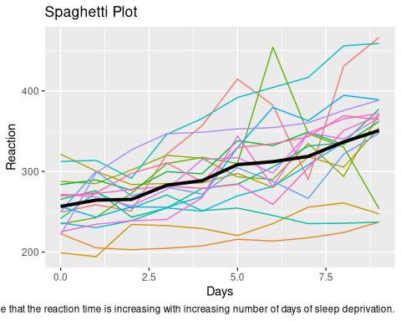

## Boxplot

The following boxplot was created to get a quick summary of the dataset’s characteristics. The mean and median seem to show a similar increase throughout the study. For day nr 6, 7 and 10, outliers are observed.  
The variance increases with an increase in days of sleep deprivation but the interquartile range appears to expand not as strongly as the minimum and maximum of the boxplot.

To put together, some subjects deviate more from the mean with an increase in days of sleep deprivation (see outliers on both sides) while most others stay around the mean (see slower increase in interquartile range).

The violin plot supports the above observations of the distribution of the data around the mean with outliers.

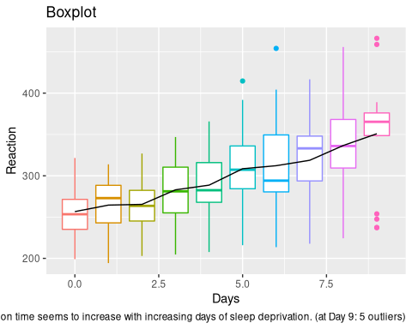

## Summary

|  |  |  |  |  |  |
| --- | --- | --- | --- | --- | --- |
|  | Days | Mean | SD | Var | n |
| 0 | 0 | 256.65 | 32.13 | 1032.30 | 18 |
| 1 | 1 | 264.50 | 33.43 | 1117.59 | 18 |
| 2 | 2 | 265.36 | 29.47 | 868.68 | 18 |
| 3 | 3 | 282.99 | 38.86 | 1509.92 | 18 |
| 4 | 4 | 288.65 | 42.54 | 1809.47 | 18 |
| 5 | 5 | 308.52 | 51.77 | 2680.09 | 18 |
| 6 | 6 | 312.18 | 63.17 | 3990.92 | 18 |
| 7 | 7 | 318.75 | 50.10 | 2510.41 | 18 |
| 8 | 8 | 336.63 | 60.20 | 3624.01 | 18 |
| 9 | 9 | 350.85 | 66.99 | 4487.15 | 18 |
| The c | alculat | ions of t | he mean, | standard | deviation and variance of the reaction time for each day of all subjects, further support our exploratory plots: we observe an increase in the mean and variance with more days of sleep deprivation. |

## Mean evolution

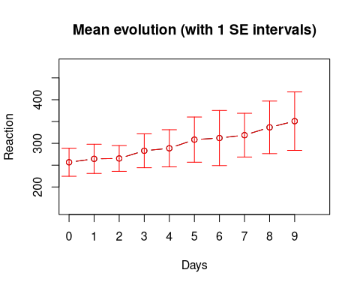 To further support our previous findings, we looked at the mean evolution. Here, an increasing trend of reaction time with increasing number of days is also observed, together with expanding standard deviations (see errorbars).

## Correlation

|  |  |  |  |  |  |  |  |  |  |  |  |
| --- | --- | --- | --- | --- | --- | --- | --- | --- | --- | --- | --- |
|  | Subject | Reaction.0 | Reaction.1 | Reaction.2 | Reaction.3 | Reaction.4 | Reaction.5 | Reaction.6 | Reaction.7 | Reaction.8 | Reaction.9 |
| 1 | 308 | 249.5600 | 258.7047 | 250.8006 | 321.4398 | 356.8519 | 414.6901 | 382.2038 | 290.1486 | 430.5853 | 466.3535 |
| 11 | 309 | 222.7339 | 205.2658 | 202.9778 | 204.7070 | 207.7161 | 215.9618 | 213.6303 | 217.7272 | 224.2957 | 237.3142 |
| 21 | 310 | 199.0539 | 194.3322 | 234.3200 | 232.8416 | 229.3074 | 220.4579 | 235.4208 | 255.7511 | 261.0125 | 247.5153 |
| 31 | 330 | 321.5426 | 300.4002 | 283.8565 | 285.1330 | 285.7973 | 297.5855 | 280.2396 | 318.2613 | 305.3495 | 354.0487 |
| 41 | 331 | 287.6079 | 285.0000 | 301.8206 | 320.1153 | 316.2773 | 293.3187 | 290.0750 | 334.8177 | 293.7469 | 371.5811 |
| 51 | 332 | 234.8606 | 242.8118 | 272.9613 | 309.7688 | 317.4629 | 309.9976 | 454.1619 | 346.8311 | 330.3003 | 253.8644 |
| 61 | 333 | 283.8424 | 289.5550 | 276.7693 | 299.8097 | 297.1710 | 338.1665 | 332.0265 | 348.8399 | 333.3600 | 362.0428 |
| 71 | 334 | 265.4731 | 276.2012 | 243.3647 | 254.6723 | 279.0244 | 284.1912 | 305.5248 | 331.5229 | 335.7469 | 377.2990 |
| 81 | 335 | 241.6083 | 273.9472 | 254.4907 | 270.8021 | 251.4519 | 254.6362 | 245.4523 | 235.3110 | 235.7541 | 237.2466 |
| 91 | 337 | 312.3666 | 313.8058 | 291.6112 | 346.1222 | 365.7324 | 391.8385 | 404.2601 | 416.6923 | 455.8643 | 458.9167 |
| 101 | 349 | 236.1032 | 230.3167 | 238.9256 | 254.9220 | 250.7103 | 269.7744 | 281.5648 | 308.1020 | 336.2806 | 351.6451 |
| 111 | 350 | 256.2968 | 243.4543 | 256.2046 | 255.5271 | 268.9165 | 329.7247 | 379.4445 | 362.9184 | 394.4872 | 389.0527 |
| 121 | 351 | 250.5265 | 300.0576 | 269.8939 | 280.5891 | 271.8274 | 304.6336 | 287.7466 | 266.5955 | 321.5418 | 347.5655 |
| 131 | 352 | 221.6771 | 298.1939 | 326.8785 | 346.8555 | 348.7402 | 352.8287 | 354.4266 | 360.4326 | 375.6406 | 388.5417 |
| 141 | 369 | 271.9235 | 268.4369 | 257.2424 | 277.6566 | 314.8222 | 317.2135 | 298.1353 | 348.1229 | 340.2800 | 366.5131 |
| 151 | 370 | 225.2640 | 234.5235 | 238.9008 | 240.4730 | 267.5373 | 344.1937 | 281.1481 | 347.5855 | 365.1630 | 372.2288 |
| 161 | 371 | 269.8804 | 272.4428 | 277.8989 | 281.7895 | 279.1705 | 284.5120 | 259.2658 | 304.6306 | 350.7807 | 369.4692 |
| 171 | 372 | 269.4117 | 273.4740 | 297.5968 | 310.6316 | 287.1726 | 329.6076 | 334.4818 | 343.2199 | 369.1417 | 364.1236 |

##   
## Shapiro-Wilk normality test  
##   
## data: sleep.resh[, i]  
## W = 0.97667, p-value = 0.9093  
##   
##   
## Shapiro-Wilk normality test  
##   
## data: sleep.resh[, i]  
## W = 0.94756, p-value = 0.388  
##   
##   
## Shapiro-Wilk normality test  
##   
## data: sleep.resh[, i]  
## W = 0.98688, p-value = 0.9936  
##   
##   
## Shapiro-Wilk normality test  
##   
## data: sleep.resh[, i]  
## W = 0.97738, p-value = 0.919  
##   
##   
## Shapiro-Wilk normality test  
##   
## data: sleep.resh[, i]  
## W = 0.97247, p-value = 0.8427  
##   
##   
## Shapiro-Wilk normality test  
##   
## data: sleep.resh[, i]  
## W = 0.978, p-value = 0.9271  
##   
##   
## Shapiro-Wilk normality test  
##   
## data: sleep.resh[, i]  
## W = 0.95912, p-value = 0.5847  
##   
##   
## Shapiro-Wilk normality test  
##   
## data: sleep.resh[, i]  
## W = 0.94648, p-value = 0.3724  
##   
##   
## Shapiro-Wilk normality test  
##   
## data: sleep.resh[, i]  
## W = 0.97112, p-value = 0.8186  
##   
##   
## Shapiro-Wilk normality test  
##   
## data: sleep.resh[, i]  
## W = 0.86251, p-value = 0.01342

## Reaction.0 Reaction.1 Reaction.2 Reaction.3 Reaction.4 Reaction.5  
## Reaction.0 1.0000000 0.6594427 0.5686275 0.4179567 0.4571723 0.2239422  
## Reaction.1 0.6594427 1.0000000 0.7461300 0.6367389 0.5562436 0.3581011  
## Reaction.2 0.5686275 0.7461300 1.0000000 0.8534572 0.7234262 0.4344685  
## Reaction.3 0.4179567 0.6367389 0.8534572 1.0000000 0.9133127 0.6553148  
## Reaction.4 0.4571723 0.5562436 0.7234262 0.9133127 1.0000000 0.7296182  
## Reaction.5 0.2239422 0.3581011 0.4344685 0.6553148 0.7296182 1.0000000  
## Reaction.6 0.2218782 0.2920537 0.4551084 0.6759546 0.7812178 0.7667699  
## Reaction.7 0.3457172 0.3312693 0.5087719 0.4509804 0.5789474 0.7254902  
## Reaction.8 0.1640867 0.1496388 0.2899897 0.4654283 0.5376677 0.8121775  
## Reaction.9 0.3106295 0.2899897 0.3168215 0.4633643 0.5933953 0.7378741  
## Reaction.6 Reaction.7 Reaction.8 Reaction.9  
## Reaction.0 0.2218782 0.3457172 0.1640867 0.3106295  
## Reaction.1 0.2920537 0.3312693 0.1496388 0.2899897  
## Reaction.2 0.4551084 0.5087719 0.2899897 0.3168215  
## Reaction.3 0.6759546 0.4509804 0.4654283 0.4633643  
## Reaction.4 0.7812178 0.5789474 0.5376677 0.5933953  
## Reaction.5 0.7667699 0.7254902 0.8121775 0.7378741  
## Reaction.6 1.0000000 0.7110423 0.6904025 0.6181631  
## Reaction.7 0.7110423 1.0000000 0.6573787 0.6243550  
## Reaction.8 0.6904025 0.6573787 1.0000000 0.8452012  
## Reaction.9 0.6181631 0.6243550 0.8452012 1.0000000

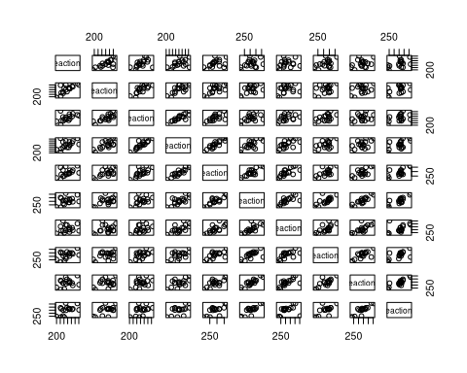 We used the Shapiro-Wilk test to check for normality of the reaction times per day.

The test revealed a non normal distribution of day 9. Thus, we performed the spearman correlation method instead of pearson to check for a correlation of the reaction times between days.

Looking at the correlation matrix, there is a correlation higher then 0.6 between subsequent days (e.g. between Day 8 and 9, between Day 3 and 4, …). However, the further the days are apart, the lower the correlation (e.g. low correlation between Day 1 and Day 8).

Aligning nicely with our previous results, there is a linear trend between the number of Days and reaction time.

## Regression per person

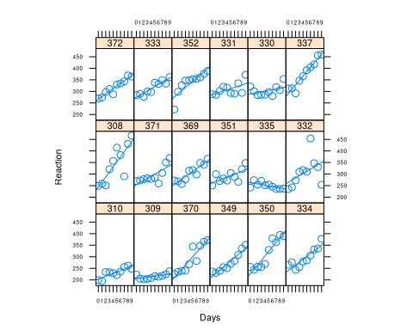 We performed a linear regression model on each subject based on the function: reaction time = b0 + bi* Days.

We then created a trellis graph to visualise the intercepts and slopes of these subject-specific linear regression models.

The graph suggests that the slope and intercept of each subject’s linear model are independent of each other as there is no observable trend between the height of the intercept and the steepness of the slope. This is further supported by plotting the intercept against the slope. Overall, all subjects have a positive slope besides subject 335.

The linear regression lines fit the datapoints closely, suggesting that a linear model is appropriate to represent this dataset.

## Between subject variability

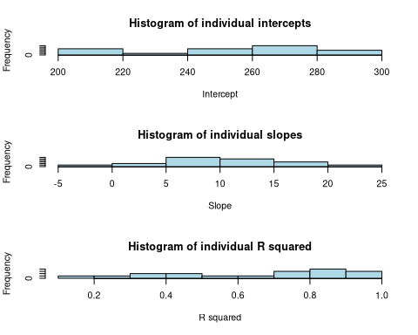

The individual intercepts shown in the first histogram correspond to the initial reaction time and are non normally distributed. Given the small data set, this is not surprising as it shows a variety of their initial reaction time. However, if this data came from a large dataset, it would be surprising that even the initial data points are not normally distributed and could suggest a wrong data sample compared to the population.

Looking at the histogram of individual slopes, we see a normal distribution. As seen on the previous graph showcasing the individual linear regressions, very little slopes are negative. This shows again that reaction time increases by days of sleep deprivation.

Finally, looking at the histogram of R squared, we see that the majority of subjects have a R squared of above 0.6. This shows that the linear model is appropriate for this data set. However, sometimes the individual linear model does not fit the specific data of some subjects, specifically 7 of the 18 subjects.

## Fitting the model - with REML

## Linear mixed model fit by REML ['lmerMod']  
## Formula: Reaction ~ 1 + Days + (1 + Days | Subject)  
## Data: sleep  
##   
## REML criterion at convergence: 1743.6  
##   
## Scaled residuals:   
## Min 1Q Median 3Q Max   
## -3.9536 -0.4634 0.0231 0.4633 5.1793   
##   
## Random effects:  
## Groups Name Variance Std.Dev. Corr  
## Subject (Intercept) 611.90 24.737   
## Days 35.08 5.923 0.07  
## Residual 654.94 25.592   
## Number of obs: 180, groups: Subject, 18  
##   
## Fixed effects:  
## Estimate Std. Error t value  
## (Intercept) 251.405 6.824 36.843  
## Days 10.467 1.546 6.771  
##   
## Correlation of Fixed Effects:  
## (Intr)  
## Days -0.138

## Values

$$\begin{matrix}γ_{0} & =251.405 \\ γ_{1} & =10.467 \\ \\ σ_{ϵ}^{2} & =654.94 \\ σ_{0}^{2} & =611.90 \\ σ_{1}^{2} & =35.08 \\ corr(b_{0i},b_{1i}) & =0.07\end{matrix}$$

##Mathematical description

Level 1 model explains the evolution of Reaction time for each subject $Y_{ij}$ = $π_{0i}$ + $π_{1i}$ $Days_{ij}$* -> how do individuals evolve + $ϵ_{ij}$-> how the individuals deviate from their own evolution

$$\begin{matrix}Y_{ij} & =π_{0i}+π_{1i}*{\text{Days}}_{ij} & & \text{how do individuals evolve} \\ & +ϵ_{ij} & & \text{how the individuals deviate from their own evolution}\end{matrix}$$

Level 2 model tries to explain why the Subjects differ from each other $π_{0i}$ = $γ_{0}$ + $b_{0i}$- model for explaining the intercept $π_{1i}$ = $γ_{1}$ + $b_{1i}$- model for explaining the slope

- Level 2 residual variance in true intercept $π_{0i}$ across all individuals in the population $σ_{1}^{2}$- Level 2 residual variance in true slope $π_{1i}$ across all individuals in the population

With level 2 model we are trying to see why there is variation between individuals by looking at the intercept and at the slope. $b_{0i}$ and $b_{1i}$ are the unexplained variability

The full model describes the evolution observed in spaghetti plot: $Y_{ij}$ = $γ_{0}$ + $b_{0i}$ + $γ_{1}$ $Days_{ij}$* - fixed effects + $b_{0i}$ + $b_{1i}$ $Days_{ij}$* - random effects + $ϵ_{ij}$- error

$$\begin{matrix}Y_{ij}= & γ_{0}+b_{0i}+γ_{1}*{\text{Days}}_{ij} & & \text{fixed effects} \\ & +b_{0i}+b_{1i}*{\text{Days}}_{ij} & & \text{random effect} \\ & +ϵ_{ij} & & \text{error}\end{matrix}$$

$$\left\{\begin{matrix}Y_{ij} & =π_{0i}+π_{1i}*{\text{Days}}_{ij}+ε_{ij} \\ π_{0i} & =γ_{0}+b_{0i} & & \text{intercept} \\ <!−−π_{1i} & =γ_{1}+b_{1i} & & \text{slope}−−>\end{matrix}\right.$$

Following is the average evolution of the population: E($Y_{ij}$) = $γ_{0}$ + $γ_{1}$ $Days_{ij}$

*

The general liniar mixed model is given by:

$Y_{i}$ = $X_{i}β$ + $Z_{i}b_{i}$ + $ϵ_{i}$ $b_{i}$ ~ N(0,D) , $ϵ_{i}$ ~ N(0, $Σi$) $b_{1}...,b_{N}$, $ϵ_{1}...,ϵ_{N}$ independent

$$Y_{i}\tilde{​}N(X_{i}β,Z_{i}DZ_{i}′+Σ_{i})$$

###todo:write the model with values given by R

$$\begin{matrix}Y_{i}=X_{i}β+Z_{i}b_{i}+ε_{i} \\ b_{i}∼N(0,D)\text{, }ε_{i}∼N(0,Σ_{i}) \\ b_{1}⋯,b_{N},ε_{1}⋯,ε_{N}\text{independent}\end{matrix}$$

R uses the marginal model and our calcuation are based on that. Next step is to check if the values we retrieved are actually significant so does the number of days have a significant effect on the reaction time? We tested this with Bootstrap and Likelihood Ratio tests because th sample zise wasn’t large enough(excluding Wald test).

## Testing fixed effects - with bootstrap

## Computing bootstrap confidence intervals ...

##   
## 10 message(s): boundary (singular) fit: see ?isSingular  
## 179 warning(s): Model failed to converge with max|grad| = 0.00201644 (tol = 0.002, component 1) (and others)

## 2.5 % 97.5 %  
## sd_(Intercept)|Subject 10.9091050 35.2359502  
## cor_Days.(Intercept)|Subject -0.5668586 0.9998806  
## sd_Days|Subject 3.3618123 8.4454148  
## sigma 22.5888964 28.6198318  
## (Intercept) 239.1178569 263.8648919  
## Days 7.2969151 13.8284502

Confidence interval of the intercept and days does not include 0 therefore both of them have a significant effect on reaction time.

## likelihood ratio test with anova

## Data: sleep  
## Models:  
## sleep.intercept: Reaction ~ 1 + (1 | Subject)  
## sleep.full: Reaction ~ 1 + Days + (1 + Days | Subject)  
## Df AIC BIC logLik deviance Chisq Chi Df Pr(>Chisq)   
## sleep.intercept 3 1916.5 1926.1 -955.27 1910.5   
## sleep.full 6 1763.9 1783.1 -875.97 1751.9 158.6 3 < 2.2e-16 ***  
## ---  
## Signif. codes: 0 '***' 0.001 '**' 0.01 '*' 0.05 '.' 0.1 ' ' 1

We compared an intercept only model with a model that includes days as well and we concluded that adding days as covariate it improves our model significantly. Days have have a significant effect on the reaction time with the p-value smaller than 0.05. The decrease in AIC value also supports this conclusion.

### OLS vs LMM estimates

#plot random intercept and random slope

## (Intercept) Days  
## (Intercept) 611.897607 9.613886  
## Days 9.613886 35.081069  
## attr(,"stddev")  
## (Intercept) Days   
## 24.736564 5.922927   
## attr(,"correlation")  
## (Intercept) Days  
## (Intercept) 1.00000000 0.06561803  
## Days 0.06561803 1.00000000

$$\begin{pmatrix}
b_{0i} \\
b_{1i}
\end{pmatrix}
\sim
N\begin{pmatrix}
\begin{pmatrix}
0 \\
0
\end{pmatrix},
\begin{pmatrix}
\sigma_{0}^2 & \sigma_{01} \\
\sigma_{01} & \sigma_{1}^2
\end{pmatrix}
\end{pmatrix}\\
\begin{pmatrix}
b_{0i} \\
b_{1i}
\end{pmatrix}
\sim
N\begin{pmatrix}
\begin{pmatrix}
0 \\
0
\end{pmatrix},
\begin{pmatrix}
611.9 & 9.61 \\
9.61 & 35.08
\end{pmatrix}
\end{pmatrix}
$$

D: Random effects covariance matrix The model is built on the assumption that the b’s come from a normal distribution with mean 0 and the residual variance in true intercept $π_{0i}$ across all individuals in the population of 611.9, the residual variance in true slope for all individuals is 35.08 and residual covariance between the intercept and the slope of 9.61.

## (Intercept) Days  
## 308 2.2575329 9.1992737  
## 309 -40.3942719 -8.6205161  
## 310 -38.9563542 -5.4495796  
## 330 23.6888704 -4.8141448  
## 331 22.2585409 -3.0696766  
## 332 9.0387625 -0.2720535  
## 333 16.8389833 -0.2233978  
## 334 -7.2320462 1.0745075  
## 335 -0.3326901 -10.7524799  
## 337 34.8865253 8.6290208

This table preditcs the random effect for each subject.Almost all values lay within two standard devation from the mean.

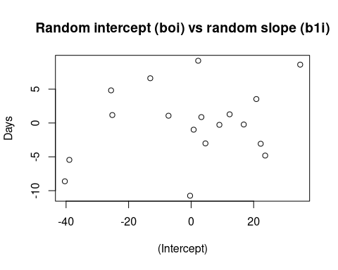

## (Intercept) Days  
## 308 253.6626 19.666560  
## 309 211.0108 1.846770  
## 310 212.4488 5.017706  
## 330 275.0940 5.653141  
## 331 273.6636 7.397609  
## 332 260.4439 10.195232

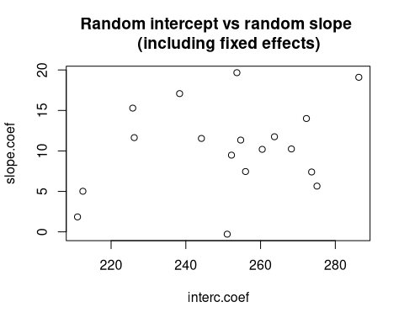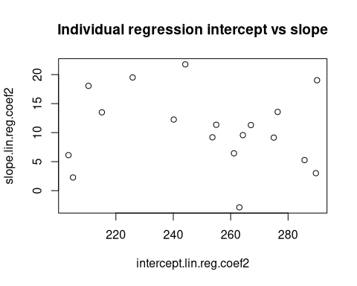

### to do: compare the two models by creating the mean!

### Discussion ???

From our analysis on the effect of sleep deprivation on the reaction time of long distance truck drivers, we concluded that there is a significant positive correlation between them. More precisely, as the sleep deprivation proceeds, the time needed for a driver to respond to a visual stimulus is increasing. Several groups of drivers with different conditions of restricted sleep deprivation or a control group would additionally help us draw a more concrete conclusion. From the existing literature, mathematical models predicting alertness from preceding sleep-wake history typically involve four factors, sleep homeostasis, circadian rhythm, sleep inertia and neuromodulatory changes. Thus, we can conclude that there is a relation between reaction time and sleep deprivation, but it is not the only factor that can fully describe the relationship of sleep deprivation and the reaction time.