10/7/2008
ForcePAD 2.4 | JonasLindemann

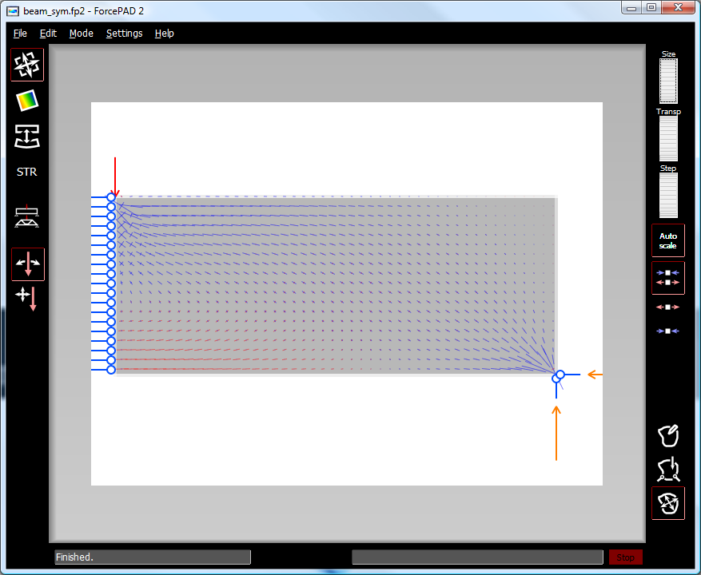
Lund University | ForcePAD Manual

Introduction
ForcePAD is a sketch program for material shape and form. Using the program structures can be easily drawn and analysed with regards to applied forces and constraints. The design of the program is based on the same conceptual model as image editing applications such as Microsoft Paint, Adobe Photoshop, Paint.NET or The GIMP. Structures are drawn using pens and other drawing tools. Forces can be places by simple clicks with the mouse. Constraints are placed in the same way as forces. Stresses and displacements are also calculated and visualized quickly without any delays.

Installation

System requirements
 | Windows | Mac OS X
Operating system | Windows XP  Windows Vista  Windows 7 | Mac OS X 10.4, 10.5 eller 10.6 with an Intel based processor
CPU | Intel Pentium 4 or higher. | Intel Pentium 4 or higher.
Memory | At least 512 Mb | At least 512 Mb
Harddrive | 4 Mb installed, 1 Gb or more to run larger models. | 4 Mb installed, 1 Gb or more to run larger models.
Graphics | Hardware accelerated OpenGL graphics. | Hardware accelerated OpenGL graphics.

Windows
Download the installation package from http://forcepad.sourceforge.net.
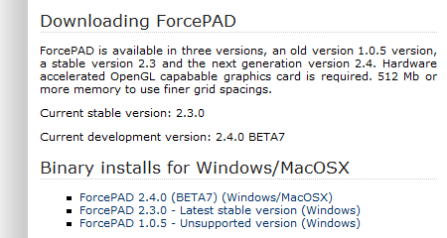
Figure 1 – Donwload page on forcepad.sourceforge.net
Click on ForcePAD 2.4.x to get the latest version. A new page is shown in the web browser.

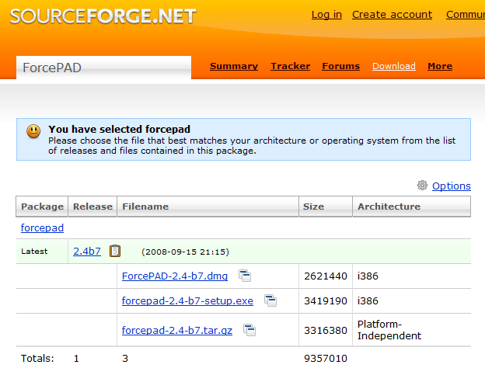
Figure 2 – Sourceforge installation package selection
The installation package for Windows is the file with the extension .exe. Click on the link to download the package. After a couple of seconds a dialog box is shown with a request to save the installation package fil.
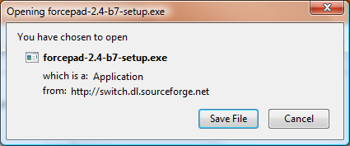
Figure 3 – Dialogbox for saving installation package
Click on Save File to save the file on the local hard drive. The installation package can then be started by double clicking on the downloaded file.
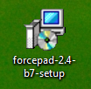
Figur 4 – Icon for the ForcePAD installation package
Follow the instructions to finish the installation. After a successful installation ForcePAD can be started from the start menu by selecting it from the start menu group “Structural Mechanics” and selecting “ForcePAD 2”.

Mac OS X

ForcePAD main window
ForcePAD uses a task oriented user interface, which means that the user interface adapts to the task at hand. The left toolbar in the main window contains the main task categories. The right toolbar shows the main tasks and their related properties.
Figur 5 - ForcePADs programfönster
To reduce user interface clutter, ForcePAD operates in three main modes:
- Sketch mode - In this mode the analysed structure is defined by sketching using the available drawing tools.
- Physics mode – In this mode the physical boundary conditions, such as loads and constraints, for the analysed structure are defined.
- Result mode – In this mode the forces and structure deflections can be visualized and analysed.
Switching between the modes is accomplished by using the mode switch buttons located in the lower right corner of the window.

Sketch mode
In sketch mode the analysed structure is created by drawing with stiffness. Black color denotes full stiffness and white color no stiffness. To create structures, paint tools used in normal image editing applications can be used, such as pens with different sizes, lines, rectangles, circles and flood fills. In this section these tools are described detail with examples how they are used.

Drawing with stiffness
The easiest way to create structures is to use the pen tools. To use this tool, select the pen task in the left toolbar (1). When this task category is chosen the available tasks are shown in the right toolbar (2).
Fiure 6 – Choice of drawing tools
When the pen task category is chosen for the first time the a pen with 100 % stiffness is preselected in the task toolbar. Drawing is done by moving the cursor over the drawing area holding the left mouse button down. As long as the left mouse button is down the pen will leave a trace with the selected stiffness and pen thickness. Figure 7 illustrates the process of drawing using the pen tool.
Figure 7 – Using the pen tool
The eraser tool is used in the same way as the pen tool with the difference that it will use 0 % stiffness.
Stiffness can be choses by clicking on the grayscale buttons in the property toolbar. Black is 100% stiffness white is no stiffness.
Pen thickness is chosen by clicking on the 5 cirlces in the property toolbar on the right. The size of the circles corresponds roughly to pen size when drawing.
Tjockleken väljs genom de 5 cirklarna i egenskapsmenyn. Storleken på cirklarna motsvarar pennans verkliga tjocklek vid uppritning. Figur 8 visar egenskapsmenyn för ritverktygen

Figure 8 - Drawing tools propery toolbar

Filling surfaces and holes
A common operation in image editing application is to fill closed surfaces with colors. In ForcePAD this is done using the floodfill tool. The tool is found in the left toolbar. Figure 9 shows were the flood fill tool is located in ForcePAD.
Figure 9 – Flood fill tool
A surface is filled by selecting the stiffness in the property toolbar and then clicking with the left mouse button in the middle of the surface. The cross in the cursor denotes where the flood fill tool will start the fill process. Figure 10 illustrates the use of the fill tool.
Figure 10 – Using the fill tool

Geometric tools
To draw geometric shapes there is a special task category for this purpose in ForcePAD. Figure 11 shows the tools in this category.
Figure 11 – Geometric tools

Rektangelverktyget
Med hjälp av rektangelverktyget kan rektanglar eller kvadrater ritas med aktuell styvhet. För att skapa en rektangel på ritytan klickar man vänster musknapp på startpunkten för rektangeln musen förflyttas sedan med knappen nertryckt till slutpunkten för rektangeln. Uppritningen avslutas genom att släppa den vänstra musknappen. Figur 12 visar principen för detta.
Figur 12 - Skapa rektanglar med rektangelverktyget

Cirkelverktyget
Med hjälp av cirkelverktyget skapas snabbt ellipser och cirklar. För att skapa en ellips på ritytan klickar man vänster musknapp på startpunkten för cirkeln musen förflyttas sedan med knappen nertryckt till slutpunkten för cirkeln. Uppritningen avslutas genom att släppa den vänstra musknappen. Figur 13 visar principen för detta.
Figur 13 - Skapa cirklar med cirkelverktyget

Linjeverktyget
Med hjälp av linjeverktyget kan linjer av olika tjocklekar skapas. För att skapa en linje på ritytan klickar man vänster musknapp på startpunkten för linjen musen förflyttas sedan med knappen nertryckt till slutpunkten för linjen. Uppritningen avslutas genom att släppa den vänstra musknappen. Figur 14 visar principen för detta.
Figur 14 - Skapa linjer med linjeverktyget

Använda raster
För att underlätta konstruktioner av mer exakta konstruktioner erbjuder ForcePAD ett raster som kan aktiveras från menyn Settings/Snap to Grid alternativt kan rastret aktiveras tillfälligt genom att använda [/Shift]-tangenten. Rastret har samma uppdelnings som beräkningsnätet. Inställningar för detta återfinns i Settings/Calculation… i menyn.

Kopiera, flytta och klippa ut

Expandera rityta till fönster

Fysikläge – Physics mode

Skapa krafter

Fästa konstruktionen

Ange egenvikt

Ange dimensioner och tjocklek

Beräkningsinställningar

Upplösning

Beräkningskonstanter

Randvillkor

Resultatläge - Action mode

Visa huvudspänningar

Visa von Mises spänningar

Visa deformationer

Uppdatera placering och riktning av krafter

Strukturoptimering

Exempel på användning

Balk på två stöd

Fackverk

Cykel

