**Responsive webshop**

**1. Introduction**

The website is a webshop. It is responsive and allows the end-user to use it on any device in a reasonable way without having to zoom in and out or go to other pages and back all the time on mobile devices.

The user is able to :

* search for products,
* view details of products including images and description,
* add products to cart,
* (check out an order)

A user with a mobile device :

* does not have to zoom in and out, the website presents its content scaled to the device screen,
* is presented less information in listings (search view / category view etc.) than on a bigger screen,
* can easily get more information by expanding details e.g. without going to different pages and back all the time,
* gets optimized functionality, e.g. the size of buttons / menu / settings etc. in order to be better accessible

**2. User Interface Design and Prototype**

The following two layouts for mobile devices show how more information can be displayed when needed and that the listing is initially overseable and does only contain the most relevant information (some key features and the price e.g).

In comparison tot he desktop layout, the mobile device layout will contain less information in general and avoid extra functionality where possible.

**Mobile Device :**

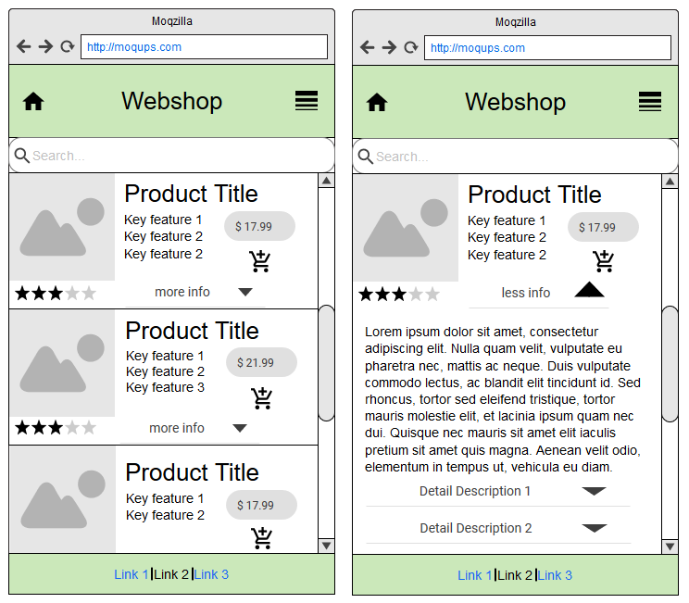

**Desktop :**

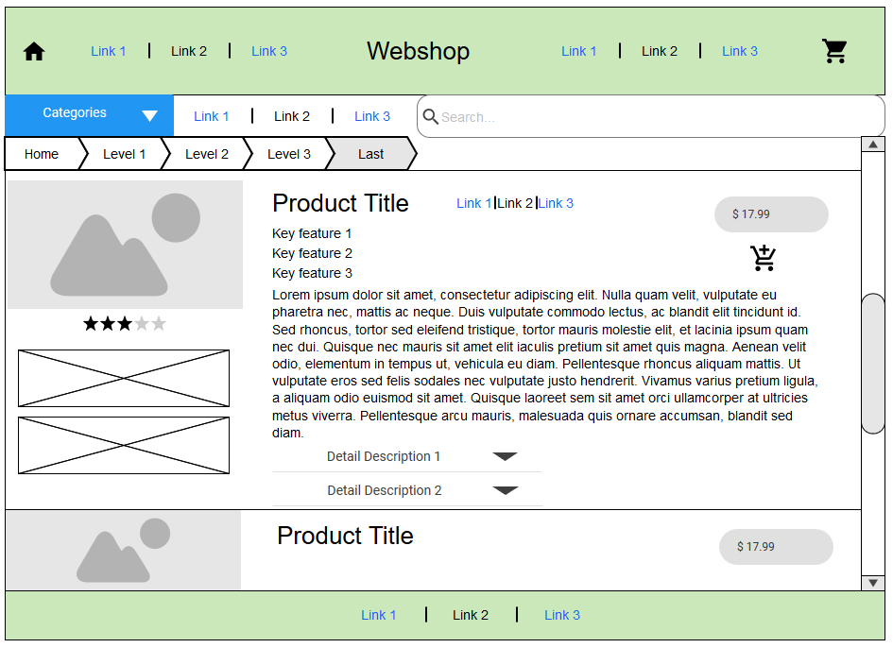

**3. Navigation Structure**

The webshop will contain a generic header including a menu and a search bar on every page nad a footer containing some links etc.

There’s a home page which might show some current items / categories / sale offers, etc. It shall be reachable from any other page / view.

There’s a listing view which presents items of a category / search results.

There might still be a detail view that presents the detail information for one product.

There’s a cart view showing the added items.

(There’s a check out view to order the items in the cart)

A collapsable menu shall be used in the header as well as some kind of breadcrumb to indicate the current state.

A typical flow looks like this:

show category / search products

show cart after directly adding item(s)

**4. References**

* Wikipedia : Responsive web design
  + Some theory and links…
  + <https://en.wikipedia.org/wiki/Responsive_web_design>
* Responsive Design für E-Commerce: Lass es sein!
  + A critical article / blog entry about responsive web design for webshops that might reveal some problems
  + <http://blog.shopgate.com/responsive-design-fuer-e-commerce-lassen-es-sein/>
* 10 brilliant examples of responsive design in ecommerce
  + Lists 10 other examples of webshops that seem to have a good responsive design and might be worth a look
  + <https://econsultancy.com/blog/61824-10-brilliant-examples-of-responsive-design-in-ecommerce>
* The Responsive Web: The Web - Past, Present, Future
  + Book about the evolution of responsive design
  + Learning from the past / getting ideas for the future
  + <https://www.amazon.com/Responsive-Web-Past-Present-Future/dp/1617291242/ref=sr_1_7?ie=UTF8&qid=1503873018&sr=8-7&keywords=responsive+web+shop>
* Mastering Responsive Web Design
  + A guide for responsive design from an experienced designer / programmer
  + <https://www.amazon.com/Mastering-Responsive-Web-Design-Ricardo/dp/1783550236/ref=sr_1_8?ie=UTF8&qid=1503873130&sr=8-8&keywords=responsive+web+design>