**Supplementary Information, Licheva et al.**

Supplementary Figures S1-S6: Page 2-9

Supplementary Tables (plasmids, yeast strains): Page 11-12

Development of mathematical models of Atg11/Atg19-cargo interaction: Page 13-18

**Supplementary Figures**

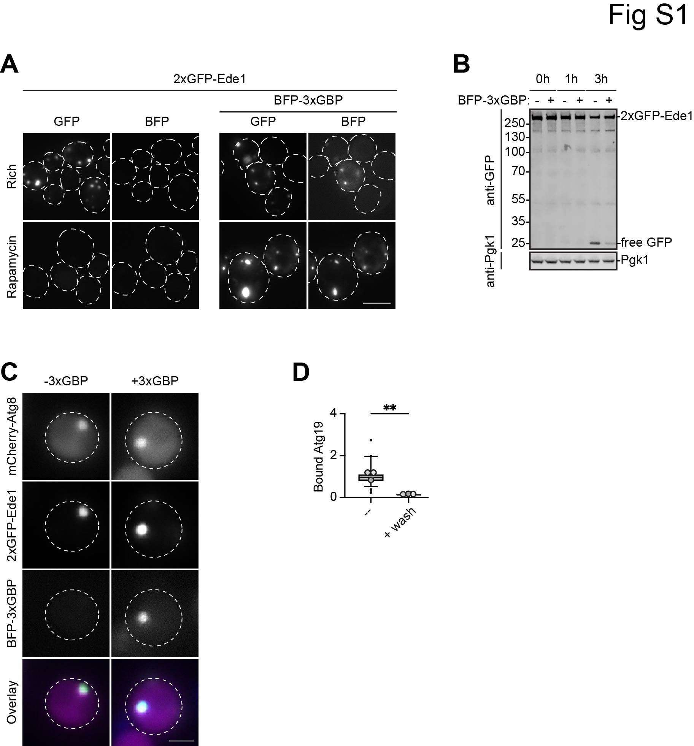

**Figure S1: High-affinity receptor-cargo interactions impair selective autophagy, related to Figure 1**

A) Representative fluorescence microscopy images from Figure 1B. One out of three independent experiments are shown. Dashed lines indicate the contour of individual cells. Scale bar: 5 µm.

B) Cells from A) were TCA precipitated and GFP cleavage was monitored by anti-GFP western blotting.

C) Representative fluorescence microscopy images from Figure 1D. One out of three independent experiments is shown. Dashed lines indicate the contour of individual cells. Scale bar: 2 µm.

D) Quantification of Figure 1E. The ratio of bead-bound protein to soluble protein was measured in a box and whiskers plot. Dark horizontal lines represent the median bound protein; box represents the 25th to 75th percentiles; whiskers expand to the 5th and 95th percentiles. Gray dots indicate the mean value of each biological replicate. Outliers are shown in black. A total of 50 beads from three independent experiments were quantified. Statistical analysis using two-tailed unpaired *t*-test. Significance is indicated with asterisks: ***p < 0.001, **p < 0.01, *p < 0.05, n.s. (not significant) p > 0.05. a.u. = arbitrary units. Exact numerical values are reported in the source data.

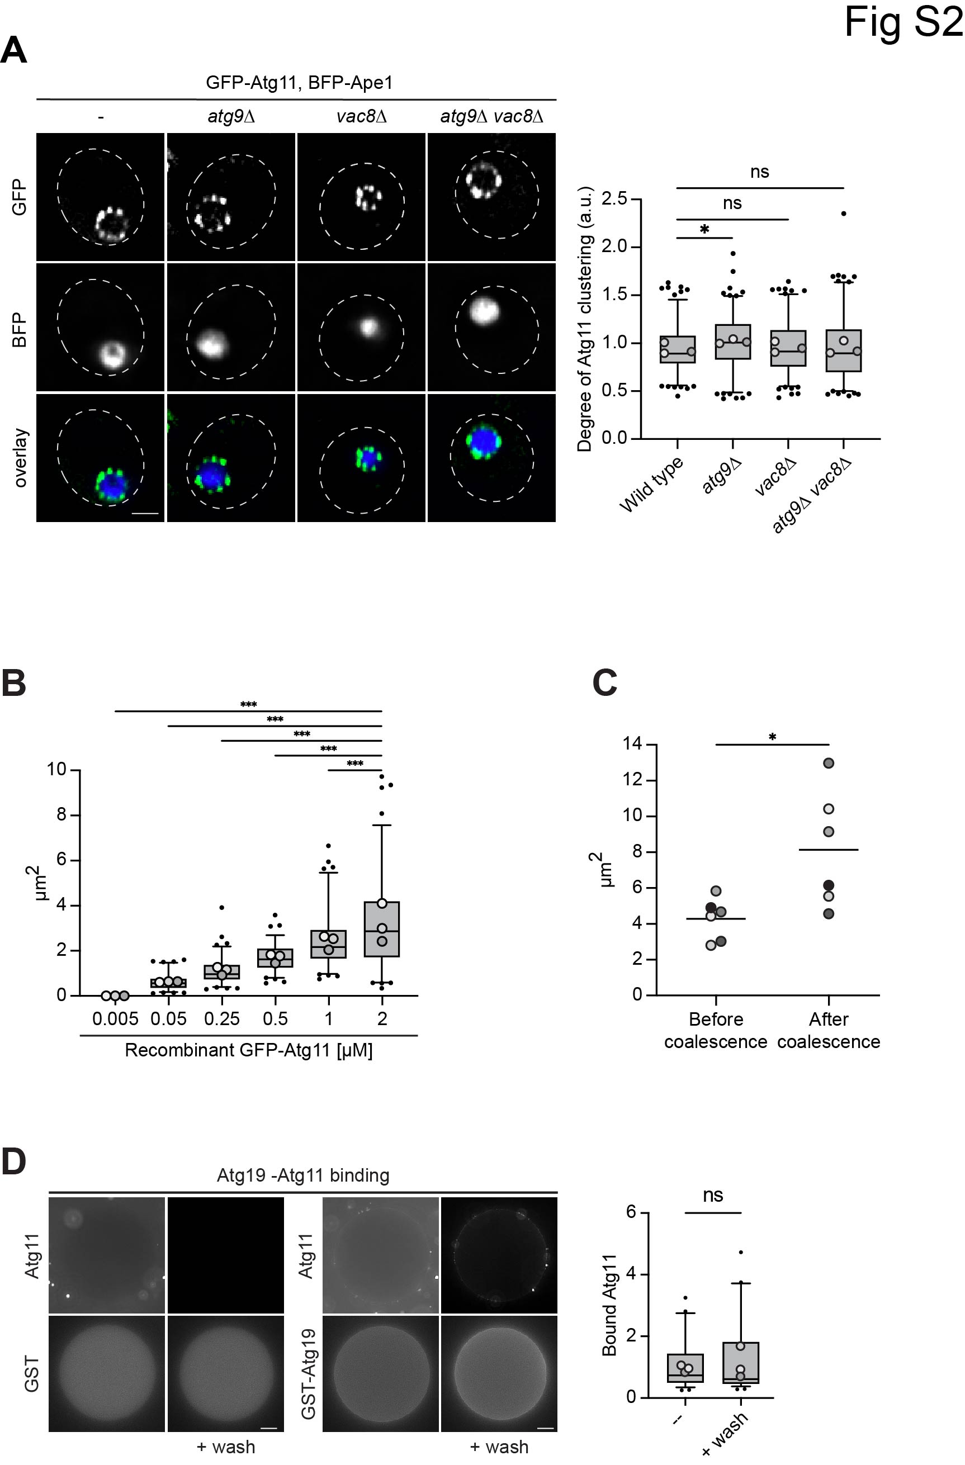

**Figure S2: Atg11 forms initiation hubs on selective cargo, related to Figure 2**

A) Indicated cells expressing GFP-Atg11, endogenous BFP-Ape1 and copper-inducible untagged Ape1 were grown to mid-log phase in the presence of 50 µM CuSO4. Representative fluorescence microscopy images of one out of three independent experiments are shown. Dashed lines indicate the contour of individual cells. Scale bar: 2 µm. The degree of GFP clustering was quantified in three independent biological replicates. For each condition and replicate at least 50 structures were analyzed and plotted in a box and whisker plot. Dark horizontal lines represent the median bound protein; box represents the 25th to 75th percentiles; whiskers expand to the 5th and 95th percentiles. Grey dots indicate the mean value of each biological replicate. Outliers are shown as black circles. Statistical analysis using one-way ANOVA followed by a Dunnett post-hoc test. Significance is indicated with asterisks: ***p < 0.001, **p < 0.01, *p < 0.05, n.s. (not significant) p > 0.05. a.u. = arbitrary units.

B) Quantification of Figure 3C. The size of *in vitro* formed GFP-Atg11 droplets (µm2) at different protein concentrations was measured from brightfield images of 30 droplets from three independent experiments and represented in a box and whiskers plot. Dark horizontal lines represent the median area size in µm2; the box represents the 25th to 75th percentiles; whiskers expand to the 5th and 95th percentiles. Outlined circles indicate the mean value of each biological replicate. Outliers are shown as black dots. Statistical analysis was performed using one-way ANOVA followed by a Dunnett post-hoc test. Significance is indicated with asterisks: ***p < 0.001, **p < 0.01, *p < 0.05, n.s. (not significant) p > 0.05.

C) Quantification of Figure 3E. The size of *in vitro* formed GFP-Atg11 droplets (µm2) before and after coalescence was measured from brightfield images of a total of 6 coalescence events and represented in a scatter plot. Dark horizontal lines represent the median area size in µm2; Statistical analysis using Welch’s *t*-test assuming unequal variances before and after coalescence. Significance is indicated with an asterisk: ***p<0.001, **p<0.01, *p<0.05, n.s (not significant) p>0.05.

D) GST-BFP or GST-BFP-Atg193D (a phospho-mimetic mutant of Atg19 known to stably interact with Atg11, S390D, S391D, and S396D 1) were expressed in *E. coli* and bound to Glutathione Sepharose (GSH) beads. Protein-bound beads were incubated with Sf9 insect cell lysates containing overexpressed GFP-Atg11, and bound GFP-Atg11 was analyzed before and after eight washing steps by fluorescence microscopy. Representative microscopy images from one out of three independent experiments are shown. Scale bar: 20 µm.

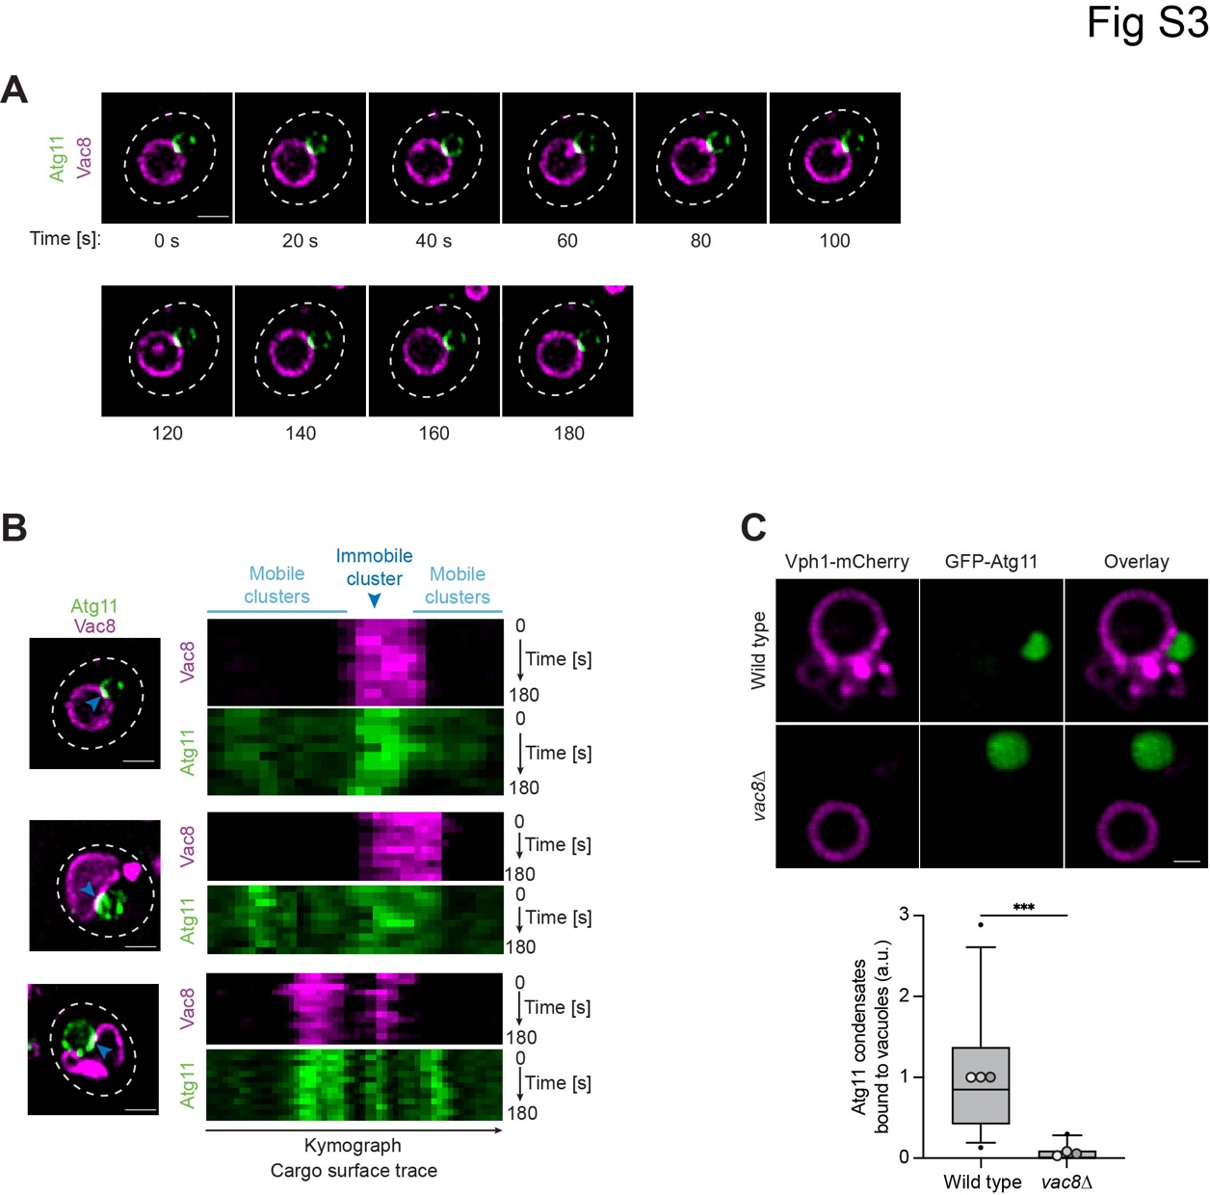

**Figure S3: Initiation hubs on selective cargo are dynamic, related to Figure 3**

A) Vac8-mCherry GFP-Atg11 cells expressing endogenous BFP-Ape1 and copper-inducible untagged Ape1 were grown to mid-log phase in the presence of 50 µM CuSO4. The dynamics of GFP-Atg11 foci were monitored over a time course of 180 sec (1 frame/20 sec). Representative fluorescence microscopy images of one out of three independent experiments are shown. The kymograph is shown in Figure S3B. Dashed lines indicate the contour of individual cells. Scale bar: 2 µm.

B) Kymograph to Figure S3A and further representative examples of kymographs. Dashed lines indicate the contour of individual cells. The blue arrow indicates a stable Atg11 cluster. Scale bar: 2 µm.

C) Purified vacuoles derived from Vph1-4xmCherry *pep4Δ atg15∆* or Vph1-4xmCherry *pep4∆ atg15∆ vac8∆* cells were incubated with recombinant GFP-Atg11 droplets. Representative microscopy images of one out of three independent experiments are shown. Scale bar: 1 µm. The ratio of Atg11 condensates bound to vacuoles divided by the total number of Atg11 condensates was quantified and normalized to the wild type. For each condition and replicate at least 600 GFP-Atg11 droplets were analyzed. Dark horizontal lines represent the median binding events; the box represents the 25th to 75th percentiles; whiskers expand to the 5th and 95th percentiles. Outlined circles indicate the mean value of each biological replicate. Outliers are shown as black dots. Statistical analysis using Welch’s *t*-test. Significance is indicated with asterisks: ***p < 0.001, **p < 0.01, *p < 0.05, n.s. (not significant) p > 0.05. a.u. = arbitrary units.

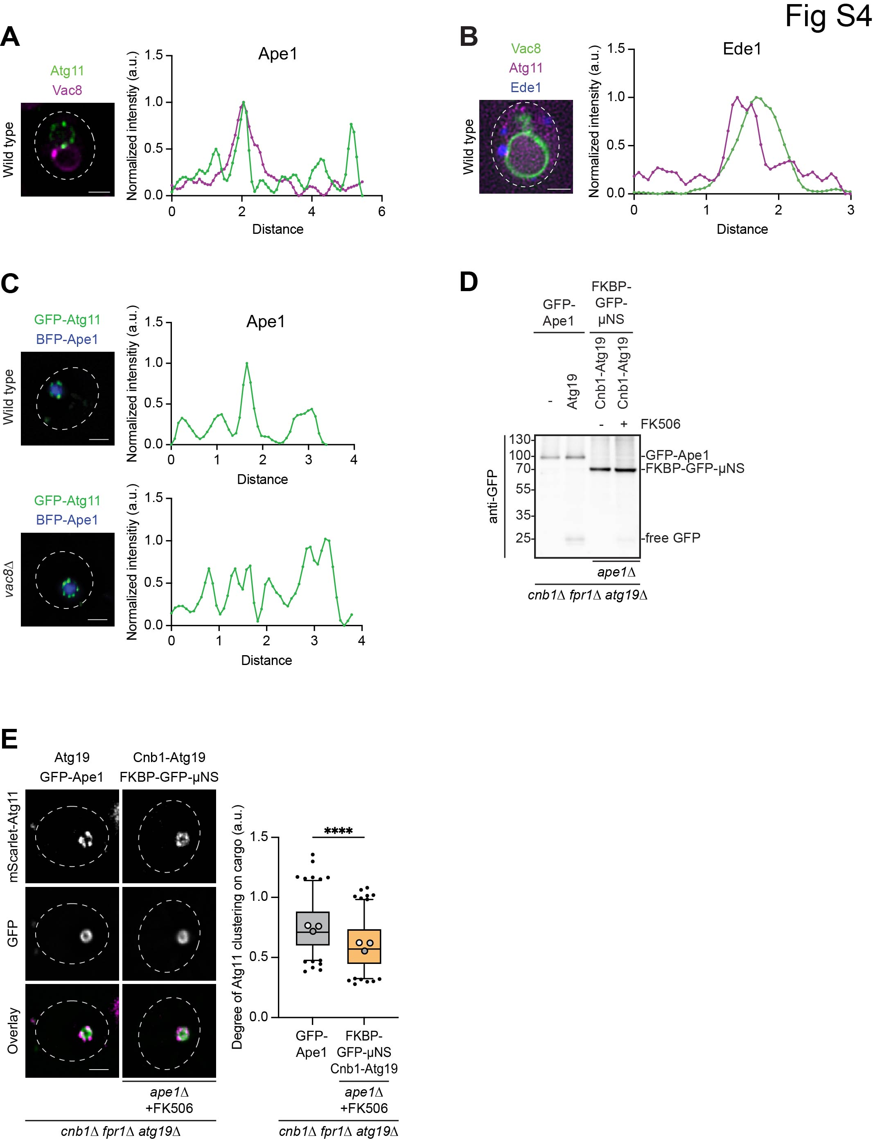

**Figure S4: Initiation hubs coalesce at the vacuolar contact site to trigger phagophore initiation, related to Figure 4**

A) GFP-Atg11 Vac8-mCherry cells expressing endogenous BFP-Ape1 and copper-inducible untagged Ape1 were grown to mid-log phase in the presence of 50 µM CuSO4. The fluorescence profile of GFP (green) and mCherry (magenta) was measured along the Ape1 condensate surface. Representative fluorescence microscopy images of one out of three independent experiments are shown. Dashed lines indicate the contour of individual cells. Scale bar: 2 µm.

B) Cells expressing Ede1-BFP, mScarlet-Atg11, and Vac8-mNeon were grown to mid-log phase. The fluorescence profile of mNeon (green) and mScarlet (magenta) was measured along the Ede1 condensate surface. Representative fluorescence microscopy images of one out of three independent experiments are shown. Dashed lines indicate the contour of individual cells. Scale bar: 2 µm.

C) GFP-Atg11 or GFP-Atg11 *vac8∆* cells expressing endogenous BFP-Ape1 and copper-inducible untagged Ape1 were grown to mid-log phase in the presence of 50 µM CuSO4. The fluorescence profile of GFP (green) was measured along the Ape1 condensate surface. Representative fluorescence microscopy images of one out of three independent experiments are shown. Dashed lines indicate the contour of individual cells. Scale bar: 2 µm.

D) Indicatedcells expressing Atg19 or Cnb1-Atg19, and GFP-Ape1 and copper-inducible untagged Ape1 or FKBP-GFP-µNS were grown to mid-log phase in the presence of 50 µM CuSO4 and treated with FK506. GFP cleavage was monitored by TCA precipitation and anti-GFP western blotting.

E) Cells from Figure S4D co-expressing mScarlet-Atg11 were monitored by fluorescence microscopy. Representative fluorescence microscopy images of one out of three independent experiments are shown. Dashed lines indicate the contour of individual cells. Scale bar: 2 µm. The degree of Atg11 clustering represented as the coefficient of variance (SD/mean mScarlet intensity) was analyzed in three independent biological replicates. For each condition and replicate at least 50 structures were analyzed and plotted in a box and whisker plot. Dark horizontal lines represent the median bound protein; box represents the 25th to 75th percentiles; whiskers expand to the 5th and 95th percentiles. Grey dots indicate the mean value of each biological replicate. Outliers are shown as black circles. Statistical analysis using one-tailed unpaired *t*-test. Significance is indicated with asterisks: ***p < 0.001, **p < 0.01, *p < 0.05, n.s. (not significant) p > 0.05. a.u. = arbitrary units.

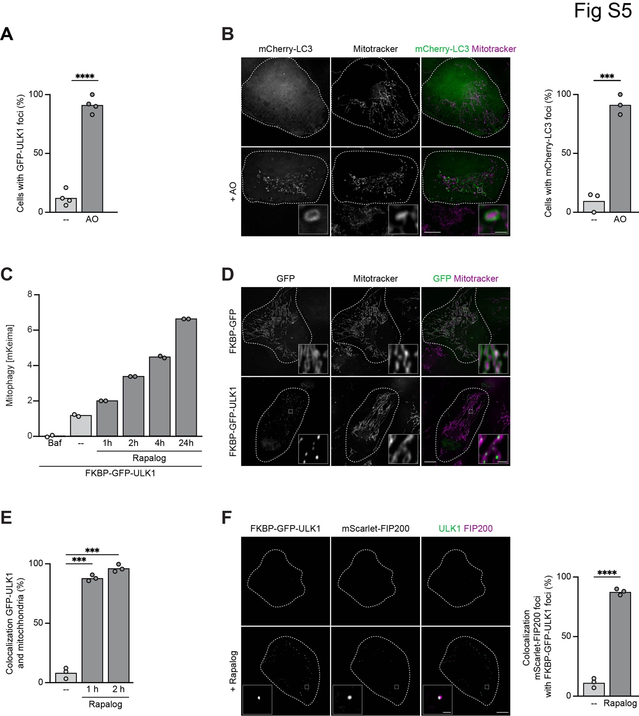

**Figure S5: Autophagy initiation hubs are conserved in human cells, related to Figure 4**

A) Quantification of Figure 5A. The percentage of cells containing GFP-ULK1 foci was quantified from four independent experiments. A total of more than 130 cells was quantified per condition. Statistical analysis using one-tailed unpaired *t*-test. Significance is indicated with asterisks: ***p < 0.001, **p < 0.01, *p < 0.05, n.s. (not significant) p > 0.05. a.u. = arbitrary units.

B) U2OS cells transfected with mCherry-LC3 and YFP-Parkin were stained with MitoTracker DeepRed. Mitophagy was induced by antimycin A and oligomycin (AO) treatment. Representative live fluorescence microscopy images of one out of three independent experiments are shown. Dashed lines indicate the contour of individual cells. Scale bar: 10 µm, scale bar inset: 1 µm. The percentage of cells containing mCherry-LC3 foci was quantified from three independent experiments. A total of at least 50 cells was quantified per condition. Statistical analysis using one-tailed unpaired *t*-test. Significance is indicated with asterisks: ***p < 0.001, **p < 0.01, *p < 0.05, n.s. (not significant) p > 0.05. a.u. = arbitrary units.

C) U2OS wild type cells stably expressing mito-mKeima and FRB-FIS93-152 and FKBP-GFP-ULK1 were grown in nutrient-rich media and treated with Bafilomycin A1 (Baf) and rapalog. Gating for GFP-expressing cells was performed. The mito-mKeima ratio of lysosomal mitochondria (561 nm) to cytosolic mitochondria (488 nm) was analyzed by FACS. Quantification was performed from two independent biological replicates and is shown as a ratio normalized to the Bafilomycin treatment.

D) U2OS cells containing FRB-FIS193-152 and transfected FKBP-GFP-ULK1 or FKBP-GFP were cultured in nutrient-rich medium and treated with rapalog. Mitochondria were stained with MitoTracker DeepRed. Representative fluorescence microscopy images of one out of three independent experiments are shown. Scale bar: 10 µm, scale bar inset: 1 µm. All GFP-positive cells showed the respective phenotype (foci on mitochondria for FKBP-GFP-ULK1 and all along the mitochondrial network for FKBP-GFP) and were therefore not quantified.

E) Quantification of Figure 5C. The percentage of cells containing GFP-ULK1 colocalizing with mitochondria was quantified from two independent experiments. A total of at least 50 cells was quantified per condition. Statistical analysis using one-way ANOVA followed by Dunnett post-hoc test. Significance is indicated with asterisks: ***p < 0.001, **p < 0.01, *p < 0.05, n.s. (not significant) p > 0.05. a.u. = arbitrary units.

F) U2OS cells containing FRB-FIS193-152 and transfected FKBP-GFP-ULK1 and mScarlet-FIP200 were cultured in nutrient-rich medium and rapalog treated. Representative live fluorescence microscopy images of one out of two independent experiments are shown. Scale bar: 10 µm, scale bar inset: 1 µm. The percentage of cells containing mScarlet-FIP200 foci colocalizing with FKBP-GFP-ULK1 foci was quantified from two independent experiments. A total of more than 50 cells was quantified per condition. Statistical analysis using one-tailed unpaired *t*-test. Significance is indicated with asterisks: ***p < 0.001, **p < 0.01, *p < 0.05, n.s. (not significant) p > 0.05. a.u. = arbitrary units.

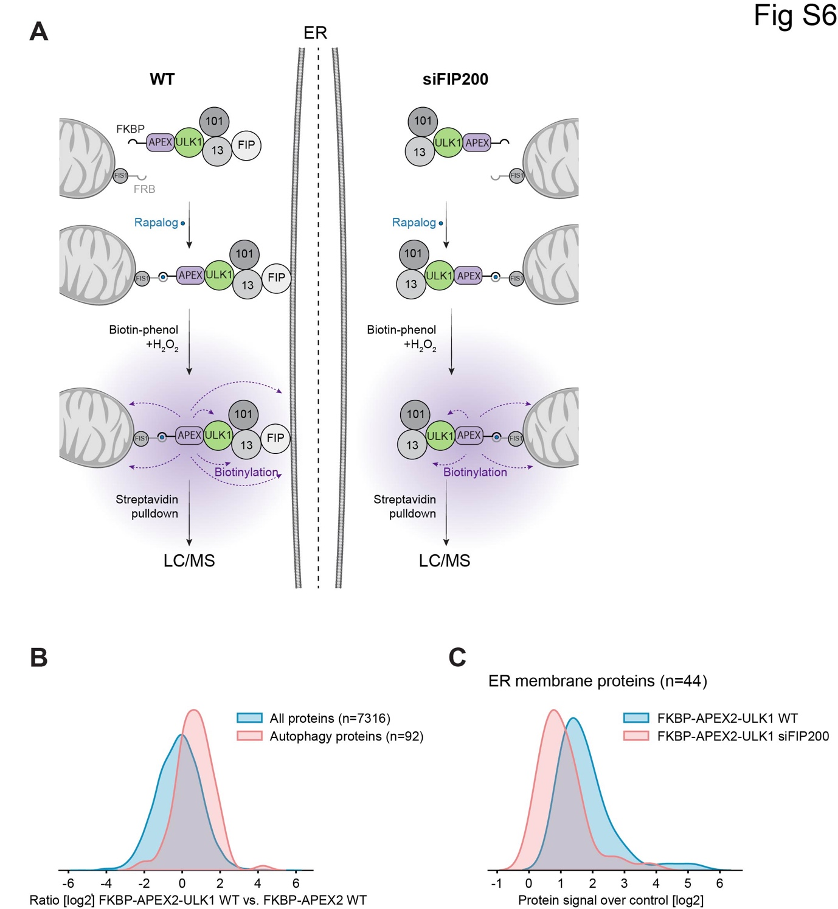

**Figure S6: Initiation hubs establish ER connections, related to Figure 5**

A) Schematic representation of the proximity biotinylation setup. FKBP-APEX2-ULK1 is tethered to mitochondrial FIS1-FRB by rapalog addition. FIP200 connects this mitochondrial assembly to the ER. Proximity biotinylation is induced by the addition of biotin-phenol and H2O2. Biotinylated proteins are isolated by affinity purification with streptavidin beads and analyzed by mass spectrometry.

B) Mass spectrometry data from Figure 5D: The Kernel density estimate (KDE) plot depicts a comparison between the FKBP-APEX2 and FKBP-APEX2-ULK1 data that is positive for the Gene Ontology (GO) term 'autophagy' (GO:0006914).

C) Mass spectrometry data from Figure 5E: The Kernel density estimate (KDE) plot, shows the comparison FKBP-APEX2-ULK1 WT vs FKBP-APEX2-ULK1 siFIP200 of all proteins that are positive for the Gene Ontology (GO) term “ER membrane” (GO:0005789). The samples were control-corrected before the analysis.

|  |  |  |  |  |  |  |  |
| --- | --- | --- | --- | --- | --- | --- | --- |
| **Supplementary Tables**  **Appendix Table S1 – Mammalian plasmids used in this study** | | | | | | |  |
|  |  | |  |  |  | |  |
| **Name** | | **Characteristics** | **Promoter** | **Terminator** | | **Source** | |
|  | | mCherry-LC3 | CMV | bGH PolyA | | Addgene #40827 | |
| pCE32 | | 2xFKBP-GFP-ULK1 | CMV | hGH PolyA | | This study | |
| pRB34 | | mScarlet-FIP200 | CMV | bGH PolyA | | This study | |

|  |  |  |  |  |  |  |  |  |
| --- | --- | --- | --- | --- | --- | --- | --- | --- |
| **Appendix Table S2 – Yeast, bacterial and insect cell expression plasmids used in this study** | | | | | | | |  |
|  |  | |  |  |  | |  |  |
| **Name** | | **Characteristics** | **Promoter** | **Terminator** | | **Source** | | |
| pRS315 | | CEN, LEU2 | - | - | | Sikorski and Hieter 1989 2 | | |
| pRS316 | | CEN, URA3 | - | - | | Sikorski and Hieter 1989 2 | | |
| pRS415 | | CEN, LEU2 | - | - | | Sikorski and Hieter 1989 2 | | |
| pRS416 | | CEN, URA3 | - | - | | Sikorski and Hieter 1989 2 | | |
| pRS304 | | Integrative, TRP1 | - | - | | Sikorski and Hieter 1989 2 | | |
| pRS305 | | Integrative, LEU2 | - | - | | Sikorski and Hieter 1989 2 | | |
| pCK782 | | Ape1; pRS315 | CUP1 | CYC1 | | This study | | |
| pCK969 | | mTagBFP-Ape1/Ape1 | Ape1/CUP1 | CYC1/Ape1 | | This study | | |
| pDH48 | | mScarlet-Atg11; pRS416 | Atg11 | CYC1 | | Hollenstein et al., 2021 3 | | |
| pDP108 | | GFP-Ape1; pRS315 | Ape1 | CYC1 | | This study | | |
| pHM83 | | StrepII-TEV-GFP-Atg11 codon-optimized for insect cells; pLIB | polh | SV40 | | This study | | |
| pHM84 | | GST-Thrombin-mCherry-Atg193D; pGEX-4T-1 | tac | - | | This study | | |
| pHM135 | | GST-Thrombin-mTagBFP2; pGEX-4T-1 | tac | - | | This study | | |
| pHM144 | | GST-Thrombin-mTagBFP2-Ape1(1-45); pGEX-4T-1 | tac | - | | This study | | |
| pHM145 | | GST-Thrombin-mTagBFP2-Atg193D; pGEX-4T-1 | tac | - | | This study | | |
| pJE7 | | Atg19; pRS416 | Atg19 | CYC1 | | This study | | |
| pJE17 | | GFP-Ape1/Ape1 | Ape1/CUP1 | CYC1/Ape1 | | This study | | |
| pJE29 | | Atg19-GBP; pRS416 | Atg19 | CYC1 | | This study | | |
| pML14 | | GFP-Atg11; pRS315 | Atg11 | CYC1 | | Hollenstein et al., 2021 3 | | |
| pML86 | | Ape1(1-45)-GFP-µNS(471-721); pRS415 | GPD | CYC1 | | This study | | |
| pML92 | | Atg19-GFP-µNS(471-721); pRS415 | GPD | CYC1 | | This study | | |
| pML145 | | Cnb1-2xProteinA-Atg19; pRS416 | Atg19 | CYC1 | | This study | | |
| pML146 | | FKBP-GFP-µNS(471-721); pRS415 | GPD | CYC1 | | This study | | |
| FWP00841 | | mTagBFP-3xGBP; pRS304 | CUP1 | - | | This study | | |
| FWP00344 | | mCherry-Atg8; pRS305 | ADH1 | - | | This study | | |

|  |  |  |  |  |
| --- | --- | --- | --- | --- |
| **Appendix Table S3 – Yeast strains used in this study** | | | |  |
| **Name** | **Genotype** | **Background** | **Source** | |
| BY4741 | his3∆1 leu2∆0 met15∆0 ura3∆0; Mat a | BY474x | Euroscarf | |
| DF5 | leu2-3 leu2-112 his3-∆200 lys2-801 trp1-1(am) ura3 | DF5 | Finley *et al*., 1987 4 | |
| yDH231 | GFP-Atg11 vac8::kan; Mat a | BY474x | Hollenstein *et al*., 2021 3 | |
| yDH334 | ape1::kan atg19::hyg; Mat a | BY474x | This study | |
| yDH439 | Vph1-GFP:His atg19::hyg vac8::kan; Mat alpha | BY474x | Hollenstein *et al*., 2021 3 | |
| yDH445 | GFP-Atg11 atg9:kan vac8::kan; Mat a | BY474x | This study | |
| yDH485 | atg19::hyg cnb1::kan fpr1::hyg; Mat a | BY474x | This study | |
| yDP692 | GFP-Atg19:Ura, Mat a | BY474x | This study | |
| yDP451 | atg19::hyg; Mat A | BY474x | This study | |
| yFK7 | Vph1-4xmCherry:Ura3 pep4::nat atg15::kan; Mat alpha | BY474x | Hollenstein *et al*., 2019 5 | |
| yFK10 | Vph1-4xmCherry:Ura3 pep4::nat atg15::kan vac8::kan; Mat a | BY474x | This study | |
| yML39 | GFP-Atg11 atg9::kan; Mat a | BY474x | Hollenstein *et al*., 2021 3 | |
| yML68 | Atg9-3xGFP:nat atg11::kan; Mat a | BY474x | Hollenstein *et al*., 2021 3 | |
| yML112 | atg11::nat atg19:hyg ape1::kan; Mat a | BY474x | This study | |
| yML118 | Nup170-GFP:His; Mat a | BY474x | This study | |
| yML134 | mScarlet-Atg11:nat atg19::hyg; Mat a | BY474x | This study | |
| yML135 | mScarlet-Atg11:nat atg19::hyg cnb1::kan fpr1::hyg; Mat alpha | BY474x | This study | |
| yML153 | mScarlet-Atg11:nat atg19::hyg ape1::kan; Mat a | BY474x | This study | |
| yML154 | mScarlet-Atg11:nat atg19::hyg ape1::kan cnb1::kan fpr1::hyg; Mat alpha | BY474x | This study | |
| yML160 | atg19::hyg ape1::kan cnb1::kan fpr1::hyg; Mat a | BY474x | This study | |
| yML172 | mScarlet-Atg8:nat Atg9-3xGFP:nat; Mat a | BY474x | This study | |
| yML177 | Atg1-3xGFP:Ura mScarlet-Atg11:nat; Mat a | BY474x | This study | |
| yTB283 | GFP-Atg11; Mat a | BY474x | Pfaffenwimmer *et al*., 2014 1 | |
| yTB281 | GFP-Atg8; Mat a | BY474x | This study | |
| yTB485 | GFP-Atg11 Vac8-mCherry; Mat alpha | BY474x | This study | |
| yTP65 | atg19::kan; Mat a | BY474x | Pfaffenwimmer *et al*., 2014 1 | |
| FWY006612 | natNT2::pADH::EGFP-Ede1-EGFP:His leu2∆::pADH1::mCherry-Atg8:Leu; Mat alpha | DF5 | This study | |
| FWY006617 | natNT2::pADH::EGFP-Ede1-EGFP:His; Mat alpha | DF5 | This study | |
| FWY006626 | natNT2::pADH::EGFP-Ede1-EGFP:His trp1∆::pCUP1::mTagBFP-3xGBP:Trp1 leu2∆::pADH::mCherry-Atg8:Leu; Mat alpha | DF5 | This study | |
| FWY006654 | natNT2::pADH::EGFP-Ede1-EGFP:His trp1∆::pCUP1::mTagBFP-3xGBP:Trp1; Mat alpha | DF5 | This study | |
| FWY006898 | natNT2::pADH::EGFP-Ede1-EGFP:His atg19::hyg; Mat alpha | DF5 | This study | |
| FWY006900 | natNT2::pADH::EGFP-Ede1-EGFP:His trp1∆::pCUP1::mTagBFP-3xGBP:Trp1 atg19::hyg; Mat alpha | DF5 | This study | |
| FWY006975 | natNT2::pADH::Ede1::mTagBFP::His Atg9::mNeon::klTRP1, Mat alpha | DF5 | This study | |
| FWY006977 | natNT2::pADH::Ede1::mTagBFP::His Vac8::mNeon::klTRP1, Mat alpha | DF5 | This study | |
| FWY006979 | natNT2::pADH::Ede1::mTagBFP::His Atg1::mNeon::klTRP1, Mat alpha | DF5 | This study | |

**References:**

1. Pfaffenwimmer, T. *et al.* Hrr25 kinase promotes selective autophagy by phosphorylating the cargo receptor Atg19. *EMBO Rep.* 9 (2014).

2. Sikorski and Hieter. A System of Shuttle Vectors and Yeast Host Strains Designed for Efficient Manipulation of DNA in Saccharomyces Cerevisiae. *Genetics*. 122(1):19-27 (1989).

3. Hollenstein, D. M. *et al.* Spatial control of avidity regulates initiation and progression of selective autophagy. *Nat. Commun.* **12**, 7194 (2021).

4. Finley, D., Özkaynak, E. & Varshavsky, A. The yeast polyubiquitin gene is essential for resistance to high temperatures, starvation, and other stresses. *Cell* **48**, 1035–1046 (1987).

5. Hollenstein, D. M. *et al.* Vac8 spatially confines autophagosome formation at the vacuole in S. cerevisiae. *J. Cell Sci.* **132**, jcs235002 (2019).

**Development of mathematical models of Atg11/Atg19-cargo interaction**

We developed a mathematical model to elucidate the difference between avidity-driven interactions and affinity-driven interactions for the assembly of initiation hubs. In the following, the mathematical foundations and assumptions of the model and the implementation in simulations are introduced. For this purpose, first, the mechanics of the individual agents of the agent-based model and their interactions are defined. Subsequently, the numerical implementation of the simulations is introduced and finally, the results of the modeling show that simulations based on low-affinity but high-avidity-mediated interactions produced a pattern of Atg11/Atg19 clusters on the cargo, while high-affinity interactions could not produce these clusters.

**Mechanics of agent-based models**

The developed model consists of agents which represent the proteins of interest and individual sections of the cargo. As Atg11 and Atg19 interact with very high affinity, they were assumed as one entity for simplification (Atg11w19). We model the positions of all agents by point-like particles and their interactions via forces given by potentials. To describe the stochastic molecular motion together with forces arising due to interactions, we use Brownian dynamics given by

(1)

where a full list of parameters can be found in Table M1.

**Affinity-interactions of particles based on force-potentials**

Particles interact via a predefined force-potential which can be adapted by modifying its parameters. The force can be calculated by the following equations. The variable *r* indicates the distance between the two particles *i* and *j* of interest whileand describe their radii respectively. The non-dimensional variable *σ* is just used to simplify some of the equations. A value of means that the two interacting soft spheres are overlapping and the resulting force should be repelling the two. Conversely, means that the interacting particles are separated and do not overlap.

(2)

The strength of the interaction can then be calculated via

. (3)

We can see that the overall sign is positive when and negative in the other case. This leads to repelling and attracting forces. For numerical stability, we have to enforce an upper bound *β* on the interaction strength. We expect that the simulation will very rarely reach this bound but it is a safety mechanism to keep the simulation running in the rare case that this happens. The value 4 can be calculated when considering that particles which overlap 50% produce a value of , which generates the first in the potential.

(4)

Furthermore, it is often necessary to restrict the interaction range of such potentials. We introduce the interaction range *ζ*. Since we assume that our particles are not point-like but rather extend in space as soft spheres, we need to add the radius of the current particle and the interacting particle to the total interaction range to obtain the actual cutoff

(5)

The complete interaction potential can then be calculated via

(6)

where θ is the Heaviside step-function which enforces the interaction cutoff given by *β.*

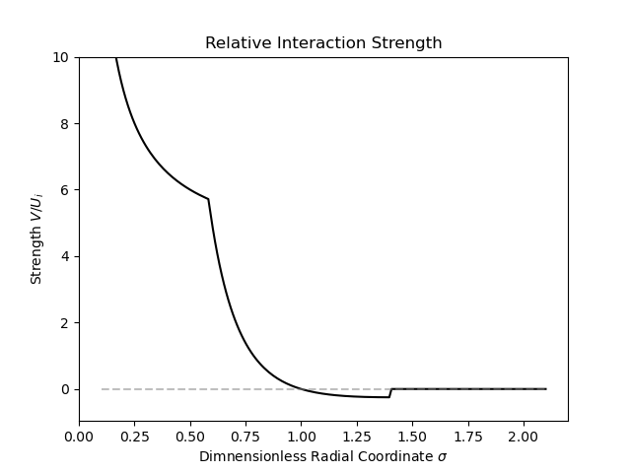

**Figure M1:** Shape of the force acting between particles. The cutoff was chosen to be . Since the plot shows the relative interaction strength, this is the only parameter.

|  |  |
| --- | --- |
| **Parameter** | **Description** |
|  | Number of particles in the simulation |
|  | Thermodynamic energy |
|  | Increment of the Wiener process |
|  | Diffusion Constant |
|  | Radii of the particles |
|  | Interaction strengths between particle species |
|  | Interaction ranges |

**Table M1:** Parameters of the Simulation. Variables with index c correspond to properties of the cargo particles while a corresponds to Atg11w19.

**Avidity-interactions**

To model avidity, which is the cooperation of neighboring molecules in attracting another species of particles, we alter the potential strengths between the combined Atg11w19 protein particles and the cargo particles.

**Numerical Implementation**

We used cellular_raza(https://github.com/jonaspleyer/cellular_raza) to solve the equations of motion.

**Initial Positions**

**Cargo**

Initially, cargo particles are placed randomly inside a sphere with a given radius. They are then propagated until they reach an equilibrium state. This serves as the initial state for the next simulation step.

**Atg11w19**

After the cargo particles have reached equilibrium, we introduce the Atg11w19 particles into the simulation. They are placed randomly outside of a sphere which radius is given by the initial cargo placements and an additional band which acts as a spacer.

**Simulation Flow**

For simulation in which Cargo and Atg11w19 particles are combined, the position of cargo particles is fixed in space for the remainder of the simulation time. Meanwhile, the Atg11w19 particles are subject to the motions described above. They still interact with the cargo particles. If a particle collides with the simulation boundary, it is reflected. However, this behavior only occurs infrequently in our simulation.

**Storing Results**

One particle can be represented as a

collection of all its parameters. They are stored in multiple files. A typical section of such a file is represented in Figure M2. Similarly, the overall settings required to run a single simulation are also stored in a single file. This is automatically done by cellular_raza in the background.

|  |
| --- |
| {  "mechanics": {  "pos": [  8.85747417305744e-7,  1.6095030291306556e-6,  9.080380540878439e-7  ],  "diffusion_constant": 4.8000000000000003e-17,  "kb_temperature": 4.141947e-21,  "random_vector": [  -0.7010850624988277,  5.667906385578381,  -3.523344099774444  ]  },  "interaction": {  "species": "Atg11w19",  "cell_radius": 1.0000000000000001e-7,  "potential_strength_cargo_cargo": 3e-12,  "potential_strength_atg11w19_atg11w19": 6.2e-13,  "potential_strength_cargo_atg11w19": 1e-12,  "interaction_range_cargo_cargo": 8.000000000000001e-8,  "interaction_range_atg11w19_atg11w19": 8.000000000000001e-8,  "interaction_range_atg11w19_cargo": 1.2000000000000002e-7,  "relative_neighbour_distance": 1.5,  "neighbour_count": 0  }  } |

**Figure M2:** Json representation of a single particle of species Atg11w19.

|  |
| --- |
| {  "n_cells_cargo": 220,  "n_cells_atg11w19": 360,  "cell_radius_cargo": 1.0000000000000001e-7,  "cell_radius_atg11w19": 1.0000000000000001e-7,  "diffusion_cargo": 5e-17,  "diffusion_atg11w19": 4.8000000000000003e-17,  "temperature_atg11w19": 300.0,  "temperature_cargo": 300.0,  "potential_strength_cargo_cargo": 3e-12,  "potential_strength_cargo_atg11w19": 1.1000000000000002e-12,  "potential_strength_atg11w19_atg11w19": 6.2e-13,  "interaction_range_cargo_cargo": 8.000000000000001e-8,  "interaction_range_atg11w19_cargo": 1.2000000000000002e-7,  "interaction_range_atg11w19_atg11w19": 8.000000000000001e-8,  "relative_neighbour_distance": 1.5,  "dt": 0.12,  "t_max": 8400.0,  "save_interval": 6.0,  "extra_saves": [],  "n_threads": 4,  "domain_size": 5e-6,  "domain_cargo_radius_max": 6.000000000000001e-7,  "domain_atg11w19_radius_min": 6.5e-7,  "domain_n_voxels": 5,  "storage_name": "out/autophagy_param_space",  "substitute_date": "0000000603",  "cargo_initials_dir": "out/cargo_initials",  "show_progressbar": false,  "random_seed": 4  } |

**Figure M3:** All settings needed to specify a complete simulation run.