Homework 1 – Jonas Strand Aasberg

CQ1:

Found in Excel directly:

Sample avergage: 467,4876

Sample Standard deviation: 288,0880

CQ2:

1. Regression, because it provides a linear set of outputs
2. This is Extrapolation because it predicts something outside the original sample area

CQ3:

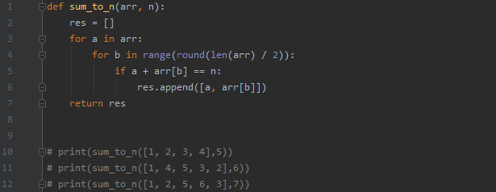

CQ4:

1. Features A,B and C are categorial because they only take an integer value and in my mind are most likely related to year day and month. The day and month value fluctuates between 1 and 7 and a and 31 respectively.
2. 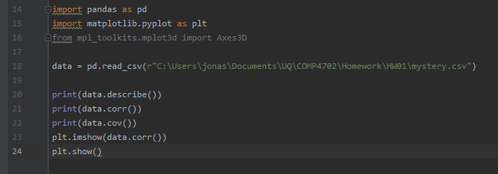Features E and F are most strongly correlated shown from this snippet of code and plot. Indexes 5 and 4 indicate feature F and E respectively. As they are positively correlated they seem to increase and decrease in some degree of sync with each other.
3. 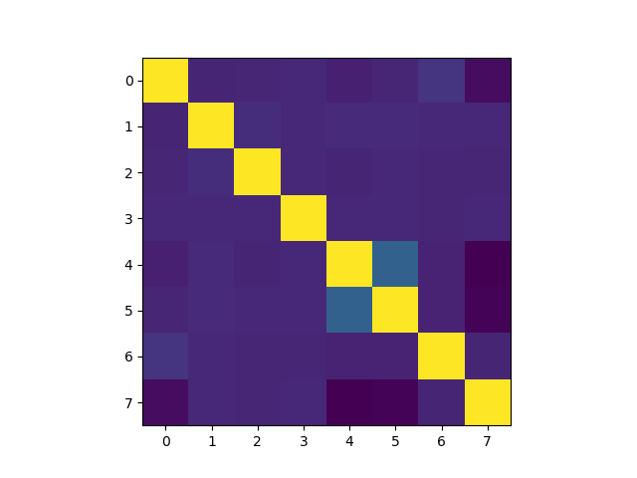The features E and H are negatively correlated to some degree.
4. F is a value fluctuating between 180 and -180 this leads me to believe it is either a measurement of degrees or a part of polar coordinates.
5. A close up of a logo

   Description automatically generated

ii) D and F have the lowest correlation value: -0.019961

iii) They are the two least correlated which means they have the lowest degree of linear relation. The low value indicates a low or almost non existent linear relationship.