1. INTRODUCTION

1.1. BACKGROUND

Soaring house prices in major cities is a hot topic. From 1980 to 2019, Stockholm has seen a rise in real estate price index of around 1060%[1](https://www.scb.se/en/finding-statistics/statistics-by-subject-area/housing-construction-and-building/real-estate-prices-and-registrations-of-title/real-estate-prices-and-registrations-of-title/pong/tables-and-graphs/real-estate-price-index/). Naturally, this has narrowed the scope in terms of what people can afford to live in the city. It has also affected the business landscape, large corporations such as Telia and SEB moving out of the city center and the closing of mom & pop stores.

1.2. PROBLEM

The rise in house prices has also affected restaurants. They are not able to just move out of the city center like large corporations – but it seems that they have not been ousted by large restaurant-chains (except for fast-food) or by e-commerce (for natural reasons), like in the example of the mom & pop stores. The Stockholmer’s demand seems to still be high for unique restaurants. But what types of restaurants are actually surviving in the cut-throat restaurant industry of Stockholm? That is what this paper intends to find out.

1.3. USE OF REPORT

This report may be used by entrepreneurs trying to setup new restaurants in Stockholm. What types of restaurants are common in what type of districts? Is there a gap in the market for another Pizza Place in Vasastan, Stockholms highest priced district?

2. DATA

Forsquare API was used to retrieve data for restaurants, restaurant types and their location.

FORSQUARE API DATA:  
Name of restaurant

Restaurant Type

Latitude,

Longitude

Mäklarstatistik was used to retrieve housing prices for different Stockholm districts I then manually added the corresponding zip-codes to the districts (Mäklarstatistik had their own way of dividing and combining the districts)

HOUSING PRICE DATA:

District

Price / SQM (Last 12 month)

Average Price (Last 12 month)

Zipcode of district

2.1. SOURCES

Forsquare API: https://developer.foursquare.com/

Mäklarstatistik: https://www.maklarstatistik.se

3. METHODOLOGY

Restaurant data will be retrieved from Forsquare API. I will use the Districts and corresponding coordinates to retrieve restaurants for each district.

Then I transform the dataset into a dataset where District will be a column along with columns of restaurant types with dummy variables, i.e. a 1 if that restaurant type exists in that District. Then I group the data by District to get a value of how common each restaurant type is in each district.

This will then be used to see which ten restaurant types are most common in each corresponding district.

Afterwards I will make a Kmeans clustering to see if the less expensive districts are clustered together and the more expensive districts are clustered together.

4. RESULTS

This table shows the 10 most common restaurant types for each district.



The map shows the clustering, the more expensive districts are the central ones (those that are close to the Stockholm text – central locations - and the less expensive districts are the ones spread around):

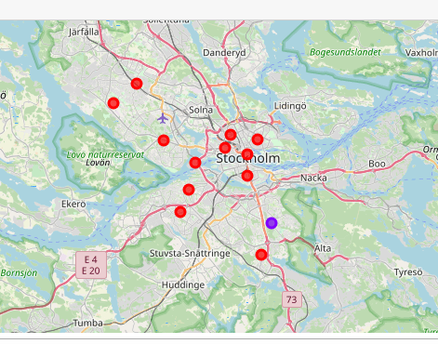

5. DISCUSSIONS

The Kmeans shows that there is only one District that is distinct from the others. This likely indicates that all Districts have similar restaurant types, possibly is the one district distinct, but likely not. It is likely only shown as distinct as Kmeans is divided into two groups and there has to be two groups.For someone that wants to establish a new restaurant in Stockholm, one should look at the top restaurants in each district and stay away from those restaurant types if they wants to avoid competition.

6. CONCLUSION

In conclusion, there seems to be no indication from this study that the house prices affects what restaurant type can afford to establish in what location in Stockholm. It seems like the kinds of restaurants are similar in each district in Stockholm.