115. Distinct Subsequences
給出兩個string s和t，s比t長，數s中有多少個subsequence等於t
思路：
遇到这种两个串的问题，很容易想到DP。但是这道题的递推关系不明显。可以先尝试做一个二维的表int[][] dp，用来记录匹配子序列的个数（以S="rabbbit",T = "rabbit"为例）：
r a b b b i t
1 1 1 1 1 1 1 1
r 0 1 1 1 1 1 1 1
a 0 0 1 1 1 1 1 1
b 0 0 0 1 2 3 3 3
b 0 0 0 0 1 3 3 3
i 0 0 0 0 0 0 3 3
t 0 0 0 0 0 0 0 3
从这个表可以看出，无论T的字符与S的字符是否匹配，dp[i][j] = dp[i][j - 1].就是说，假设S已经匹配了j - 1个字符，得到匹配个数为dp[i][j - 1].现在无论S[j]是不是和T[i]匹配，匹配的个数至少是dp[i][j - 1]。除此之外，当S[j]和T[i]相等时，我们可以让S[j]和T[i]匹配，然后让S[j - 1]和T[i - 1]去匹配。所以递推关系为：
dp[0][0] = 1; // T和S都是空串.
dp[0][1 ... S.length() - 1] = 1; // T是空串，S只有一种子序列匹配。
dp[1 ... T.length() - 1][0] = 0; // S是空串，T不是空串，S没有子序列匹配。
dp[i][j] = dp[i][j - 1] + (T[i - 1] == S[j - 1] ? dp[i - 1][j - 1] : 0).1 <= i <= T.length(), 1 <= j <= S.length()
public int numDistinct(String S, String T) {
2 int[][] dp = new int[S.length() + 1][T.length() + 1];
3 dp[0][0] = 1;//initial
4
5 for(int j = 1; j <= T.length(); j++)//S is empty
6 dp[0][j] = 0;
7
8 for (int i = 1; i <= S.length(); i++)//T is empty
9 dp[i][0] = 1;
10
11 for (int i = 1; i <= S.length(); i++) {
12 for (int j = 1; j <= T.length(); j++) {
13 dp[i][j] = dp[i - 1][j];
14 if (S.charAt(i - 1) == T.charAt(j - 1))
15 dp[i][j] += dp[i - 1][j - 1];
16 }
17 }
18
19 return dp[S.length()][T.length()];
20 }

375. Guess Number Higher or Lower II
思路：top-down解法
給定一個區間【a,b】嘗試區間中每一個數字都選下，找出最小的一個。用二維數組記錄，dp[i][j]表示在【i,j】內最小的支出。挑出一個數字x后，在[I,x-1]和[x+1,j]中看看那邊的支出大。在最大支出中挑出最小那個。
最後，結束迭代的條件是arr[a][b]不為0。可以減少很多迭代次數
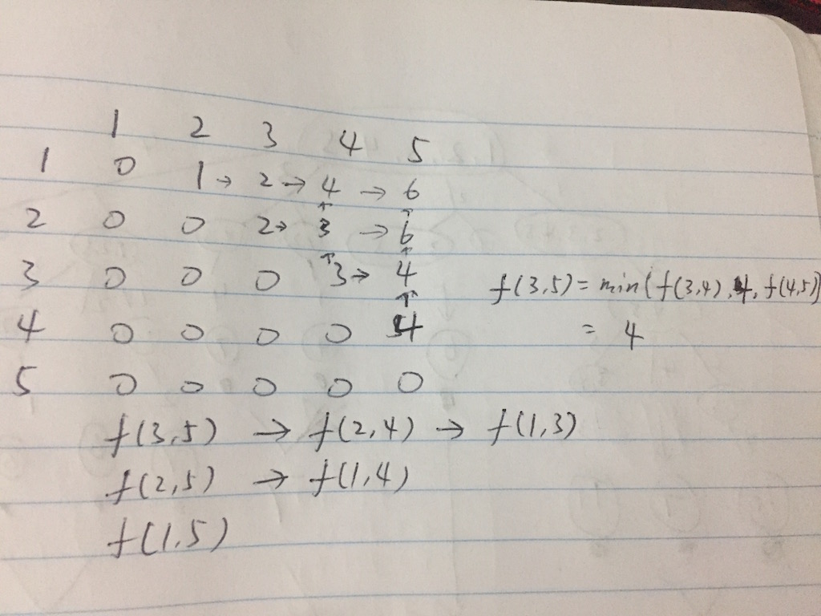
public class Solution {
public int getMoneyAmount(int n) {
int[][] table = new int[n+1][n+1];
return DP(table, 1, n);
}

int DP(int[][] t, int s, int e){
if(s >= e) return 0;
if(t[s][e] != 0) return t[s][e];
int res = Integer.MAX_VALUE;
for(int x=s; x<=e; x++){
int tmp = x + Math.max(DP(t, s, x-1), DP(t, x+1, e));
res = Math.min(res, tmp);
}
t[s][e] = res;
return res;
}
}

最長palindrome子序列
思路：一個矩陣按對角線從左上到右下方向掃描。L(x,y)

https://www.youtube.com/watch?v=yZWmS6CXbQc
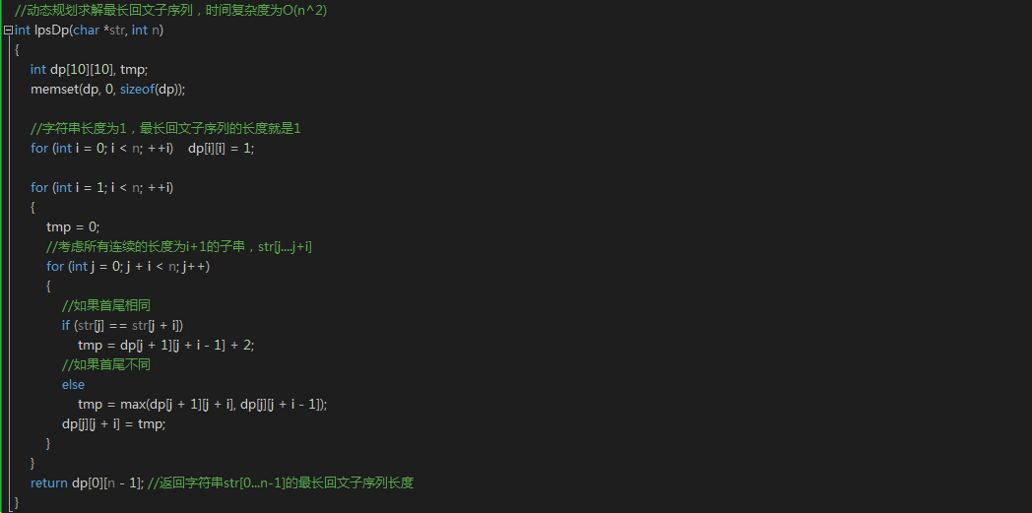

403. Frog Jump
A frog is crossing a river. The river is divided into x units and at each unit there may or may not exist a stone. The frog can jump on a stone, but it must not jump into the water.
Given a list of stones' positions (in units) in sorted ascending order, determine if the frog is able to cross the river by landing on the last stone. Initially, the frog is on the first stone and assume the first jump must be 1 unit.
If the frog's last jump was k units, then its next jump must be either k - 1, k, or k + 1 units. Note that the frog can only jump in the forward direction.

思路：每到了一個石頭上，下一步可以選擇跳K-1，K或K+1。分別拿出可以到達的石頭對應的hashset，往裡面插入下一次可以跳的步數。
Use map to represent a mapping from the stone (not index) to the steps that can be taken from this stone.
so this will be
[0,1,3,5,6,8,12,17]
{17=[], 0=[1], 1=[1, 2], 3=[1, 2, 3], 5=[1, 2, 3], 6=[1, 2, 3, 4], 8=[1, 2, 3, 4], 12=[3, 4, 5]}
Notice that no need to calculate the last stone.
On each step, we look if any other stone can be reached from it, if so, we update that stone's steps by adding step, step + 1, step - 1. If we can reach the final stone, we return true. No need to calculate to the last stone.
Here is the code:
public boolean canCross(int[] stones) {
if (stones.length == 0) {
return true;
}

HashMap<Integer, HashSet<Integer>> map = new HashMap<Integer, HashSet<Integer>>(stones.length);
map.put(0, new HashSet<Integer>());
map.get(0).add(1);
for (int i = 1; i < stones.length; i++) {
map.put(stones[i], new HashSet<Integer>() );
}

for (int i = 0; i < stones.length - 1; i++) {
int stone = stones[i];
for (int step : map.get(stone)) {
int reach = step + stone;
if (reach == stones[stones.length - 1]) {
return true;
}
HashSet<Integer> set = map.get(reach);
if (set != null) {
set.add(step);
if (step - 1 > 0) set.add(step - 1);
set.add(step + 1);
}
}
}

return false;
}

123. Best Time to Buy and Sell Stock III
最多買兩次，每次只能持一股票，求最大利潤
First assume that we have no money, so buy1 means that we have to borrow money from others, we want to borrow less so that we have to make our balance as max as we can(because this is negative).
sell1 means we decide to sell the stock, after selling it we have price[i] money and we have to give back the money we owed, so we have price[i] - |buy1| = prices[i ] + buy1, we want to make this max.
buy2 means we want to buy another stock, we already have sell1 money, so after buying stock2 we have buy2 = sell1 - price[i] money left, we want more money left, so we make it max
sell2 means we want to sell stock2, we can have price[i] money after selling it, and we have buy2 money left before, so sell2 = buy2 + prices[i], we make this max.
So sell2 is the most money we can have.
Hope it is helpful and welcome quesions!
public int maxProfit(int[] prices) {
int sell1 = 0, sell2 = 0, buy1 = Integer.MIN_VALUE, buy2 = Integer.MIN_VALUE;
for (int i = 0; i < prices.length; i++) {
buy1 = Math.max(buy1, -prices[i]);
sell1 = Math.max(sell1, buy1 + prices[i]);
buy2 = Math.max(buy2, sell1 - prices[i]);
sell2 = Math.max(sell2, buy2 + prices[i]);
}
return sell2;
}
解法2：
class Solution {
public:
int maxProfit(vector<int> &prices) {
int len = (int)prices.size();
if(len <= 1) {
return 0;
}

vector<int> profits;
profits.resize(len);

//首先我们正向遍历得到每天一次交易的最大收益
//并保存到profits里面
int minP = prices[0];
int sum = numeric_limits<int>::min();
for(int i = 1; i < len; i++) {
minP = min(minP, prices[i - 1]);
profits[i] = max(sum, prices[i] - minP);

sum = profits[i];
}

int maxP = prices[len - 1];
int sum2 = numeric_limits<int>::min();

//逆向遍历
for(int i = len - 2; i >= 0; i--) {
maxP = max(maxP, prices[i + 1]);
sum2 = max(sum2, maxP - prices[i]);

if(sum2 > 0) {
//这里我们直接将其加入profits里面，
//不需要额外保存
profits[i] = profits[i] + sum2;
sum = max(sum, profits[i]);
}
}

return sum > 0 ? sum : 0;
}
};

[LeetCode] Coin Change 硬币找零
我们维护一个一维动态数组dp，其中dp[i]表示钱数为i时的最小硬币数的找零，递推式为：
dp[i] = min(dp[i], dp[i - coins[j]] + 1);
其中coins[j]为第j个硬币，而i - coins[j]为钱数i减去其中一个硬币的值，剩余的钱数在dp数组中找到值，然后加1和当前dp数组中的值做比较，取较小的那个更新dp数组。

Partition Equal Subset Sum
數組求和，如果是奇數，不能拆分。target是求和/2
然後用01背包，縱坐標是nums，橫坐標是0到target。
如果算到最後一個坐標dp[nums[last]][target]=target說明可以，否則不行
public boolean canPartition(int[] nums) {
int sum=0;
for (int num:nums) sum+= num;
if(sum % 2 == 1) return false;
else{
sum /=2;
int n=nums.length;
// dp[i][j] 表示 如果我们取前i个数字，且背包容量为j的情况下，最多能放入多少东西
int dp[][]=new int[n][sum + 1];
// dp[0][0] 为初始状态，表示，没有任何没有东西没有体积，其余部分初始化
for(int i=nums[0];i<=sum;i++){
dp[0][i] = nums[0];
}
//遍历n个数字，即视为n个产品
for(int i=1;i<n;i++){
//加入了这种物品后更新状态
for(int j=nums[i];j<=sum;j++){
dp[i][j]=Math.max(dp[i-1][j], dp[i-1][j-nums[i]]+nums[i]);
}
}
//放满了才能表示正好1/2
if(dp[n-1][sum]==sum)
return true;
else
return false;
}

}

Longest increasing subsequence
思路：tails 數組中 tails[i]表示長度為i+1的遞增序列中最後一位數字。如果發現一個比當前數字比所有尾都大，len+1。否則在tails>當前數當中找出最小的一個，把tail 改為num

public int lengthOfLIS(int[] nums) {
int[] tails = new int[nums.length];
int size = 0;
for (int x : nums) {
int i = 0, j = size;
while (i != j) {
int m = (i + j) / 2;
if (tails[m] < x)
i = m + 1;
else
j = m;
}
tails[i] = x;
if (i == size) ++size;
}
return size;
}
// Runtime: 2 ms
309. Best Time to Buy and Sell Stock with Cooldown
sell[0] = 0;
buy[0] = -prices[0];

for (int i = 1; i < prices.length; ++i) {
sell[i] = Math.max(sell[i - 1], buy[i - 1] + prices[i]);
buy[i] = Math.max(buy[i - 1], (i > 1 ? sell[i - 2] : 0) - prices[i]);
}
buy[i] = max(buy[i-1], sell[i-2]-prices[i]);
sell[i] = max(buy[i-1]+prices[i], sell[i-1]);

221. Maximal Square
dp[i][j] = min(dp[i-1][j-1], dp[i-1][j], dp[i][j-1]) + 1

198. House Robber
int[][] dp = new int[num.length + 1][2];
for (int i = 1; i <= num.length; i++) {
dp[i][0] = Math.max(dp[i - 1][0], dp[i - 1][1]); 不搶
dp[i][1] = num[i - 1] + dp[i - 1][0]; 搶
}
return Math.max(dp[num.length][0], dp[num.length][1]);

337. House Robber III
public class Solution {
public int rob(TreeNode root) {
int[] ans= helper(root);
return Math.max(ans[0],ans[1]);
}

public int[] helper(TreeNode root)
{
if(root==null)return new int[]{0,0};
int[] left=helper(root.left);
int[] right=helper(root.right);
int[] res=new int[2];
res[0]=Math.max(left[0],left[1])+Math.max(right[0],right[1]); 不搶當前點
res[1]=left[0]+right[0]+root.val; 搶當前點
return res;
}
}

377. Combination Sum IV（數組元素可以重複使用）
DP數組長度是target+1的長度，DP[n]指target是n時，combination數量

public int combinationSum4(int[] nums, int target) {
int[] comb = new int[target + 1];
comb[0] = 1;
for (int i = 1; i < comb.length; i++) {
for (int j = 0; j < nums.length; j++) {
if (i - nums[j] >= 0) {
comb[i] += comb[i - nums[j]];
}
}
}
return comb[target];
}

376. Wiggle Subsequence
首先skip掉前幾個相同的元素
如果nums[i] > nums[i-1], that means it wiggles up. the element before it must be a down position. so up[i] = down[i-1] + 1; down[i] keeps the same with before.
If nums[i] < nums[i-1], that means it wiggles down. the element before it must be a up position. so down[i] = up[i-1] + 1; up[i] keeps the same with before.
If nums[i] == nums[i-1], that means it will not change anything becasue it didn't wiggle at all. so both down[i] and up[i] keep the same.
public class Solution {
public int wiggleMaxLength(int[] nums) {

if( nums.length == 0 ) return 0;

int[] up = new int[nums.length];
int[] down = new int[nums.length];

up[0] = 1;
down[0] = 1;

for(int i = 1 ; i < nums.length; i++){
if( nums[i] > nums[i-1] ){
up[i] = down[i-1]+1;
down[i] = down[i-1];
}else if( nums[i] < nums[i-1]){
down[i] = up[i-1]+1;
up[i] = up[i-1];
}else{
down[i] = down[i-1];
up[i] = up[i-1];
}
}

return Math.max(down[nums.length-1],up[nums.length-1]);
}
}

343. Integer Break
一個整數分為n個數的和，使得分出的n個數字乘積最大
先拆出3，如果最後拆到2或者4就不要再拆

53. Maximum Subarray
public static int maxSubArray(int[] A) {
int maxSoFar=A[0], maxEndingHere=A[0];
for (int i=1;i<A.length;++i){
maxEndingHere= Math.max(maxEndingHere+A[i],A[i]);
maxSoFar=Math.max(maxSoFar, maxEndingHere);
}
return maxSoFar;
}

368. Largest Divisible Subset
從小到大排序
對於一個元素A，看看前面哪個可以整除的，如果B能整除的dp[A]=Max(dp[A],dp[B]+1)，并用另一個數組，在position[A]記錄下前面那個元素的位置，方便回頭的時候找回以前的元素加到subset

152. Maximum Product Subarray
掃描數組
暴力一點，min[i]=MIN( max[i-1]*num,min[i-1]*num, num);
max[i]=MAX[max[i-1]*num, min[i-1]*num,num]
public class Solution {
/**
* @param nums: an array of integers
* @return: an integer
*/
public int maxProduct(int[] nums) {
// write your code here

int res=nums[0];
int max=nums[0];
int min=nums[0];
for(int i=1;i<nums.length;i++){
int tempmax=max;
int tempmin=min;
max=Math.max(nums[i],Math.max(nums[i]*tempmax,nums[i]*tempmin));
min=Math.min(nums[i],Math.min(nums[i]*tempmax,nums[i]*tempmin));
res=Math.max(res,max);
}
return res;
}
}

494. Target Sum
給你一個數組，填入加或減號，使求和等於S。找出有多少種填法
Input: nums is [1, 1, 1, 1, 1], S is 3.
Output: 5
Explanation:

-1+1+1+1+1 = 3
+1-1+1+1+1 = 3
+1+1-1+1+1 = 3
+1+1+1-1+1 = 3
+1+1+1+1-1 = 3

There are 5 ways to assign symbols to make the sum of nums be target 3.
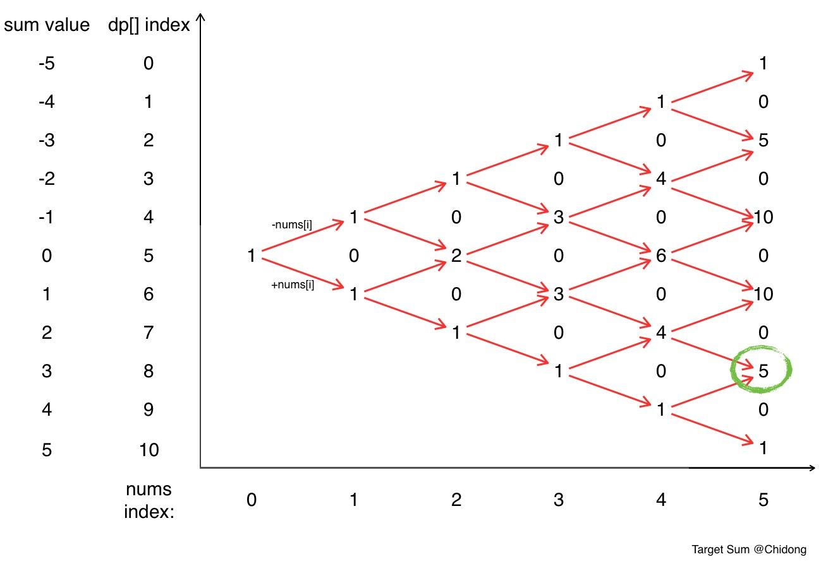
思路：算出sum，如果S>sum 或S< sum 肯定是0個填法。
弄一個dp數組，dp[ 2*sum+1 ]。現在開始至少有一種，所以在dp[0+sum]填入1；
每次循環新建一個數組next[ 2*sum+1] 對於之前那排dp數組。
next[ k+ nums[i]] += dp[k]; next[ k- nums[i]]-= dp[k];
然後dp=next；
最後答案就在 dp[sum+S]中

public class Solution {
public int findTargetSumWays(int[] nums, int s) {
int sum = 0;
for(int i: nums) sum+=i;
if(s>sum || s<-sum) return 0;
int[] dp = new int[2*sum+1];
dp[0+sum] = 1;
for(int i = 0; i<nums.length; i++){
int[] next = new int[2*sum+1];
for(int k = 0; k<2*sum+1; k++){
if(dp[k]!=0){
next[k + nums[i]] += dp[k];
next[k - nums[i]] += dp[k];
}
}
dp = next;
}
return dp[sum+s];
}
}

72. Edit Distance
給出兩個string，找出從string1 變為string2 最少的操作次數
操作包括如下：插入一個字符，刪除一個字符，替換一個字符

思路：
 | 空 | K | I | T | T | I | N | G
空 | 0 | 插入1 | 插入2 | 插入3 | 插入4 | 插入5 | 插入6 | 插入7
K | 刪除1 | 0 | 插入1 | 插入2 | 插入3 | 插入4 | 插入5 | 插入6
I | 刪除2 | 刪除1 | 0 | 插入1 | 插入2 | 插入3 | 插入4 | 插入5
T | 刪除3 | 刪除2 | 刪除1 | 0 | 插入1 | 插入2 | 插入3 | 插入4
T | 刪除4 | 刪除3 | 刪除2 | 刪除1 | 0 | 插入1 | 插入2 | 插入3
E | 刪除5 | 刪除4 | 刪除3 | 刪除2 | 刪除1 | 替換1 | 插入1 | 插入2
N | 刪除6 | 刪除5 | 刪除4 | 刪除3 | 刪除2 | 刪除1 | 保持1 | 插入2

如果當前字符不相等，每一格是左上，正上，和左邊三個中最小值加1。否則就是，三個中的最小值，不用加1

139. Word Break
要求給你一個string和dictionary，看string能不能有dictionary的詞組成
思路：注意有可能出現如下情況
[hello, love] str=hellove這種不行
所以必須用一個dp，dp[i]記錄string的第i位為止，是否有一個完整的單詞。
如上例子，雖然找到love，但是l對應的位置沒有找到單詞，所以這個不能算數
public class Solution {
public boolean wordBreak(String s, List<String> wordDict) {
boolean[] dp=new boolean[s.length()+1];
dp[0]=true;
for(int i=1;i<=s.length();i++){
for(int j=0;j<i;j++){
String sub=s.substring(j,i);
if(dp[j]&&wordDict.contains(sub)){
dp[i]=true;
break;
}
}
}

return dp[s.length()];
}
}

132. Palindrome Partitioning II
Given a string s, partition s such that every substring of the partition is a palindrome.
Return the minimum cuts needed for a palindrome partitioning of s.
For example, given s = "aab",
Return 1 since the palindrome partitioning ["aa","b"] could be produced using 1 cut.
思路： dp[i][j]記錄從i到j（包含）的字符串是否是parlindrome。按列掃描，當前i到j是parlindrome的判斷條件是 1. char I ==char j 並且 2. j-i<=1 或 dp[i+1][j-1]是true(除去頭尾兩個字母后字符串還是parlindrome)
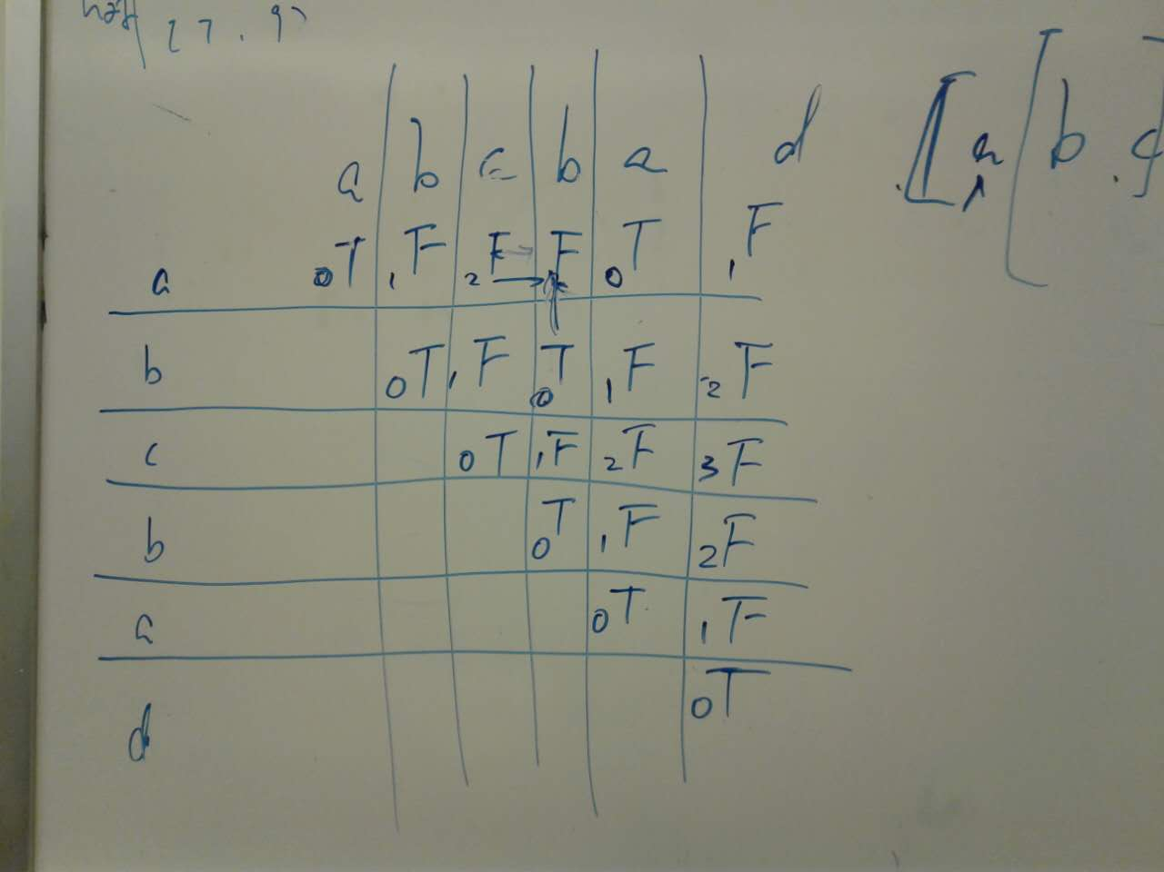
別管上圖的數字，數字是錯的。
// f[i] 表示前i个字母，最少可以被分割为多少个回文串
// 最后return f[n] - 1
然後一列列地看，例如第二個b那一列，第二行是true，說明bcb是回文串，所以abcb可以分為a 和bcb 兩個回文串。f[4]=min（f[4], f[1] + 1） 最後把f[6] -1 就是結果
// f[i] 表示前i个字母，最少可以被分割为多少个回文串
// 最后return f[n] - 1

public class Solution {
private boolean[][] getIsPalindrome(String s) {
boolean[][] isPalindrome = new boolean[s.length()][s.length()];

for (int i = 0; i < s.length(); i++) {
isPalindrome[i][i] = true;
}
for (int i = 0; i < s.length() - 1; i++) {
isPalindrome[i][i + 1] = (s.charAt(i) == s.charAt(i + 1));
}

for (int length = 2; length < s.length(); length++) {
for (int start = 0; start + length < s.length(); start++) {
isPalindrome[start][start + length]
= isPalindrome[start + 1][start + length - 1] && s.charAt(start) == s.charAt(start + length);
}
}

return isPalindrome;
}

public int minCut(String s) {
if (s == null || s.length() == 0) {
return 0;
}

// preparation
boolean[][] isPalindrome = getIsPalindrome(s);

// initialize
int[] f = new int[s.length() + 1];
f[0] = 0;

// main
for (int i = 1; i <= s.length(); i++) {
f[i] = Integer.MAX_VALUE; // or f[i] = i
for (int j = 0; j < i; j++) {
if (isPalindrome[j][i - 1]) {
f[i] = Math.min(f[i], f[j] + 1);
}
}
}

return f[s.length()] - 1;
}
}
523. Continuous Subarray Sum
Given a list of non-negative numbers and a target integer k, write a function to check if the array has a continuous subarray of size at least 2 that sums up to the multiple of k, that is, sums up to n*k where n is also an integer.
Example 1:
Input: [23, 2, 4, 6, 7], k=6
Output: True
Explanation: Because [2, 4] is a continuous subarray of size 2 and sums up to 6.
Example 2:
Input: [23, 2, 6, 4, 7], k=6
Output: True
Explanation: Because [23, 2, 6, 4, 7] is an continuous subarray of size 5 and sums up to 42.
思路：sum是記錄從開始到當前的sum
到了第i位，sum%k 的值如果在前面出現過，且出現位置與i相隔至少兩位，說明找到了
注意corner case k=0
class Solution {
public:
bool checkSubarraySum(vector<int>& nums, int k)
{
if (nums.size() < 2)
return false;
int runningSum = 0;
unordered_map<int, int> quickFind;
quickFind[0] = -1;
for(int i = 0; i < nums.size(); i++)
{
runningSum += nums[i];
if(k != 0)
runningSum %= k;
std::unordered_map<int, int>::iterator it;
it = quickFind.find(runningSum);
if(it == quickFind.end())
quickFind[runningSum] = i;
else if(i - it->second > 1)
return true;
}
return false;
}
};

