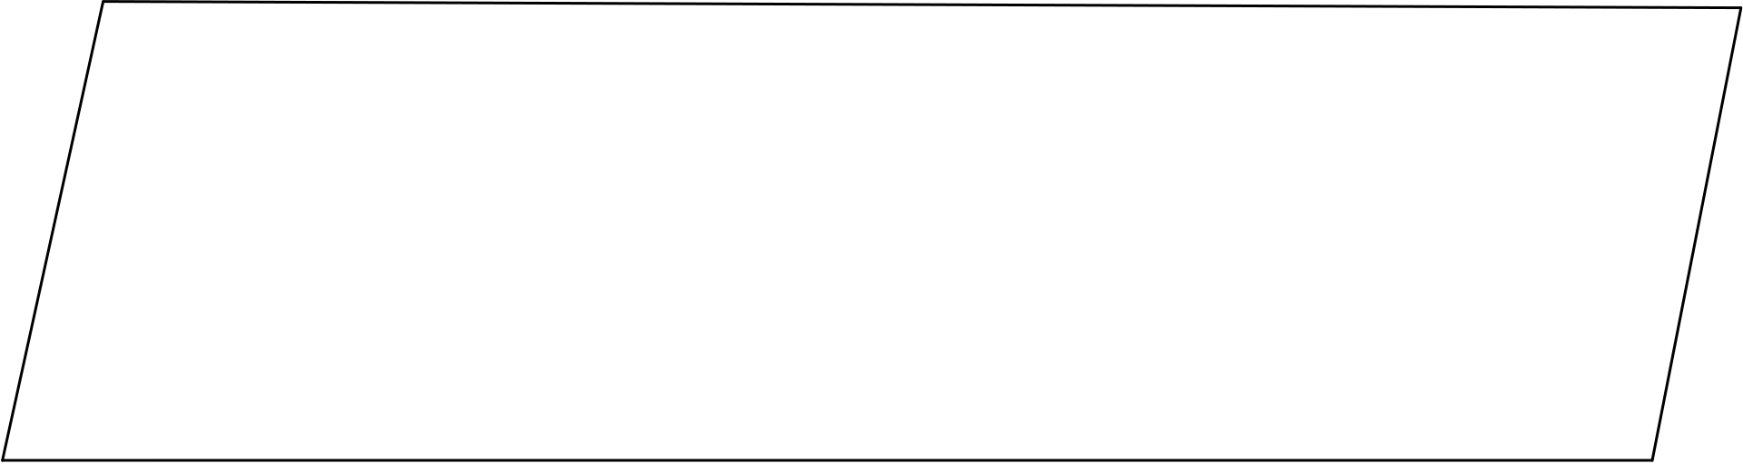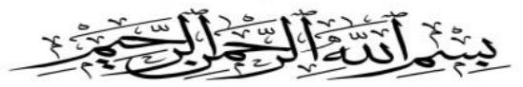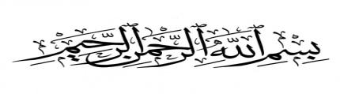

|  |  |  |  |  |  |  |  |  |  |  |  |  |  |
| --- | --- | --- | --- | --- | --- | --- | --- | --- | --- | --- | --- | --- | --- |
| **0202 اختبار اللغة العربية دورة يناير**  **Châteauguayمدرسة النور**  **اللغة العربية التمرين االول:**  **أعد كتابة الحروف اآلتية :****1.**  .. ... ..... ..... .. ... .. ... . ... . . .... .... . . .... **أ**  ..... ..... ..... ..... ..... ..... ..... ..... .....  **ت**  ..... ..... ..... . ... ..... ..... .... ..... ..... **ج -**  ..... ..... ..... ..... ..... ..... ..... ..... ..... **د-**  **أعد كتابة الكلمات اآلتية :****0.**  .... ......................... .......................... ......................... ....................... **أرنب -**  ......... .................... ... ..................... ........... ........ ....... ..... .. ................ **ثعلب -**  **اصل بسهم بين اللون واسمه : 3.**    **أحمرأخضرأصفر أسود أبيض أزرق**   |  |  |  |  |  |  | | --- | --- | --- | --- | --- | --- | | **خ** | **ج** | **جـ** | **ـﺠـ** | **ج** | **:** **ضع دائرة حول حرف الجيم.4** | | **ـﺞح** | | **غجـ** | **ز** | **ل** |   **ـﺞ**   |  |  |  | | --- | --- | --- | | **ع ج ـﺠـ** | **جـ** | **و** | |

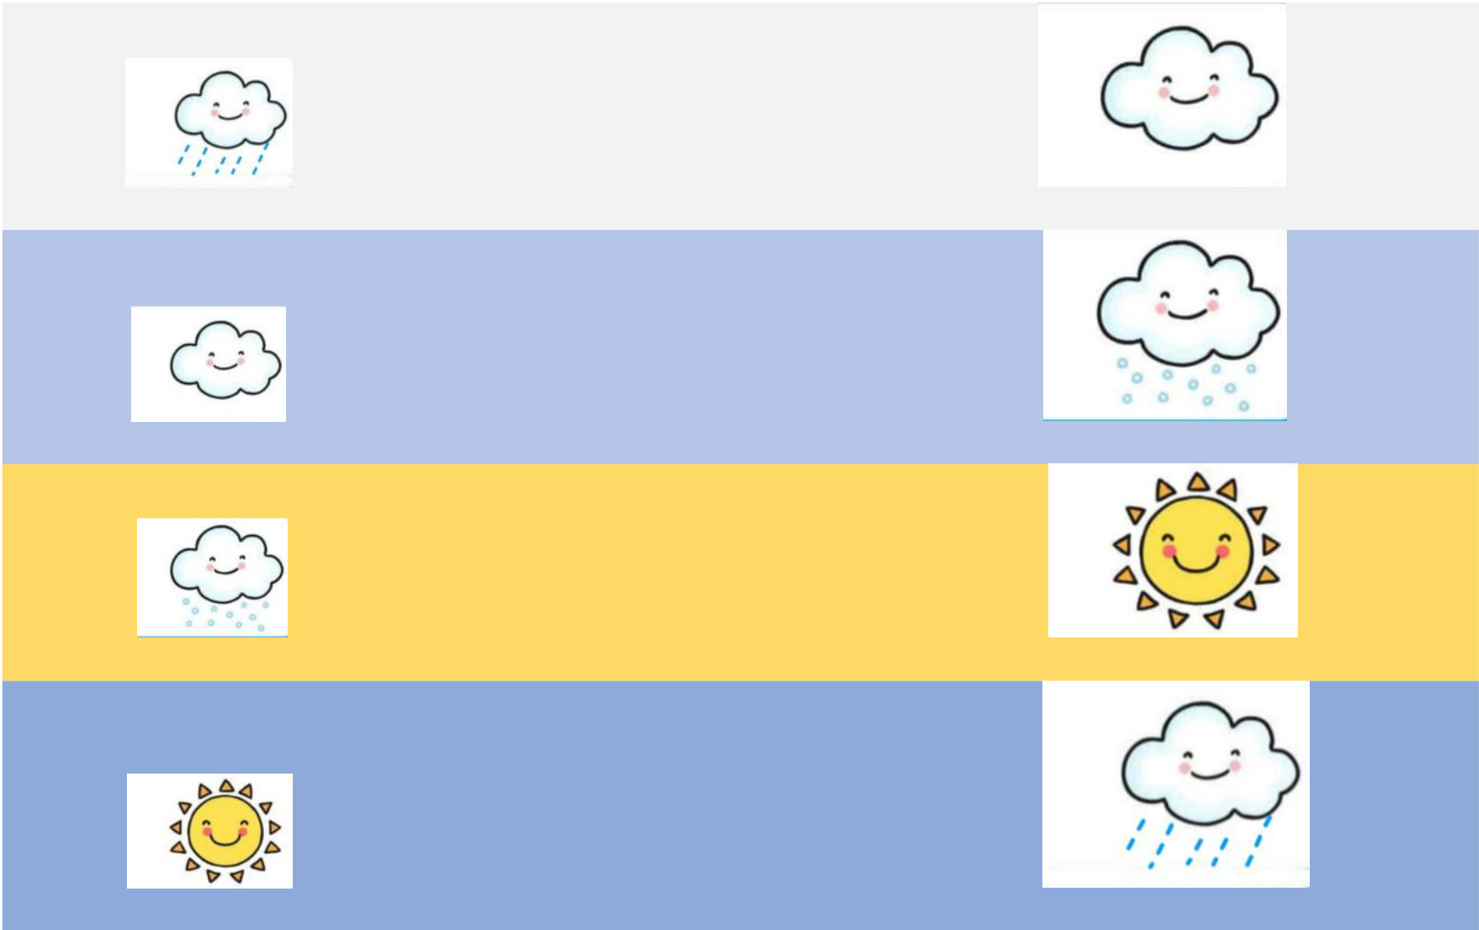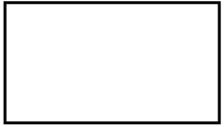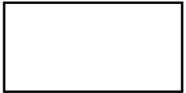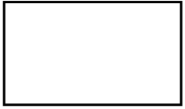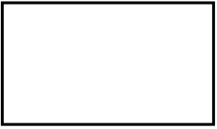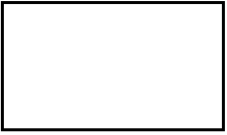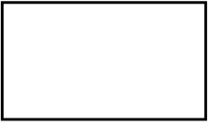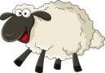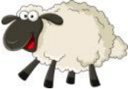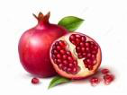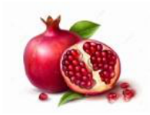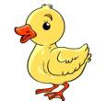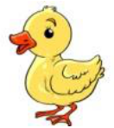

|  |  |  |  |  |  |  |  |  |  |  |  |  |  |  |  |  |  |  |  |
| --- | --- | --- | --- | --- | --- | --- | --- | --- | --- | --- | --- | --- | --- | --- | --- | --- | --- | --- | --- |
| |  |  | | --- | --- | | **رُمَّان**  **بَطَّة**  **خَرُوف** | **له: أربط الحرف بالصورة والكلمة المناسبة.5**  **خ**  **ب**  ر  **.6قم بتوصيل كل كلمة بالصورة المناسبة :** |  |  |  |  | | --- | --- | --- | | **مطر** | **●** | **●** |  |  |  |  | | --- | --- | --- | | **غيوم** | **●** | **●** |  |  |  |  | | --- | --- | --- | | **ثلﺞ** | **●** | **●** | | **شمس** | **●** | **●** |  |  |  | | --- | --- | | **:** | **إمالء** |  |  |  |  | | --- | --- | --- | |  |  |  | |

|  |  |  |  |  |  |  |  |  |  |  |  |  |  |  |  |  |  |  |  |  |  |  |  |  |  |  |  |  |  |  |  |  |  |  |  |  |  |  |  |  |  |  |  |  |  |  |  |  |  |
| --- | --- | --- | --- | --- | --- | --- | --- | --- | --- | --- | --- | --- | --- | --- | --- | --- | --- | --- | --- | --- | --- | --- | --- | --- | --- | --- | --- | --- | --- | --- | --- | --- | --- | --- | --- | --- | --- | --- | --- | --- | --- | --- | --- | --- | --- | --- | --- | --- | --- |
| |  |  |  |  |  |  |  |  | | --- | --- | --- | --- | --- | --- | --- | --- | |  |  |  | **تربية اإلسالمية لثاني: ال** | | | | **التمرين ا** | |  |  |  | **سورة الفاتحة :** | | | **.1** |  | |  |  |  | **احوط من بين الصور التالية خلق هللا عزّ و جل :** | | | **.2** |  | |  |  |  |  | |  | | | | |  |  | | | | **أمام اإلختيار الصحيح :** | **ضع عالمة √** | **ا** | **.3** |  |  |  | | --- | --- | |  | **أركان اإلسالم خمسة5** | |  | **أكل بيدي اليسرى.** | |  | **أقول بسم هللا قبل األكل والشرب .** | |  | **أعامل أصدقائي و معلمتي داخل القسم بإحترام.** |   **بالتوفيق☺**   |  | | --- | | **/ 10 النقطة : اإلسم الكامل**..............................................................................................: |   نعيمة بومزوغ |