# **SH-P2: Long term analysis of wave crest using “Random Storm Approach”**

Jonas Vørrang Jam

Mohammed Nizar Poovanmadathil

Shuzhou Jiang

Taewoo Kim

26, April 2020

TMR 4195 Design of Ocean Structures

Norwegian University of Science and Technology

(NTNU)

# **Abstract**

The random storm approach is a Peak Over Threshold (POT) approach where the response problems are complex and a time domain calculation is required. Here we estimate the q-probabilities of 10-2 and 10-4 for the maximum annual crest height for wind sea for a location in the north sea. Tp and Hs from 61 years of hindcast data was used to create “exact” distributions of the maximum crest heights for storms(Hs>8m). Those CDFs were used to estimate the maximum crest height of an arbitrary storm, and thereafter an annual maximum crest distribution was estimated. The 10-2 return value was 17.40m and 17.96m. The 10-4 return value was 20.71m and 23.89m. The larger return value is found by accounting for unobserved storms.

**ABBREVIATIONS**

ALS Accidental Limit State

ULS Ultimate Limit State

POT Peak-Over-Threshold

CDF Cumulative Distribution Function

PDF Probability Density Function

MoM Method of Moments

MLE Maximum Likelihood Estimate

LSE Least Squares Estimate

# **Table of Contents**

**Abstract** **1**

**I. Introduction** **3**

**II. Sub projects** **4**

2.1 Task 1 4

2.1.1 Correction of the hindcast Tp 4

2.2 Task 2 6

2.2.1 Filtering out storms from hindcast data 6

2.2.2 Joint scatter plot of storms 6

2.2.3 Fitting a distribution to the peak significant wave height for wind sea 7

2.2.4 Estimating 10-2 and 10-4 annual probability significant wave height 8

2.2.5 Gumbel distribution on the annual extreme Hs 8

2.2.6 Results task 2 9

2.3 Task 3 10

2.3.1 “Exact” distribution of maximum crest height of each storm 10

2.3.2 Most probable maximum crest height of each storm 12

Method of moments and MLE 15

2.4 Task 4 17

2.4.2 Maximum crest height of arbitrary storm from observed storms. (Random storm approach A) 17

2.4.2 Mom / MLE on ‘the dots’’ 18

Figure X. Random Storm approach A, and the fittings from section 2.3.2. Dots are most likely maximum crest height. 18

2.4.2 Gumbel fit - A simplification for futher analysis 18

2.4.2 Maximum crest height of an arbitrary storm accounting for unobserved data. (Random storm approach B) 19

2.4.5 Results 21

2.5 Task 5 22

**III. Conclusions & Discussion** **24**

**V. List of references** **25**

# 

# **I. Introduction**

When the response problems are complicated, and it is required to calculate the response analysis in the time domain. As a possible implementation of a peak-over-threshold (POT) approach, random storm approach can be used to calculate the probabilistic characteristics of the response problems by considering adjacent 3 hour periods (Haver, 2019).

The aim of this project is to find the long-term extreme crest height of wind sea using hindcast data from the north sea. The distribution of this extreme crest height is used to estimate the extreme wave crest with probability q=10-2 and q=10-4 which is referred to as Ultimate Limit State (ULS) and Accidental Limit State (ALS). ULS and ALS are commonly used as acceptance criteria on the norwegian continental shelf while designing ocean structures. ULS is the criterion on which a structure should resist that wave load without damage and for ALS it should resist that wave load with only minor damage. So the accurate estimations of the extreme wave crests are therefore important.

The hindcast (Nora10) was measured at latitude 67.05 and longitude 7.0 and it contains Hs and Tp for 3 hour durations from Sep. 1, 1957 to Oct. 31, 2018. This location is close to the Heidrun oil field and therefore we assume the depth to be 350m.

The analysis consists of four phases. First, the original hindcast data is corrected to more realistic data. The original data have very discrete period intervals. This stiffness is relieved by adding randomness. In the second phase, storm conditions are filtered out from the data and fitted with the Weibull distribution model. 10-2 and 10-4 significant wave heights are predicted using the Weibull distribution model and its parameters. In the third phase, the distribution of the storm maximum crest height for each individual storm is modelled. In the fourth phase, a distribution of the maximum crest height for an arbitrary storm is estimated. This result is used to estimate the annual ULS and ALS.

# **II. Sub projects**

## **2.1 Task 1**

### **2.1.1 Correction of the hindcast Tp**

A wind sea is a sea that is a result of the local wind field. Since both the wave field and the wind field are propagating in space, the observed sea at a given site may well be the result of induced wave growth over quite some distance. An interesting situation arises when the speed of propagation is the same for the wind field and wave field. This situation is expected to result in a more severe sea state than expected in view of the wind speed (Haver, 2019).

Original wind sea data of the Nora10 are discrete in following periods [0, 2.4, 2.7, 2.9, 3.2, 3.6, 3.9, 4.3, 4.7, 5.2, 6.3, 6.9, 7.6, 8.4, 9.2, 10.2, 11.2, 12.3, 13.5, 14.9, 16.4, 18.0]. This is due to the logarithmic spacing which causes the difference between consecutive values increases with period values. In long period areas, where we are interested in, the resolution is low. As this original data can cause poor results in statistical analysis, correction has to be made. The original data was saved like this to take less storage space.

A solution is explained in the Appendix D of (Haver, 2019). The discrete set of values are simply described by the below formula,

where, i = -2, -1, …, 19

Now, let’s add randomness to ‘i’ in order to get realistic Hs, Tp distributions.

where rnd is uniformly distributed in the range 0 - 1. Figure 1 shows original data (Hs, Tp) and modified data (Hs, Tp). Modified plot looks more realistic in figure 1.

|  |  |
| --- | --- |
|  |  |
| 1. Original | 1. Modified |

Figure 1. Hs, Tp plot of original data and modified data

|  |  |  |
| --- | --- | --- |
|  |  |  |
| 1. original | 1. Modified, bin size=1 | (c) Modified, bin size=0.5 |

Figure 2. Original data and modified data

Figure 2 shows the probability plot of original and modified data. The shape of the probability plot is changed. Figure 3 shows the effect of modification. Using original data could give unrealistic results that waves in certain periods don’t exist.

|  |  |
| --- | --- |
|  |  |
| 1. Tp spacing = 1.0 | 1. Tp spacing = 0.5 |

Figure 3. Probability shape according to Tp spacing

## **2.2 Task 2**

### **2.2.1 Filtering out storms from hindcast data**

Defining storms: A storm state is defined when a significant height is above 8 m. A storm lasts as long as the Hs is above the threshold. With a threshold of Hs>8m we got 281 storms and each storm could consist of several 3 hour durations referred to as steps *m*.

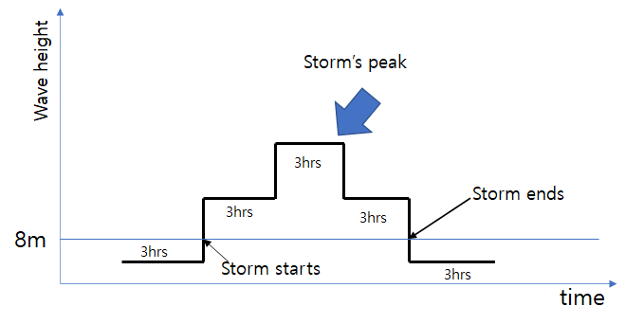

Figure 4. Storm definition. This storm has three steps.

### **2.2.2 Joint scatter plot of storms**

Figure 5 is a joint scatter plot of the storms. Every black dot is a 3 hour sea state within a storm. Red circles are peak values of each storm. As seen in the scatter, there are some large gaps between the dots above Hs larger than 11m. The more extreme storms are less probable and thus we have less data for extreme storms and this makes it difficult to get a reliable PDF fit for the extreme storms.

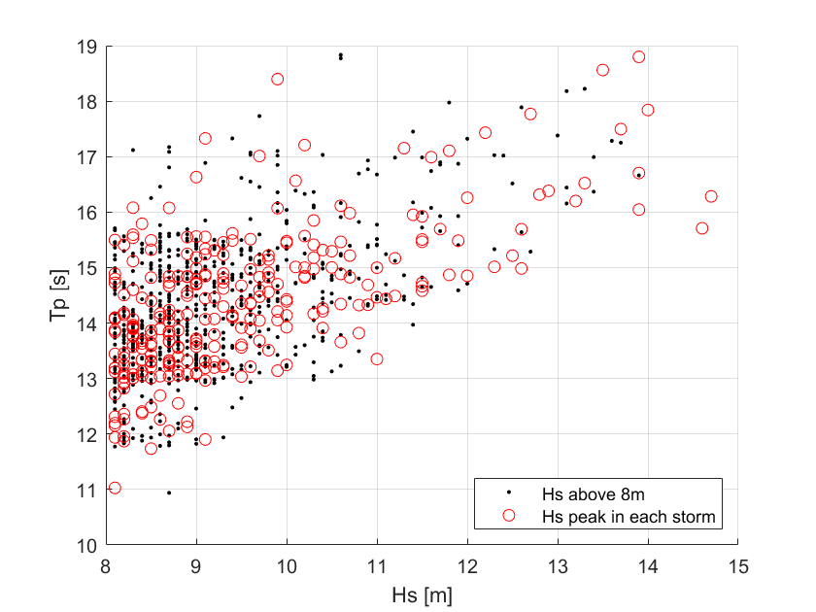

Figure 5. Joint scatter plot of storm

### **2.2.3 Fitting a distribution to the peak significant wave height for wind sea**

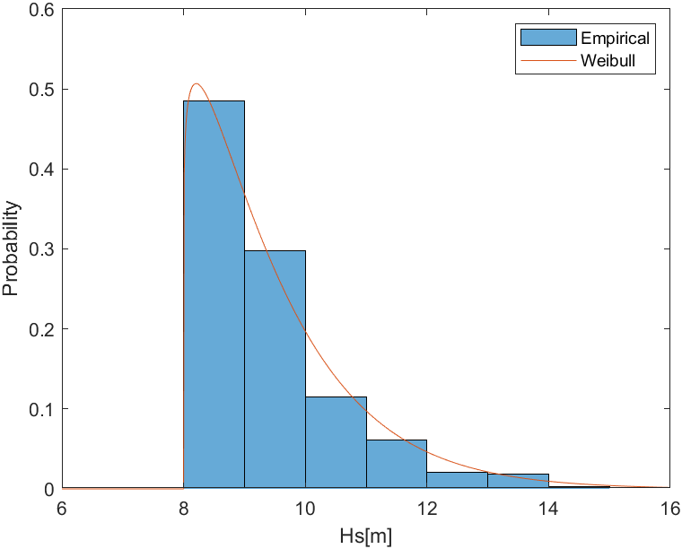

Figure 6. Empirical and Weibull fitting plot of storm peak

Empirical data and its distribution fitted by Weibull distribution are plotted in Figure 6. Empirical data are maximum significant heights of each storm. Weibull parameters are determined by the wblfit function in Matlab. The equation of Weibull PDF is as below,

The parameters , and are the scale, shape and location parameters.

The parameters are in Table 1.

### 

### **2.2.4 Estimating 10-2 and 10-4 annual probability significant wave height**

The probability of Hs can be evaluated by the below equation.

,

where is the expected number of storms per year

is total number of storms

is total numbers of observed years

According to NORA10 data,

observation period Y = 61.14 and total number of storms Kl = 281.

Hence, n1y = 4.595.

Significant height can be evaluated by the below equation.

### **2.2.5 Gumbel distribution on the annual extreme Hs**

According to DNV GL RP-205, 3.6.2.3, Peak Over Threshold statistics should be used with care as they are sensitive to the adopted threshold level. We have therefore compared our significant wave height ULS and ALS estimate with an Gumbel estimate found in RP-205.

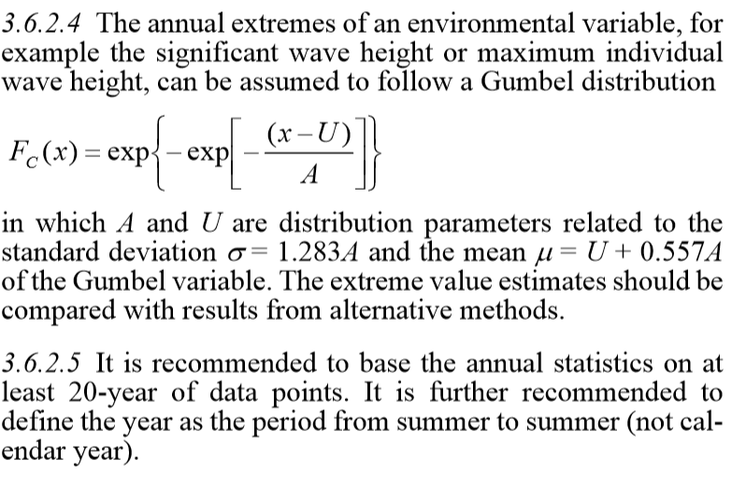

Figure 7. Screenshot of DNV GL RP-205. Annual extremes of an environmental variable.

### **2.2.6 Results task 2**

The parameters are the same with Table 1. The Annual probability q = 10-2 and 10-4 for ULS and ALS respectively.

|  |  |  |  |  |  |
| --- | --- | --- | --- | --- | --- |
| Method |  |  |  | **ULS [m]** | **ALS [m]** |
| Matlab fit | 1.5689 | 1.1159 | 8 | 15.96 | 21.17 |
| MoM | 1.7724 | 1.2067 | 7.8394 | 15.97 | 20.71 |

Table 1. Weibull parameters on peak Hs of storms

|  |  |  |
| --- | --- | --- |
| Method | **ULS [m], Hs** | **ALS [m], Hs** |
| Gumbel Annual Extremes | **16.14** | **22.07** |

Table 2. Using Gumbel distribution of annual extremes to estimate ULS and ALS Hs.

### **2.2.7 Method of Moments**

The method of moments is a method to estimate the scale, shape and location parameters of the three parameter weibull distribution. First the mean, variance and skew is calculated for the sample. Then the parameters are found by solving the equations below.

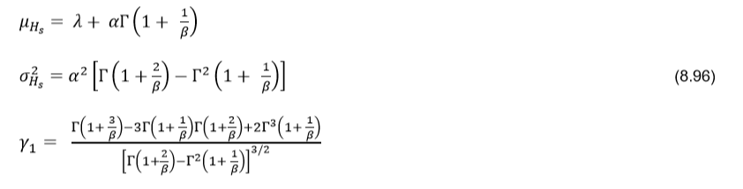

## **2.3 Task 3**

### **2.3.1 “Exact” distribution of maximum crest height of each storm**

The short-term distribution of the wave crest height above still water is reasonably well described by the Forristall crest distribution (RP-205, 3.5.10). It is based on second order time domain simulations and is a two-parameter Weibull distribution where 𝛼𝐹 and can be estimated from Tp, Hs. We have assumed the depth,d, at the location to be 350 m and assume the parameters obtained by long crested seas to be valid. This approach could however give maximum crest values that are a slightly on the lower side according to RP-205.

where, 𝛼𝐹 = 0.3536 + 0.2892𝑠1 + 0.1060Urs , 𝛽𝐹 = 2 − 2.1597𝑠1 + 0.0968Urs2

where S1 is the steepness and Urs is the Ursell number.

, where,

The mean wave period T1 is estimated using RP-205 section 3.5.3.

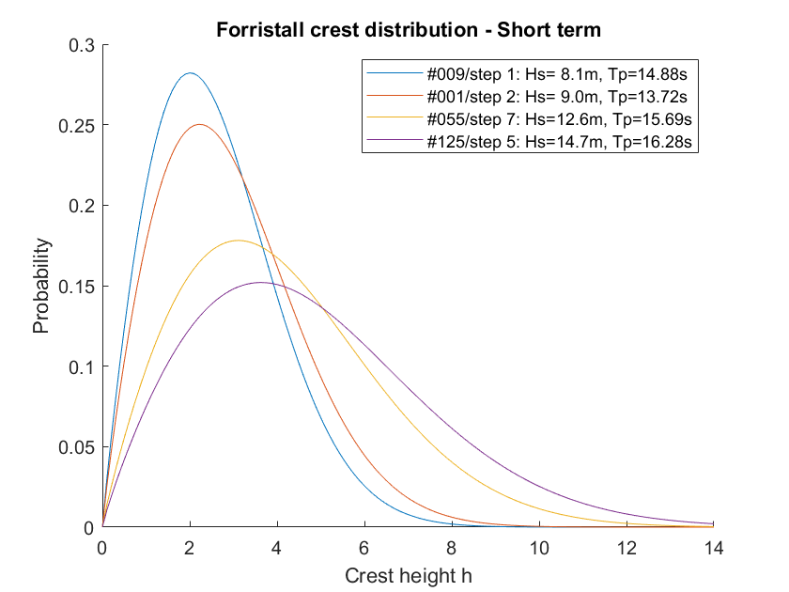

Figure 7. Short term crest height distributions for different steps in some storms.

The distribution of the maximum crest height in during each 3-hour step in each storm is obtained by raising the Forristall short-term distribution, to the expected number of global crests in 3 hours, 𝑛3ℎ.

represent the mean number of wave crests for each 3 hours duration, we can get it from the average zero up-crossing period ( RP-205, 3.5.3).

Then we get the probability distribution of the maximum crest height of each storm, k,by multiplying each 3 hour step m.

The ”exact” probability density function and the cumulative distribution function for the maximum crest height of each storm is given as below. It can be observed that for more extreme storms, there are fewer data points.

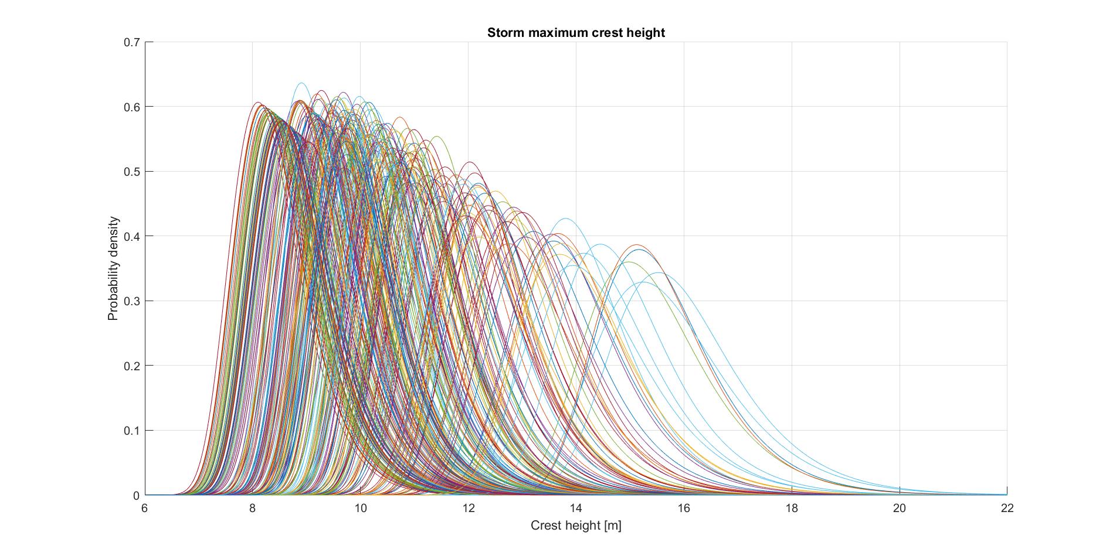

(a) Probability density function

Figure 8. Exact distributions of maximum crest heights for storms above the threshold of 8m.

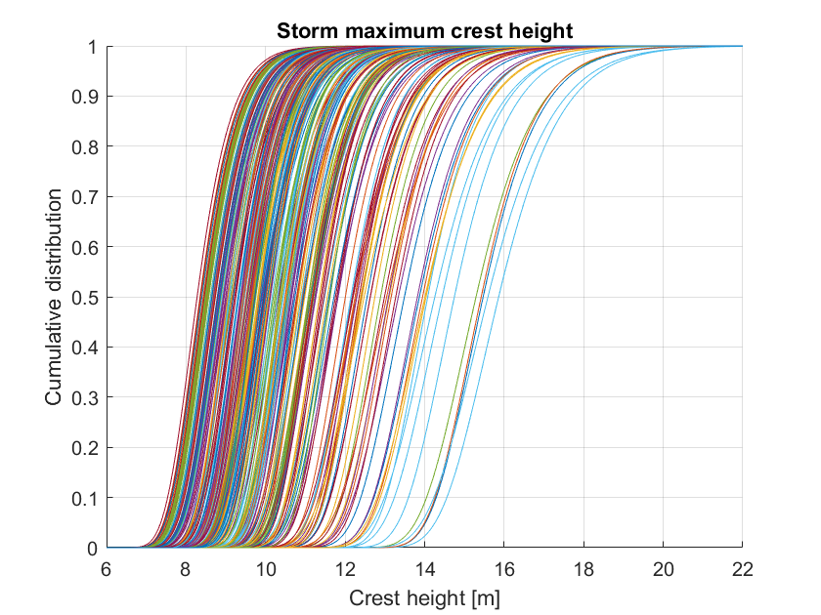

(b)Cumulative distribution function

Figure 8. Exact distributions of maximum crest heights for storms above the threshold of 8m.

### **2.3.2 Most probable maximum crest height of each storm**

By requiring 𝐹𝑌|k(𝑦 ̃k|k) =0.368 the most probable crest height of each storm can be obtained. These values will be referred to as dots. It is assumed that a three parameter weibull distribution can be fitted to the dots.

The metocean book recommends to use the method of moments(MoM) to estimate the weibull parameters because this approach yields a better fit for the tail. Another approach is to use the Maximum Likelihood Estimation (MLE) which is a built-in function in Matlab. Both methods were used and are compared below. The Gumbel probability paper clearly shows that the Method of Moment approach gives better results for the most extreme crest heights.

The most probable maximum crest height is the peak value of the probability density function of each storm, which is given in Figure 9(a). And the most probable largest crest height can be found around 0.4 in the cumulative distribution function as shown in Figure 9(b).

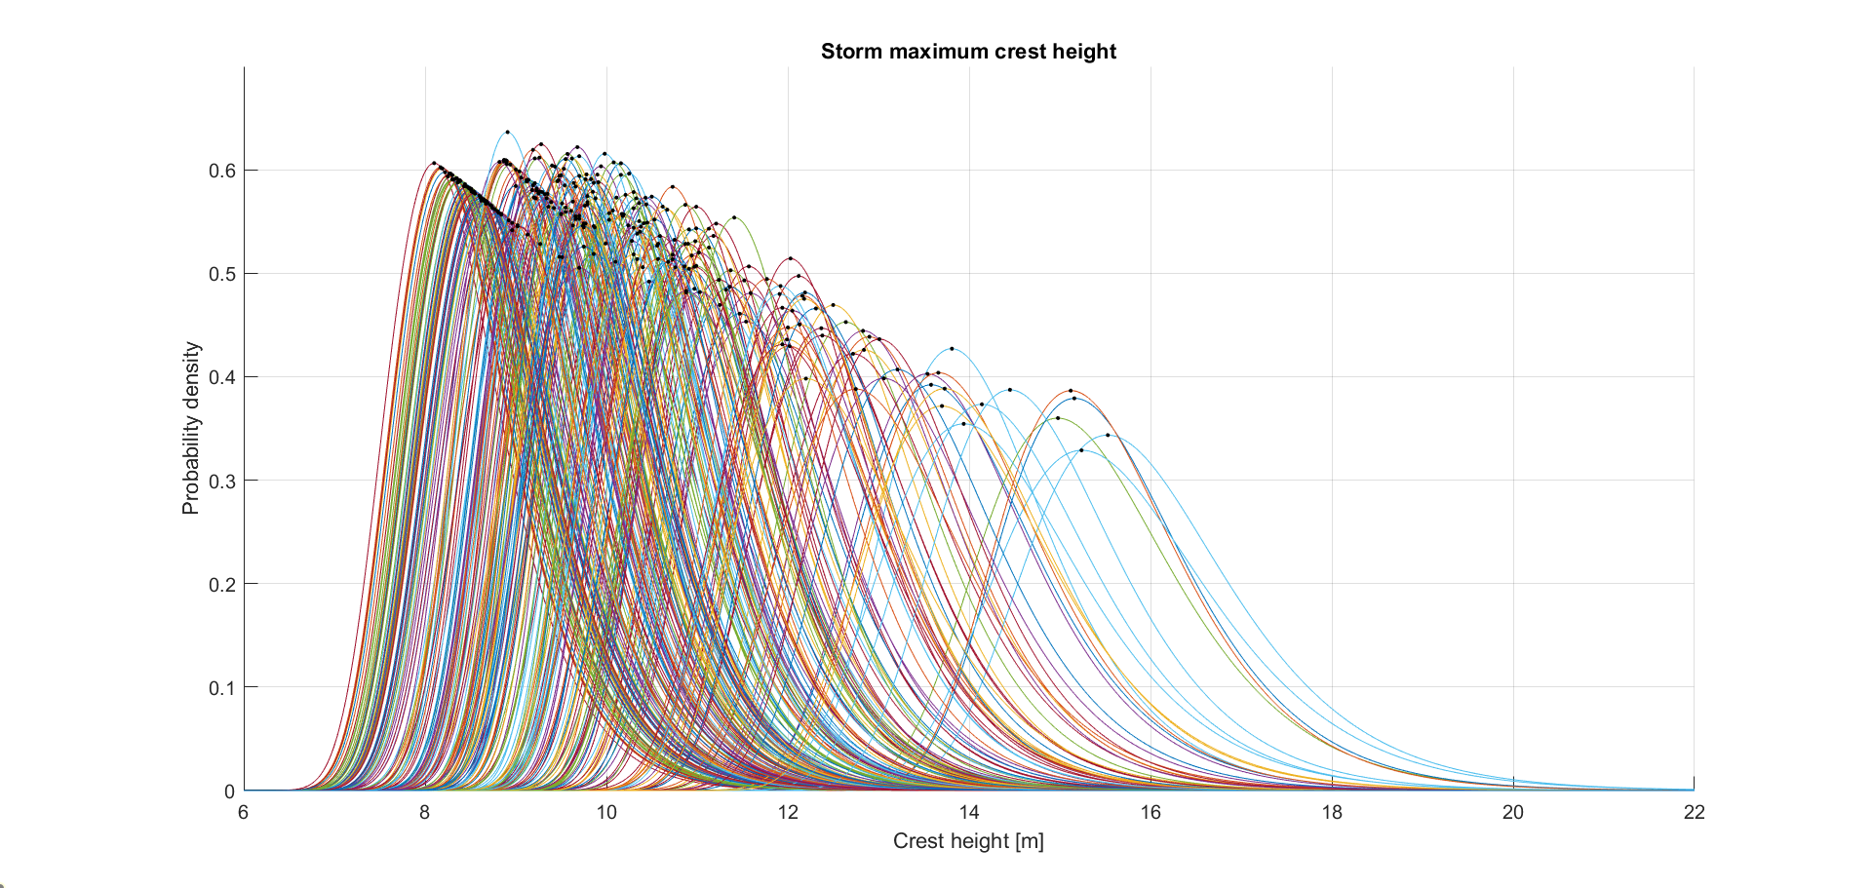

(a)Probability density function

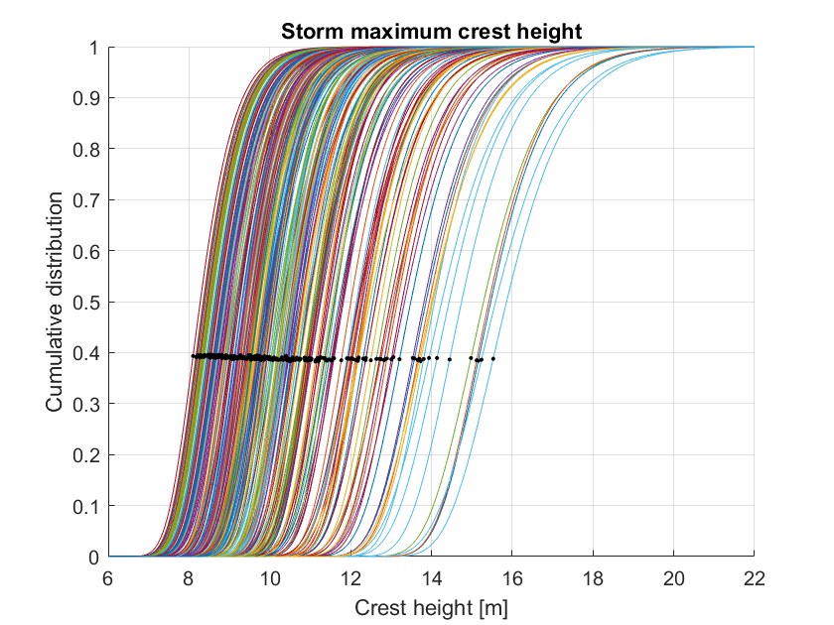

(b)Cumulative distribution function

Figure 9. Exact distributions of maximum crest heights for storms above the threshold and the most probable largest crest heights

The scatter diagram of the maximum crest heights from the “exact” distribution of each storm is given Figure 10. The Gumbel probability paper and 3-parameter Weibull model are shown in Figure 12 and 13.

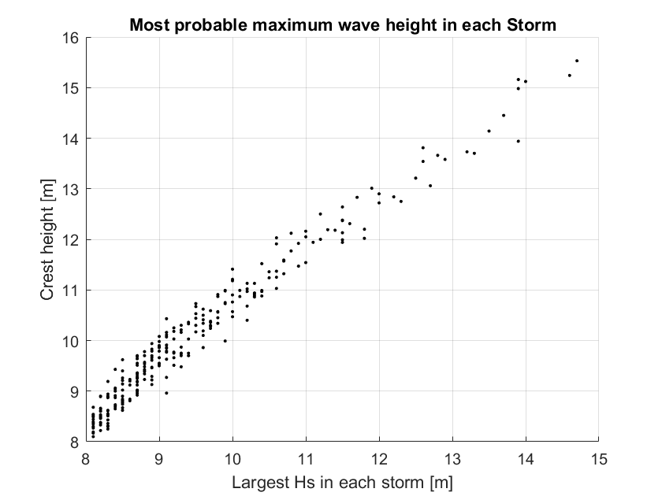

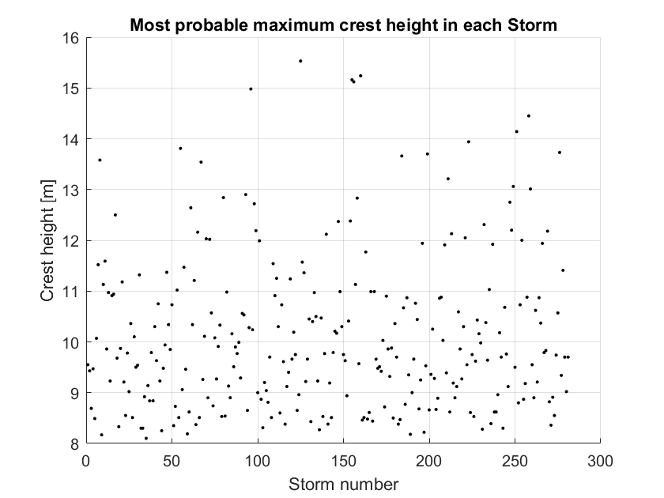

Figure 10. Scatter diagram of the most probable largest crest heights of each storm

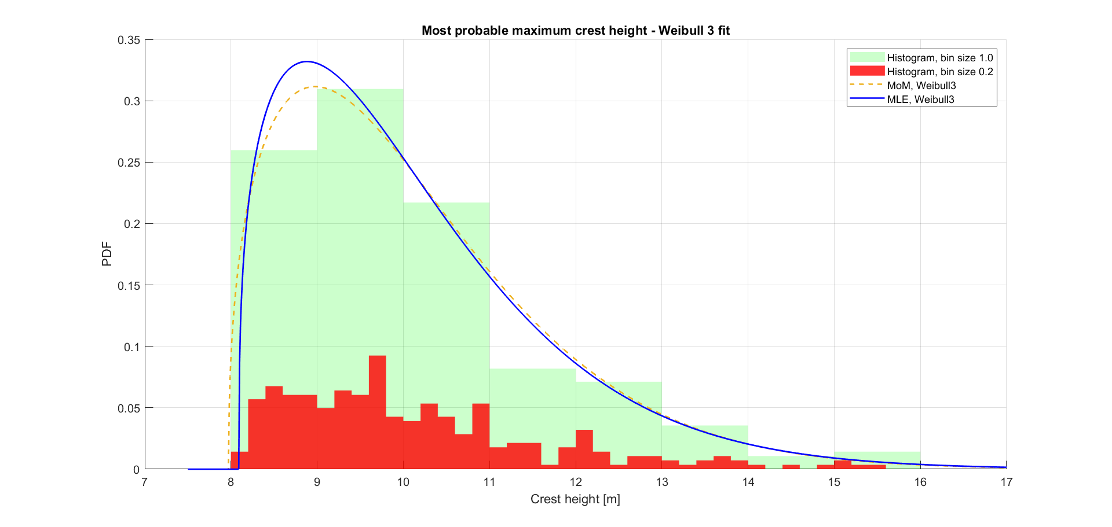

Figure 11. Comparison Method of moment and MLE

## **Method of moments and MLE**

## 

Figure 12. Gumbel probability paper

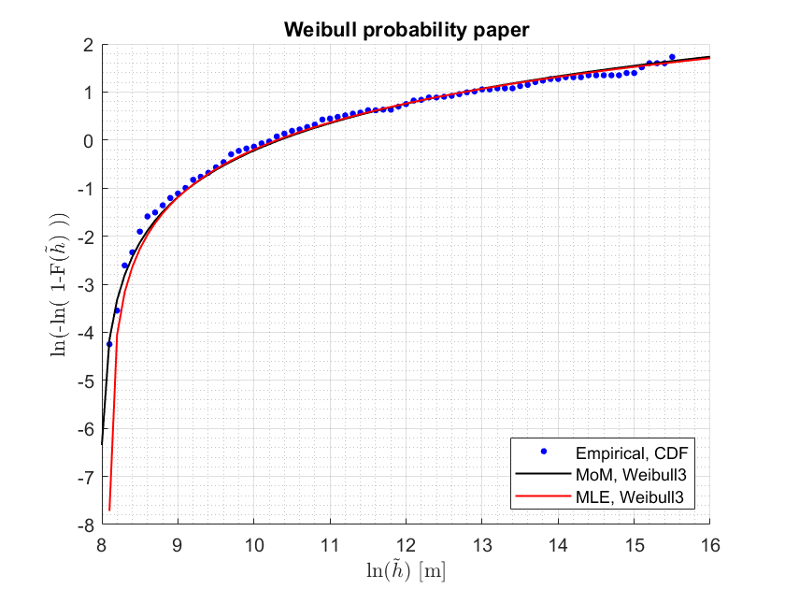

Figure 13. Weibull probability paper

## **2.4 Task 4**

**2.4.1 Number of storms per year**

There are 281 storms above the threshold and the hindcast data is from Sep. 1, 1957 to Oct. 31, 2018. Thus the expected number of storms per year is, 4.959 (= 281/61.15).

### **2.4.2 Maximum crest height of arbitrary storm from observed storms. (Random storm approach A)**

The basic idea of this approach is that the CDF of the maximum crest height of each observed storm is added together and the sum is divided by the number of storms. The result is a CDF on the maximum crest height of an arbitrary storm. Then, by considering the expected number of storms per year the annual extreme crest CDF can be obtained. The annual number of storms exceeding the given threshold, is assumed to be a random variable that is reasonably well modelled by the Poisson distribution. Section 2.3.1 describes how we get the maximum crest height CDF of each storm. The extreme crest height of an arbitrary storm is found as .

The annual extreme crest height is given as , where is the expected number of storms per year.

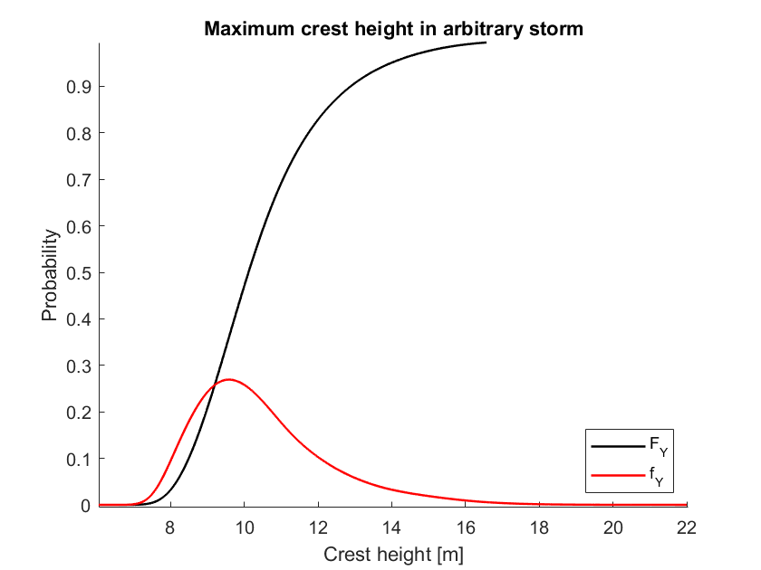

Figure 14. Maximum crest height of an arbitrary storm (Not accounting for unobserved storms)

### **2.4.2 MoM / MLE on ‘the dots’**

Instead of inserting the continuous CDF functions of each storm into the annual extreme crest height formula above (), one could try to insert the single CDF which is a fit of all the most likely extreme crest heights. This approach is probably wrong. It will be discussed in the discussion. 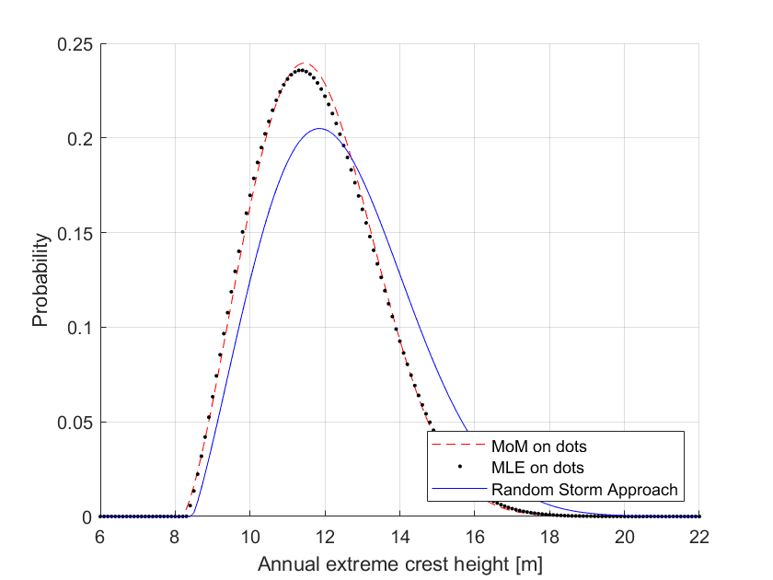

### Figure X. Random Storm approach A, and the fittings from section 2.3.2. Dots are most likely maximum crest height.

### **2.4.2 Gumbel fit - A simplification for futher analysis**

The CDFs of each storm found in section 2.3.1 are complicated to use for further analysis. Each CDF can reasonably well be fitted to a Gumbel distribution.

For this approach to be accurate, it is required that the Gumbel distribution has the same most probable storm maximum, ĥ , as the exact distribution, ĥ is found by requiring

𝐹𝑌𝑘|𝑘(𝑦 ̃𝑘|𝑘) = 0.368.

By using the same standard deviation of the exact distribution, beta can be estimated as . This procedure gives a sample of betas and ĥ, one pair per storm. By plotting hk vs βk we found that the scatter was quite small and had no particular trend. We could therefore simplify by using one constant beta for all distributions by taking the sample mean. We found the mean of beta to be 0.0646.

We have now found a CDF that gives the distribution of a storm maximum crest height given that we know the most probable maximum crest height of that storm, ĥ.

### **2.4.2 Maximum crest height of an arbitrary storm accounting for unobserved data. (Random storm approach B)**

We only have 281 storms and most of them are for Hs below 10m. For more extreme storms we don't have sufficient data. As can be seen in the plot of the CDF in section 2.3.2, there are some “gaps” between the CDFs of the most severe storms. The unobserved storms can be accounted for by weighting the CDF of the maximum crest height given the most likely maximum crest height () with the PDF of the most likely maximum crest height (). The result is a PDF and by integrating we obtain the CDF of the maximum crest height in an arbitrary storm, ). The difference between this result and the result in section 2.4.2 () is that now we have added contributions from storms that have not been observed.

For FY|Y, the Gumbel distribution from 2.4.2 is used.

The annual extreme wave crest can be found as, where is the expected number of storms per year.

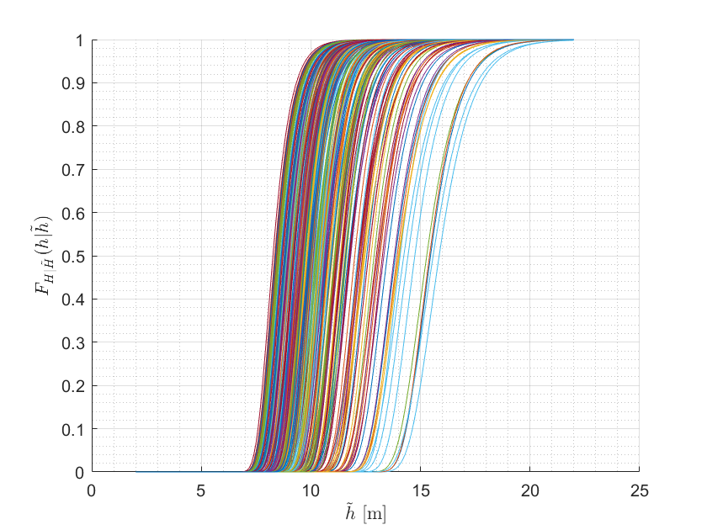

Figure 16. CDF of the maximum crest height given the most likely maximum crest height (the dots in section 2.4.2)

### **2.4.5 Results**

**Annual extreme crest height parameters - Weibull 3**

|  |  |  |  |
| --- | --- | --- | --- |
| **Method** |  |  |  |
| MoM on dots | **4.0852** | **2.4020** | **8.1831** |
| MLE on dots | **3.9630** | **2.2600** | **8.2968** |
| Random Storm Approach (A) | **4.4715** | **2.2016** | **8.4552** |

**Annual extreme crest height**

|  |  |  |
| --- | --- | --- |
| **Method** | **ULS [m]** | **ALS [m]** |
| MoM on dots | **15.90** | **18.48** |
| MLE on dots | **16.09** | **18.88** |
| Random Storm Approach (A) | **17.40** | **20.71** |
| Random Storm Approach (B) | **17.96** | **23.89** |

## **2.5 Task 5**

**2.5.1 Analysing the Beta**

For task 4 we have assumed that the scatter in Beta vs **ĥ** is quite random and does not follow a particular pattern. Also because the variation in beta is quite small, we estimated it to be a constant by taking the sample mean equal 0.0646. There appears however to be some clustering in the top left corner of figure 17. This is alarming, but on the other hand the data to the right of the plot is more important for our extreme value estimations. For ĥ above approximately 12m, the scatter looks very random (no trend). From visual inspection it also looks like the blue line is close to the mean of all the betas where ĥ is above 12m.

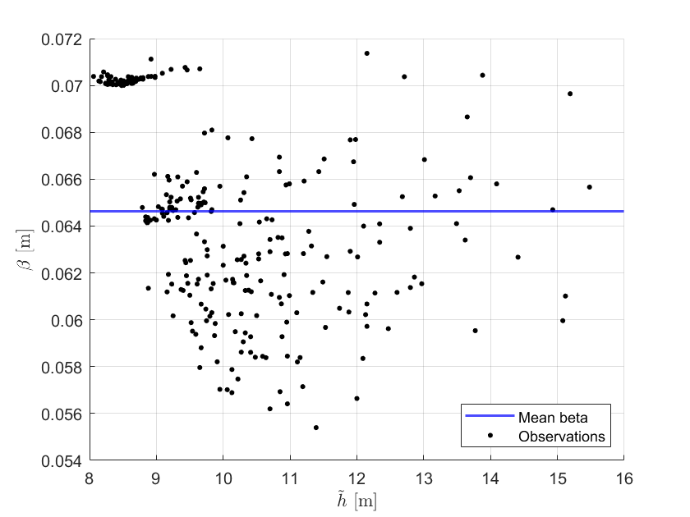

Figure 17. Scatter of the Betas vs the most probable maximum crest height of each storm. Except for maybe the top left corner, no trend was seen.

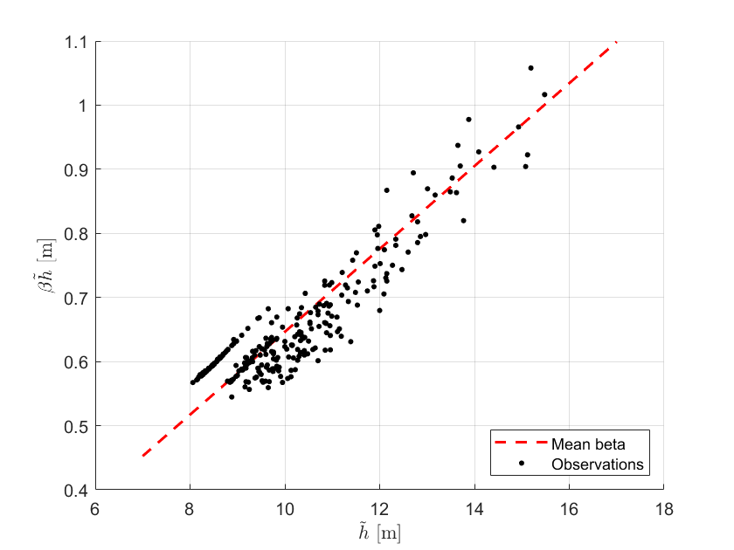

Figure 18. Line of mean beta multiplied with h.

# **III. Conclusions & Discussion**

After modifying the peak period using the suggested approach by Haver, a well scattered Tp was obtained.

For the storm peak significant wave height, we tried to fit a Gumbel distribution as suggested by the task paper. This did not give a good result and its not in the report. The weibull 3 distribution does however give a very good fit. One could also try to do a Least Squares estimate (LS) fit as advised by RP-205 for good tail fit. We used two methods to estimate the weibull parameters, Method of moments(MoM) and Maximum Likelihood Estimate(MLE). Since we are concerned with extreme datas, we have to focus on the tail datas. But the tail datas are few and there will be uncertainties regarding their long term representativity. So estimation by method of moments is often a proper compromise. The maximum likelihood principle gives too little weight to the tail data, while least square fit in probability paper may give too much weight to the tail. So extreme values estimated from the method of moment fit are considered better.

For task 2, considering only the wind sea, we were directly using the Hs data after filtering out the storms for the 61 year data and fitting the distribution to a weibull model and the extreme Hs with ULS and ALS probability are found.

For task 3, as expected we got a higher ULS and ALS for the annual maximum crest height when we included the unobserved observations. The conservative approach concerning the safety of ocean structures is to use the largest ULS and ALS maximum crest heights. However, if the estimated ULS and ALS is significantly larger than the actual ULS and ALS ocean structures become unnecessary expensive to build.

The naive Mom / MLE on the dots approach(section 2.4.2) gave the smallest maximum crest waves. This method significantly underpredicts the ULS and ALS because tail data and data on more extreme crest waves is lost. This approach is not recommended.

One of the greatest weaknesses of this whole analysis is that we have to reconstruct “Exact” distributions of maximum crest height based on Hs and Tp. The results of this analysis should therefore ideally be compared to real world exact maximum crest height. According to RP-205 the Forristall distribution of the short-term crest height above still water results in maximum values that are slightly on the lower side. Any errors from the short term could potentially give large errors for the ULS/ALS.

Another failure point is the assumption that the beta oof each storm can be simplified to a constant beta for every storm. Also for unobserved storms. There was some clustering in beta for smaller ĥ. This should however only give very slight impact on our ULS and ALS estimation. Beta for larger ĥ seems to not follow a particular trend. This is a good sign that strengthens the case for a constant beta.

# **V. List of references**

[1] Haver, S. (2018). *Metocean modelling and prediction of extremes.*

[2] Sandbakken. Long term analysis of semi submersible offset. NTNU master thesis, pages 75–89, 2016

[3] DNVGL-RP-C205. Environmental conditions and environmental loads, 2014.

[4] Pekovic (Master thesis), Long Term Analysis of Wave Characteristics, 2015.

[5] The Weibull Distribution, <http://reliawiki.org/index.php/The_Weibull_Distribution>

[6] The Gumbel Distribution, <https://en.wikipedia.org/wiki/Gumbel_distribution>