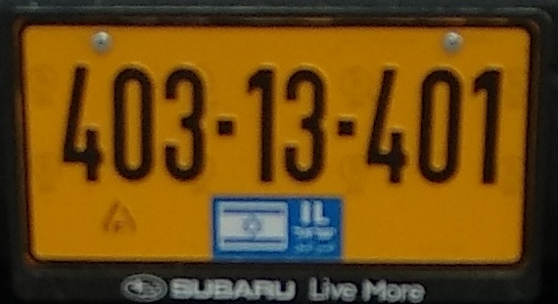

403-13-401

OBUBARU Live More