**Research Labs Inventory**

Jonathan Moore

Evan Ross

Lizzett Tapia

Sumedha Bhattacharyaa

**Concept of Operations**

REVISION – Draft

10 September 2024

Concept of Operations

for

Research Lab Inventory

Team <55>

Approved by:

_____________________________

Project Leader Date

_____________________________

Prof. Kalafatis Date

_____________________________

T/A Date

**Change Record**

| **Rev.** | **Date** | **Originator** | **Approvals** | **Description** |
| --- | --- | --- | --- | --- |
| **1.0** | 9/10/2024 | Moore,Ross, Tapia, Bhattacharyaa |  | Initial Submission |

**Table of Contents**

**Table of Contents III**

**List of Tables IV**

**List of Figures IV**

**1.** **Executive Summary** 4

**2.** **Introduction** 5

2.1. Background 5

2.2. Overview 5

2.3. Referenced Documents and Standards 6

**3.** **Operating Concept** 6

3.1. Scope 6

3.2. Operational Description and Constraints 6,7

3.3. System Description 7,8

3.4. Modes of Operations 8

3.5. Users 8

3.6. Support 8

**4.** **Scenario(s)** 8

4.1. Check-Out as Student 8

4.2. Check-In as Student 8

4.3. Monitor Students as Staff…………………………………………………………………………………………………. 9

4.4. Add/Manage Inventory as Staff………………………………………………………………………………………… 9

**5.** **Analysis** 9

5.1. Summary of Proposed Improvements

5.2. Disadvantages and Limitations 9

5.3. Alternatives 9

5.4. Impact 9, 10

**List of Tables**

# Table 1: Referenced Documents…………………………………….6

**List of Figures**

# Figure 1: Visual Functional Diagram………………………………..5

# Figure 2: Landing Page of Web-app………………...……………...7

# Figure 3: System Layout Description…………………...…………..7

# Executive Summary

An important aspect of a research lab is the ability to track inventory. This is important for many reasons such as the ability to know when an item inventory is low, tracking who is responsible for what items, and knowing what items are available. Our project at its core is to develop a website, along with a smartphone app, that allows users to track and make changes to the Inventory in research labs. Users will need to login using their credentials, and they will either be categorized as a student or a staff member based on initial registration. Students will be able to check out and check in items in the lab, and the inventory will adjust accordingly. Staff members will be able to make larger changes to the inventory, allowing for the addition and deletion of large amounts of components. Our Inventory data will be stored on a database that will be linked to both the app and the website, so that changes can be made from both. Our smart phone application will also have a machine learning component where users will be able to scan an item and have it automatically identified. After scanning an item, the app will open the page where users can either check out or check in that specific item. This will make tracking components in laboratories easy and intuitive.

# Introduction

The current lab inventory system existing is inefficient and disorganized. Lab members often go to check things out, and are met with the issue of not knowing how many things they checked out, and how much stock the lab has left of items. The current system has a person manually check things out to members, without much of a record. As a consequence, the lab lacks cohesive organization, and its members face challenges in maintaining an efficient workflow.. We aim to tackle this simple logistical issue with a highly methodized Lab Inventory Tracking system.

## Background

This Lab Inventory Tracking system aims to replace the manual process of logging items being checked in or out. The system comprises both a website and app that will have a live tracking method that can show what’s checked out by whom. The app will also have a Machine Learning component that allows users to use their device’s camera to locate items’ locations. This will enhance the current system’s efficiency as this system can update the log faster than it is being done manually. Replacing the manually updated log, with a live-updated one, allows users to also know the stock and status of items they may need.

## Overview

To check-out an item, a user can direct themselves to either the app or website. Through either, they can add however many items they need to a cart. They will then be prompted to check a box that agrees that they will return items in the condition needed (if it’s an item that needs to be returned). The app version will allow users to take a picture of all the items they’re checking back in. The machine learning model will then automatically log those items as being checked back in. This process can be shown visually in **Figure 1**.

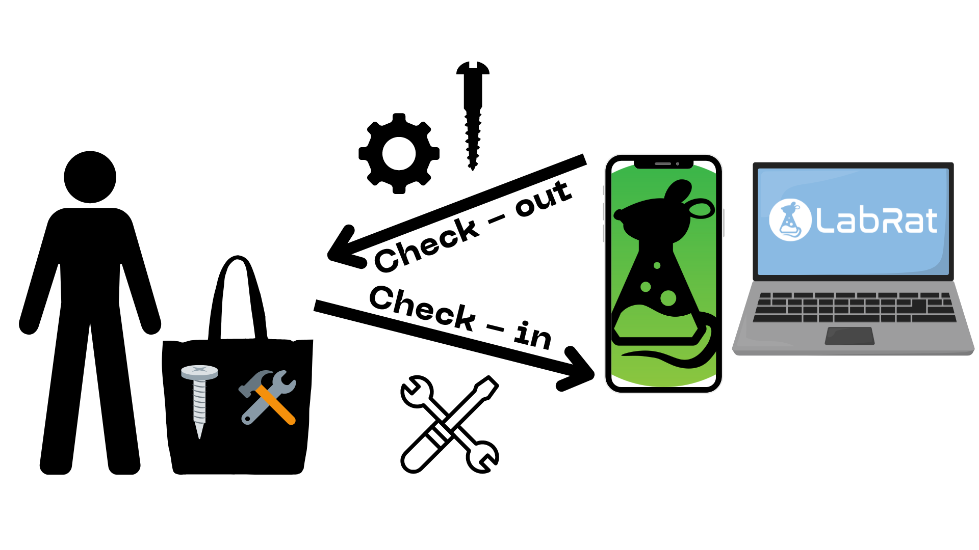

**Figure 1.** Visual Diagram of how the app and website will work synonymously for checking items in and out.

## Referenced Documents and Standards

**Table 1.** Referenced Documents

| Document Name | Revision/Release Date | Publisher |
| --- | --- | --- |
| Google’s Machine Learning Crash Course | 2023 | Google Machine Learning Education |
| Building a Python Image Recognition System | 2024 | Cloudinary |
| OpenCV Library | 4.10.0 | OpenCV |
| Flutter document | 2017 | Flutter |

# Operating Concept

## Scope

The scope of our project is centered around people at Texas A&M. The intent of this project is for research students and faculty to use the application to find items in their associated lab. We will include functionality for other labs at Texas A&M to register their inventory and users, so any Texas A&M labs that aren’t included in the initial design can make use of our product. Theoretically we can add functionality for labs outside of Texas A&M to use our services, but it was a deliberate decision to limit our scope to people at this university.

## Operational Description and Constraints

Our project has two interfaces, a native mobile application and a web-based application. From the web-app, users will be able to log in and access all inventory items in the database for their assigned lab. If a user has access to multiple labs on campus, then they will be able to switch access between each for individual access.

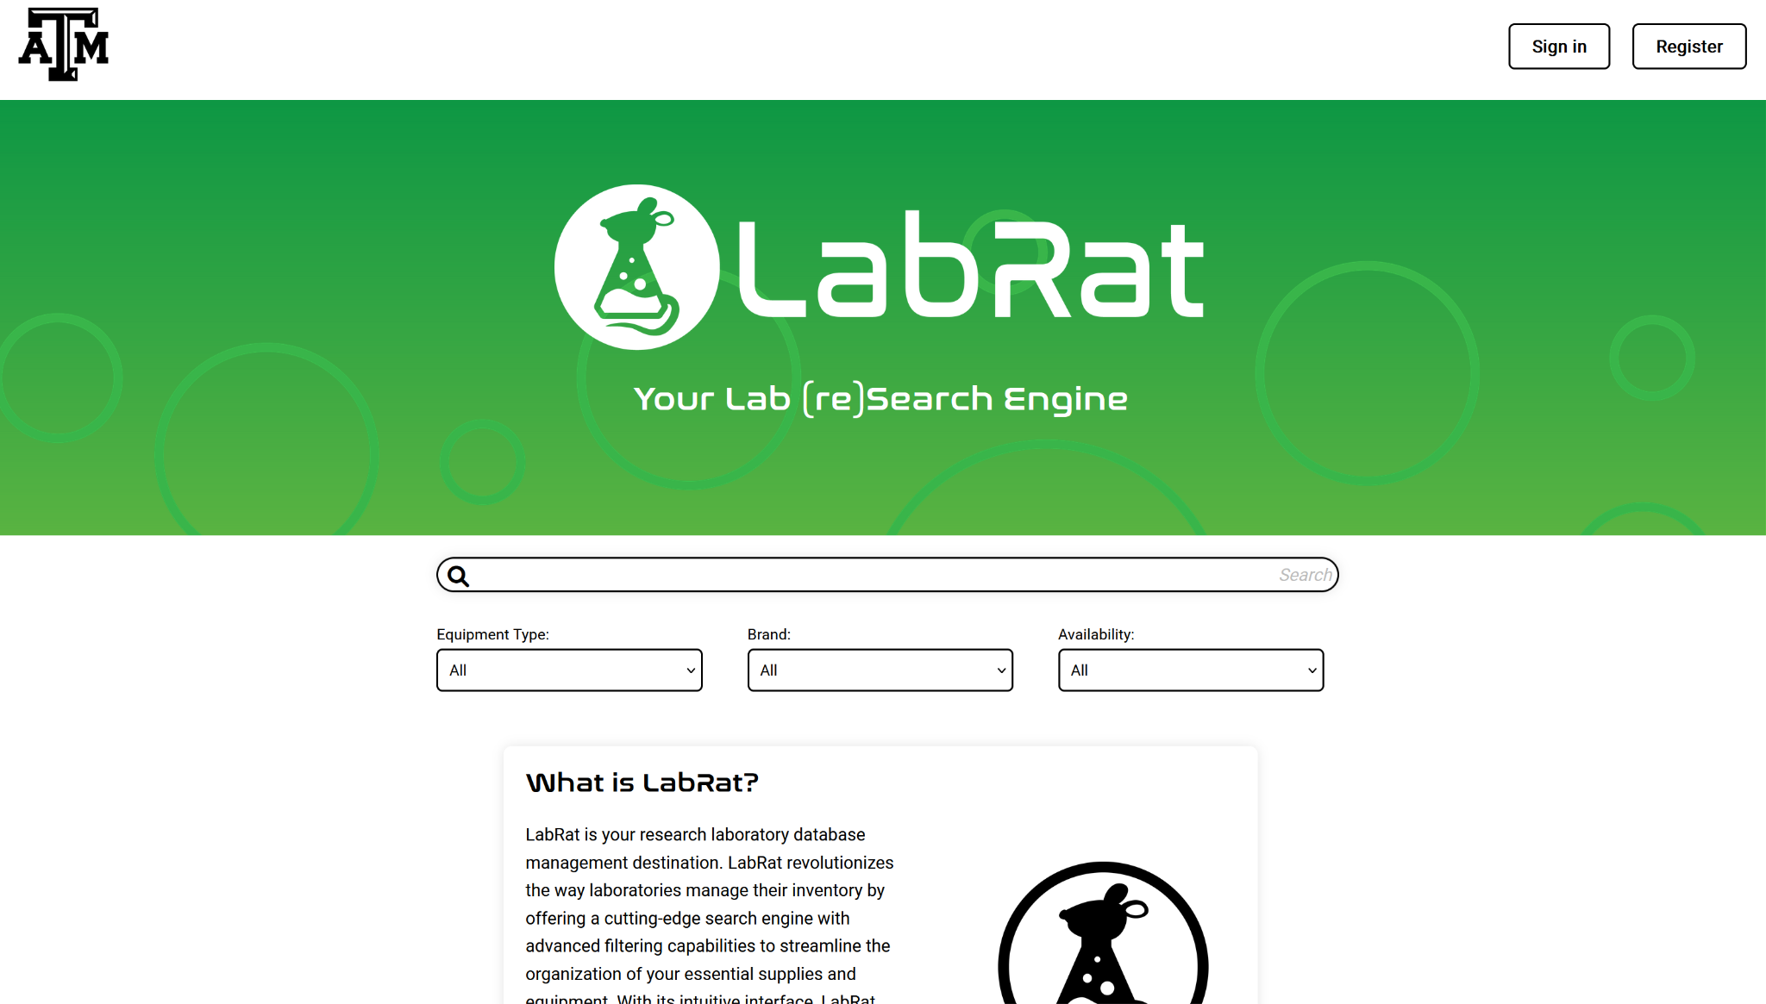  
Figure 2: Landing Page for Web-app

From the mobile-app, users will be given the same abilities as the web-app in addition to an item-finder. If a user cannot find more of a certain item, they can take an image of what they want to find more of and the machine learning model will help the user. Assuming that there are no barcodes or QR codes on the items, items can be found in the laboratory using this model.

## System Description

The project is divided into four subsystems. These consist of the database, the web-app, the mobile application, and a machine learning model. Below is a visual representation of how each part interacts:

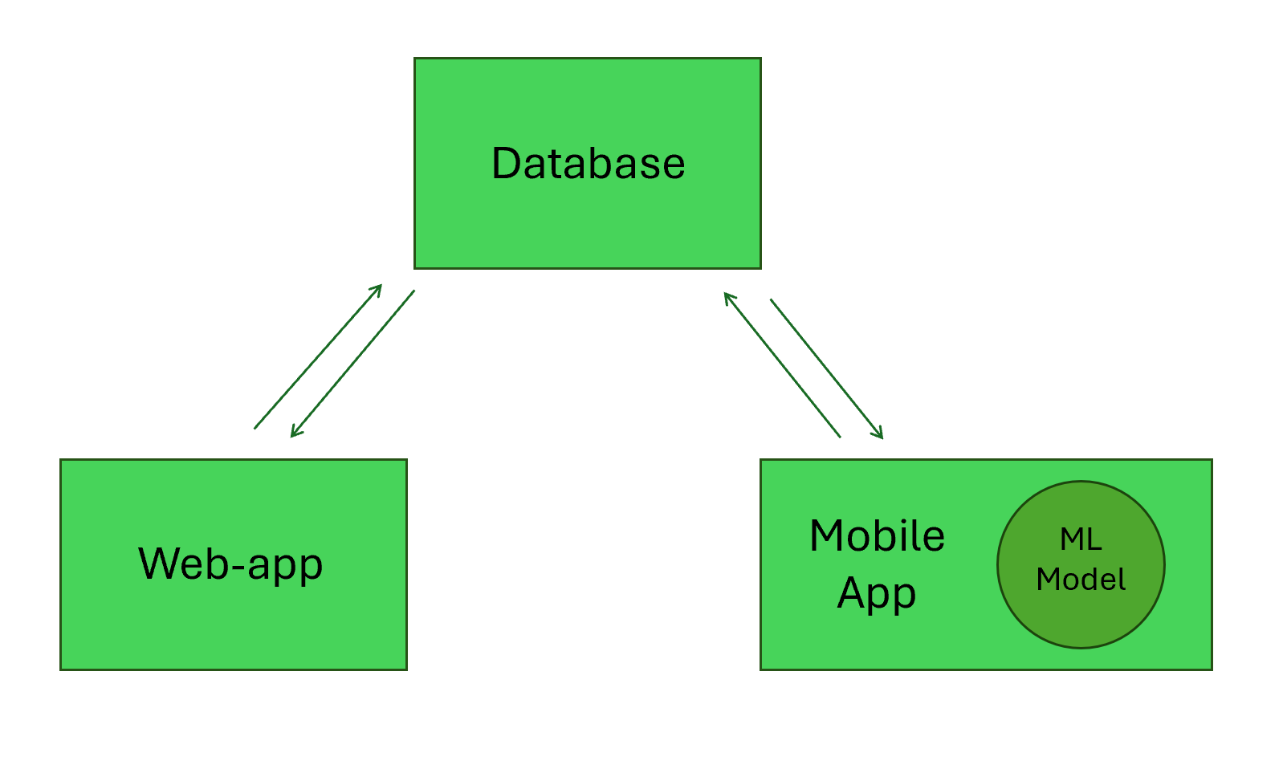

Figure 3: System Layout Description

As you can see, all parts of the project connect back to the database. Whether a user is operating on the web-app side or the mobile-app side, the database will be able to receive requests from both and update all information dynamically. For example, if changes to the database were made from the mobile application, then the database should populate the pages of the web-app automatically. The machine learning model is only accessed from the mobile application, and any time the camera is used to find items or check in/out those items.

## Modes of Operations

The modes of operation for the software will be via android smartphone or computer. The camera functionality will only be able to be accessed through the app on the smartphone. It can be used in any environment where the device being used is functional. It is intended to be used in research labs or similar facilities requiring storage (Libraries, warehouses, ect.).

## Users

As of now, there are only two defined users, but we have the ability to add new permission levels for new types of users later in development. Currently, we have “student” and “staff” roles. Students have the ability to check into their lab and look at all the inventory of their respective lab(s). They can check-out any items they need, see which items are available, and see how much of each the lab has for their own reference. Staff users have slightly more abilities. They are able to see the recent login times of other users and see who the most recent borrower of any item was. This will make tracking students’ usage easier for staff.

## Support

Our website along with the smartphone application will have a FAQ page. This will be the main form of support. Any questions not included in the FAQ can be emailed to the team member whose subsection the question pertains to.

# Scenarios

## Check-out as Student

As a student, users should be able to login to observe all available tools in the lab, see which ones are available, locate where the item is stored, and check-out the item they need.

## Check-in as Student

As a student, users should be able to login to return any items to the lab. Upon returning, the student should be able to take a picture of the item, use the machine learning model to recognize which item it is, and change the status of the item to “checked-in” so anyone else can use it

## Monitor Students as Staff

As a member of the lab’s staff, users should be able see the recent login times of their students and monitor the most recent borrower of tools from the lab. If something is damaged, then staff members should be able to find the person responsible for damage.

## Add/Manage Inventory as Staff

As a staff member, I should be able to add new items to the inventory of my lab, edit the attributes of any of the items, remove any unnecessary items, and deactivate items that I deem unusable.

# Analysis

## Summary of Proposed Improvements

This research lab inventory tracker will be able to provide improvement for the current traditional inventory management process. With the use of the website and application, the user will be able to have real-time updates of such inventory. This helps reduce overstocks or stockouts. The automatic inventory updates help minimize manual work that could eventually lead to human error. By having one central database server, there is a reduction in inconsistency, as staff and students are both accessing the same data.

## Disadvantages and Limitations

While the proposed inventory tracker system offers various improvements, it also comes with disadvantages and limitations. There is a possibility of running into server issues that can cause data loss or website downtime. If the server becomes unavailable, the user will not be able to access the inventory data, which can cause delay in tracking or order processing. The machine learning model has the possibility of not being as accurate. As the user uploads a picture of the inventory, the machine learning model could accidentally end up confusing a piece of inventory for another, and therefore updating the wrong data. Another issue could be that item locations are not correct due to human error, such as item misplacement.

## Alternatives

Some alternative solutions for this inventory management include using Excel or Google Sheets. This allows for manual data entry without having to depend on a database server. Using spreadsheets is free and is very simple to use, but not dynamic for a website management system.

## Impact

A website and application inventory tracker has environmental positive impacts. There is a clear reduction in paper consumption, as there is no need for any physical records. By being able to avoid over stockings, laboratories are able to reduce overall waste. Overall, laboratories are able to reduce human error and improve productivity. In return, more reliable information can be provided to users.