1. Selecting a class label for a new point would take O(n) time because each new point needs to be compared with all the data. The space complexity is also O(n) because it stores the data.
2. The training time is O(1) because it just stores the data. The prediction does the work.
3. Yes, a KNN classifier predicts based on the data and can easily bend and curve.
4. A KNN classifier does not work as well when considered on a larger range of inputs because it may overfit to training data. In the drawing, green dots represent the training data, and the red dots represent the additional data.

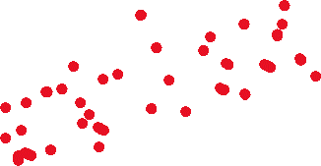

1. Users are compared to each other by their ratings given to movies with each user represented with a vector of their movie ratings. Users who gave similar ratings to the same movies are considered similar and grouped together. These K neighbors would be used to estimate the rating a user would give for a movie they have not seen.
2. Mean: 19, Median: 10. The fewer movies two users have in common, the more difficult it is to find the distance because there are fewer data points for comparison. Movies that no user has rated are ignored.
3. .
4. .
5. .
6. .
7. .
8. With high dimensionality, two similar points may still have a large distance. Additionally, the time and space used would be high as both have a complexity of O(n).
9. A transformation can be applied to the data to decrease its dimensionality, which would decrease prediction times.
10. .
11. The classification accuracy on the training set will initially increase, as the effect of outliers will decrease. The effect of outliers can also be decreased with proper weighting. As k nears n, the classification accuracy will decrease, as too many neighbors are being taken in to create an effective prediction.