System Design 5

System Architecture

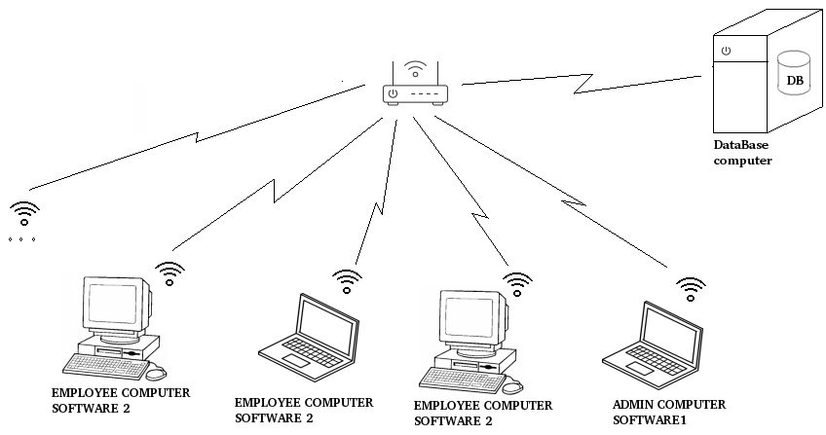

I. Hardware Requirement
- wifi router
- several desktop / laptops
* headless desktop unit

II. Software Requirement
* 2 softwares: employee, and admin
* database system software

III. Interconnectivity
- database is wire connected to router
- database is static address
- desktop / laptop connected via wifi

Gantt Chart

November - December  2017 | Week 1 | Week 2 | Week 3 | Week 4
November - December  2017 | Nov 5 – 11 | Nov 12 – 18 | Nov 19 – 25 | Nov 26 – Dec 2
analyze company process
preliminary design
database design

January  2018 | Week 1 | Week 2 | Week 3 | Week 4
January  2018 | Dec 31 – Jan 6 | Jan 7 – 13 | Jan 14 – 20 | Jan 21 - 27
database software implementation
database hardware purchase
database hardware setup
sw feature requirement generation
sw user interface design
sw backend implementation

February  2018 | Week 1 | Week 2 | Week 3 | Week 4
February  2018 | Jan 28 – Feb 3 | Feb 4 – 10 | Feb 11 – 17 | Feb 18 – 24
sw backend implementation

March  2018 | Week 1 | Week 2 | Week 3 | Week 4
March  2018 | Feb 25 – Mar 3 | Mar 4 – 10 | Mar 11 – 12 | Mar 18 – 24
sw backend implementation
sw Documentation
sw User Training
sw Testing
sw Bugfixes

Analysis
- analyze company process
  - Company will be analyzed regarding the processes and what could be automated.
- preliminary design
  - Preliminary design of the system will be generated and shown. Includes the Hardware architecture of the system.

Database
- database design
  - Design of database ER diagram. Will be based on what data can be collected and transform into desired output.
- database software implementation
  - Implementation of database ER diagram into mySQL.
- database hardware purchase
  - Purchase of hardware receipt will be provided.
- database hardware setup
  - Purchased hardware would be setup into a dedicated server.
- database office installation
  - Installation of the database hardware into actual office.

Software Development
- sw feature requirement generation
  - Determine the desired outputs of the software.
- sw user interface design
  - Design the apperance and behavior of the software.
- sw user interface implementation
  - Implement the proposed design and functionality.
- sw backend implementation
  - Implement the underlying computations of the software requirement.

Polishing stages
- sw Documentation
  - Includes User Manual and Technical Manual for use by succeeding developer.
- sw User Training
  - A slideshow presentation of the User Manual.
- sw Testing
  - Actual testing by all users of the software.
- sw Bugfixes
  - Fixes of bugs found during testing.

Scope of Work

- This project only includes System Software. Which only includes:
  - database hardware / software
  - software for use with data
- Does not yet include the “Expert System”.
- The “Expert System” will have its own quotation independent of this quotation.
- Software feature recommendations will have a deadline on January 2018.
- All software features being asked after January 2018 is not included in this project and should have its own quotation.
- All bugs found after March 24, 2018 will not be covered by this contract and will have its own charge.
- For any delays that i might cause. Justification and schedule adjustment would be provided.

Payment Breakdown

Hardware Database | 5000pesos
Hardware Installation Cost | 1000pesos
Total Hardware Cost |  | 6000pesos
Software Database Design / Implementation | 5000pesos
Software User Interface / UI implementation | 5000pesos
Software Backend | 15000pesos
Software Documentation: User Manual | free
Software Documentation: Technical Manual | 5000pesos
Total Software Cost: |  | 30000pesos
Total |  | 36000pesos

Payment Schedule

Total Cost
Hardware Cost | 100% | 6000pesos | 6000pesos | Dec 10, 2017
Software Cost | 100% | 30000pesos
 | 33.333% |  | 10000pesos | Jan 26, 2018
 | 33.333% |  | 10000pesos | Feb 9, 2018
 | 33.333% |  | 10000pesos | Mar 23, 2018

Note : price and schedule of payment for Database Hardware may change depending on the hardware supplier. Their quotation and receipt will be provided.

- JonathanCempron

