Convergent

System Database

Week 3 Objectives : reference see quotation document

- analyze company process
- database design

Database Design

A part of analysis of the company process. Transforms their documents into one organized in a database fashion. Ideally helps reduce redundancy in the system. And also provides future features as relationships of data are recorded. Presented is the diagram of the database.

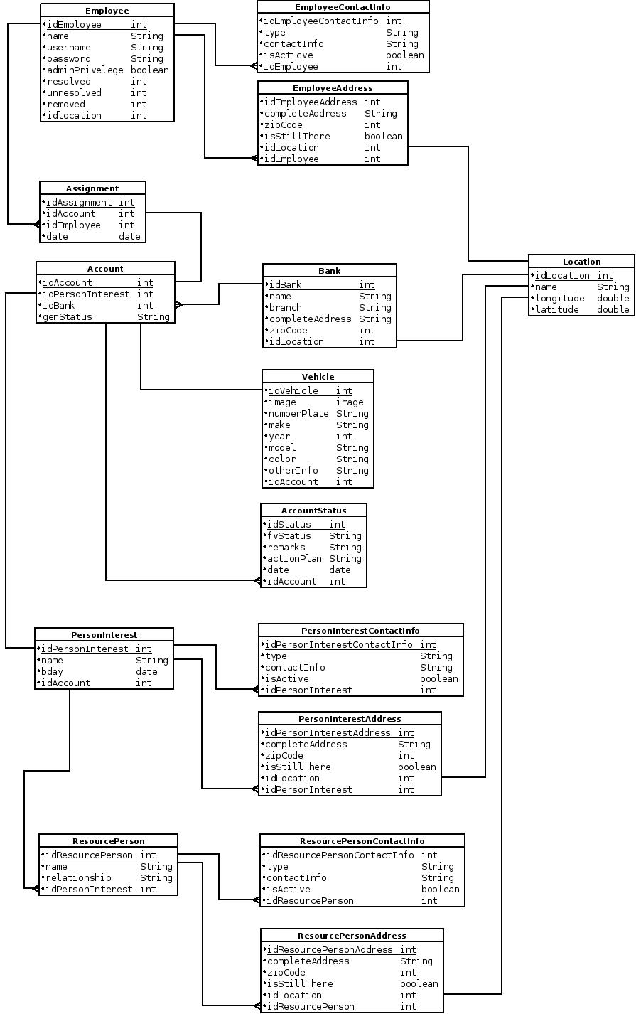

OTHER NOTES

resource person could be wife, employer etc...

contact info types include
- telephone
- cellphone
- email
- facebookUsername

ContactInfo isActive
- if the info is still being used or evidently not
- true or false

address isStillThere
- if still using that location or had transferred
- true or false

Account genStatus include
- resolved
- unresolved
- on-going

account status
- has idemployee because assignment might switch

Employee has
- resolved : number of cases resolved
- unresolved : number of cases unresolved
- removed : number of cases reassigned away from them
- current cases he handles can be viewed via
assignment -> account -> genStatus == on-going

