Installation and Installation Requirements
TwinCAT 3 XAE (Engineering)
- Windows XP with SP3 (x86) or Windows 7 (x86 or x64)
- Processor running at 1,6 Ghz or higher, with Enabled Intel VT-x extension
- 2 GB RAM
- 500 MB free harddisk space if Visual Studio 2010 shell already installed
- 3 GB free harddisk space if Visual Studio 2010 shell not already installed
- Graphics adapter supporting DirectX9, running at a minimum resolution of 1024x768

C++ development requires the Windows Driver Kit, Installation Instructions here: http://infosys.beckhoff.com/english.php?content=../content/1033/tc3_c/html/TC3-XAE-CPP-InstallDDK.htm&id=

TwinCAT3 can at the time of writing, be downloaded via this link: http://www.beckhoff.co.nz/english.asp?download/tc3-downloads.htm?id=1905053019883865

The TwinCAT3 software starts a program with a system tray interface which is used to launch the TwinCAT3 environment. I have not spent time looking for a way around this launch method. This launch method will only run the program correctly if you are logged in on an administrative account.

For my current work, I requested a new system be set up by IT, on which I am a local administator. I have internet access via the uni wireless network. They have given me a DELL Latitude E4200 with a clean windows 7 (64bit) install + antivirus which works fine.

Setting up the Network Device
Only certain Ethernet Devices will work with TwinCAT. A list of supported devices can be found here: http://infosys.beckhoff.com/english.php?content=content/1033/tcsystemmanager/reference/ethercat/html/ethercat_supnetworkcontroller.htm

Ethernet Driver Setup
Right click the TwinCAT3 Icon shown below. This brings up the context menu also shown below.
Illustration 1: TwinCAT System Tray Icon
Select TwinCAT XAE. Once the program has started. Click TwinCAT, Show Realtime Ethernet Capable Devices...
Illustration 2: TwinCAT RealTime Ethernet Devices
Find the network device you will use for connecting to the EtherCAT network and click install. After the network driver installation finishes, close the TwinCAT3 XAE software.

Ethernet Address Configuration
We now need to configure the Network address of the network device. Select start, control panel, Network and Sharing center, change adapter settings.
Illustration 3: Control Panel Network and Sharing

Right Click the adapter you will use for EtherCAT communications and select properties. The following window will open.
Select Internet Protocol Version 4 (TCP/IPv4). Then click properties.

Illustration 4: TwinCAT Device Properties

Ensure the next window is set in the following way.
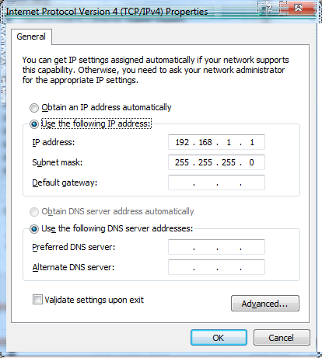Illustration 5: TwinCAT Device IP Settings

EtherCAT AMS NetID Configuration
Right click the TwinCAT3 icon as shown in Illustration 1: TwinCAT System Tray Icon. Select Router, Change AMS NetID. The ID field should be set to “192.168.1.1.1.1”. The system then needs to be restarted. If you do not restart immediately, the AMS NetID field will return to the value it was initially. I have not tested if restarting at a later time with use the old or new value. Therefore I would recommend restarting using the systems prompt dialog when it requests.

Hardware Configuration
Before proceeding further, ensure your hardware is set up in a known configuration. Information about the current setup at the time of writing can be found in other folders of this documentation.

C++ Setup

Windows DDK
TwinCAT3 need an installation of the windows driver development kit. Instructions for doing this are available on the beckhoff site here: http://infosys.beckhoff.com/english.php?content=../content/1033/tc3_c/html/tc3-xae-cpp-installpreqrequirements.htm&id=

A summary of what is on the linked page:
Windows DDK can be downloaded from here: http://www.microsoft.com/downloads/en/details.aspx?displaylang=en&FamilyID=36a2630f-5d56-43b5-b996-7633f2ec14ff
Run the installer. Only the Build Environment needs to be installed. The DDK by default is installed to C:\WinDDK\(Version number) in this case: C:\WinDDK\7600.16385.1

click start, control panel, system, advanced system settings, environment variables, new.
Complete the form as follows, where the version number may need to be changed to suit your version.

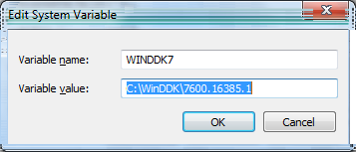

64Bit driver Signing
64bit windows platforms will not run unsigned drivers. To allow run c++ projects, it is necessary to be able to run arbitrary drivers. The process to make this work is as detailed below.
Click start, all programs, microsoft visual studio 2010, Visual Studio Tools. Then right click Visual Studio Command Prompt and select Run as administrator.
Enter the following:
makecert -r -pe -ss PrivateCertStore -n CN=MyTestSigningCert MyTestSigningCert.cer
certmgr.exe /add MyTestSigningCert.cer /s /r localmachine root
bcdedit /set testsigning yes

click start, control panel, system, advanced system settings, environment variables, new.
TwinCAT needs to know which certificate to use. To do this:

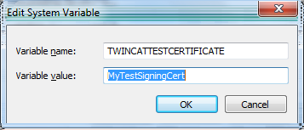

The system needs to be rebooted for the changes to take effect.

Setting up a new project for use with the Delta Robot
Start the TwinCAT3 XAE environment as mentioned in Ethernet Driver Setup. Select File, New Project.
Illustration 6: TwinCAT Project Settings
Make sure the project type shown above is selected and set whatever name/location you want. Click Ok.

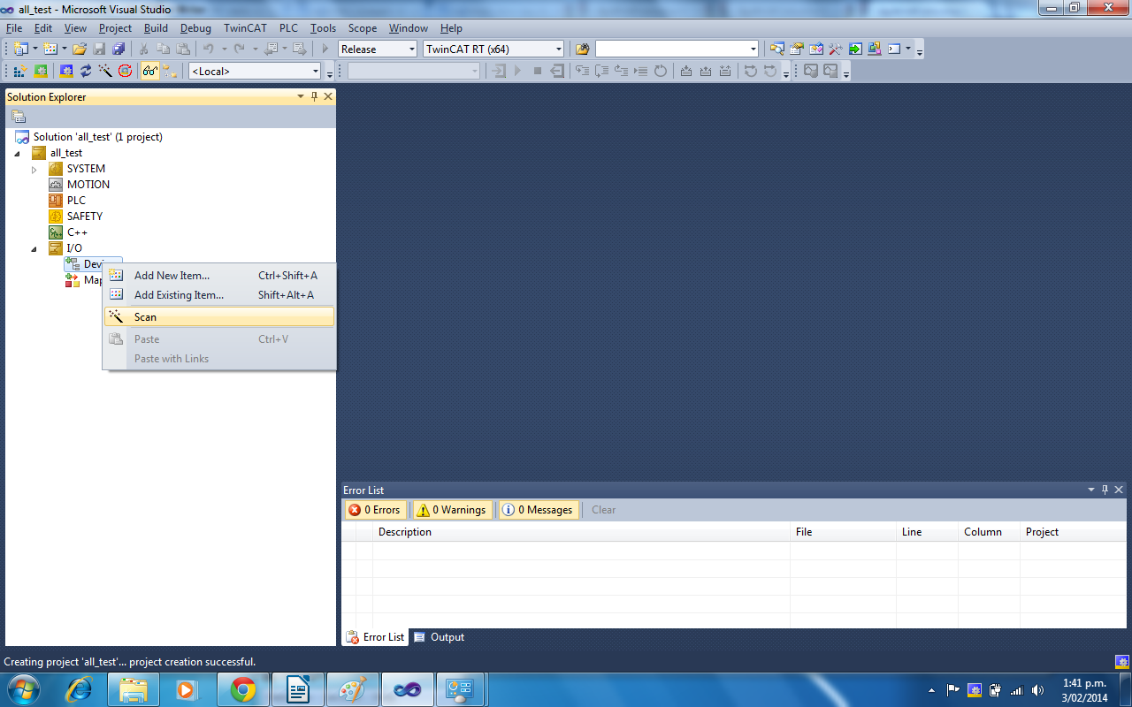
Expand I/O and write click Devices. Select Scan.
TwinCAT will inform you that not all devices can be found automatically. Click OK.
In some cases (I have not isolated the cause) TwinCAT will then inform you that no devices can be found. Restarting fixes this issue.
If this does not occur, you will be greeted with a window similar to the following:
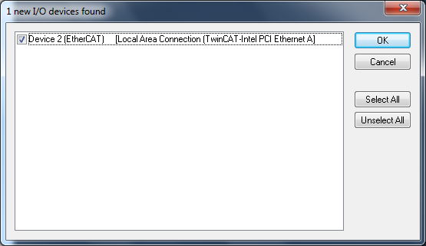
Ensure only devices you intend to use are checked, then click okay.
It will then asks to scan for boxes. I believe this means scan for ethercat slaves on the network.
The following then appears. Click Yes.
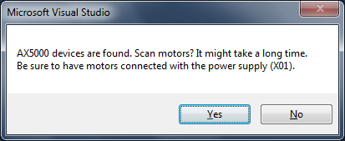

The software then says “EtherCAT drive(s) added. Append linked axis to NC-Configuration”. Click Yes.
Click yes to activate free run. (I believe this allows using the software built into TwinCAT to control the motors instead of our own software. This is good for testing the systems works correctly. It can be disabled from File/Edit/Etc Toolbar, TwinCAT, Toggle Free Run State.

AX5000 Setup
Double Click the AX5103 drive that should now be shown as a device under the EtherCAT device. In the main window select Configuration.

In the configuration window, expand Channel A, Parameter. Click Motor and Feedback.
Click the image of the Servo Drive.

Select the AM3031-0E00-0000 drive.
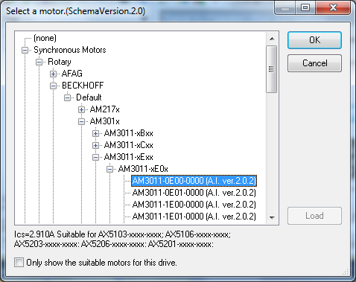

A power configuration window then appears. Ensure the power settings are set as follows:
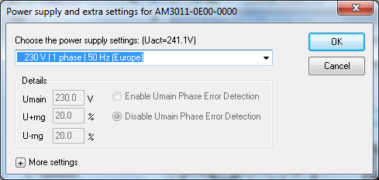

Click ok to “Set Nc-Scaling and some Nc-parameters now?”.

Repeat this for the AX5203 drive. The AX5203 drive drives two motors. Make sure the motor and power is selected both the channel A and Channel B drives.

On the File/Edit/Etc toolbar, select TwinCAT, Activate Configuration. Click Okay to activate it (overwriting old settings). Then click okay to enter run mode.

Testing the AX5000
Once in run mode, two new tabs show up for each drive channel. NC: Online and NC: Functions.
These tabs can be used to drive the motors. We will use the respective NC: Online tab to drive each motor.
First press the Blue Reset button labelled F8. Then press the Set button. In the pop-up window click all then okay.
Now click the green go button. If an error appears in the status window at the bottom, read it, and then adjust whichever parameter it says has an error so that it does not. Then click go again.
After any errors have been sorted, you can then click the F(1-4) buttons to move the motor.
