Intro
This file describes how to set up a new c++ project. This is probably not what you want to do but it will help you to understand how my existing c++ project is set up and how it can be modified. When reading this document you may find it useful to refer to my existing project as well as refer to the beckhoff documentation on this subject. It can be found here: http://infosys.beckhoff.com/english.php?content=../content/1033/tcinfosys3/html/startpage.htm&id=

Existing Configuration
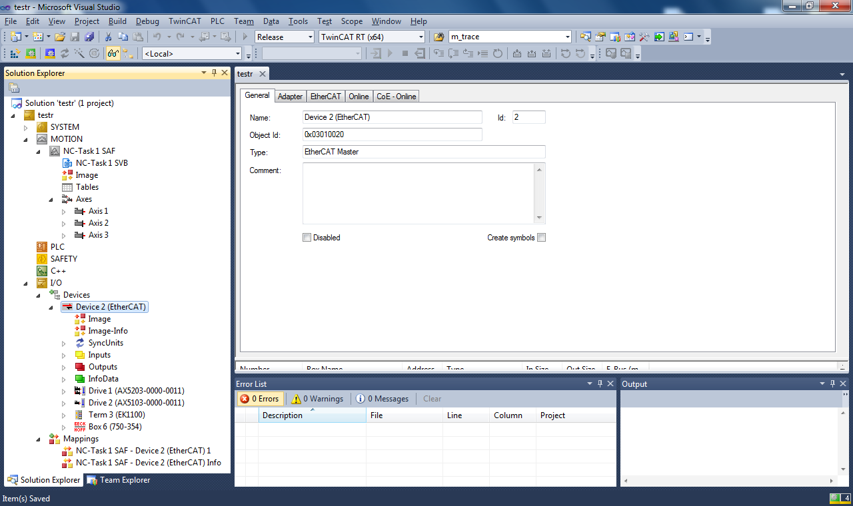
As of starting this your system should be configured. It should look somewhat like this. If it does not please follow the TwinCAT3Setup document.

New C++ Project
To add a new c++ project click. Right click c++ in the solution explorer. Click add new item. To start with, you probably want a TwinCAT3 Driver Project. This is a 'standalone application'. If instead you want to access TwinCAT3 devices from another application you'll want to choose the second option.

Give the project a name and click add. This brings up the following window.
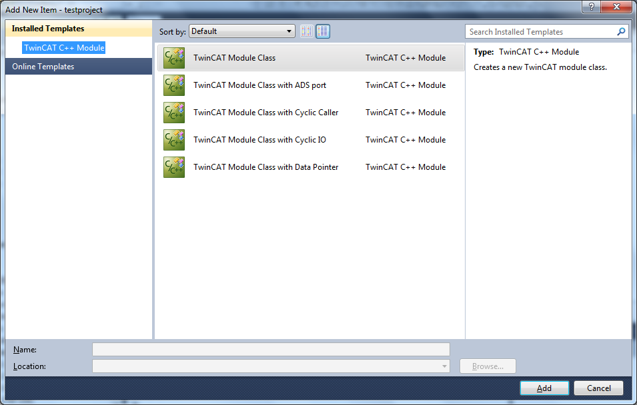
With this I've been using “TwinCAT Module Class with Cyclic IO”. Once you've selected the one you want Click Add.

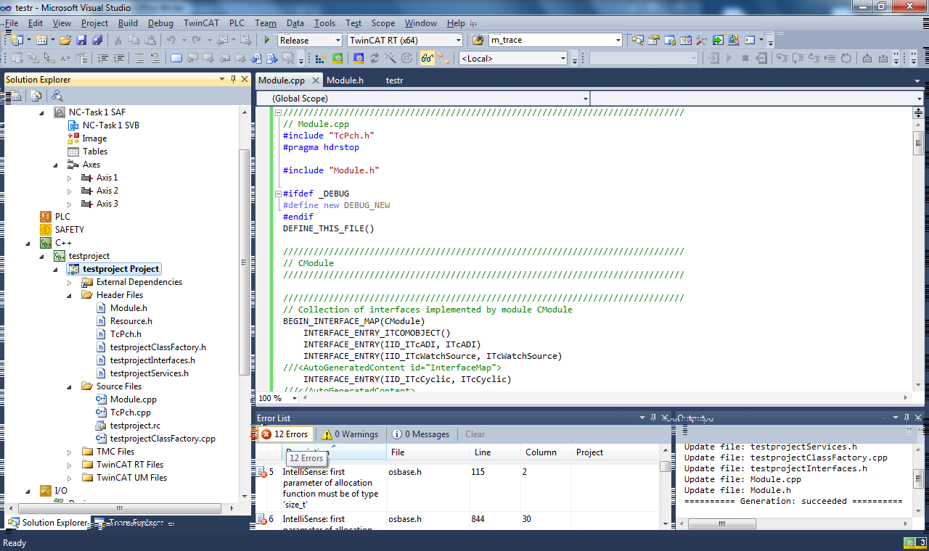
On clicking the final accept, your Visual Studio window will change to:

File Descriptions
Module.cpp is a standard c++ class. Most of this module you will not need to modify.
In this module there are the following methods:

HRESULT CModule::SetObjStatePS(PTComInitDataHdr pInitData)
This method can be modified to add any additional configuration necessary to bring any slaves from PREOP to SAFEOP. The slaves I am currently using(check system diagram) do not require any setup here.

HRESULT Cmodule::SetObjStateSO()
Once the function AddModuleToCaller has been called from this function the cyclic function will be called (cyclically). This function will not necessarily have finished executing. Make sure anything you add to this that needs to be ready for cyclic execution is ready before this call.
This function should be used to add any configuration necessary to move from SAFEOP to OP. The slaves I am currently using(check system diagram) do not require any setup here.

// State transition from OP to SAFEOP

HRESULT Cmodule::SetObjStateOS()
Any configuration needed to safely bring the device from OP to SAFEOP should be added to this function.

// State transition from SAFEOP to PREOP

HRESULT Cmodule::SetObjStateSP()
Any configuration needed to safely bring the device from SAFEOP to PREOP should be added to this function.

HRESULT CModule::CycleUpdate(ITcTask* ipTask, ITcUnknown* ipCaller, ULONG_PTR context)
This is where the main code (probably a state machine?) should be executed. My code uses a state machine.

Mapping Input/Output parameters
To map slave inputs/outputs into your c++ program you first need to create a data area and describe how it is laid out. Then you need to link slave variables to each part of the data area.

Creating data area
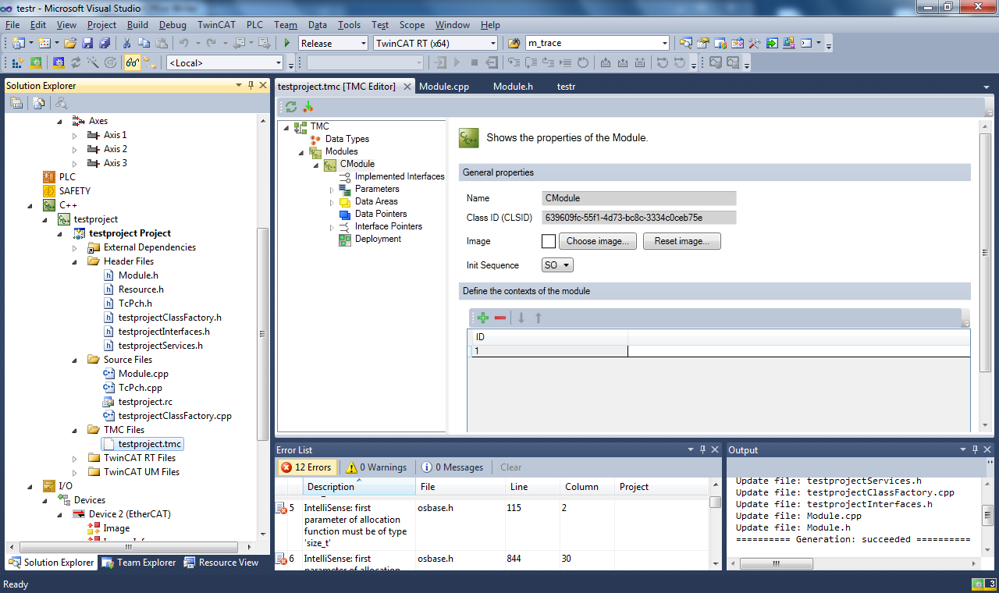
Double click the project TMC file. This file describes how the input and output data area's will be made up. The data area's are two separate consecutive blocks of memory. Your c++ program must expect the same memory layout as the one you create here. (More on that in a bit).
If you expand the data area's, Inputs. Then double click fields the following window will show.
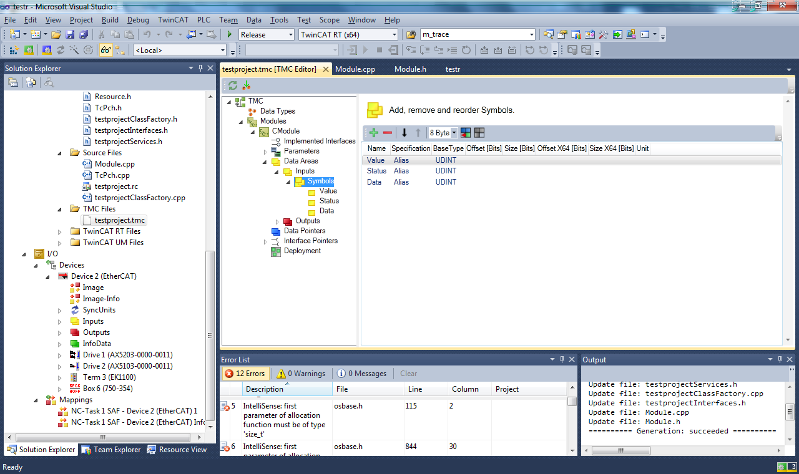
From this window you can set which variables on the ethercat slaves you want to map to the data area (anything you want to read or write needs to be mapped here). By default the project has 3 symbols. You'll want to remove these and then configure this as needed for your application.
For the WAGO 750-354 coupler connected to the 750-402, 750-671 and 750-504 you will want to map Tx and Rx PDO mapping terminals in their entirety. The other data fields may not be necessary unless you want to keep track of the coupler configuration. (Default configuration currently works for my purposes).

When mapping devices, I find it easiest to work out the size of the data area I need and then to create an array of BIT8 to represent it. This way you can create a structure in your c++ program, as long as the structure is the same size as the array you can simply interchange it. (this makes maintaining some horribly complicated structure in this window unnecessary).

Once you've mapped all the fields you want, you then need to 'create an instance' of your c++ module. This can be done by right clicking your c++ project and selecting add new item.
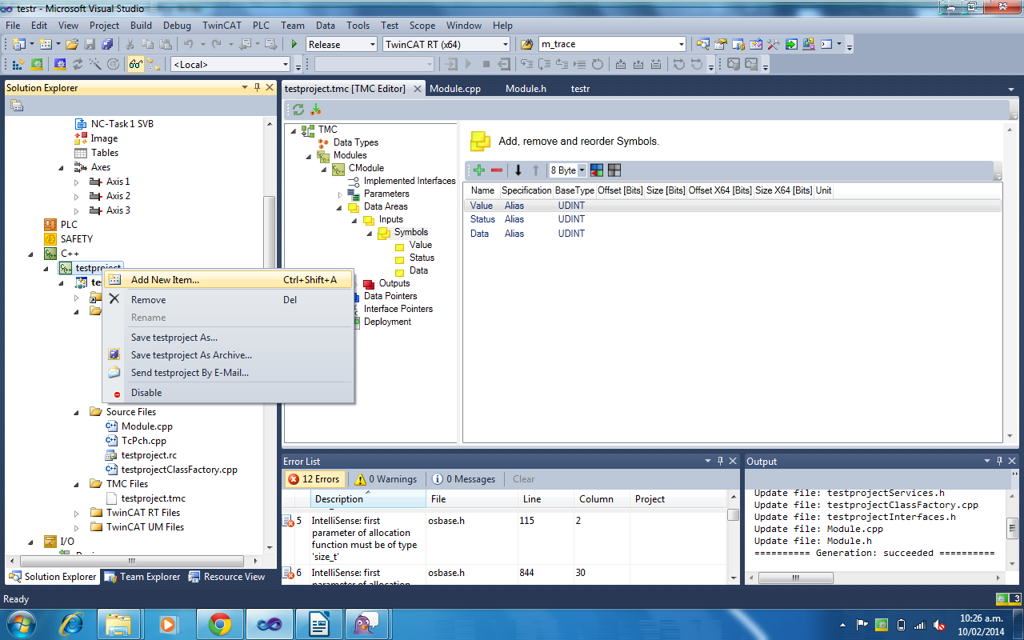
Expand the shown fields so you have the following selected:
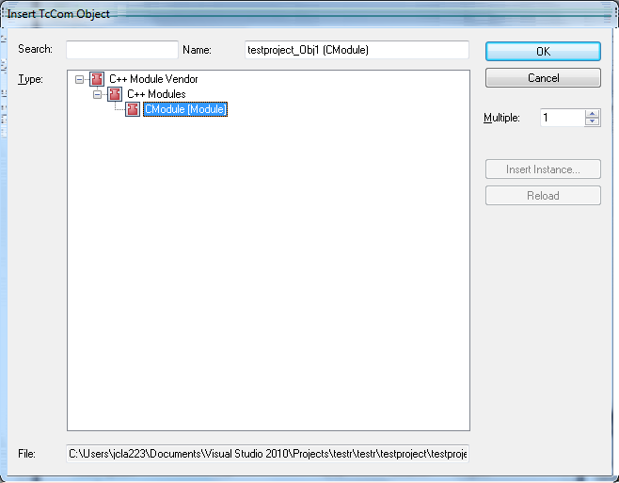
Then click OK.
This add the following to the project. If you expand the module in the solution explorer you can see your input and output data areas show as you described. If you need to modify the data area, you can update the module configuration by right clicking the (Cmodule) and selecting Tmi/Tmc file, Reload Tmi/Tmc File. You'll need to navigate to the TMC file which can be found in (Your projectdir)/(your project)/(your c++ project)/xxxx.tmc
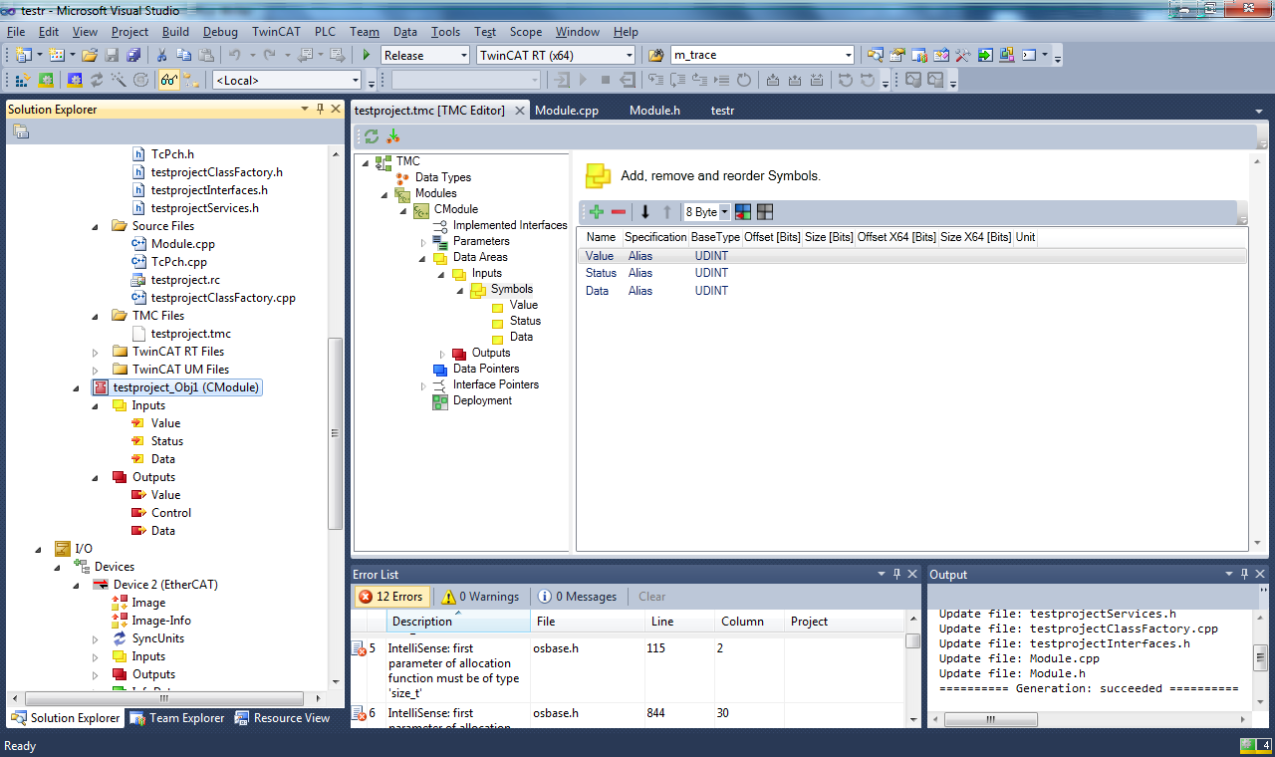

Linking slave variables to mapping
If you double click on each section name in your data area (see below image) you can use the link to button to link that area of the data area to a slave variable.
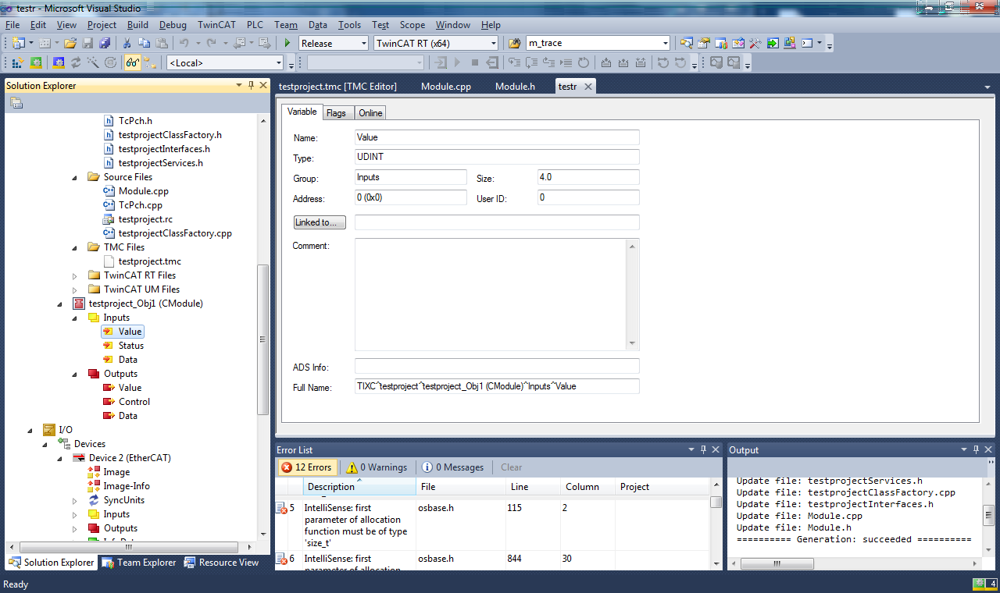
When you add things you can use array mode to add consecutive slave variables to a single section of the data area.
I found when linking in array mode that for the WAGO coupler, the devices all mapped backwards (ie the first byte was linked to the last byte) so I ended up mapping it byte by byte myself.

Adding a c++ task
For the cyclic code to be executed, the background ?service? Needs to know it will be executing a cyclic c++ task. To notify this, expand system in the solution explorer. Right click Tasks and select add new item.
Give it any name then click OK.
If you double click the newly added task, you can modify properties such as the rate the cyclic function is called.

Link c++ module to c++ task
In the solution explorer double click your c++ module. The following window will open.
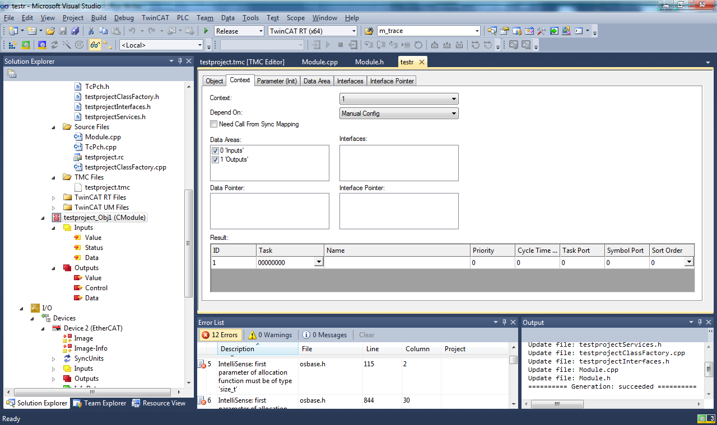
If you select the context tab you can then select the Task dropdown box. You need to set the value of this to the number that has your task name you just create beside it. (Click it).

Programming
Now that everything is set up, you can write your c++ code. In (projectname)Services.h you will need to modify the _ModuleInputs and _ModuleOutputs structures to match your data area. I think only the size of the structure actually needs to match (though I could be wrong). I have substituted the arrays in the Mappings i've created for struct types inside this structure. Ie:

typedef struct _Module1Inputs
{
struct wago_stepper_t wago_stepper_inputs0;
struct wago_stepper_t wago_stepper_inputs1;
struct wago_stepper_t wago_stepper_inputs2;

} Module1Inputs, *PModule1Inputs;

You can then access the values of these inputs and outputs via the m_Inputs and m_Outputs structures.

To run your program click the activate configuration button
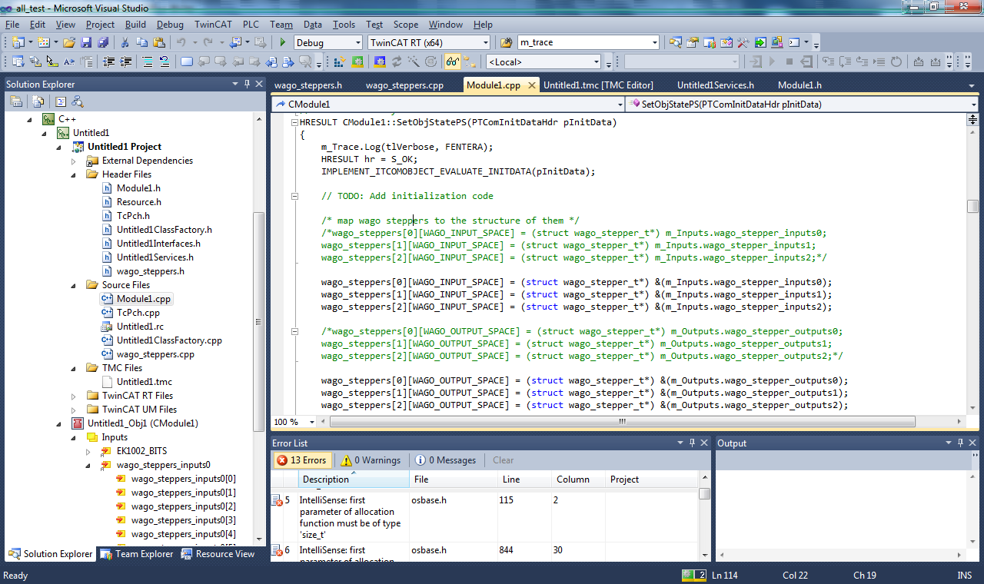
Once its done it will ask if you want to enter run mode. Click yes and your code will be exectuted.

