**Dynamical systems, ergodic theory**

**and applications**

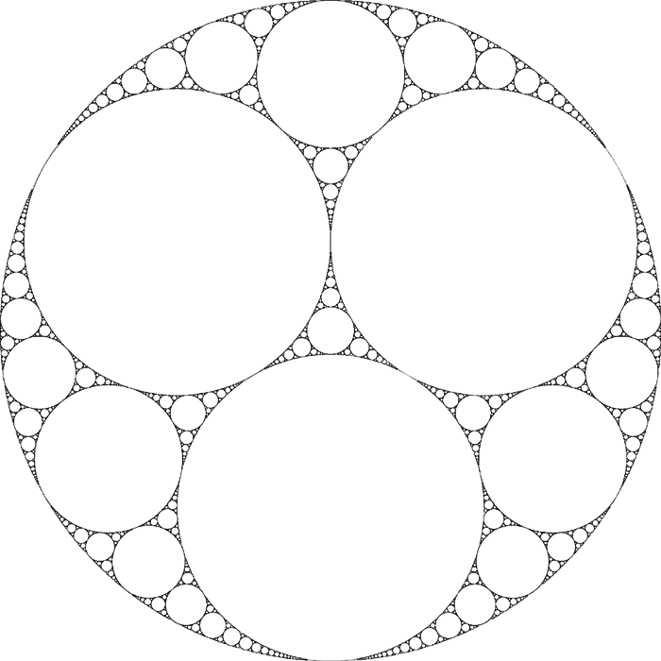Thursday 23rd June 2016 - Friday 24th June 2016

This is an *LMS Northern Regional Meeting*, generously funded by the London Mathematical Society. The meeting will take place in the Alan Turing Building of the University of Manchester. Society meeting on afternoon of 23rd.

Confirmed plenary speakers:

Julien Barral (Paris 13)

De-Jun Feng (Chinese University of Hong Kong)

Ian Melbourne (University of Warwick)

Sanju Velani (University of York)

For further information, contact me at:

jonathan.fraser@manchester.ac.uk

