Strong Uniform Distribution

As sequences is strongly uniformly distributed if for bounded measurable f we have
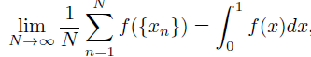

The study of S.U.D. begins with a 1923 question of A. Khinchin.
He asked whether it is the case that if for a set B contained in the unit interval of positive Lebesgue measure we always have

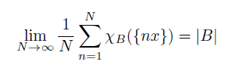

for almost all x with respect to Lebesgue measure. The answer is no as shown by J. M. Marstrand in a 1970 paper. In this talk I will discuss what questions are still current in this subject and what progress has been made. The talk will involve ideas from ergodic theory.

