|  |  |
| --- | --- |
| **ESG Test Java Application** | **Jonathan Campbell Jones**  **18th August 2024** |

**Introduction**

This Project demonstrates an API updating a database using the data posted to it.

It is a bare bones implementation to demonstrate functionality, and though some validation and error management is performed, this is not comprehensive,

**API**

Project located: <https://github.com/jonathan-hcj/ESGAPI>

The SQL Customer table that holds the customer records takes for following format:

|  |  |  |
| --- | --- | --- |
| Table Customer schema | | |
| CustomerRef | nvarchar(50) | NOT NULL – Primary Key |
| CustomerName | nvarchar(50) | NULL |
| AddressLine1 | nvarchar(50) | NULL |
| AddressLine2 | nvarchar(50) | NULL |
| Town | nvarchar(50) | NULL |
| County | nvarchar(50) | NULL |
| Country | nvarchar(50) | NULL |
| Postcode | nvarchar(20) | NULL |

**Post method**

*https://localhost:[port]/customer*

When adding records, a test is made against the CustomerRef if the reference already exists it will error with the message ‘Customer account already exists’, if no CustomerRef is suppled at all, the error ‘Customer has no reference specified’ is returned, and if the Insert fails for any other reason, the post method returns the error ‘Customer record could not be inserted’.

**Get method**

*https://localhost:[port]/customer?reference=[CustomerReference]*

Searches the database Customer table for a record with the CustomerRef matching the parameter supplied in the call to the method. If the Customer ref does not exist in the table a NotFound response is issued, if it is, then a customer object is populated and returned.

**Setup**

Download the ESGAPI project from git and open solution (*ESGAPI.sln*) in Visual Studio 2022.

From the project folder ‘Files’ restore ‘ESG.bak’ using MSSQL Management studio, this will create the database in which the customer records are stored. The customer table is empty in this backup. Create a user API1 and set the password to ‘Blat’. Ensure that the user has both read and write access to the database.

Set the connection details in the connection string builder as appropriate for your database instance (in file CustomerController.cs):

private readonly SqlConnectionStringBuilder builder = new()

{

DataSource = "JONATHANS_LT\\SQLEXPRESS",

UserID = "API1",

Password = "Blat",

InitialCatalog = "ESG",

TrustServerCertificate = true

};

Run the project. When it starts, a swagger screen will open, this has standard swagger functionality, you may add customers via the post method and recover customers information via the get method.

**Java Console App**

Projects located <https://github.com/jonathan-hcj/ESG-Gradle>

For us to know that the updates have been performed I have added a call to get call to the API to recover a single record. If this works you will see the line ‘Customer 012254 recovered’

**Setup**

Download the ESG-Gradle project and open it in Visual Studio Code.

Place the customers.csv file in a folder located on your C drive in a folder called ESG.

In the main function of the App.java file set the variable baseURL to the server running the API.

Run the project.

**Notes**

The app uses two libraries:

**gson** provides Json support for serialising and deserializing objects

**opencsv** provides support for opening the customer CSV from file, this library is a reliable implementation that allows you to wrap field that contains a field separator with quotes.

For simplicity, the https connection will not check certificates, this is not suitable for a production release.

**Expected results**

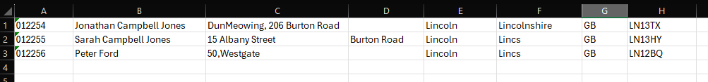

Terminal output

c:\Projects\ESG Gradle> c: && cd "c:\Projects\ESG Gradle" && cmd /C "C:\Users\jonat\.gradle\jdks\eclipse_adoptium-21-amd64-windows\jdk-21.0.4+7\bin\java.exe @C:\Users\jonat\AppData\Local\Temp\cp_4bz0ivw9t490ai37miyos50qa.argfile esg.gradle.App "

Customer 012254 created

Customer 012255 created

Customer 012256 created

Customer 012254 recovered

Looking back at management studio you will see the records have been inserted, the final line of the output shows that the app was able to recover a customer record from the API.

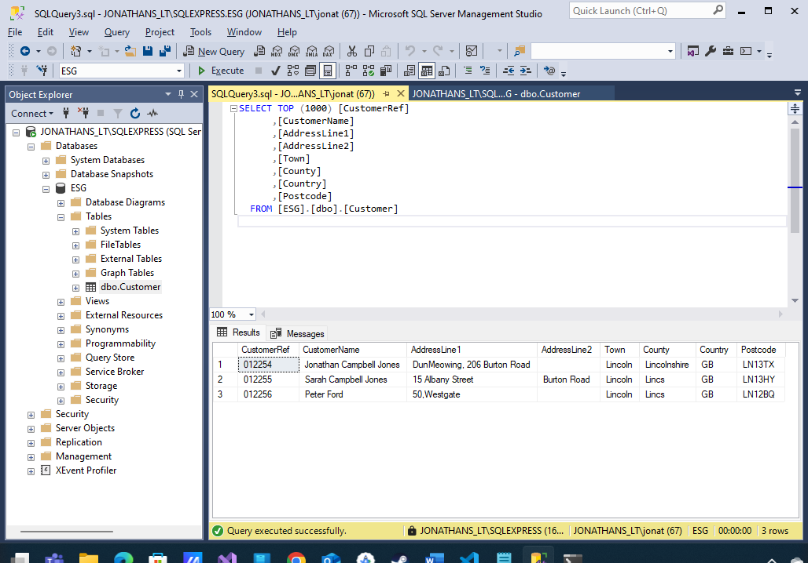

**Error handling**

A file has been included in the project to demonstrate basic error handling: Customers.error.csv. Clear the data table in MSSQL Manager studio and replace the records in the customer.csv file with this data in this file.

The system will skip blank lines, however if a record is found, then validation occurs to ensure that the record is both 8 fields long and a CustomerRef is present. If any single record is malformed as described, the app will not post any records to the API.

Terminal output

um-21-amd64-windows\jdk-21.0.4+7\bin\java.exe -agentlib:jdwp=transport=dt_socket,server=n,suspend=y,address=localhost:57670 @C:\Users\jonat\AppData\Local\Temp\cp_4bz0ivw9t490ai37miyos50qa.argfile esg.gradle.App "

Some customers were not valid in the csv:

Line 5: Customer reference missing

Line 6: 8 fields are required per customer

Unable to recover customer: response 404

**Authentication**

I have added code to manage basic authentication on the API to demonstrate how it might be implement, however I have disabled it in the development environment to simplify this demonstration.

See BasicAuthenticationHandler.cs.