Fully Formed Hoh-Whitton-Jarrahi-Groppi-Sinclair Algorithm

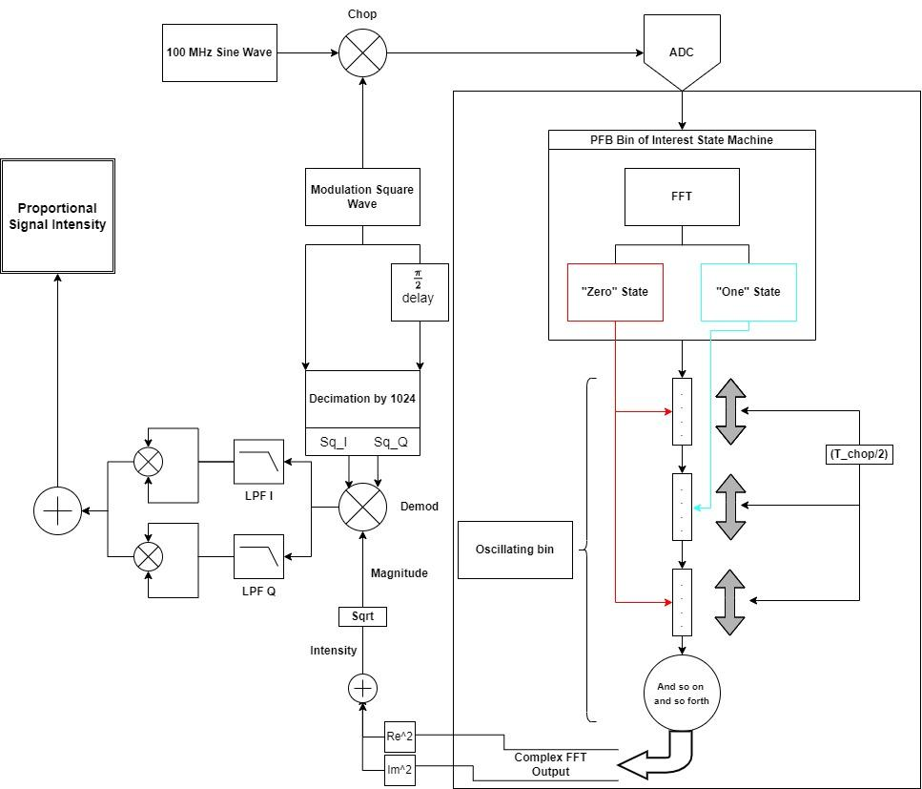

# Lock-in V3 (Newest)

### ***Noiseless 10 MHz signal chopped at 10 KHz at input***

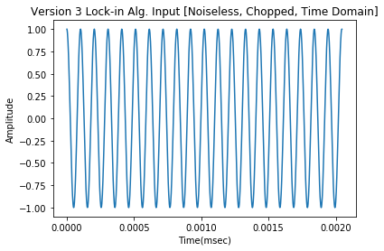

**Fig 1.1** Input Signal of 100 MHz for one FFT frame in time

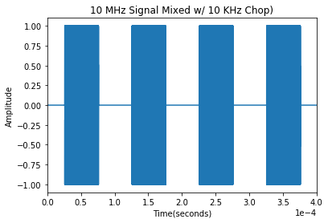

**Fig 1.2** Snapshot of signal entering FFT stage of algorithm

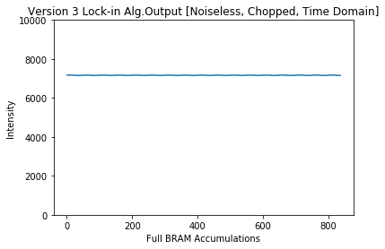

**Fig 1.3** Proportional Intensity seen at output of firmware module

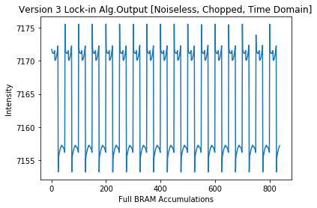

**Fig 1.4** Zoomed In view of BRAM accumulations over 50 seconds

* 1. **Integrated Output Intensity: 5996232.071702398**
  2. **Avg. output intensity: 7163.95707491326**

### ***Noisy, π/6 phase-shifted, 10 MHz signal chopped at 10 KHz at input***

**Fig 2.1** 100 MHz input signal with white and pink noise

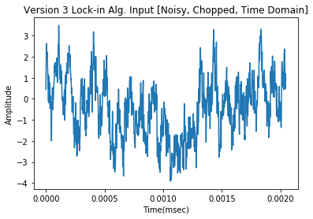

**Fig 2.2** Snapshot of signal entering FFT stage of algorithm

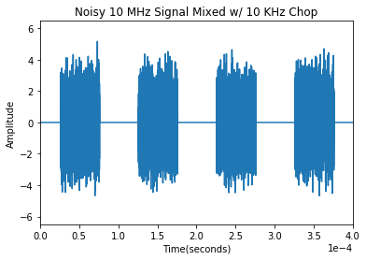

**Fig 2.3** Proportional Intensity seen at output of firmware module

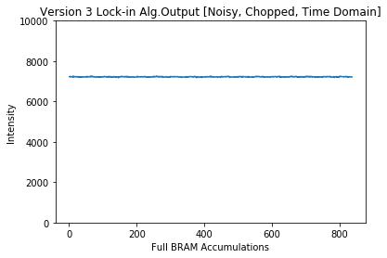

**Fig 2.4** Zoomed In view of BRAM accumulations over 50 seconds

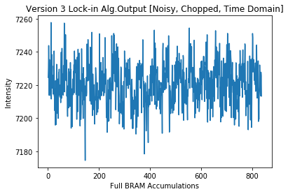

* 1. **Integrated Output Intensity:**6043756.087339907
  2. **Avg. output intensity:** 7220.736066116973

### Noiseless 10 MHz signal with no chop at input

* 1. Since this module is not chopped at the input, the FFT receives the same signal as the ADC

**Fig 3.1** Input Signal of 100 MHz for one FFT frame in time

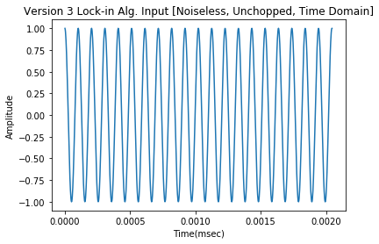

**Fig 3.2** Proportional Intensity seen at output of firmware module

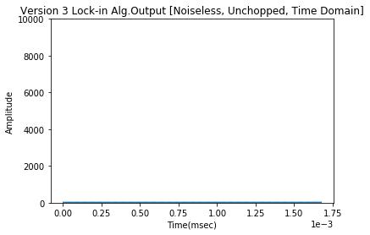

**Fig 3.3** Zoomed proportional Intensity seen at output of firmware module

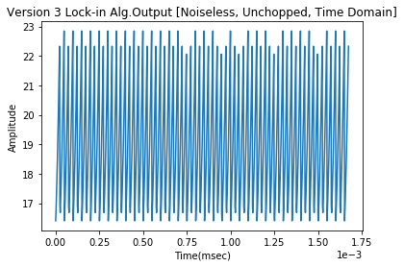

* 1. **Integrated Output Intensity:** 15958.799789610439
  2. **Avg. output intensity**: 19.066666415305185
  3. I expect that with a better LPF, the remaining intensity at the output of the unchopped simulation would be suppressed even further. This is important as this noise will be present, non-linear, and impossible to remove after the filtering stage
     1. Looking at the Real and Imaginary components that make up the output intensity, it is apparent that the low pass filters still leave small traces of the demodulation clock signal
     2. Interesting to note how the spikes in the data do seem to be 90 degrees out of phase with one another

**Fig 3.6.2** Real (above) and imaginary (below) portions of the filtered output from the demodulation mixer for an unchopped signal. The figures on the right are zoomed in versions of those on the left.

