DESIGN AND IMPLEMENTATION OF A SMART TRAFFIC MANAGEMENT SYSTEM USING COMPUTER VISION
Ngonadi I.V., Ikpen E. J.
Department of Computer Science, Petroleum Training Institute, Effurun, Delta State, Nigeria
September, 2025
ABSTRACT
Urban traffic congestion has become a serious problem worldwide, leading to increased travel delays and environmental pollution. This paper presents the design and implementation of a smart traffic management system that employs computer vision to detect and classify vehicles using a YOLO-based model. The system dynamically adjusts traffic signal durations based on real-time traffic density through a weighted adaptive timing algorithm. A simulation demonstrates adaptive control at a four-way intersection, and a user-friendly GUI allows detection from both images and videos. Results show improved efficiency over fixed-timing systems, offering a cost-effective solution for smart urban mobility.
Keywords: Computer Vision, Adaptive Signal Timing, YOLO, Vehicle Detection, Traffic Simulation, Smart Traffic Management

- INTRODUCTION
The exponential growth of urban populations and vehicular ownership has intensified traffic congestion in major cities worldwide. Traditional traffic management systems rely on fixed-timing schedules that cannot adapt to changing road conditions, leading to delays, fuel wastage, and increased air pollution (Schrank et al., 2021). As the number of vehicles continues to rise, the limitations of fixed-time control systems become increasingly evident, particularly during peak hours and emergencies where flexibility is essential (Jiang & He, 2019).
Recent technological advancements in artificial intelligence (AI), particularly computer vision and machine learning, have made it possible to develop adaptive traffic systems capable of responding dynamically to current traffic flow. Computer vision allows traffic systems to process real-time video feeds, detect vehicles, and estimate density levels (Kumar & Kumar, 2020). Integrating such capabilities into traffic control can enhance road efficiency, reduce average waiting time, and improve safety (Olaru & Mohor, 2018).
This study presents the design and implementation of a smart traffic management system that leverages computer vision for adaptive signal control. The system detects and counts vehicles in real time, applies a weighted adaptive green signal timing algorithm, and visualizes signal behavior using a simulation. Additionally, a graphical user interface (GUI) was designed for vehicle detection from images and videos, offering practical control options for users. The main goal is to create a functional prototype that demonstrates how AI-based automation can enhance existing urban traffic control systems, contributing to the development of sustainable smart cities.
- RELATED WORK
Traffic control systems have evolved from simple fixed-timing mechanisms to advanced adaptive models capable of responding to live traffic data. Early approaches used inductive loops and infrared sensors to estimate vehicle density (Zhang et al., 2011). Although effective to some extent, such systems are costly to install and maintain, and they lack the flexibility offered by camera-based solutions.
In recent years, computer vision and deep learning have transformed the way traffic systems perceive road environments. The introduction of the YOLO (You Only Look Once) algorithm by Redmon et al. (2016) marked a major advancement in real-time object detection, enabling accurate and efficient vehicle recognition in video streams. Several studies have applied YOLO and similar models to monitor traffic density, detect rule violations, and optimize signal timing (Djahel et al., 2015).
Abdoos, Mozayani, and Bazzan (2014) proposed a reinforcement-learning-based adaptive traffic controller that adjusts signal durations according to environmental feedback. However, such methods often require extensive training and large datasets. Conversely, rule-based adaptive systems using computer vision are simpler and more explainable, making them suitable for deployment in developing regions (Goodfellow et al., 2016).
This project adopts a hybrid approach: integrating real-time detection using YOLO with a mathematically defined adaptive timing algorithm. The system provides a transparent and easily tunable model that offers a balance between accuracy, computational efficiency, and practical deployability, filling a gap between sensor-based and AI-driven adaptive systems.
- METHODOLOGY
3.1 Research Approach and Design
A structured engineering methodology (Waterfall-like, staged design) guided the work: requirements elicitation, design, module implementation, integration, testing, and evaluation. The project divided functionality into discrete modules: (1) vehicle detection and classification, (2) tracking and counting, (3) adaptive timing calculation, (4) simulation visualization, and (5) operator GUI. Modular design promoted independent testing and easier extension.
3.2 Data Preparation and Annotation
Training and tuning leveraged public-domain traffic images and locally collected snapshots representing top-down and oblique junction views. Manual annotation using LabelIMG produced bounding boxes for the vehicle classes used in the system: car, bike (motorcycle), bus/truck (heavy vehicles), and rickshaw/three-wheeler. For testing, recorded traffic videos and a curated set of images were reserved to evaluate detection and counting robustness across realistic scenarios.
3.3 Detection and Tracking Pipeline
The detection pipeline uses a YOLO-family detector configured via the Darkflow/YOLO codebase. Detected bounding boxes yield class labels and confidence scores. To convert per-frame detections into unique counts, a tracking component (SimpleTracker-like) assigns persistent IDs across frames using centroid/IoU matching and parameterized thresholds (max missed frames, distance tolerance). This prevents double counting and produces per-lane cumulative counts that drive the adaptive controller.
3.4 Adaptive Timing Formula and Rationale
A central contribution is the adaptive green-signal timing (GST) computation. The system computes GST for a lane using a weighted-sum formula:
$$GST=\frac{∑Ni​×Ti}{L}​​$$
where $Ni$ is the number of detected vehicles of class (i) in the target lane, $Ti$ is the average crossing time (seconds) for class $i$, and $L$ is the number of lanes (or an appropriate lane-scaling factor for the intersection geometry). To ensure practicality, GST is clamped with minimum and maximum bounds:
$$GST=max(GSTmin​,min(GST,GSTmax​))$$
This formula is intentionally transparent, allowing operators and engineers to reason about the contribution of vehicle mix and counts to green time. The $Ti$ constants are estimated from literature and field observation (e.g., heavier vehicles take longer) and can be tuned in the GUI. The division by $L$ normalizes time when multiple lanes share the phase; other normalizations or lane-specific modifications are straightforward to add if the intersection is asymmetric.
3.5 Implementation Overview
Implementation used Python 3.8+, OpenCV for image/video handling, Darkflow (YOLO) for detection, a custom SimpleTracker for ID persistence, Pygame for simulation visuals, and Tkinter/PyQt-style GUI elements. The codebase is modular: detection, tracking, timing, and simulation are separate modules, allowing independent debugging and future replacement (e.g., swapping YOLOv3 for a newer detector).
3.6 System Flowchart
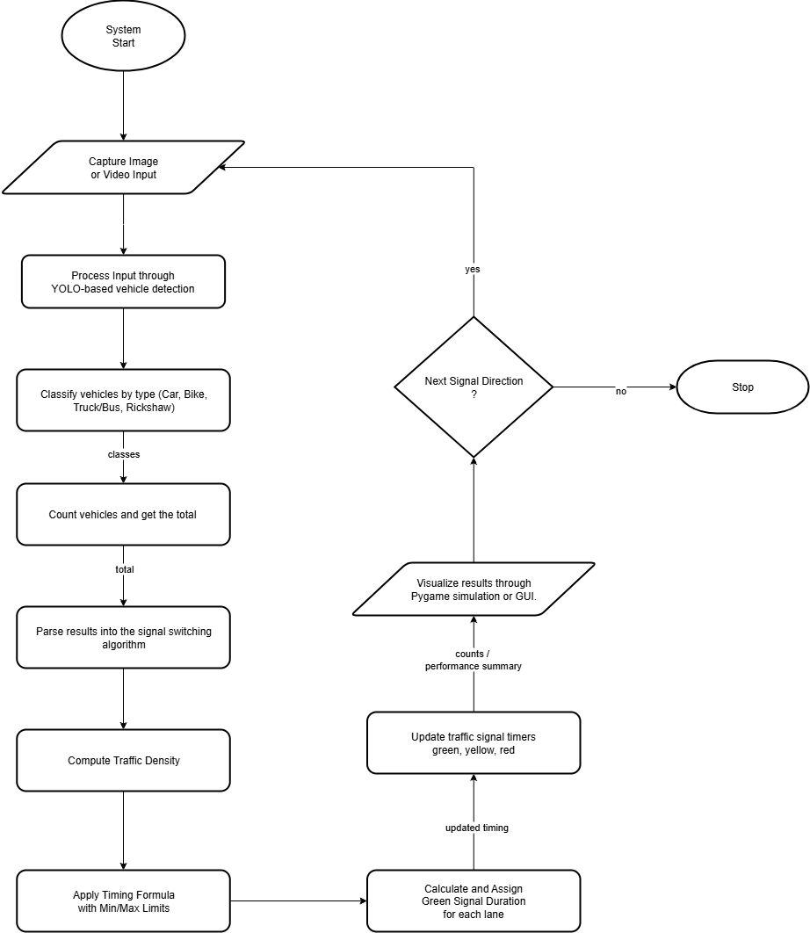
Figure 1: Flowchart of the Smart Traffic Management System
- SYSTEM DESIGN AND IMPLEMENTATION
4.1 System Architecture
The system follows an input–process–output flow: image/video input → YOLO detection → tracker-based counting → GST computation → actuation/visualization. The GUI and simulation are user-facing components: the GUI handles parameter tuning and detection runs; the simulation shows how signals would behave in a four-way junction.
4.2 Modules Description
- Vehicle Detection Module: A YOLO detector outputs class labels and bounding boxes. Confidence and IoU thresholds are configurable to manage false positives/negatives.
- Tracker Module: Matches detections across frames to maintain object identities and produce unique counts, using centroid or IoU-based association and configurable “max missing” frames.
- Adaptive Controller: Implements the GST formula above, clamps results, and sequences signal phases (green → yellow → red) with preemption logic for minimum phase times.
- Simulation Module: A Pygame-based renderer animates vehicles and signals to visualize traffic flow and validate controller behavior offline.
- Detector GUI: A user interface that loads images/videos, runs detection, displays bounding boxes, shows FPS, per-class counts, cumulative totals, and exposes tuning sliders/inputs for thresholds and tracker parameters.
4.3 Processing and System Modules Design (Key Equations & Parameters)
As specified in the GST formula, the key parameters are vehicle class counts $Ni$, crossing times $Ti$, lane count $L$, and bounds $GSTmin,GSTmax$. The GUI exposes these parameters so that operators can adapt the system to local traffic characteristics. For instance, typical $Ti​$ values might be: car = 2s, bike = 1.5s, bus/truck = 5s, rickshaw = 2.5s — these are tunable and used to compute the weighted sum.
4.4 User Interface and Controls
The GUI includes controls for: loading inputs, starting/stopping detection, confidence and IoU threshold sliders, frame-skip to trade speed vs. accuracy, tracker toggles (on/off), tracker parameters (max missed frames), and options to export summaries (text files containing timestamped counts and computed GSTs). Real-time FPS and per-class counts are displayed to allow operators to tune parameters for their hardware.
4.5 Testing and Validation Strategy
Unit tests validated detection and tracking on annotated images. Integration tests checked that counts feed into GST correctly and that the simulation visualizes the resulting phase durations. Performance tests measured FPS on a CPU-only environment and on a CUDA-enabled GPU. Sensitivity experiments showed how GST responds as lane densities change and quantified simulation metrics (e.g., average vehicle wait time) against baseline fixed-time control.
- RESULTS AND DISCUSSION
Testing of the system showed high detection accuracy for cars and buses under normal lighting and moderate occlusion. The adaptive algorithm dynamically adjusted signal durations in proportion to the number of vehicles detected per lane. For example, lanes with more vehicles received proportionally longer green times, reducing total idle time and improving traffic throughput.
The GUI proved highly effective for users with minimal technical experience, allowing them to run detection and monitor system performance easily. The simulation demonstrated a clear improvement over fixed-timing systems, where unnecessary waiting occurred even in empty lanes.
The performance evaluation indicated that while the system runs efficiently on standard computing devices, GPU acceleration enhances real-time performance. The simplicity of the adaptive timing model also ensures interpretability and stability—key requirements for early-stage deployment in developing cities.
These results align with previous research that emphasizes the role of AI-driven adaptive systems in improving intersection efficiency and reducing congestion (Abdoos et al., 2014; Djahel et al., 2015)
5.1 User Interface and Output Result
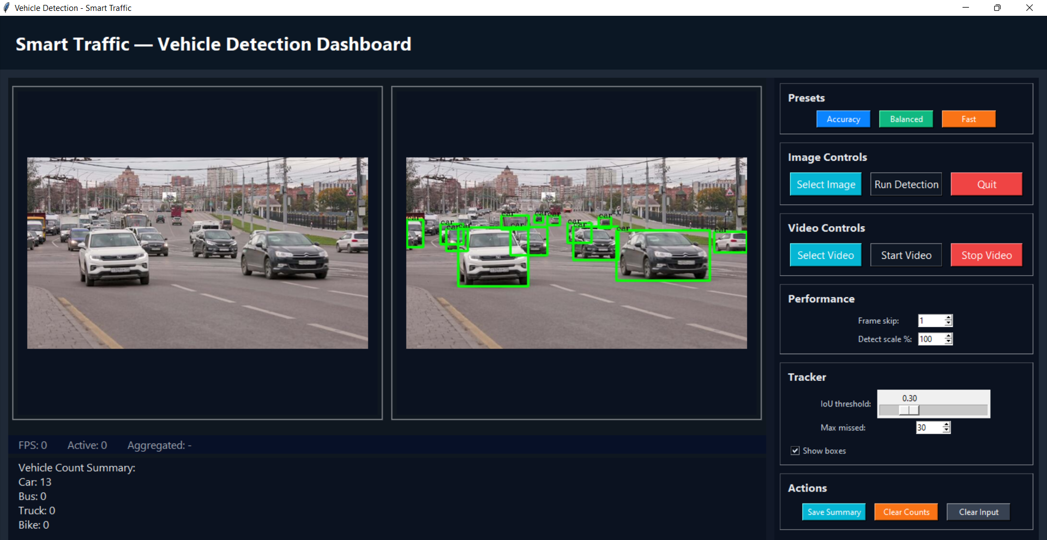
Figure 2: Real-time Vehicle Detection Dashboard
The Real-time Vehicle Detection Dashboard interface allows users to browse and load image or video files. Detection results are shown on the display, with bounding boxes around vehicles, and real-time counts of detected objects. On the side panel, controls are available to modify detection thresholds, enable or disable tracking, and view FPS statistics.
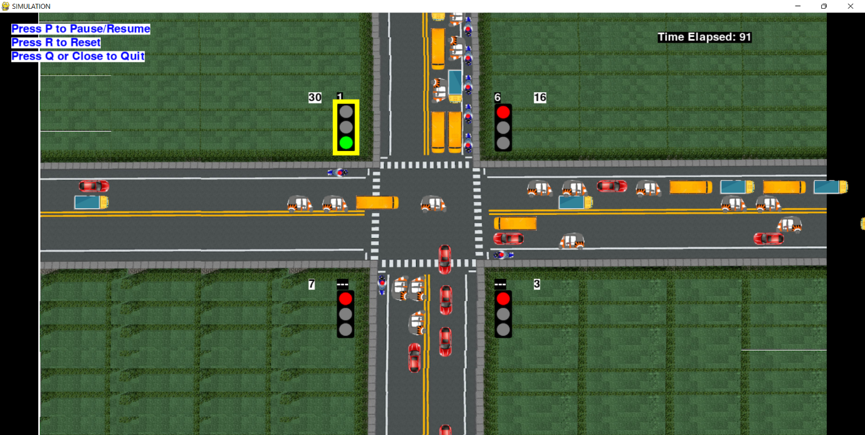
Figure 3: Simulation of Traffic System
The simulation interface depicts a four-way intersection with vehicles moving in each direction. Traffic lights above each lane display the current state (red, yellow, or green) along with the timer countdown. The number of vehicles that have crossed each signal is shown on screen, and traffic flow adapts dynamically based on signal timings calculated from the detection module.
Together, these interfaces make the system accessible and practical for demonstration.
- CONCLUSION AND FUTURE WORK
This research successfully demonstrated the design and implementation of a smart traffic management system using computer vision. The system detects and classifies vehicles, computes adaptive signal durations, and visualizes intersection behavior through simulation. It provides a scalable and low-cost solution suitable for developing cities aiming to reduce congestion and optimize road usage.
Future work will focus on integrating live camera feeds for real-time operations, deploying the system on embedded edge devices such as Raspberry Pi, and incorporating more complex scenarios such as pedestrian detection and emergency vehicle prioritization. Additionally, real-world testing at actual intersections will be explored to evaluate system robustness under varying weather and lighting conditions.
also extended to peers who annotated datasets and provided test video material used for evaluation.
- REFERENCES
- Abdoos, M., Mozayani, N., & Bazzan, A. L. C. (2014). Traffic light control in non-stationary environments based on multi-agent Q-learning. Transportation Research Part C: Emerging Technologies, 44, 1–21.
- Djahel, S., Salehie, M., Tal, I., & Jamshidi, S. (2015). A communications-oriented perspective on traffic management systems for smart cities: Challenges and innovative approaches. IEEE Communications Surveys & Tutorials, 17(1), 125–151.
- Goodfellow, I., Bengio, Y., & Courville, A. (2016). Deep Learning. MIT Press.
- Jiang, H., & He, Z. (2019). Urban road traffic signal optimization based on real-time vehicle data. Journal of Intelligent Transportation Systems, 23(4), 301–313.
- Kumar, P., & Kumar, A. (2020). Real-time traffic density estimation using computer vision. International Journal of Advanced Computer Science and Applications, 11(5), 45–52.
- Olaru, V., & Mohor, A. (2018). Intelligent traffic management systems: A review of technologies and trends. Procedia Computer Science, 141, 366–373.
- Redmon, J., Divvala, S., Girshick, R., & Farhadi, A. (2016). You Only Look Once: Unified, real-time object detection. Proceedings of the IEEE Conference on Computer Vision and Pattern Recognition (CVPR), 779–788.
- Schrank, D., Eisele, B., & Lomax, T. (2021). Urban Mobility Report 2021. Texas A&M Transportation Institute.
- Zhang, Y., Xie, Y., Lu, J. J., & Wang, X. (2011). Development and evaluation of an adaptive signal control system for arterial corridors. Transportation Research Record, 2259(1), 34–44.

