MEDICAL KNOWLEDGE-BASED EXPERT SYSTEM FOR THE DIAGNOSIS AND TREATMENT OF LUNG INFECTIONS
Ikpen E. J., Ajokpeoghene O. O., Orugbo G. S., Owagbemi B. F., Itedjere T., Gabriel S. O., Nwankwo C. U.
Department of Computer Science, Petroleum Training Institute, Effurun, Delta State, Nigeria
September 2025

ABSTRACT
Lung infections such as pneumonia, tuberculosis, and viral respiratory illnesses remain leading causes of illness and death worldwide. In low-resource settings, diagnosis is often delayed due to limited medical expertise and equipment. This paper presents a Medical Knowledge-Based Expert System designed to assist in early diagnosis of lung infections. Developed using Python Flask with rule-based reasoning, the system features interactive interview and chatbot modes that evaluate user-reported symptoms to suggest possible conditions and treatment advice. Results show accurate differentiation of pneumonia, tuberculosis, bronchitis, and viral infections, demonstrating the potential of artificial intelligence in improving healthcare accessibility.
Keywords: Expert System, Artificial Intelligence, Knowledge Base, Lung Infections, Diagnosis, Flask Framework, Python Programming, Medical Decision Support

1. INTRODUCTION
Medical diagnosis is a complex process that requires the integration of clinical knowledge, patient history, and diagnostic tests. In developing regions, the scarcity of trained healthcare professionals often leads to delays or inaccuracies in diagnosis. The increasing prevalence of respiratory illnesses such as pneumonia, tuberculosis, and viral infections has intensified the need for intelligent diagnostic aids. These infections collectively contribute to millions of deaths annually, according to the World Health Organization (WHO, 2023).
Expert systems—computer programs designed to emulate the decision-making ability of human experts—have proven valuable in clinical applications by providing consistent, evidence-based reasoning. By employing a structured set of rules, such systems can infer diagnoses from user-provided symptoms, improving both accuracy and accessibility.
Artificial Intelligence (AI) has become a vital component of modern healthcare, providing computational tools for data-driven diagnosis, prognosis, and treatment planning. Expert systems—computer programs designed to emulate the reasoning process of human experts—are particularly effective in diagnostic support (Buchanan & Shortliffe, 1984). By employing structured sets of rules, these systems can infer possible diagnoses from user-provided symptoms, thus improving both the consistency and accessibility of diagnostic reasoning.
This study, therefore, focuses on the development of a Medical Knowledge-Based Expert System for Lung Infection Diagnosis, which leverages rule-based reasoning to provide a reliable and explainable diagnostic process. The system’s strength lies in its dual interaction design: the Interview Mode guides the user through sequential medical questions, while the Chatbot Mode supports conversational symptom reporting similar to modern AI symptom checkers such as Symptomate or Ada Health (Symptomate, 2025).
The system’s primary goal is to serve educational and triage purposes, providing early diagnostic guidance and helping users decide when to seek medical care.

2. RELATED WORKS
Artificial intelligence (AI) applications in medicine have evolved substantially over the past decades. The earliest medical expert systems, such as MYCIN (developed in the 1970s), demonstrated the ability of rule-based inference to assist in diagnosing bacterial infections and recommending treatments. MYCIN’s success inspired the development of various systems across different domains of medicine.
Several contemporary systems, such as Symptomate, Ada Health, and Infermedica, have integrated AI and probabilistic reasoning to evaluate symptoms entered by users. However, these systems often rely on large-scale datasets and black-box machine learning algorithms that limit interpretability. In contrast, rule-based expert systems remain explainable—they can show the reasoning behind conclusions through explicit IF–THEN relationships (Shortliffe, 2021).
Other related studies include knowledge-based diagnostic tools for malaria, diabetes, and heart disease, which apply similar inference mechanisms. These systems demonstrate the potential of knowledge engineering to bridge the gap between healthcare expertise and patient access. Nevertheless, most existing works lack specialization for respiratory diseases, particularly lung infections, which require distinguishing between conditions with overlapping symptoms. This project therefore contributes a domain-specific rule-based system targeted exclusively at lung infection diagnosis.

3. METHODOLOGY

3.1 System Design Overview
The system architecture consists of three main components: the Knowledge Base, the Inference Engine, and the User Interface. The backend was implemented in Python Flask for lightweight processing and efficient data handling, while the front end was developed using HTML, CSS, and JavaScript to provide a responsive and user-friendly experience.
The system operates in two modes:
- Interview Mode: Presents guided, structured medical questions in sequence.
- Chatbot Mode: Allows conversational, AI-like interaction where users input symptoms in natural language.
Both modes connect to the same inference engine, which processes inputs and generates diagnoses based on rule evaluation.

3.2 Knowledge Base Development
The Knowledge Base (KB) is the repository of medical expertise in the system. It consists of structured IF–THEN rules representing expert medical reasoning. Each rule connects a set of symptoms to a possible condition, with associated confidence weights reflecting their diagnostic importance.
For instance:
- IF the patient reports fever and productive cough, THEN community-acquired pneumonia is likely.
- IF the patient reports weight loss, night sweats, and cough lasting over 14 days, THEN tuberculosis suspicion is high.
Emergency flags such as blue lips, confusion, or very low oxygen levels trigger urgent medical advice. These rules were compiled from verified clinical guidelines and medical references, including WHO reports on respiratory diseases (WHO, 2023).

3.3 Inference Engine
The Inference Engine applies forward chaining—a data-driven reasoning technique—to evaluate symptoms provided by users. It evaluates the rules iteratively to determine which conditions are consistent with the reported facts. As new symptoms are entered, the engine checks for matching conditions in the rule base, incrementally updating the confidence levels of potential diagnoses.
The system’s inference process includes:
- Matching user inputs to symptom definitions in the knowledge base.
- Activating rules that correspond to those symptoms.
- Calculating the weighted confidence of each possible condition.
- Generating a ranked list of likely conditions with explanations.
Transparency is a defining feature: users can view which symptoms triggered each conclusion, making the reasoning process interpretable and trustworthy.

3.4 System Implementation
The backend, implemented on the Python Flask framework, handles data transfer between the user interface and the inference engine. The chatbot component uses regular expression matching to detect symptoms from natural language inputs. The interview mode employs a sequential question-stepper that gathers information systematically, while progress and responses are stored and analyzed.
Quick-reply buttons help guide users to valid answers such as Yes, No, Not sure, or specific symptom categories. The combination of user guidance and natural input flexibility enhances both accuracy and usability.
Once all questions are completed, the inference engine evaluates the collected answers and displays diagnostic outcomes, confidence levels, and medical advice. All processing occurs locally within the Flask server, ensuring real-time performance and maintaining user data privacy.

3.5 System Flowchart
The system follows a logical sequence:
- The user starts either in Interview or Chatbot mode.
- The system collects symptom input.
- The inference engine matches inputs against the rule base.
- The system computes confidence scores and identifies possible conditions.
- Diagnostic results and recommended actions are displayed.
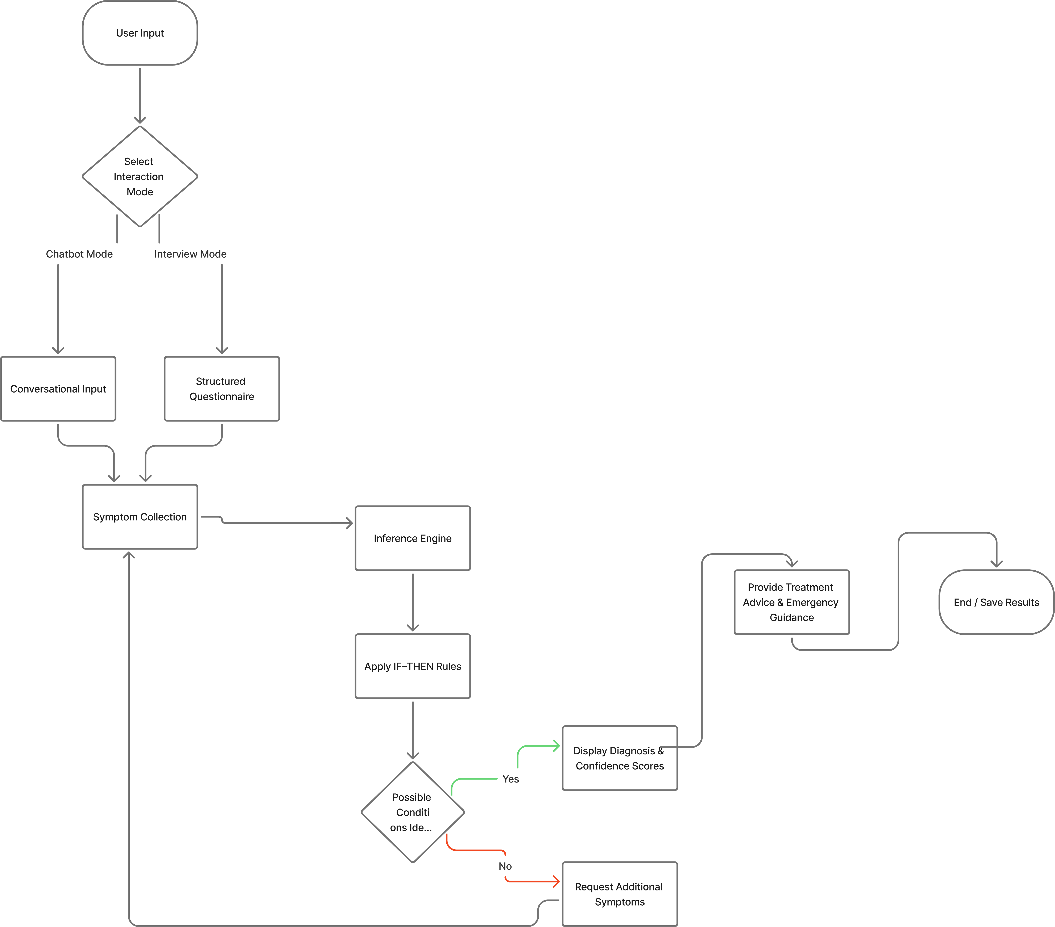
Figure 1: Flowchart of the Lung Infection Diagnostic Expert System

3.6 Pseudocode of the System
BEGIN
DISPLAY "Welcome to the Lung Infection Diagnostic System"

PROMPT user to SELECT interaction_mode
IF interaction_mode = "Interview" THEN
CALL Interview_Mode()
ELSE IF interaction_mode = "Chatbot" THEN
CALL Chatbot_Mode()
ENDIF

PROCEDURE Interview_Mode()
INITIALIZE answers ← empty dictionary
FOR each question IN QUESTIONS
DISPLAY question.text
RECEIVE user_input
STORE response IN answers[question.id]
ENDFOR
CALL Evaluate_Answers(answers)
END PROCEDURE

PROCEDURE Chatbot_Mode()
INITIALIZE session_state ← {symptoms: [], asked: []}
LOOP
RECEIVE user_message
IF user_message CONTAINS "diagnose" OR "result" THEN
CALL Evaluate_Symptoms(session_state.symptoms)
EXIT LOOP
ENDIF

DETECT new_symptoms ← Extract_Symptoms(user_message)
UPDATE session_state.symptoms WITH new_symptoms
next_question ← Next_Best_Question(session_state)

IF next_question EXISTS THEN
DISPLAY next_question.text
DISPLAY quick_reply_suggestions(next_question.type)
ELSE
CALL Evaluate_Symptoms(session_state.symptoms)
EXIT LOOP
ENDIF
END LOOP
END PROCEDURE

PROCEDURE Evaluate_Answers(answers)
facts ← Extract_Facts(answers)
CALL Evaluate_Symptoms(facts)
END PROCEDURE

PROCEDURE Evaluate_Symptoms(facts)
matched_rules ← []
scores ← empty dictionary

FOR each (condition, rules) IN KNOWLEDGE_BASE
FOR each rule IN rules
IF rule.required_symptoms ⊆ facts THEN
INCREMENT scores[condition] BY rule.weight
ADD rule TO matched_rules
ENDIF
ENDFOR
ENDFOR

IF scores IS EMPTY THEN
DISPLAY "I need more information. Please provide additional symptoms."
ELSE
COMPUTE confidence_scores FOR each condition
DISPLAY "Possible Conditions:" WITH confidence_scores
DISPLAY corresponding medical advice
ENDIF
END PROCEDURE

PROCEDURE Extract_Symptoms(user_message)
detected ← []
FOR each symptom IN SYMPTOM_SYNONYMS
IF any synonym OF symptom FOUND IN user_message THEN
ADD symptom TO detected
ENDIF
ENDFOR
RETURN detected
END PROCEDURE

PROCEDURE Next_Best_Question(session_state)
FOR each question_id IN PRIORITY_ORDER
IF question_id NOT IN session_state.asked AND
question_id NOT IN session_state.symptoms THEN
RETURN corresponding question FROM QUESTIONS
ENDIF
ENDFOR
RETURN NULL
END PROCEDURE

END

4. RESULTS AND DISCUSSION
The developed system successfully simulates human expert reasoning for diagnosing lung infections. Tests were conducted using hypothetical patient cases, and the system produced logical and medically sound results. For example, when symptoms such as fever, productive cough, and chest pain were entered, the system suggested Community-Acquired Pneumonia with over 70% confidence. When symptoms such as night sweats, weight loss, chronic cough, and exposure to tuberculosis were entered, it correctly inferred Tuberculosis (TB) suspicion.
Similarly, users presenting dry cough, low-grade fever, and fatigue were assessed as likely having Viral or COVID-19-related lung infection, while wheezing and shortness of breath indicated possible Asthma Exacerbation. The chatbot was capable of handling both natural text input and guided multiple-choice replies, producing human-like interactions while maintaining reasoning transparency.
The user interface provides a modern, clean design with smooth transitions and SVG illustrations, ensuring a professional and intuitive user experience. Diagnostic explanations appear alongside results, clearly showing which symptoms contributed to each condition’s score.
The system demonstrates the value of rule-based expert systems in healthcare, particularly where trained personnel are scarce. However, limitations include its reliance on predefined rules, inability to analyze laboratory or imaging data, and a confined range of respiratory diseases. The inference engine depends entirely on symptom patterns and cannot perform probabilistic reasoning beyond its defined rules. Despite these constraints, the system performs consistently within its designed scope, providing accurate and interpretable diagnostic feedback.

4.1 User Interface and Output Result
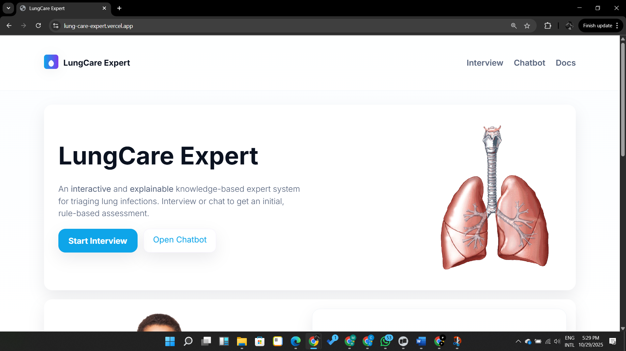
Figure 2: Home Page Interface of the Lung-Care Expert System
The Home Page serves as the starting point of the Lung-Care Expert System. It introduces the system, provides a short description of its purpose, and allows the user to proceed directly to the diagnosis process.

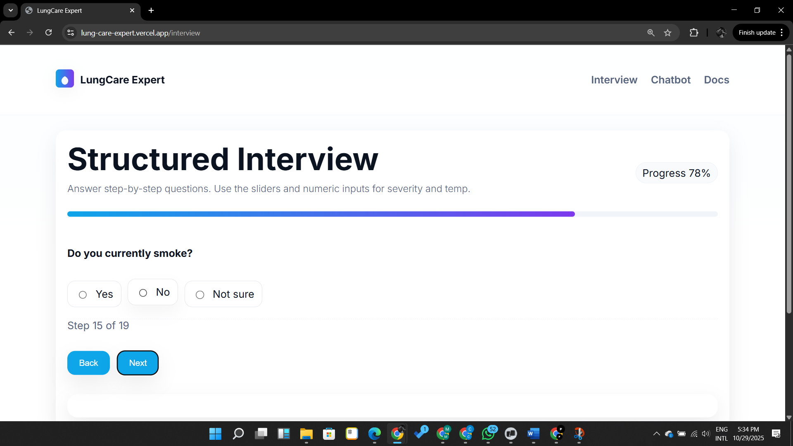
Figure 3: Structured Interview Page of the Lung-Care Expert System
The Structured Interview Page is the section where users provide information about the health issues they are experiencing. It presents symptoms as selectable options using checkboxes or toggles, such as cough, fever, chest pain, night sweats, fatigue, and breathing difficulties.

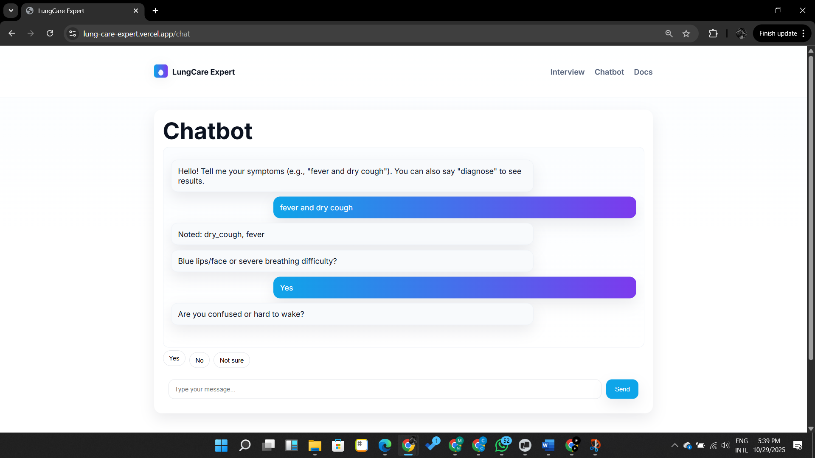
Figure 4: Chatbot Page of the Lung-Care Expert System
The Chatbot Page provides a conversational interface that allows users to interact with the system using natural language. Instead of selecting checkboxes, users can describe their symptoms in their own words, such as “I have had a cough and fever for three days.”

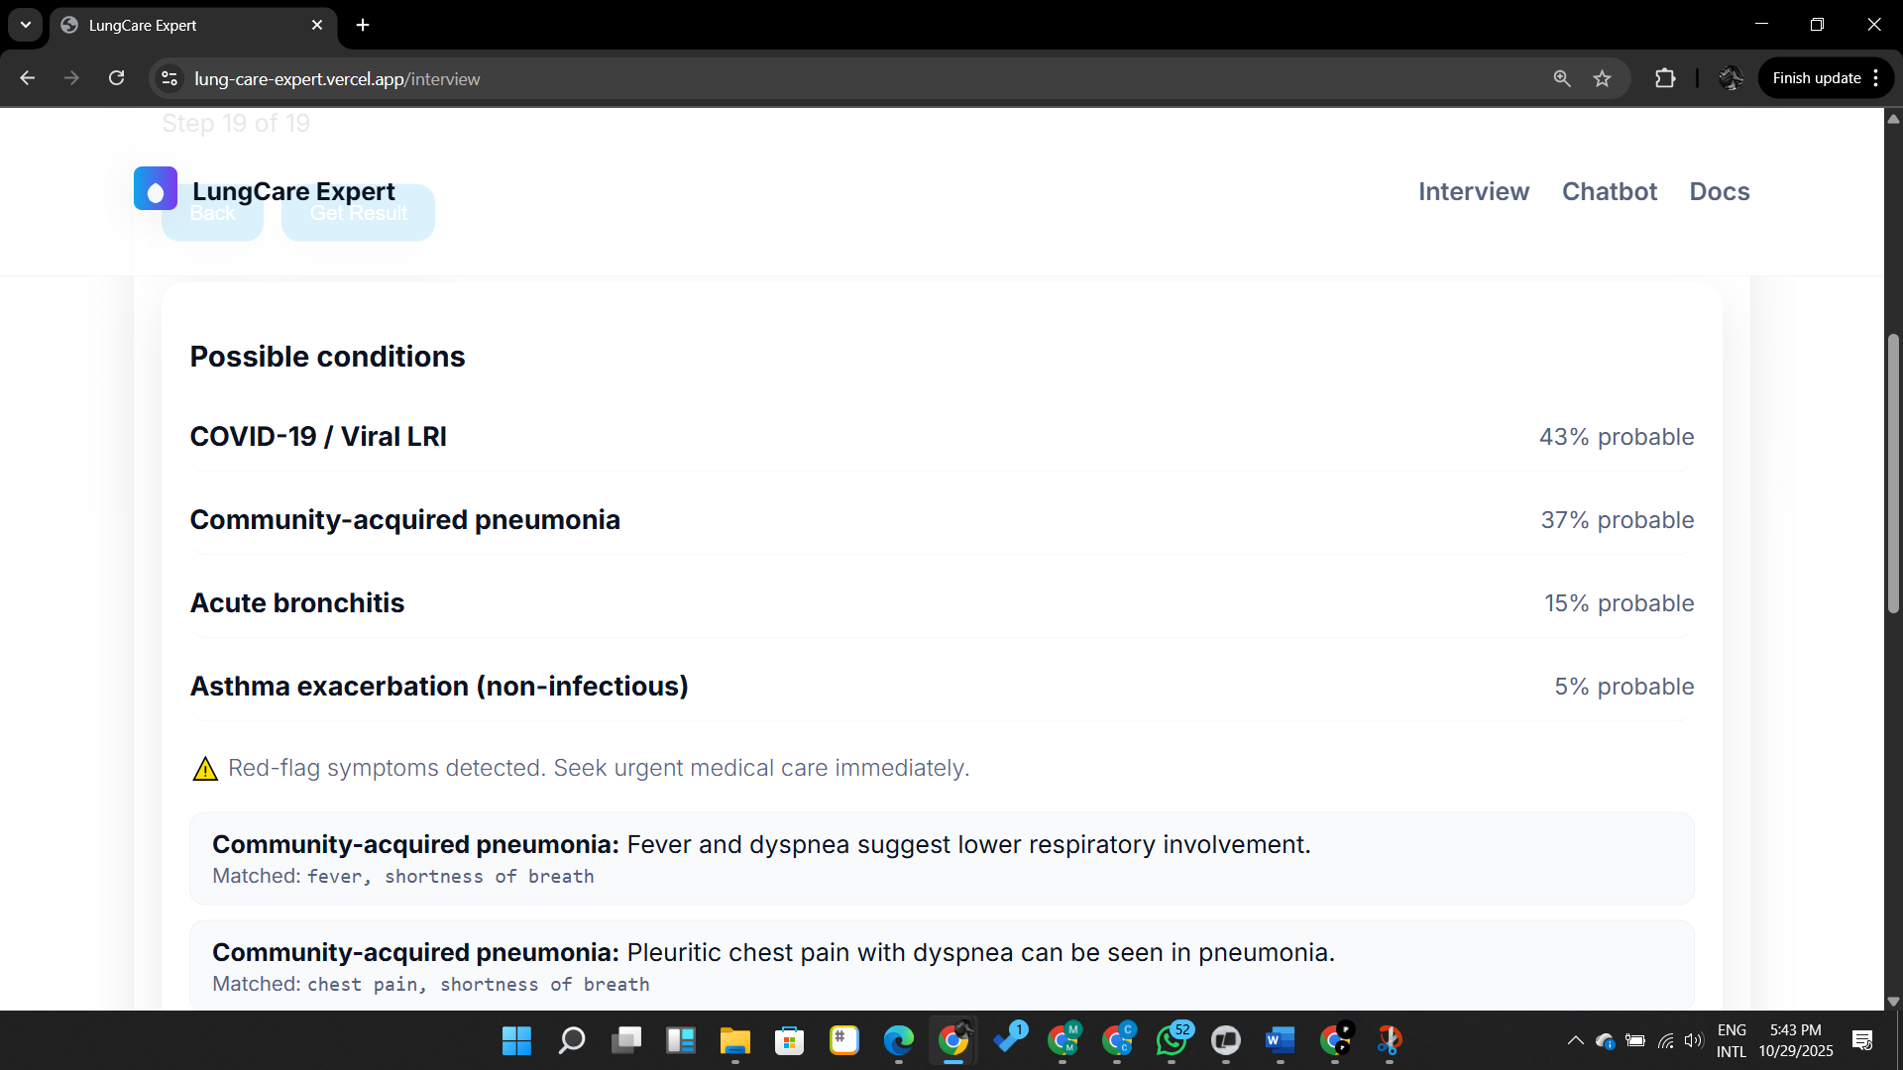
Figure 5: Results Page of the Lung-Care Expert System
The Results Page displays the outcome of the diagnostic process. It presents possible conditions such as pneumonia, bronchitis, tuberculosis, or viral infection based on the symptoms provided by the user. Each diagnosis is accompanied by short reasoning, highlighting the key symptoms that matched the condition.

5. CONCLUSION AND FUTURE WORK
This study successfully designed and implemented a Medical Knowledge-Based Expert System for the Diagnosis and Treatment of Lung Infections. The system integrates explainable rule-based reasoning, structured medical knowledge with an interactive user-centered web interface to deliver a functional diagnostic tool.
By offering dual interaction modes, it accommodates both guided and conversational diagnostic experiences, simulating the reasoning of medical experts while maintaining transparency. Its diagnostic coverage of pneumonia, bronchitis, tuberculosis, viral lung infections, and asthma exacerbation provides a solid foundation for future expansion.
Its educational and triage capabilities make it valuable in rural and resource-limited areas where medical expertise is scarce. The findings reaffirm the usefulness of expert systems in supporting health decision-making.
Future improvements should focus on expanding the knowledge base, incorporating probabilistic reasoning, integrating laboratory and radiological data, and deploying the system as a mobile and voice-enabled application. These enhancements will increase accuracy, accessibility, and impact.

REFERENCES
- Buchanan, B. G., & Shortliffe, E. H. (1984). Rule-Based Expert Systems: The MYCIN Experiments of the Stanford Heuristic Programming Project. Addison-Wesley.
- Shortliffe, E. H. (2021). Artificial Intelligence in Medicine: Past, Present, and Future. Artificial Intelligence in Medicine, 119, 102108.
- Symptomate. (2025). AI Symptom Checker. Retrieved from https://symptomate.com
- World Health Organization. (2023). Pneumonia. Retrieved from https://www.who.int/news-room/fact-sheets/detail/pneumonia
- World Health Organization. (2023). Tuberculosis. Retrieved from https://www.who.int/news-room/fact-sheets/detail/tuberculosis

