**Spring 2022 Introduction to Artificial Intelligence**

**Report of Homework #1**

Student name: 劉子齊 Jonathan

Student ID: 0716304

1. Load and prepare your dataset

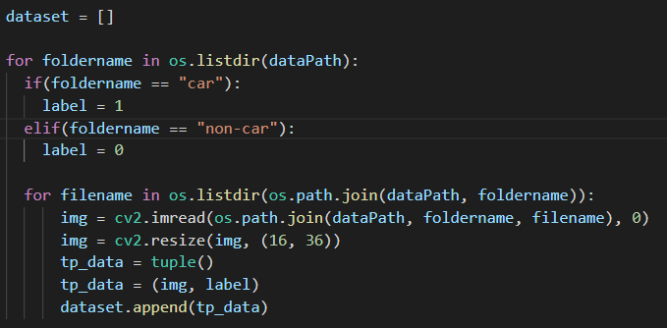

For the first part, I applied two for loops in my program, since

1. Implement Adaboost algorithm

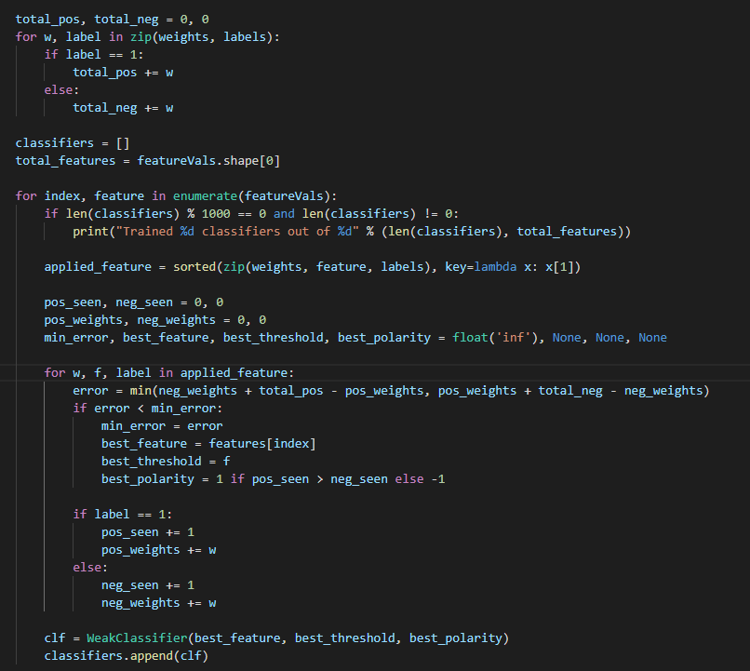

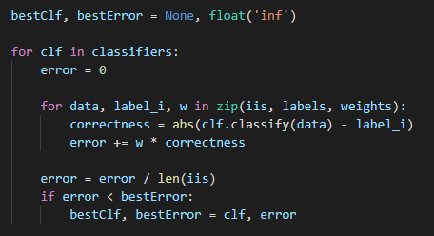

1. Additional experiments

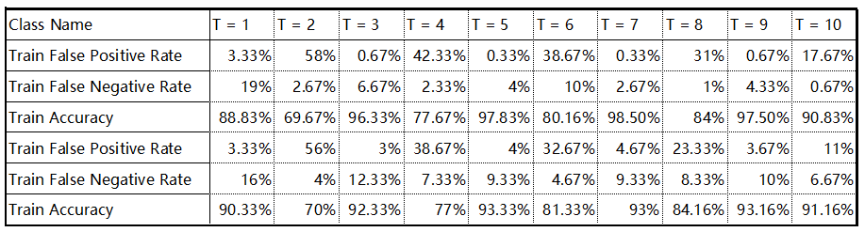

1. Detect car

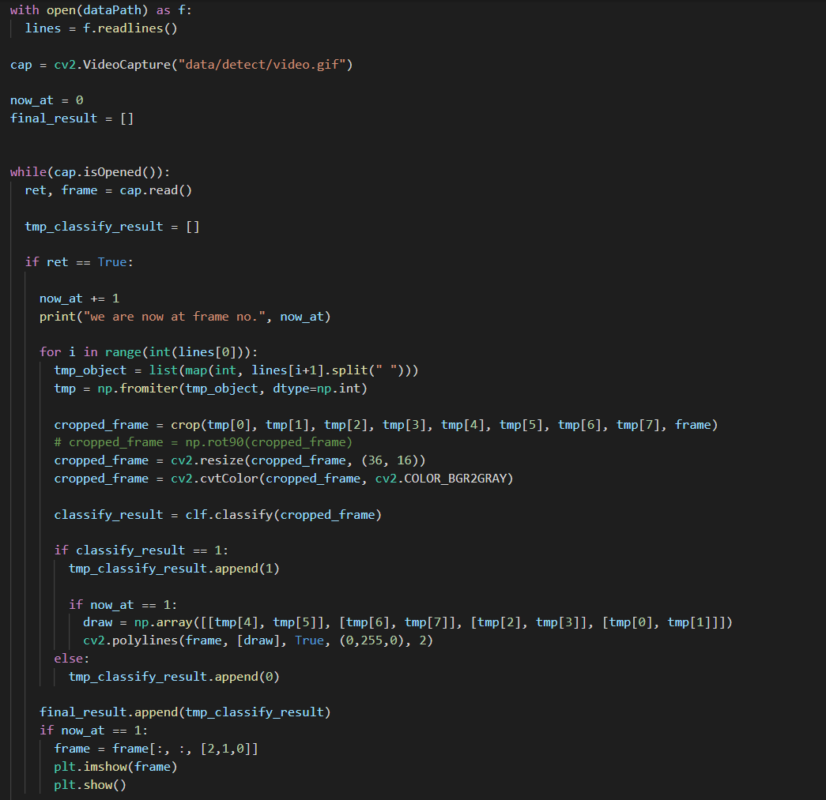

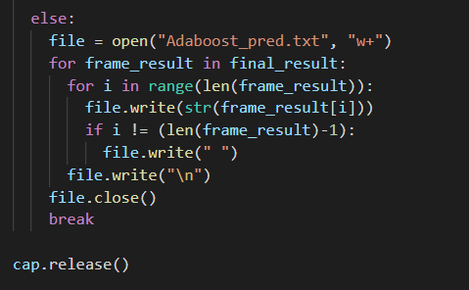

1. Difference between Adaboost and Yolov5
2. Obstacles Encountered