**Spring 2022 Introduction to Artificial Intelligence**

**Report of Homework #3**

Student name: 劉子齊 Jonathan

Student ID: 0716304

**Part 1 : Adversarial search**

Part 1-1: Minimax Search

When the computer wants to make the next move in Pacman, of course it will play the one with the most points, which is eating all the food in this case, but this can easily fall into the opponent's trap, which is being eaten by the ghosts.

Therefore, a reasonable idea is to divide all levels into two categories of enemy and us, which will be Pacman and the Ghost in ours case. The more points the level under our side has, the better, and the level under the other side loses as few points as possible.

Also, we can't assume that the opponent is a fool, so at every level, we have to think that "the opponent may make the move that will cost us the most points", and we must choose the strategy of "minimizing maximum points loss" as much as possible. As a result, this strategy makes the Minimax Search.

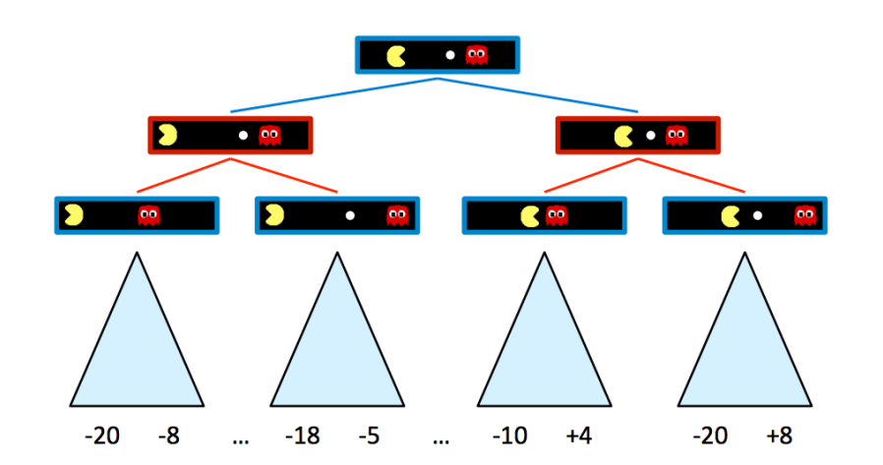

In the figure above, blue nodes correspond to nodes that Pacman controls and can decide what action to take, which will pick the choice with the max value, while red nodes correspond to ghost-controlled nodes, which will pick the minimum. Now let’s move onto the second depth of the tree in the figure above.

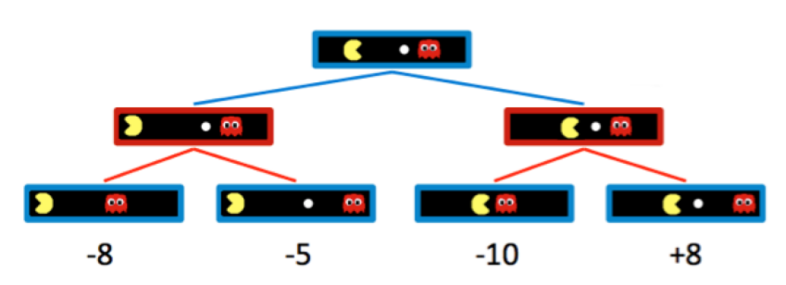

As we can observe from the figure above, the blue Pacman nodes chose the option with the max value, which Pacman believes to be the best choice. The minimax algorithm only maximizes over the children of nodes controlled by Pacman, while minimizing over the children of nodes controlled by ghosts. Hence, the two ghost nodes above have values of min(−8,−5) = −8 and min(−10,+8) = −10 respectively. Correspondingly, the root node controlled by Pacman has a value of max(−8,−10) = −8. As a result, the Pacman will get -8 as the score of this game.

However, if I was the Pacman in this game, I will mot be satisfied, since I knew that I could have get +8 as my final score, if I chose the right way. Hence, we will need to have the Pacman put some bet to move to way which is not so straightforward and will take some risks correspondingly.

When implementing the Minimax algorithm, I found it kind of similar to DFS (Deep First Search), which they both start with the leftmost terminal node and all the way to the right of the game tree. Basically, I followed the pseudocode found on a website of UC Berkeley in the figure below.

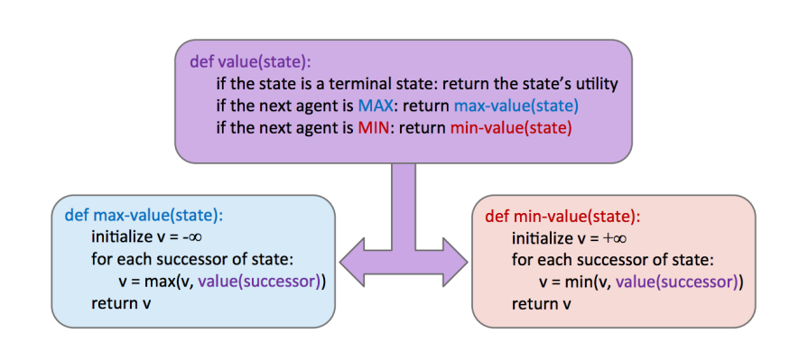

簡單講一下 minimax 運作原理

講一下程式架構、配程式截圖

講一下結果輸出、配終端機結果截圖

Ref

[n3.pdf (berkeley.edu)](https://inst.eecs.berkeley.edu/~cs188/fa18/assets/notes/n3.pdf)

[adversarial_search/multiAgents.py at master · srinadhu/adversarial_search · GitHub](https://github.com/srinadhu/adversarial_search/blob/master/multiagent/multiAgents.py)



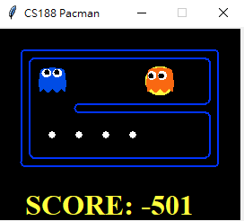



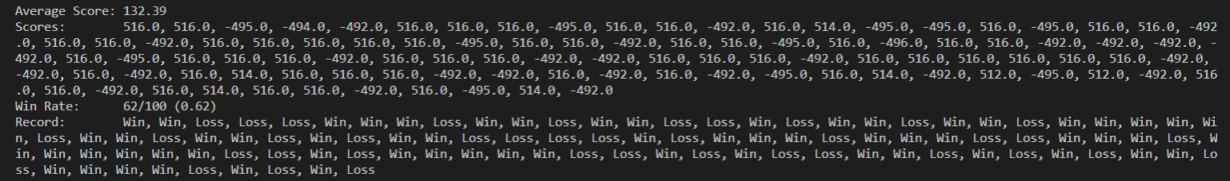

Part 1-2: Expectimax Search

Part 1-3: Evaluation Function (Bonus)

**Part 2 : Q-learning**

Part 2-1: Value Iteration

Part 2-2: Q-learning

Part 2-3: epsilon-greedy action selection

Part 2-4: Approximate Q-learning

**Part 3 : DQN**

**Part 4 : Try other SOTA methods (Bonus)**