**Summer 2022 Deep Learning**

**Report of Lab #6**

Student name: 劉子齊 Jonathan

Student ID: 311605004

**Part 1: Introduction**

In this lab, our goal was to implement 2 deep reinforcement algorithms, which are the Deep Q-Learning Network and Deep Deterministic Policy Gradient, to get the highest score as we could in LunarLauncher-v2 and LunarLauncherContinuous-v2 correspondingly. The following figure is how LunarLauncher-v2 looked like.

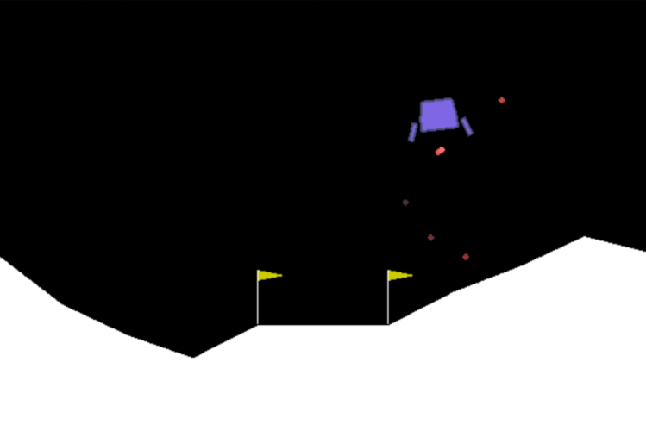

In LunarLauncher-v2, there are 8 possible observations, which are the horizontal coordinate, the vertical coordinate, the horizontal speed, the vertical speed, the angle, the angle speed, the contact of left leg to the moon, and the contact of the right leg to the moon. We can take 4 kinds of actions on the spaceship, which are do nothing, fire left engine, fire main engine, and fire right, based on the 8 possible observations we may obtain.

In LunarLauncherContinuous-v2, the 8 possible observations we can get are the same. However, the actions are different. The main engine can be controlled by a continuous value, when the value is between -1 to 0, the main engine is closed, and when the value is between 0 to +1, the main engine will throttle from 50% power to 100% power. The left and right engine basically work in the same way, but just on and off for their power, which when the value is between -1 to -0.5, the left engine will be fired, when the value is between +0.5 to +1, the right engine will be fired, otherwise, both engines are off.

For the Deep Q-Learning Network algorithm, we will work on the LunarLauncher-v2, and the output actions will be discrete actions. For the Deep Deterministic Policy Gradient, we will work on the LunarLauncherContinuous-v2, and the output actions will be continuous actions.

**Part 2: Implementation Details**

**Part 2-A: Implementation of Deep Q-Learning Network**

We can divide DQN into 2 parts, which are behavior network and the target network. The architecture of the two networks are basically the same. They are both formed with three fully connected layers following by an ReLU function as its activation function. The following figure is how I implemented the network architecture.

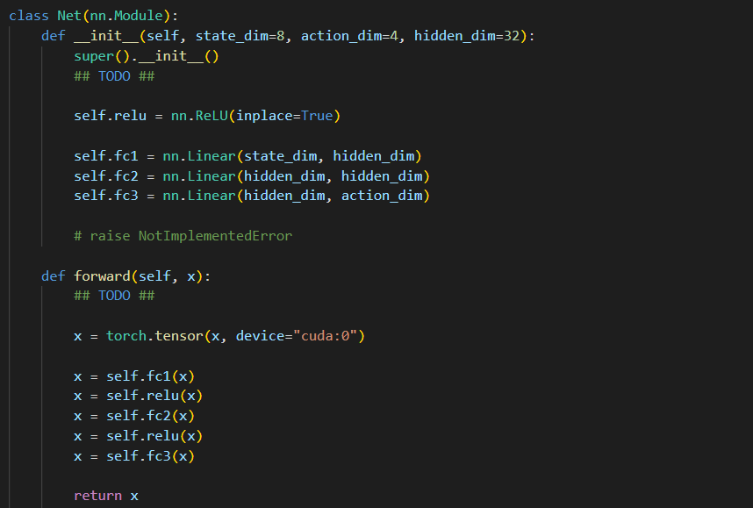

However, their purposes are different. Both of them are about the q value, but the behavior network gets the q value through the state and the action through each episode, and the target network estimates the target q value.

As the figure below, we can find that DQN either chose the action randomly or the one with the highest q value which obtained through the behavior network. Besides, the epsilon which was initially set as 1 would be multiplied by 0.995, which was the epsilon decay rate, until the lowest epsilon value, which was 0.1. These two processes are known as the epsilon greedy algorithm, and is one of the policies that DQN adopted.

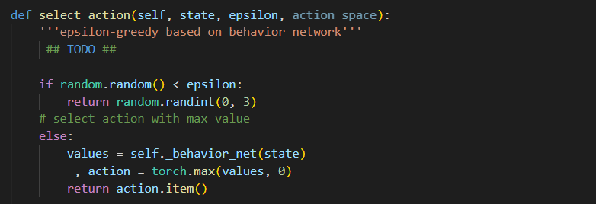



Afterwards, the chosen action would be fed into the environment then the reward, the status of the game, and the next step would be returned by the environment. This information would form a transition set and would be stored in the reply memory. Then the stored transitions in the reply memory would be sampled into several mini batch transitions by the model in the training process. The following figure is how I implemented the reply memory, and how they were made use of.

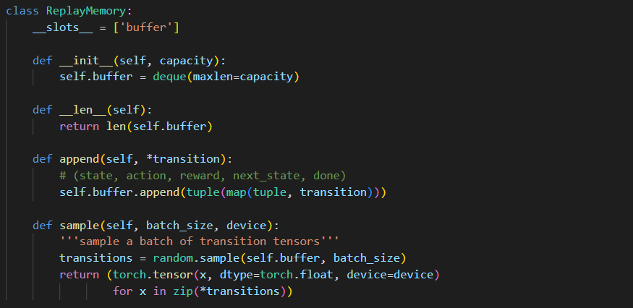





With the mini batch transitions sampled, we would calculate all the q-value and get the highest one among all the sampled states by the behavior network mentioned above. Also, we would calculate the highest next q-value for the calculation of the target value through the target network. Besides, gamma here is the discount factor, which determines whether the model will depend on the future more or the past. When gamma is 1, it means that we will take the next q-value into the target value. When gamma is 0, we will simple update the model parameters by the reward. By comparing the q-value and the next q-value, we could get the loss through the MSE loss. Below is the implementation of the updating of the target network.

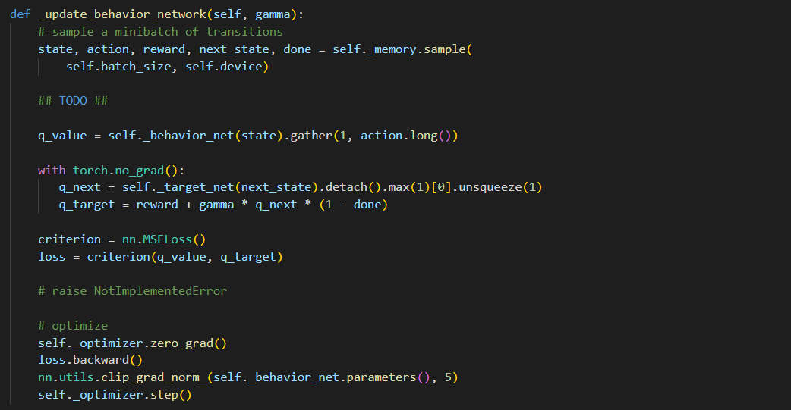

For the update of the target network, we applied the soft update. The reason why I applied soft update here is the characteristic of the soft update which brings more stability to the target network when updating. Below is the implementation of the updating of the target network.

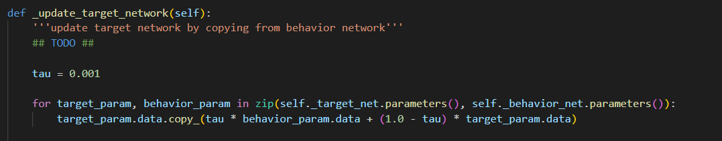

**Part 2-B: Implementation of Deep Deterministic Policy Gradient**

The basic structure of the DDPG is very similar to the DQN, but with slightly differences. Start with the actor network, the network will choose the action by adding the Gaussian noise to the action distribution which generated by the actor network. Below is the implementation of the actor network and the Gaussian noise function.

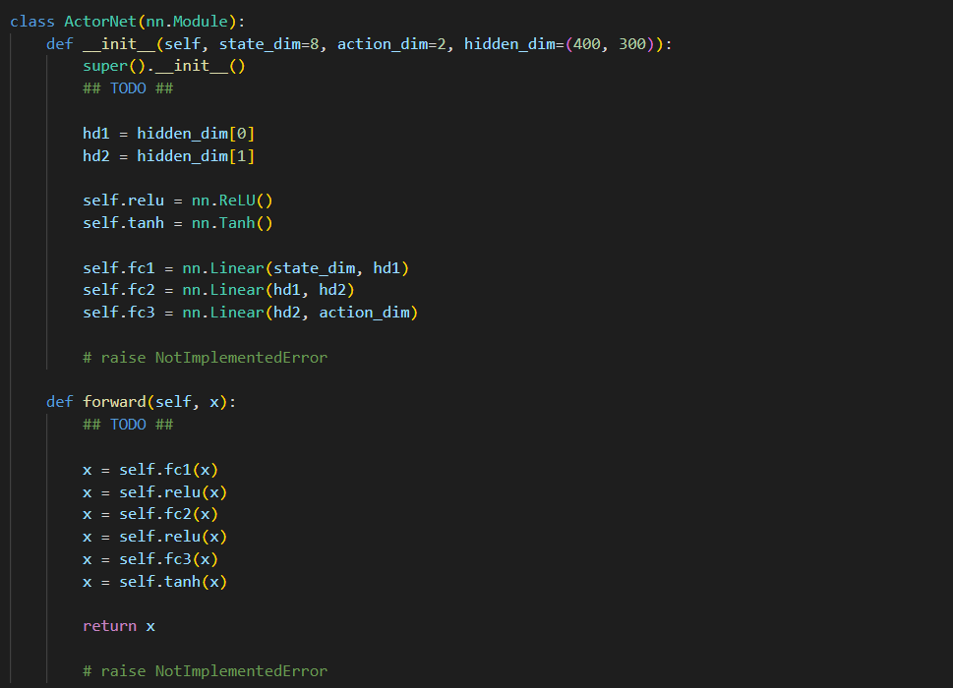

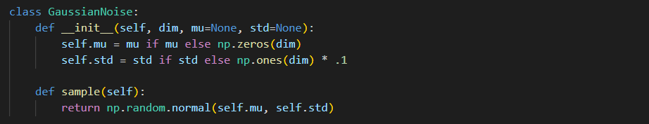

For the critic network, it will estimate the q-value through the action and the state from the actor network. Besides, we will concatenate the state and the action together before feeding them to the critic network. Below is the implementation of the critic network.

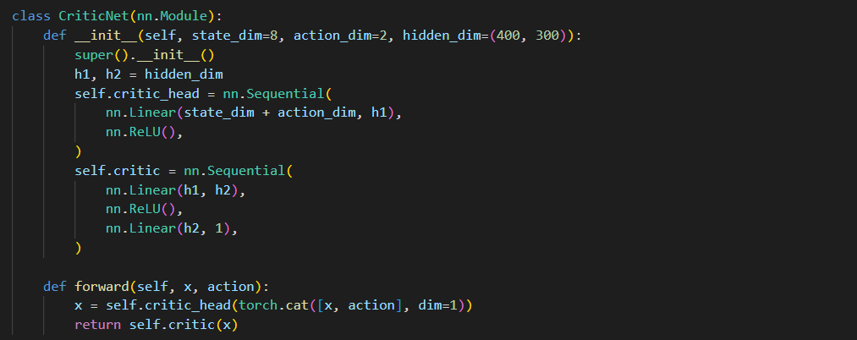



The whole training and updating process are actually quite similar to the ones of the DQN. We will first get the q-value through the states sampled from the reply memory by the behavior critic network. Then we will get the next q-value through feeding the next action provided by the target actor network and the next state into the target critic network. Besides, as I mentioned above, gamma here is the discount factor, which determines how we will update the model parameters. When gamma is 1, it means that we will take the next q-value into the target value. When gamma is 0, we will simple update the model parameters by the reward. Finally, we will get the MSE loss and update the behavior critic network. The implementation of the updating of the behavior critic network is in the following figure.

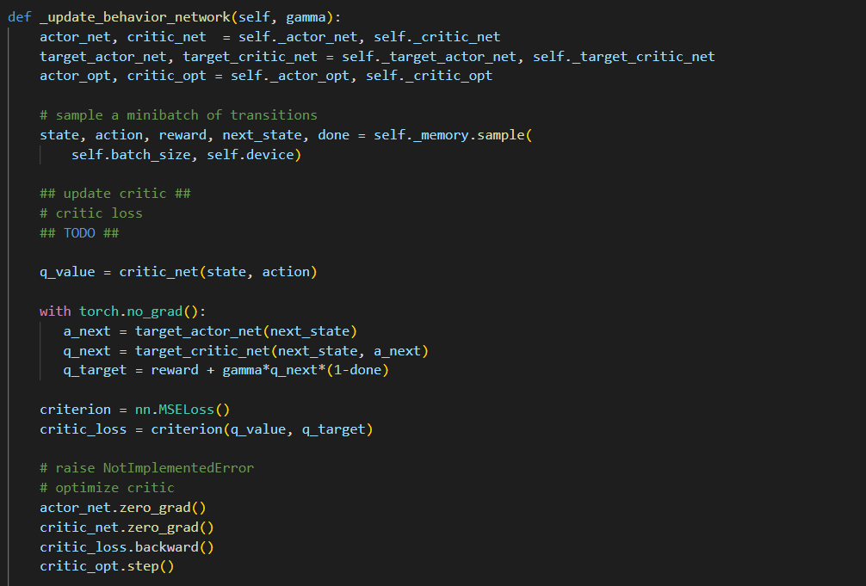

Besides, there is also a super important element I the DDPG, which is the actor loss. The actor loss, which is actually the negative summation of the of all the q-values, can help to update the network by maximizing the expecting value of the q-value, below is the implementation of the actor loss.

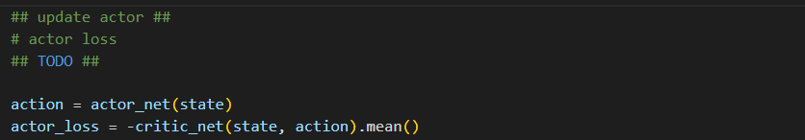

Finally, for the update of the target network, we also applied the soft update. As I mentioned above, to bring more stability to the target network when updating, we adopted soft update here, and below is the implementation.

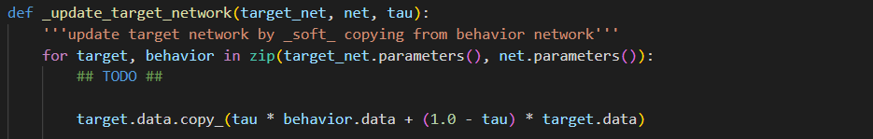

**Part 3: Experimental Results & Discussions**

**Part 3-A: Best Results**

**Part 3-A-1: DQN**

Below is the capture, the curves of the best result I got for the DQN, which was with the average score of “”. The hyperparameters I adopted were as the following:

* Episode: 2000
* Learning Rate: 0.0005
* Batch Size: 128
* Capacity: 10000
* Optimizer: Adam
* Eps Decay: 0.995
* Eps Minimum: 0.01
* Gama: 0.99
* Frequency: 4
* Target Frequency: 4
* Test Epsilon: 0.001

**Part 3-A-2: DDPG**

Below is the capture, the curves of the best result I got for the DDPG, which was with the average score of “”. The hyperparameters I adopted were as the following:

* Episode: 2000
* Learning Rate of Actor: 0.001
* Learning Rate of Critic: 0.001
* Batch Size: 64
* Capacity: 500000
* Optimizer: Adam
* Gama: 0.99
* Frequency: 4
* Target Frequency: 4
* Test Epsilon: 0.001

**Part 3-B: Further Discussions**