**Homework #5 Report  
[EECN30168] Self-Driving Cars 2022**

**Student ID:** 311605004 **Name:** 劉子齊 **Date: 2022.10.26**

**Video Name: Point-Plane and Generalized ICP – 5 Minutes with Cyrill**

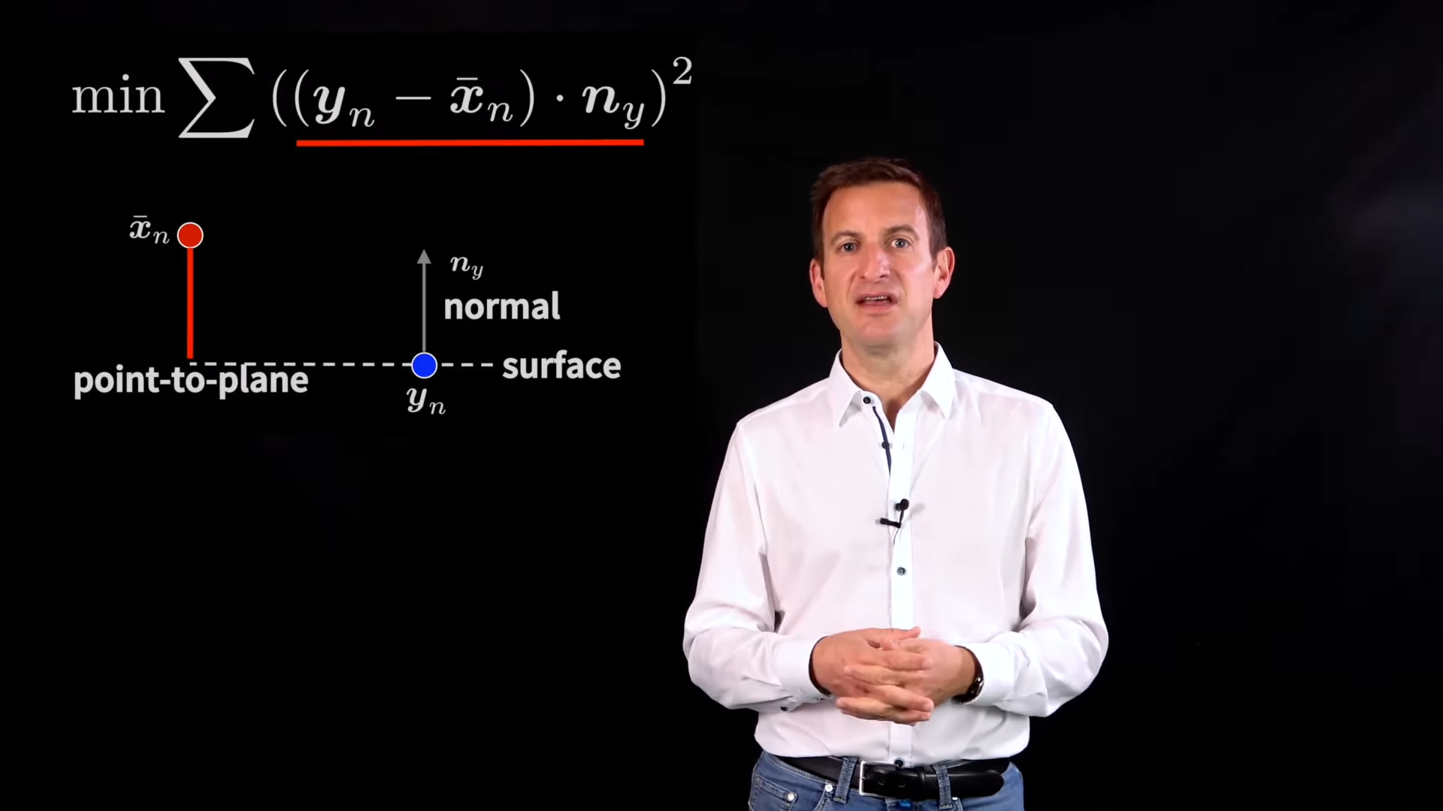

**Video Link:** <https://www.youtube.com/watch?v=2hC9IG6MFD0>

**Introduction:**

This video is basically an extension of the video “[Iterative Closest Point (ICP) - 5 Minutes with Cyrill](https://youtu.be/QWDM4cFdKrE)”. In this video, Cyrill explained that point-to-plane ICP basically changes the cost function of the point-to-point ICP. Different from point-to-point ICP, we project the point-to-point error vector onto the surface normal. Besides, Cyrill also made a brief explanation on the Generalized ICP. Cyrill stated that the GICP combines the point-to-point metric, the point-to-plane metric and the plane-to-plane metric. Cyrill explained the complex algorithm and the differences between different ICP variants in his video, and made them a lot easier to understand.