**Theory of Computer Games 2022**

**Report of Project #1**

Student name: 劉子齊 Jonathan

Student ID: 311605004

In project 1, our goal is to implement a simple heuristics-based player. For the framework of the game, and the environment, I followed the given sample.

The original given method was to play randomly, but care nothing about the reward. In the following method which I implemented, I applied the backward method and an 8 x 4 tuple network. In my implementation, I calculate the corresponding reward of each operations, which are “slide up”, “slide down”, “slide left”, “slide right”. By calculating reward of each potential operations, I will choose the operation with the highest reward and act to it. The following figure is the implementation of my greedy sliding method.

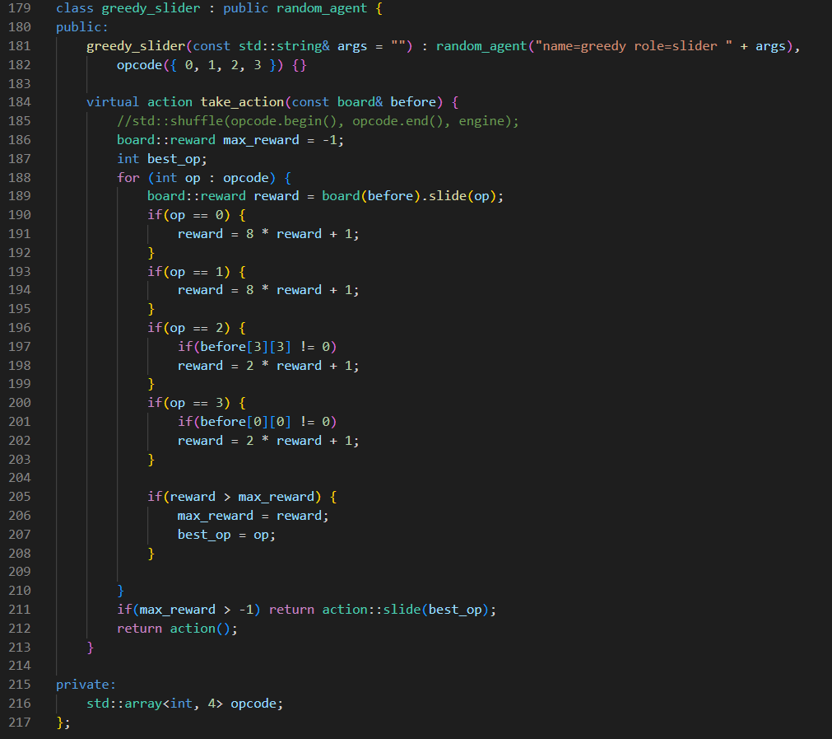

With my greedy sliding method introduced above, I obtained a way better result than the original strategy with the score of “92.3” in the provided Linux workstation, which is shown in the following figure.

