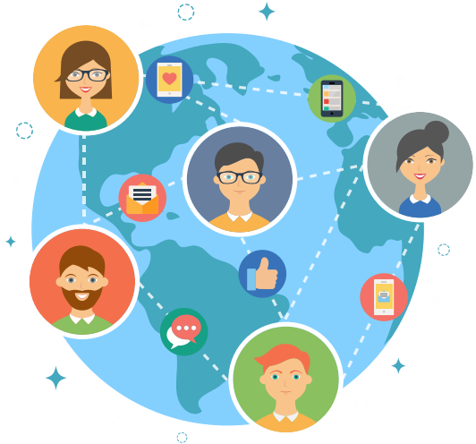

C15487922

sftgm ca group 8 report

JONATHAN NOBLE | DT282-2 | 03/05/2017

Contents

Work Practices 3

Elicitation Strategy 4

Interview reports: 4

Interview Q&A (1) 4

Interview Q&A (2) 6

Interview Q&A (3) 8

Observation reports: 10

PERSONA 11

PRIMARY PERSONA 11

SECONDARY PERSONA 11

Scenarios 12

Primary Scenario 12

Secondary Scenario 13

Design Guidelines and Heuristic Evaluation 14

Page Design Prototype(LOFI) 14

Storyboard 16

Heuristic Evaluation 17

Page Design Prototype(MEFI) 18

CATERING HOFSTEDE’S CULTURAL DIMENSIONS ON BOTH ENDS 19

I18N and L10N 23

Conclusion 25

# Work Practices

We set a day each week to meet up and brief each other on our progress in our assignment. We also made a google drive collaborative folder where all our files and ideas are accessible to everyone and we also created group chat where anything Software for Global Market assignment related was shared.

All these files have been added to this report.

|  |  |
| --- | --- |
| DATE  February 20-24 | * Decided to work as a group. * Decided how we were going to approach the assignment. * Set up a timeline of what needs to be accomplished when. |
| February 24- March 7 | * Elicitation strategy was discussed and decided upon. * Interviews and observations results were discussed. * Low-fidelities were made based on the discussion.   Heuristic evaluation developed. |
| March 8 | * Presented first part of the project to Deirdre |
| April 18 | * Individual High fidelity was being developed based on the low fidelity |
| April 26 | * Finalised presentation |
| May 3 | * Finalised individual report and medium fidelity |

# Elicitation Strategy

## Interview reports:

### Interview Q&A (1)

**Name:** Kim Lee

**Age:19**

**Cultural Background/Language skills:** Irish /SouthKorean, Proficient in Korean and English

**So, tell me about how you spend a typical day or week …**

A: I go to work as a sales assistant and on my days off I study or complete assignments as I am also a full-time Science student.

**What activities take up most of your time?**

A: As I am in 2nd year, it’s getting tough to keep up with my assignments. On top  
of that, I am also working to help fund my tuition and lifestyle.

**What is/are your biggest pain point(s)?**

A: not having enough time reading wordy information, doesn’t have the initiative to explore for different perspective and hate making mistakes.

**What would an ideal day or week look like? What would you be  
Doing?**

A: Shopping, eating out and watching movies with my friends

**How is the real world different from that ideal week?**

A: In reality, I would need some sort of income to fund my desired lifestyle. I would  
therefore need to work to maintain this

**Are you planning to go to Erasmus on your third year, if so how long are you planning to go?**

**One or two semesters or more?**

A: I am plan to go for two semesters if there is a place for me

**Are you doing a language with your course? If so what is your level in that language and is that the country you’re planning to go to?**

A: Yes, I am currently doing German, it is basic. I am thinking of going to Germany or Korea.

**So, tell me how you use our Erasmus school portal… What does it  
allow you to do, that you couldn’t do otherwise?**

A: Rather than communicating face-to-face or over-the-phone at a college admin office, which can be quite daunting and time consuming(travel), the website is a convenient and efficient way to get things done.

**Where does it fall short? What doesn’t it do (or do well) that you  
need it to do?**

A: lack visual, no search feature, dull colour scheme keep forgetting where certain features are. Navigation is not very clear. Too wordy and plain.

**Have you used other similar websites that do that in the past? What were  
they? Which website is better/best? Why?**

A: Google is my go-to for my life  
questions. Other than that, I'm not too familiar with other websites  
that cater to this

**What data do they provide to you?**

A: brief FAQ on application form from other colleges  
no details about accommodation listing, info about country

**What is your favourite INTERFACE from a website? Preferably from an Application Form website.**

A: I like amazon website. It has a lot of images and it comes with text as well, gives me assurance that I am clicking on the right item and easy to navigate from page to page, I also like everything is sort of grouped together in their type for example. There’s a section division for every different type of items/products.

**How comfortable are you with technology? Do you use the internet  
often?**

A: I use google, Facebook, twitter, Instagram and snapchat everyday  
using my Samsung phone.

**What is your mobility grant? Will you be funded by your parents/SUSI grant/ only yourself?**

A: I am working really hard to be able to save enough money for my Erasmus.

### Interview Q&A (2)

**Name:** Kelly Maher

**Age:** 20

**Cultural Background/Language skills:** Irish,English

**Tell me about your typical week as a student.**

A: Well my typical week as a student is basically work, college, study and socialising with friends.

**How many hours per week do you work and have college?**

A: I work roughly 19 hours and college hours is 24 hours per week.

**Do you find it a bit tiring with college and work?**

A: Yes, it is, especially when there’s test and assignments coming up. I try my best to juggle them and get good grades.

**What languages do you know and what are your fluency in them?**

A: Languages that I know are, Irish, English, French and Spanish I would say I am very fluent in Irish as I went to an Irish school in primary and secondary school and of course English as well. For Spanish I would say I am Leaving cert level ordinary and for French very basic.

**Are you planning to go to Erasmus on your third year, if so how long are you planning to go?**

**One or two semesters or more?**

A: I am planning to go for two semesters if I can. If not I will go for one semester.

**Are you doing a language with your course? If so what is your level in that language and is that the country you’re planning to go to?**

A: Yes I am currently doing a language in my course. I would say at a beginner level. It is the country that I’m planning to go to but I’m also stuck on another country to go for Erasmus.

**So tell me how you use our erasmus school portal… What does it**

**allow you to do, that you couldn’t do otherwise?**

A: Well of course it doesn’t allow me to talk face to face with an interviewer, which in my opinion takes longer and it is quite intimidating. The website allows me to do my application quite fast and not intimidating.

**Where does it fall short? What doesn’t it do (or do well) that you need it to do?**

A: I it is quite dull. Very wordy, I feel the need to remember where things are.

**Have you used other websites to do that in the past? Why were they? Which website is better l/best and why?**

A: Yes, I did, the best one is google docs. When I applied for some talk they have always used google docs and it is aesthetic and appealing for me.

**What is your level of computer skills?**

A: I would say that it’s average, I will not be confused on how a website works. But prefer websites that has instructions on how to navigate around or which item is clickable

**What is your favourite INTERFACE from a website? Preferably from an Application Form website.**

A: I like the Log in Page of the Instagram minimal design but straightforward. I also like forms that has image icons as sometimes I don’t even need to read the description. It helps a lot as I have mild dyslexia

**How many times per day do you spend browsing the web every day?**

A: A lot roughly 4 hours per day.

**What is your mobility grant? Will you be funded by your parents/SUSI grant/ only yourself?**

A: Currently I am not being funded by SUSI, I have applied before but I wasn’t accepted. I will hopefully be granted some funding from ERASMUS and of course by my parents. I am also planning to save up if I do get accepted for the ERASMUS.

### Interview Q&A (3)

**Name:** Jonas Müller

**Age:** 20

**Cultural Background/Language skills:** German, English

**Tell me about what your typical week is as a student.**

A: I am a 2nd year German male student studying Food Innovation – we ensure the requirement of the modern food society. Every week consists of labs which is quite stressful but fun at the same time.

**Are you full time or part time student? Do you work on weekends? If working, how do you find free time** to study?

A:  I am part time student who works 15 hours a week – from Friday to Sunday. I find my spare study time right after lectures which is not a lot to be honest.

**What is/are your biggest frustration(s) as a student?**

A:  Not enough time to study due to work and various social activities.

**How many times per day do you spend browsing the web every day?**

A: Approximately around 7 hours since I need to use the Internet for research and assignment work.

**Are you planning to go to Erasmus on your third year? If so, would it be one or two or more semesters?**

A: Yes, I’m planning on staying for the whole year, equivalent to two semesters.

**Where does it fall short? What doesn’t it do well that you need it to do?**

A: I think the interface itself is unappealing and too wordy to read everything.

**How comfortable are you with technology?Do you use the internet  
often?**

A:I use google,facebook and snapchat everyday  
using my Samsung phone. I also know a bit of HTML coding and CSS

**What is your favourite INTERFACE from a website? Preferably from an Application Form website.**

A: I admire the interface of the Home Page of the Instagram as it’s bright in colour and lighting and easy to read.

**How would you portray an Application Form differently? E.g. Different CSS layout, whether it’s done online or locally**

A: A better CSS layout and different positioning of the widget buttons would hugely affect the appearance and attract more students to be informed about the Erasmus package.

**What would an ideal Erasmus website look like for you?**

A: An ideal Erasmus website for myself would easily catch my eye – meaning the colour scheme is in pastel range, the text font and size is proportional to read and it consists of tons of descriptive images.

**Are you doing a language with your course? If so, what is your level in that language and is that the country you’re planning to go to? Also, what is your fluent language?**

A: Yes, I’m currently doing English as my second language – it’s at proficiency level. My native language is German.

**Are you comfortable with filling up personal information on this kind of websites?**

A: Yes, as long as these websites are approved by my college.

**Tell me how you use the Erasmus website… What does it allow you to do, that you couldn’t do otherwise?**

A: The Erasmus website allows me to fill up a form online which is faster and possibly simpler instead of doing it via a time-consuming Erasmus office.

**What is your mobility grant? Will you be funded by your parents/SUSI grant/ only yourself?**

A: I will work full-time during summer to earn and save up for the whole third year.

## Observation reports:

|  |  |  |  |
| --- | --- | --- | --- |
|  | **INTERVIEW 1 -KIM** | **INTERVIEW 2-KELLY** | **INTERVIEW3-JONAS** |
| **College Erasmus Portal layout findings** | Lack of images, difficult to navigate | Dull, wordy, sometimes confusing | Unappealing too wordy |
| **Availability** | Extremely busy working student | Extremely busy working student | Extremely busy working student |
| **Computer/Technical Skills** | Lower than average | Average, interested | Technical, likes to have control, customizing layout |
| **Favourite Interface from other websites** | Amazon website, full of visual, grouped and organized | Instagram login page minimal and simple, likes items with icons helps recognition | Instagram home page bright and easy to read simple |

From these reports we have noticed that there were two main users. One being users who are proficient in technology and does not need much instructions/directions when browsing and have little free time. The other, being someone who is not as proficient in technology and would prefer both visual and text to have a better browsing experience.

# **PERSONA**

### PRIMARY PERSONA

Our primary persona is mainly based on a 2nd year female student applying for Erasmus. She works 15 hours a week – usually during the weekends to save enough for Erasmus. She has mild dyslexia and is interested in how technology works.

Name: Caoimhe Sheeran

Age: 20

Location: Dublin, Ireland

Course: Food Innovation

Mobility Choice: Caoimhe would like to apply to Germany for two semesters

Goals: She would like to know more info about Erasmus and apply through it as time efficient and simple as possible to save her from stress and hassle.

Frustrations: Caoimhe is busy most of the time due to work and social activities. She also has trouble reading jampacked texts and awkward colour scheme.

### SECONDARY PERSONA

Our secondary persona is solely based on a 2nd year Irish/Korean female student who has only been in Ireland for 3 years. Her mother is Irish while her dad is Korean. She is currently studying Science in DIT. She works 12 hours a week mainly on the

Name: Sandra Park

Age: 20

Location: Dublin, Ireland

Course: General Science

Mobility Choice: Sandra would like to apply to Germany for the year.

Goals: She would like to access information efficiently with organized colour coordinated layout that is filled with images, icons and anything else that would make browsing quicker and easier.

Frustrations: Sandra is busy most of the time due to work and college. She also tends to get lost in websites and dislikes the idea of content that is mainly text based.

## **Scenarios**

### Primary Scenario

On a Friday evening, after school Caoimhe went home and opened her laptop to apply for her Erasmus exchange, she has only 30 minutes before going to her part time job. When she opened the page, she is not overwhelmed with wordy website but a visual one as she has no time to read them. Her eyes are pleased with the colours as they complement each other. She noticed that there are Irish and English flags that you can click, she is quite delighted with this as this is quick and efficient way to do. She chose the Irish flag and the language changed to Irish. As she has mild dyslexia, some of the words she sees are a bit jumbled up. She noticed there are some speaker buttons on the side of some boards and plays it, it says what was written on it. She wanted the requirements needed before signing up and the slideshow on the left side helped her. She also wanted to know the rent for the Erasmus exchange but it seems that she couldn’t find it. She typed in “rent” in the search bar and she is shown links for the rents. She found out that it is 350eu per month.

Pleased, she logged in and is taken to a page. There are four different flags that are clickable. As she wants to go to Germany she clicked the German flag. She is taken to the application page, similar to the flags, it has four clickable circles. She quickly fills it up and picked the dates when she wants to and leave, using a calendar widget. When she inserts her bank details, she accidentally pressed a letter and it didn’t show up in the text box as it only allows numbers not letters to prevent error. She noticed that she needed to add another number but she can’t. She double checked the numbers and she detected that she doubled a number in the middle. She submits the application and goes to work.

### Secondary Scenario

On a Friday evening after school, Sandra received an email from the Erasmus official that she must complete her application before midnight. She only has 3o minutes as she needs to go to her work place. She goes to the portal. Immediately saw a progress bar image with bold red text saying “incomplete application” beside it is a form icon accompanied by a text saying “click me to go to the application page”.

She clicks the button and is then brought to the application page which clearly indicates the incomplete form. The different types of forms are organised and grouped on the bottom left hand side of the page represented by images(icons) and labelled. If the icon is clicked the form is displayed on the right-hand side.

Calendar is provided to pick the dates of her duration for the Erasmus rather than typing it. There are little “i” buttons that gives a dialog explanation of each question in the form it also gives suggestions for answers. Sandra found it very helpful that there is an option to change the page language to Korean as she is not very fluent in English.

She found the images and accompanying text made her application very efficient.

# **Design Guidelines and Heuristic Evaluation**

## Page Design Prototype(LOFI)

Our group decided to design a lo-fi home page, page to pick the chosen country and application page for this project. Keeping in mind of the 2 persona’s wants and needs. We recognized any issues users had with the current Erasmus portal and came up with the ideas to address these issues.

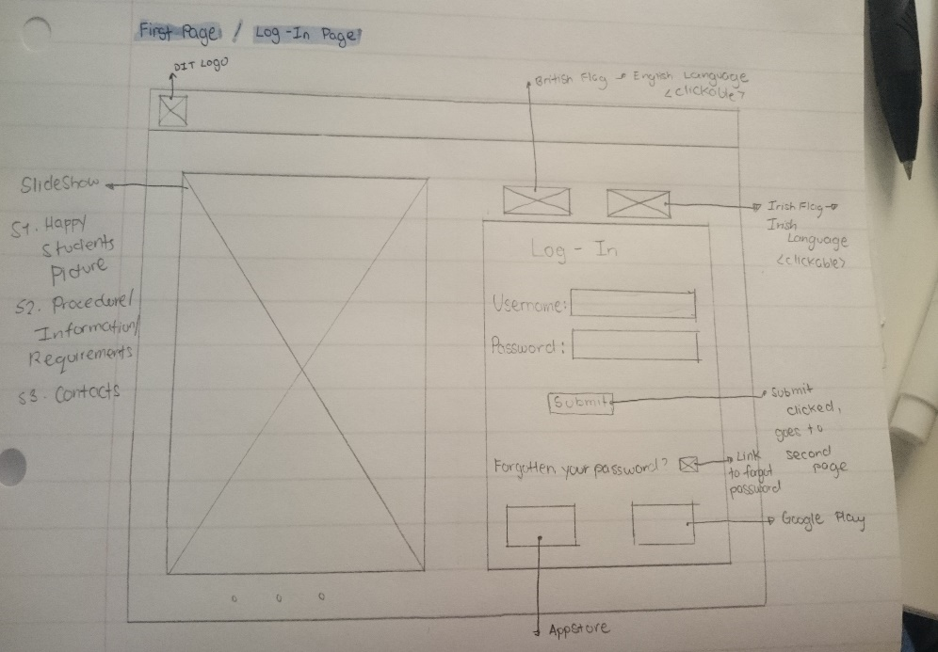

Figure 1-Jonathan's Design homepage

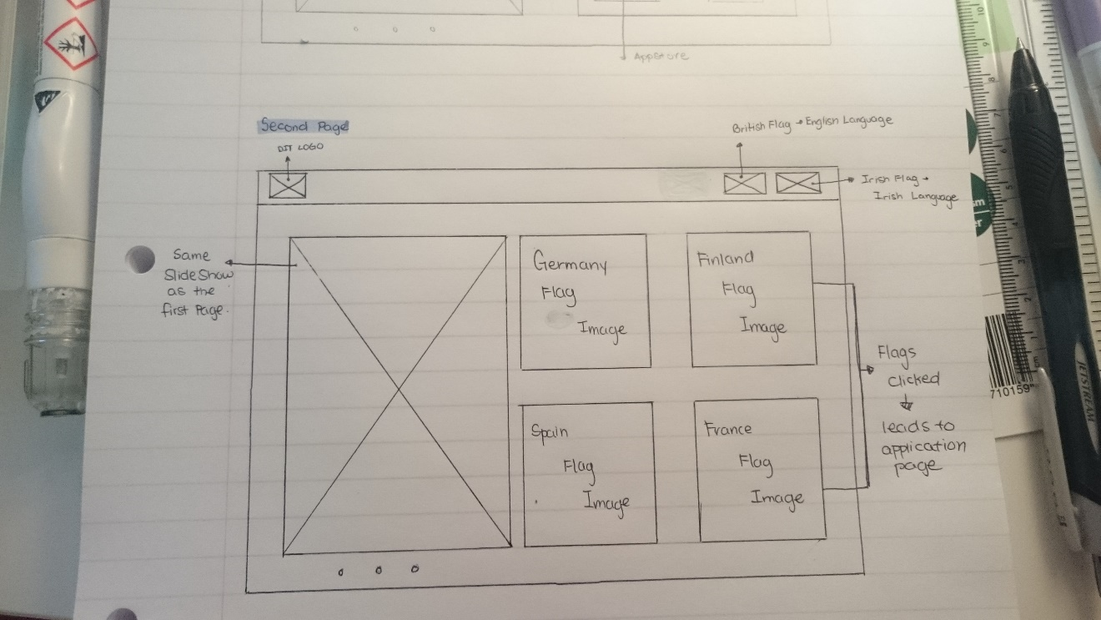

Figure 2-Erika's Design country picker page

We decided to go with a simple mainly visual and minimal design home and country page to satisfy the first persona’s needs and for the second persona we decided to go with a very visual, organized , colour coordinated design and is also filled with accompanying text and instructions.

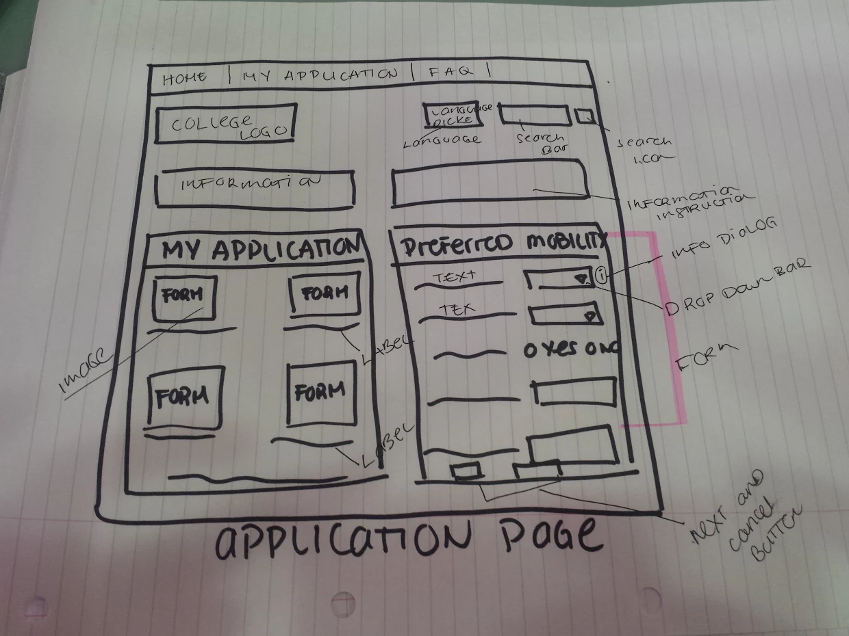

## Storyboard

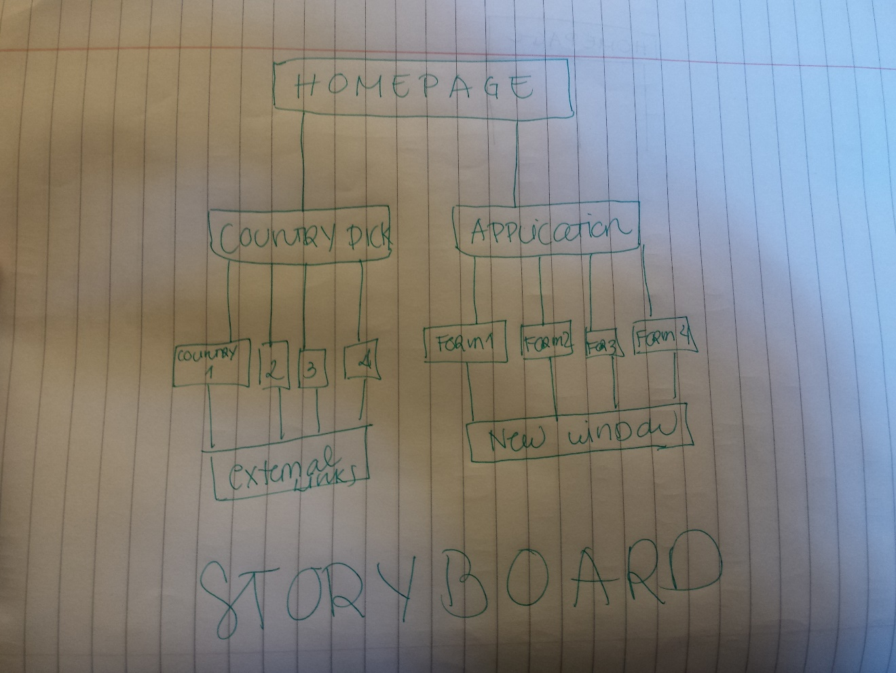

# **Heuristic Evaluation**

After creating our low-fidelity, we created a heuristic evaluation method and checklist based upon The Seven Principles of Universal Design.

1.Equitable Use

In hopes to implement this principle our design incorporated the ability to switch between languages in hopes to not isolate any specific user group. Our design incorporated colour co-ordination, appropriate font colour and style.

2.Flexibility in Use

Unfortunately, in the current design there isn’t much accommodation for user personalization and customization. The user can currently only personalize the language option. The user can also provide feedback to help further changes.

3.Simple and Intuitive Use

In hopes to convey simplicity and minimalism along with a sense of intuitiveness there are many buttons which have clearly indicated what their functions are when clicked. With this in mind, we also wanted to keep the design along the lines of simplicity which was incorporated through using flat design which often provides a non-cluttered appearance even when in an interface with multiple items present.

4.Perceptible Information

The information communicated to the user is clear as each button is labelled with regards to its functionality or navigational requirement, such as, “Home” which takes the user to the home page of the interface. The font used, Helvetica, is very clear and simple which shouldn't have the user confused with regards to certain words or letters or typography. The colours used are done in a manner where they all complement each other and allow maximum visibility of content.

5.Tolerance for Error

Aside from this the rest of the program requires mouse clicks and has minimal user input from a keyboard. All actions are reversible (i.e. switching between languages).

6.Low Physical Effort

Throughout the interface there is a “one-click” theme which has been constructed so that the user only needs one click to access information or separate pages which they wish to access.

7.Size and Space for Approach in Use

The size of the window is one that won’t take up the user’s entire screen on their computer, however, it is large enough that all information can be viewed clearly but small enough that there wouldn’t be any pixelation or issues if the user is on a smaller screen.

Individual report

JONATHAN NOBLE – C15487922

## **Page Design Prototype(MEFI)**

The user interface design that I was designated to was the Home Page or in our case – the Log-In Page. I based it on the primary persona – Caoimhe Sheeran – who is an Irish woman with a little time to spare so she prefers simplicity in choice, in functionality and in design.

I used PyQt to implement my low fidelity prototype and ensured that I adhere to every clause within our design guidelines when creating this prototype.

For this UI, the Hofstede’s cultural dimension I would mainly cover are: power distance and individualism. I made sure that what I implemented caters for both high and low of the cultural dimensions. Primarily, I implemented features that will showcase simplicity and I hope to extend each of the features in depth.

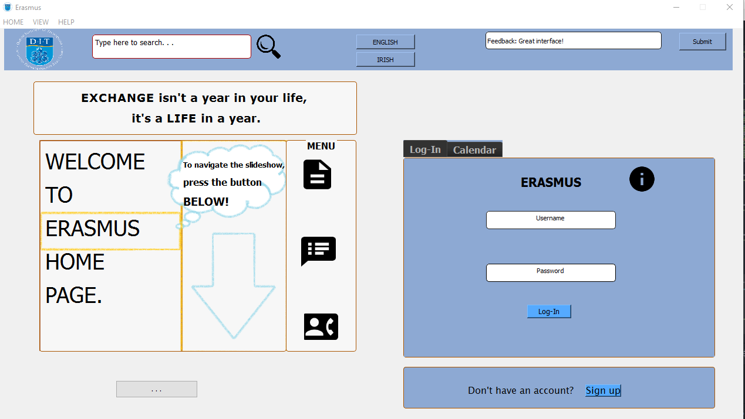

## **CATERING HOFSTEDE’S CULTURAL DIMENSIONS ON BOTH ENDS**

***Power Distance (PD)***

*At 28 Ireland sits in the much lower rankings of PDI – i.e. a society that believes that inequalities amongst people should be minimized. Within Irish organisations, hierarchy is established for convenience, superiors are always accessible and managers rely on individual employees and teams for their expertise.  Both managers and employees expect to be consulted and information is shared frequently.  At the same time, communication is informal, direct and participative.*

* Since Ireland has a low power distance index, they prefer informal layouts with clear access, and multiple choices on use. Flexible interactions that guide in case of errors will be valued. Visual elements that are more universal are preferred.
* Clear indicators of navigation that present all information at once are appreciated in high power distance countries WHEREAS less dense and informally organized structure is preferred in low power distance countries.
* Introducing visuals, expressions, images with authoritative body language, that are informative and guiding will work well in high power distance countries. Low power distance cultures may prefer activities of daily life, popular images, symbols and colours.

**HOW DO I CATER FOR BOTH ENDS?** The slideshow caters high power distance countries since it aims to provide a *RESTRICTED ACCESS* (singular button navigation only instead of the left and right selection) in information for dexterity considerations on people with control:

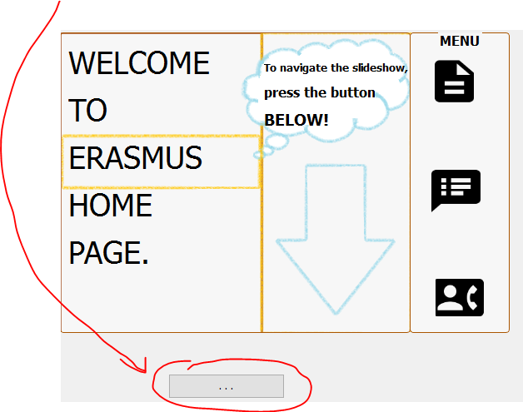

Also, the need of an instruction of support for navigational cues through the Welcome slide-show: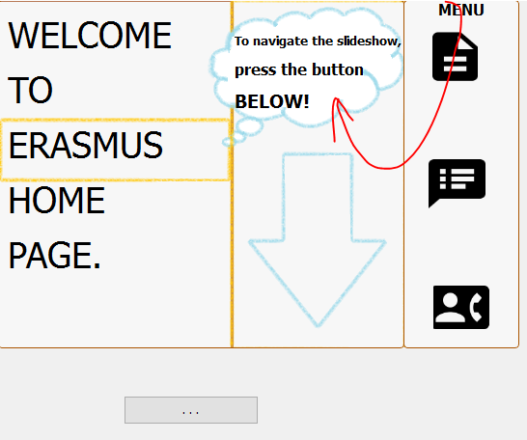

I also implemented a QUrl for a *STEADY* design that provides further text information of the application.

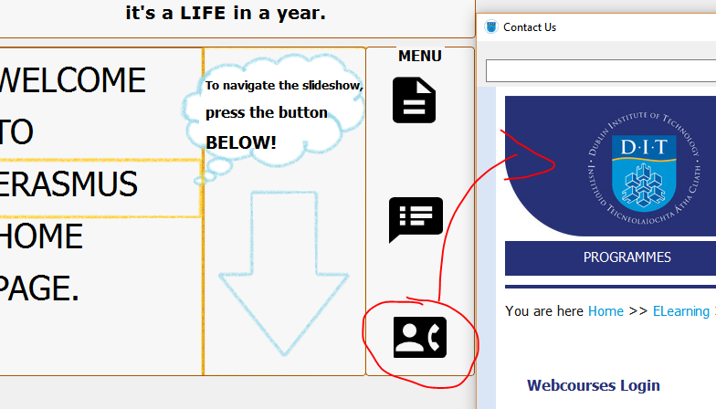

WHEREAS for the counterpart, it also caters low power distance since it brings a lot of functionalities by icon buttons and the buttons are mostly intuitive - not compared to high power distance where the button names are below them usually. Also, the widgets’ layouts are designed informally yet still assures that the UI appeals the user from *scanning the design* at a right pace and doesn’t give an impression of a forced by-product. Widgets then have different sizes to each other i.e. Horizontal layout on Slideshow whereas a vertical layout on the Menu beside it. Username and password tag-lines compared to our lo-fi design is **NOW** inside of the labels to improve simplicity. Another interesting thing about PyQt is that it can change the cursor indicator whenever an object is hovered through – which gives a more intuitive feeling to it.

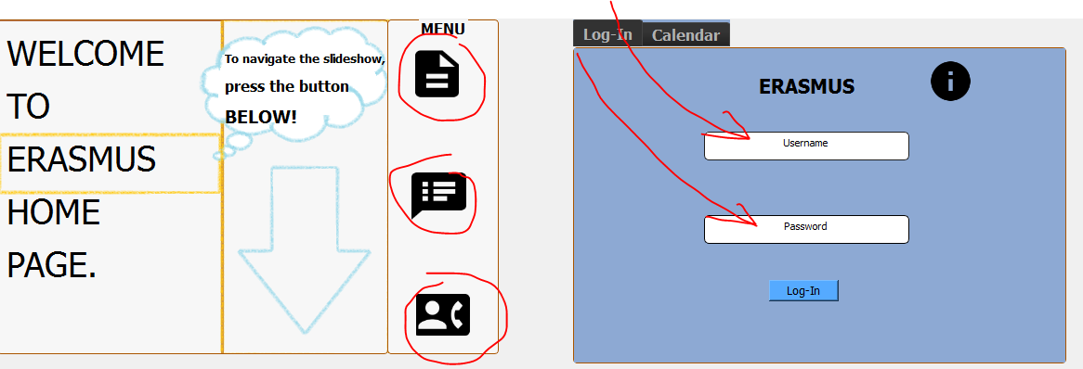

***Individualism***

*At a score of 70 Ireland is an Individualist culture. In the business world, employees are expected to be self-reliant and display initiative.  Also, within the exchange-based world of work, hiring and promotion decisions are based on merit or evidence of what one has done or can do.*

* Language, sound, videos and metaphors that emphasize individual successes will be preferred in high IDV countries; with larger successes and goals will matter more in low in IDV cultures.
* Individualistic countries will value importance given to the youth, whereas social actors of experience and wise leaders will be preferred in collectivist cultures.

**HOW DO I CATER FOR BOTH ENDS?** Colour scheme between the widgets and the slideshow brings out the traditional colour of Europe - blue and yellow - to enhance collectivism but the colour scheme between the background, icon buttons and the texts - black and white - bring out a monotonous tone for individualism. All in all, I think it brings fair balance to an average user.

The toolbar gives features to target users with high collectivism. I implemented a translation mechanism (which I have covered in the Localization section) and a feedback section to show the importance of diversity and criticism from a collectivist culture.



First image in slideshow that will show a youth among other youths to show the significance of the generation - essential for individualism:

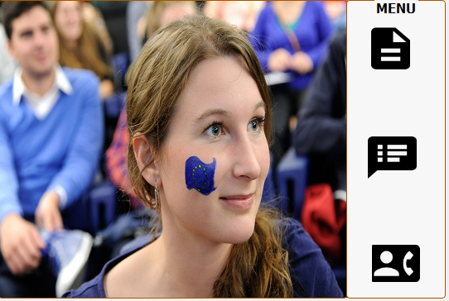

In addition, a metaphor to emphasize individual successes:

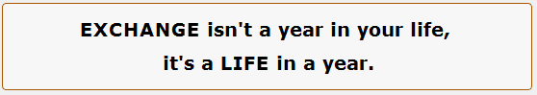

Also, a window for TESTIMONIALS to encourage user to be more interested in applying for Erasmus, all of which offers extrinsic rewards valued by individualism.

***Uncertainty Avoidance***

*At 35 Ireland has a low score on Uncertainty Avoidance. Ideas are important, being imaginative is appreciated. Irish businesses embrace creativity and are always looking for new ways to approach problems. Making a point with practical facts is more appreciated than the use of too much technical language.*

* Redundant cues in colour and typography that increase ambiguity are shunned by cultures with a high uncertainty avoidance index. They prefer very clean and distinct choices.
* Content and visuals that are clear and concretely associated with lives of individuals will be preferred greatly by high UA cultures.
* More general and symbolic messages with less detail will be valued by low UA cultures.

**HOW DO I CATER FOR BOTH ENDS?** Simplicity through the UI design is the major factor in catering a high UA whereas if you noticed, the spacing in between some of the texts in windows and buttons in the toolbar sticks together which is not ideal for a high UA design.

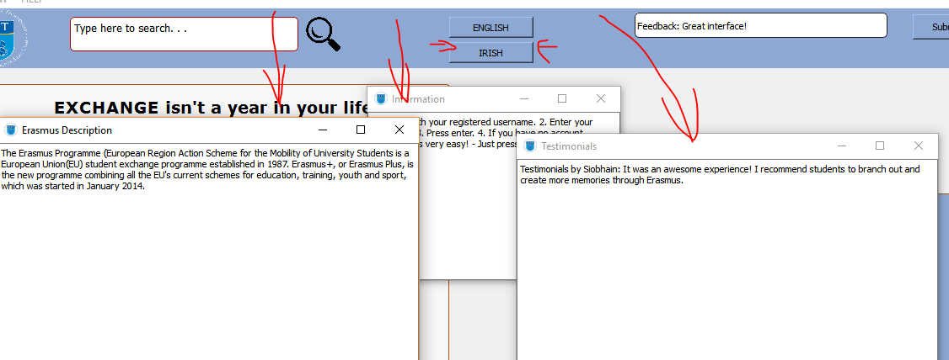

Also, the addition of a calendar and a real-time update offers confirmation of time thus less error for the user.

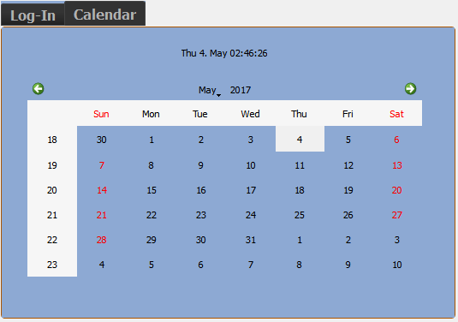

I implemented a log-in widget which would base it on the specified username “noble” and password “lad1234”. It gives an authentication error for the users so they acknowledge their human error.

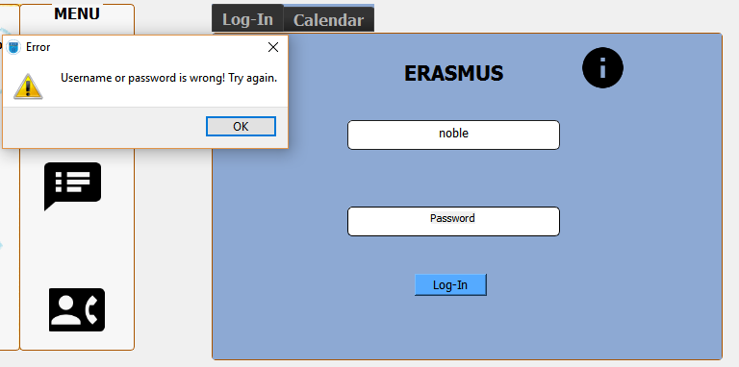

## **L10N and I18N**

These two methods are the epitome of Software for the Global Market and in order to achieve these methods, one must understand it. There are plenty of definitions about the two and sometimes are even mixed up. According to Apple:

**Internationalization** is the process of designing and building an application to facilitate localization. **Localization**, in turn, is the cultural and linguistic adaptation of an internationalized application to two or more culturally-distinct markets.

From my understanding, Internationalization is used to allocate the cultural needs of the market in the means of bettering the engineering behind a certain application. Meanwhile, localization is the offspring of the former and with it, applications are diversified globally and it is an immense impact in breaking cultural barriers around the world.

* Internationalization (i18n)
  + Creating a function for each of the language function instead of wiring each of the strings by hard-code - this then offers the ideal design of the aforementioned method and utilizes the ability of the user to adapt to the interface intuitively quick.
  + Lambda function used for translation mechanism of different languages
  + Use of colours/layout/user experience
  + Usage of gettext library
  + Usage of of Unicode(utf8) generated by PyQt Designer
* Localization (l10n)
  + Process of adapting software for a specific region or language by adding locale-specific components and translating text.
  + I implemented 2 translation one for Ireland (EN) and one for Irish(IE)
  + Usage of POEditor for text translation
  + Ideally, WindowTitle also changes to enhance the visibility of what type of cultural interface the user is in and usage of JSON for real-time geographical updates

Translating strings – Process

1. Marking translation strings in source code
2. Extracting them into a translation ready format
3. Translating them
4. Compiling the resource containing the translated string
5. Loading the translation into the application

# **Conclusion**

In conclusion, I found that the lecture notes and lab sessions really helped me to develop the user interface I have created. In this report, I have covered the elements and components I used to create the UX. I considered the users requirements within the interaction. I considered feedback mechanism in the context of the interaction. In the making I made sure that I adhered to the design guidelines. Moreover, I have addressed internationalization, localization and two of Hofstede’s dimensions.