- Data loading and preprocessing
  - Data loading
We begin by setting up the environment for the rest of the workflow. The code imports os, sets TensorFlow environment variables to suppress irrelevant warnings, and loads common libraries and modules. NumPy and TensorFlow random seeds are fixed to 24 so that the results can be reproduced later. Any warnings that appear do not affect the actual functionality and can be ignored.
The dataset includes sign_mnist_train.csv and sign_mnist_test.csv. Pandas is used to read and print the dataset structure; the training set contains about 27,455 records, and the test set about 7,172. A file existence check is added to prevent the program from crashing when files are missing.
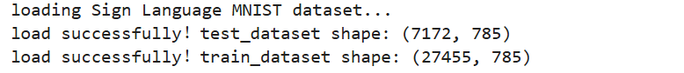
  - Preprocessing
Raw data are first converted to a suitable input format, and the mapping rules are defined. Pre‑processing maps the labels; extracts feature and normalises them. The normalised array is reshaped into a two‑dimensional image of size (28,28,1), and the integer labels are turned into one‑hot vectors to match the multi‑class classification output. This procedure works like a packaged function: it follows a standardised format and only needs the dataset to be supplied.

We reserve 10% of the training set as a validation set. The split is stratified using y_train_full (integer labels) so that the class proportions in both training and validation sets stay consistent with the full dataset. The test set is processed with the same function to keep the data distribution uniform. The output is shown below.
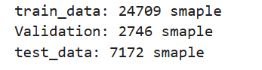
  - Justification
The original labels are integers from 0 to 25, skipping ‘j’ and ‘z’. Neural networks expect labels that start at 0, so we apply label_map to shift them. The inverse mapping reverse_label_map is kept for later visualisation. Pixel values are divided by 255 and scaled to [0,1]. This normalisation stabilises gradient updates, prevents activation values from becoming too large, and speeds up convergence. The data is reshaped to (28,28,1) so that convolutional kernels can extract local 2D features, meeting CNN input requirements. The to_categorical function converts integer labels into one‑hot encoding for the multi‑class output format. The validation set is used to monitor generalisation, enable early stopping, and adjust the learning rate.

The purpose of this pre‑processing is to keep model inputs on a similar scale, to reduce overfitting, and to standardise the data for CNNs.
  - Visualization
We created several visualisations to examine data quality and distribution at a glance.

Figure 1 shows 10 random test samples and their true labels, confirming that data loading and pre‑processing contain no errors.

Figure 2 presents examples of all 24 categories in a 3×8 grid, making it easy to compare the visual characteristics of each category.

Figure 3 checks whether the data is balanced. If the bars for certain letters are shorter, that category has fewer samples, and strategies such as oversampling may be needed later.
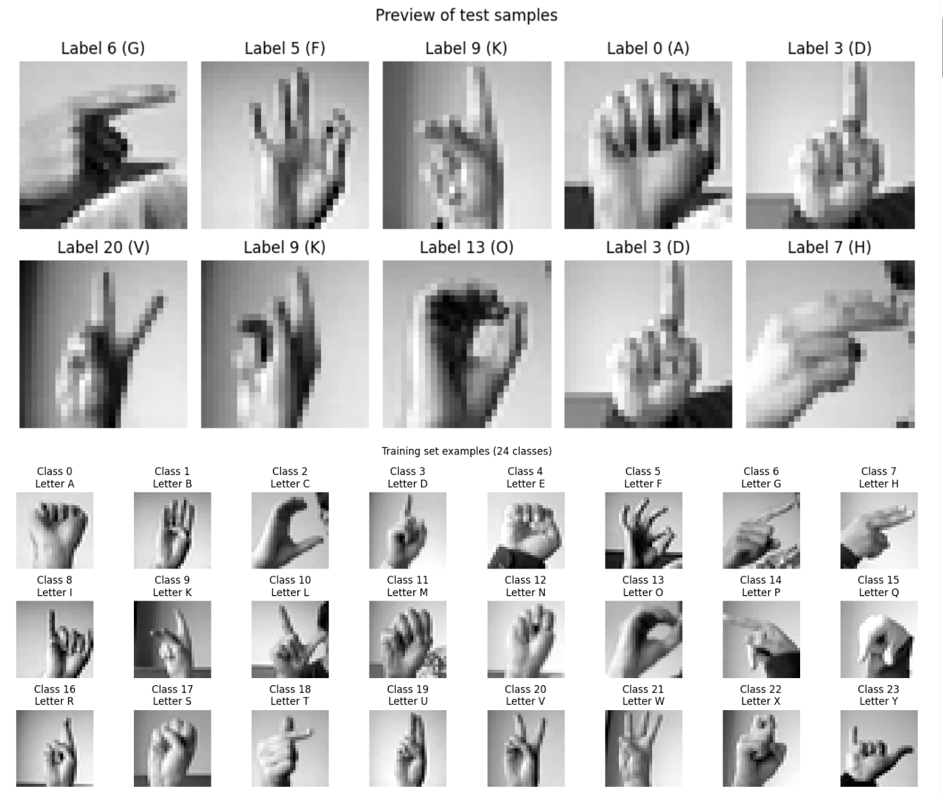
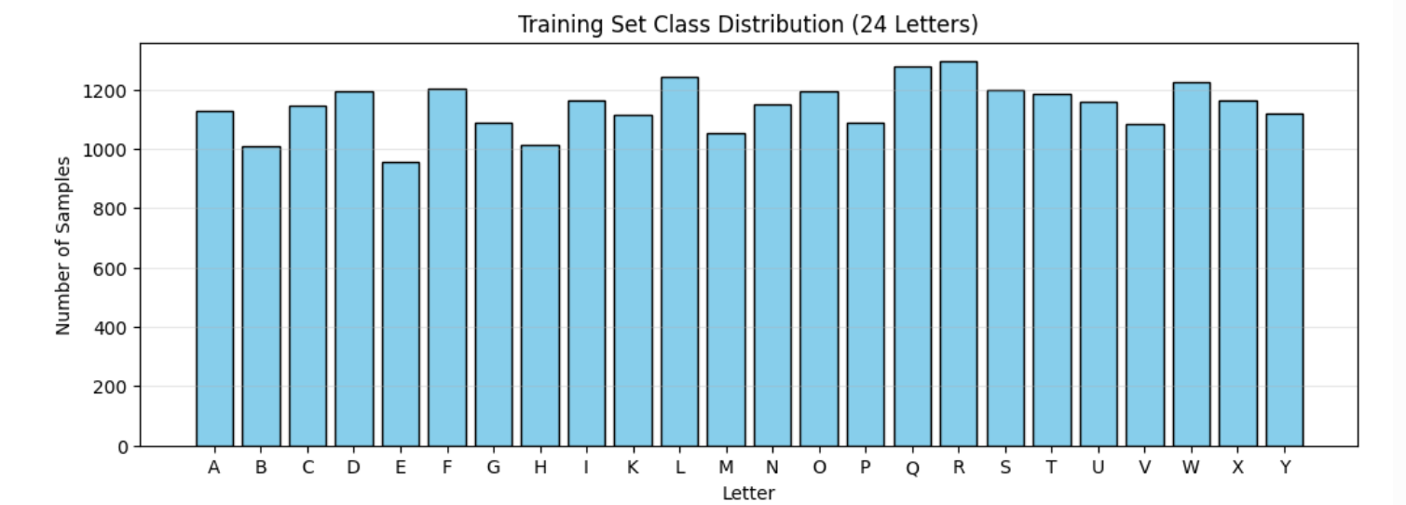
- CNN architectures
  - Model
We built two convolutional neural network models for sign language letter recognition: a simple baseline CNN and an enhanced VGG-style CNN (Simonyan & Zisserman, 2015). The baseline has a light architecture with few parameters and quick training. The VGG-style model deepens the convolutional layers and adds batch normalization to reach higher accuracy and stronger feature extraction.
  - Function encapsulation
To keep the code modular and readable, we wrapped the main steps into functions. The compile_and_train function configures the optimiser, loss and callbacks for the given model and data, runs the training, and returns the training history along with the elapsed time. Early stopping is used: if validation accuracy does not improve for 10 consecutive epochs, training halts to avoid a drop in performance from overfitting. The remaining three functions handle visualization and are discussed in Section 3.2 and 3.3.
  - Simple CNN
The simple CNN contains two convolutional-pooling blocks. The first block has 32 filters of size 3×3 with ReLU and padding, followed by 2×2 max-pooling. The second block uses 64 3×3 filters and the same pooling. The result is flattened into a 128-dimensional dense layer with a dropout rate of 0.5, and a 24-class SoftMax output layer finishes the network. The total number of parameters is about 423,000. This architecture trains quickly and provides baseline performance; it is suitable for hyperparameter tuning and as a reference benchmark for more complex models
  - Enhanced CNN
The VGG-style CNN has three convolutional blocks, each stacking two 3×3 convolution layers. The three blocks use 32, 64 and 128 filters respectively. Batch Normalisation is applied after every convolutional layer to speed up convergence and stabilise training. Each block ends with 2×2 max-pooling and a 0.25 dropout. The classifier part includes two hidden dense layers of 256 and 128 units, both with Batch Normalisation and 0.5 dropout, and a final Softmax layer outputs 24 classes. The model contains roughly 621,000 parameters. Stacking small kernels increases nonlinear capacity, and the heavier use of Batch Normalization and dropout helps control overfitting and improves generalization.
  - Comparison
comparison of the two models
Features | Simple Baseline CNN | VGG-style CNN
Number of convolutional layers | 2 | 6 (3 blocks, 2 layers each)
Filters per layer | 32, 64 | 32,32,64,64,128,128
Number of arguments | Less time, faster training | More parameters, excellent fitting capability
Suitable scenarios | Quick experiments, baseline performance | Pursuit of more accurate and robust feature extraction
The simple model has two convolutional layers, uses fewer filters, trains faster, and fits quick experiments. The VGG-style model has six convolutional layers, more filters and parameters, and aims for more accurate and robust feature extraction.

- Training, testing, and evaluation, including hyperparameters tuning
  - Hyperparameters
According to Ioffe & Szegedy stated (2015), We ran a grid search over learning rate (0.001, 0.0005), batch size (32, 64, 128) and optimiser (Adam, SGD). Each combination was trained for eight epochs with early stopping, and the highest validation accuracy was used as the evaluation metric. As shown in the figure based on the search results, Adam clearly outperformed SGD, a batch size of 32 gave the best results, and a learning rate of 0.001 reached a validation accuracy of 1.0. We selected this combination as the hyperparameter configuration for the following experiments..
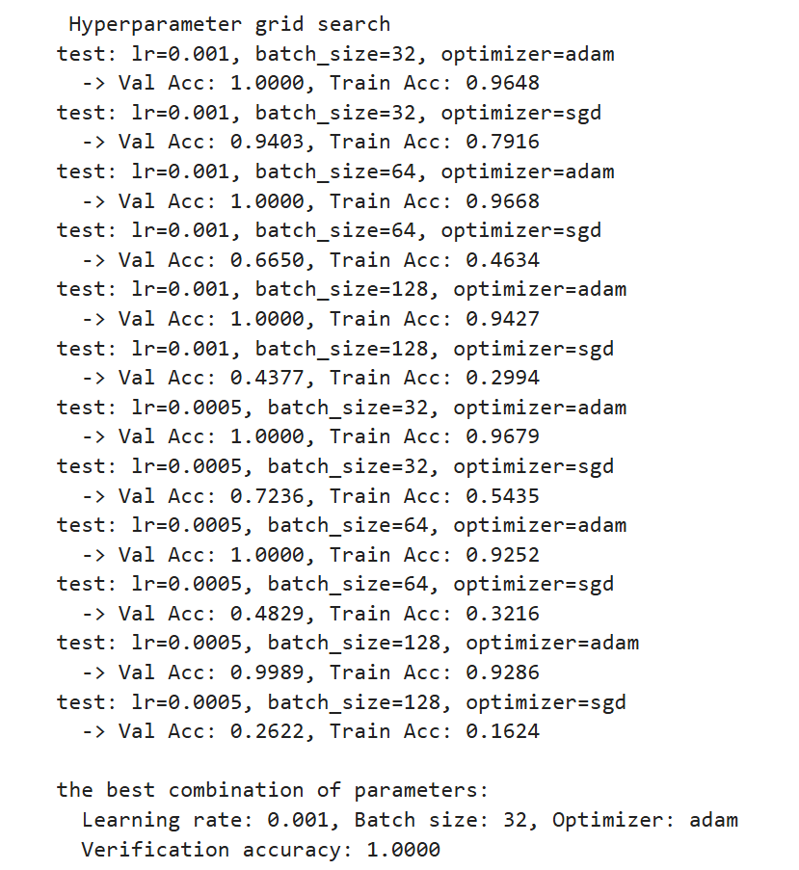

  - Training Curves and tables
Both models were trained for up to 30 epochs with the optimal hyperparameters. We also used ReduceLROnPlateau (monitoring validation loss, factor 0.5, patience 3) and EarlyStopping (monitoring validation accuracy, patience 10, restoring best weights).

The simple CNN stopped training at epoch 15. Its validation accuracy reached 1.0 by epoch 5 and stayed flat afterwards. The test accuracy was 0.9380 and the test loss was 0.2480. Although the validation accuracy was very high, the test accuracy was much lower, indicating some overfitting.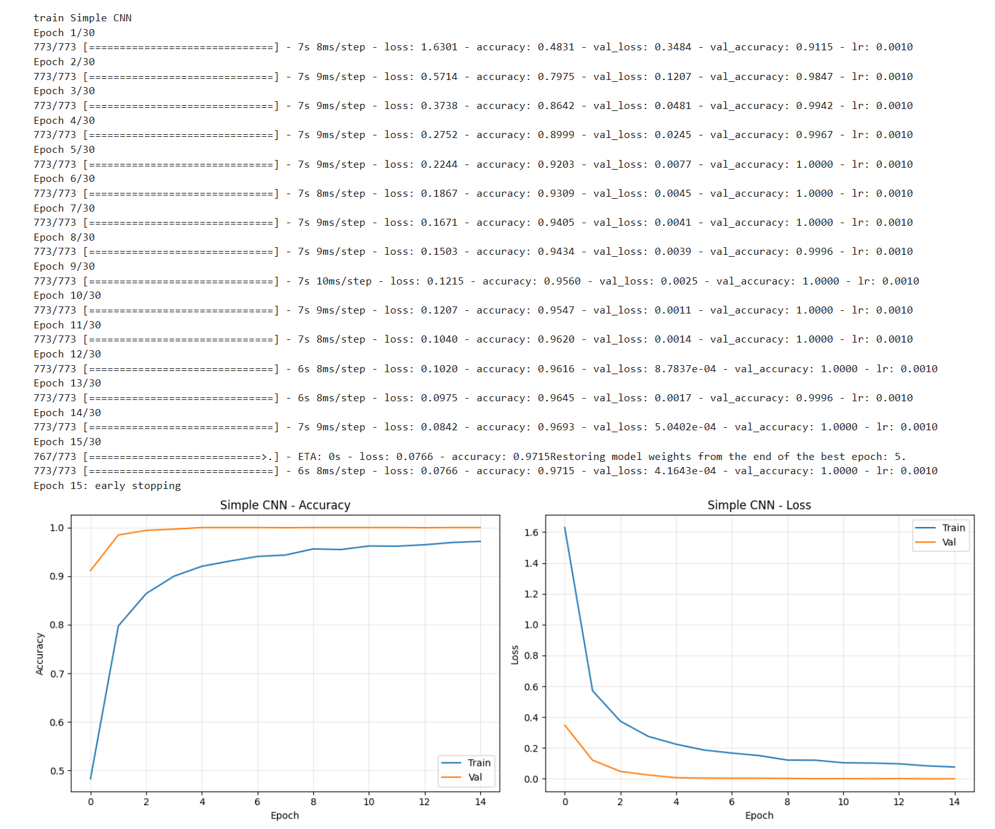
The VGG-style CNN stopped at epoch 18. Validation accuracy hit 1.0 at epoch 8, and the learning rate was reduced several times after that. The final test accuracy was 0.9893, with a test loss of only 0.0229. Its generalisation was clearly better than that of the simple CNN..
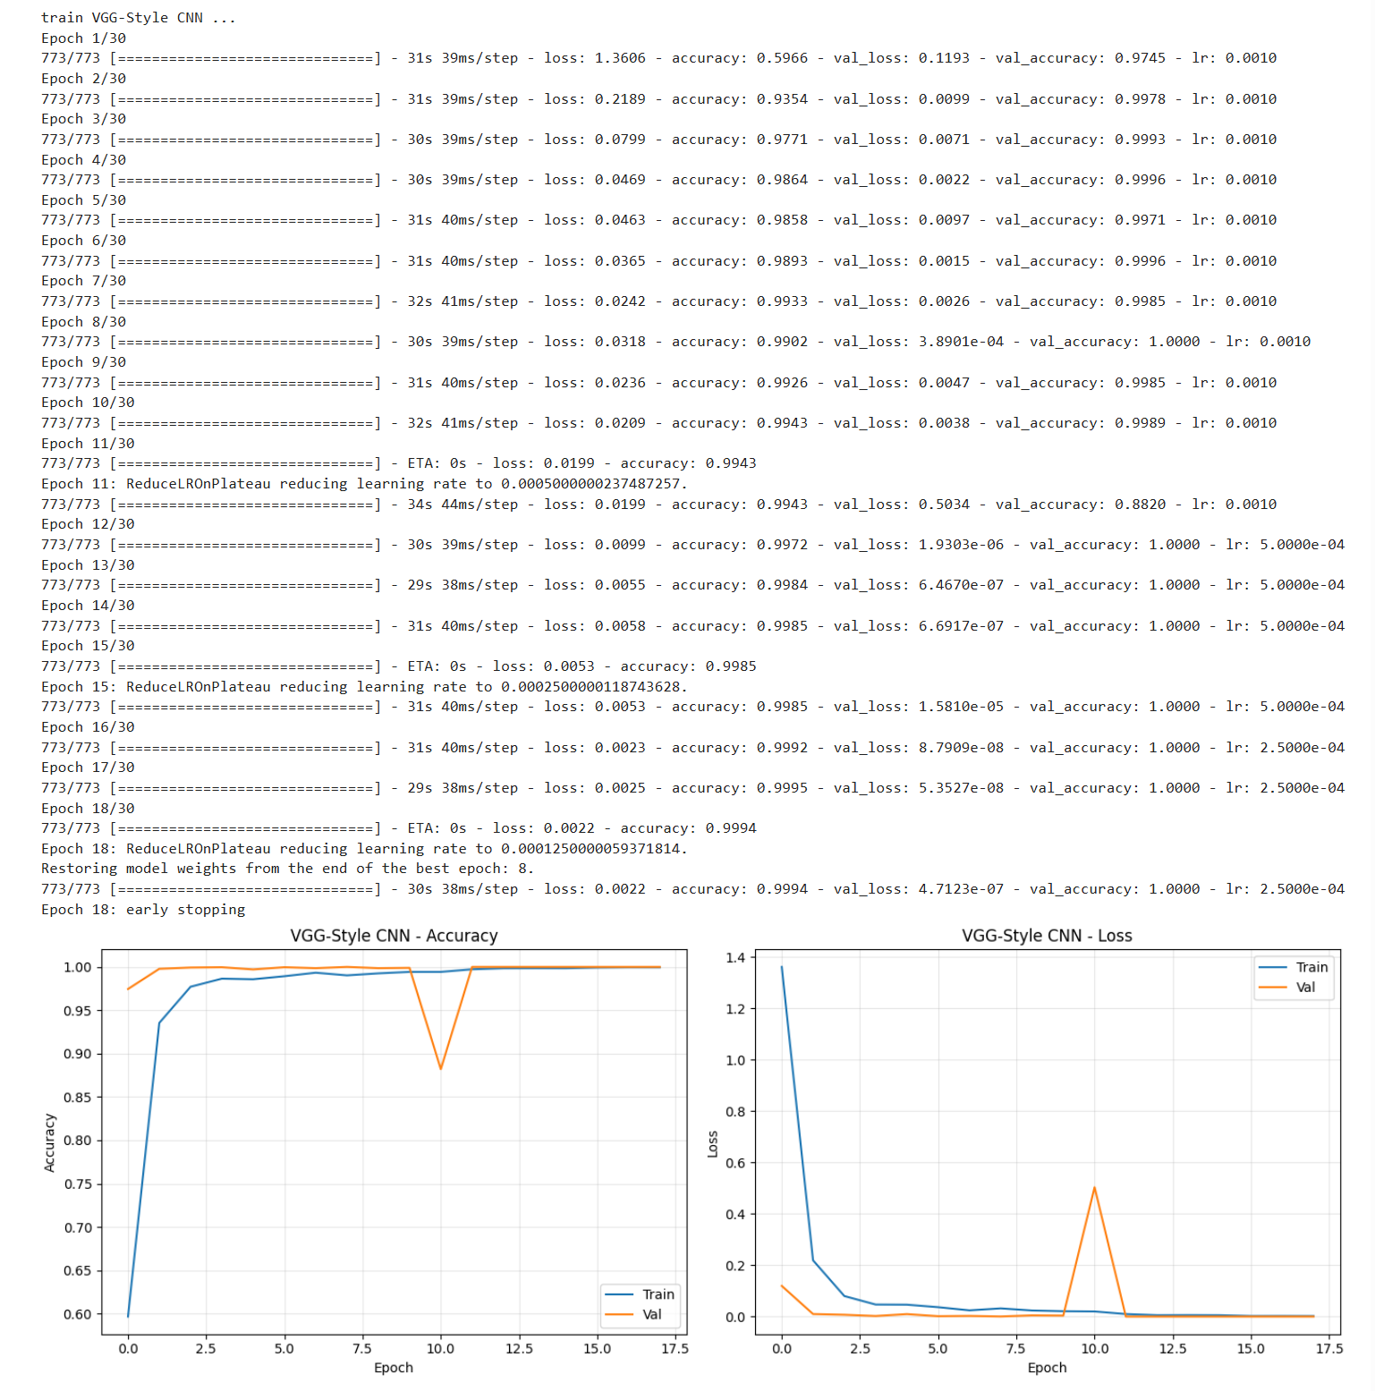
The simple CNN trained for about 101 seconds, while the VGG-style CNN took about 553 seconds. A gain of approximately 5.1% in accuracy is worth the extra complexity. The figure below therefore shows more clearly that the VGG-style CNN is the better model..
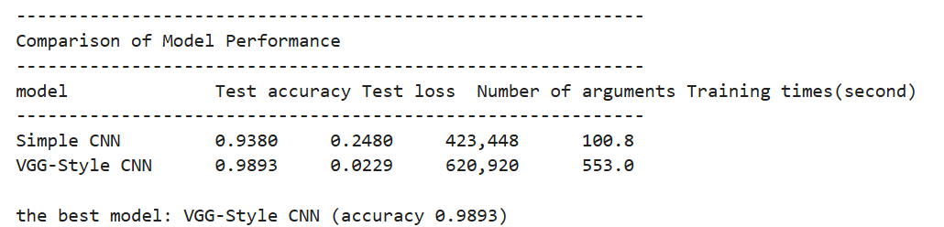
  - Confusion Matrix
We performed a detailed evaluation of the best model, the VGG-style CNN. The confusion matrix shows that predictions were accurate for most categories. Errors were concentrated among a few letters that are easily confused: the recall for ‘R’ was 0.90, for ‘T’ 0.92, and for ‘G’ and ‘M’ around 0.95. This suggests that some gestures share visual similarities, such as ‘R’ and ‘U’, or ‘T’ and ‘D’. The overall weighted average F1 score reached 0.99, and the classification report confirms that the model recognises sign language letters reliably. Prediction results for a random set of 16 test samples further support its strong performance on real images. Green marks a correct prediction, red an incorrect one
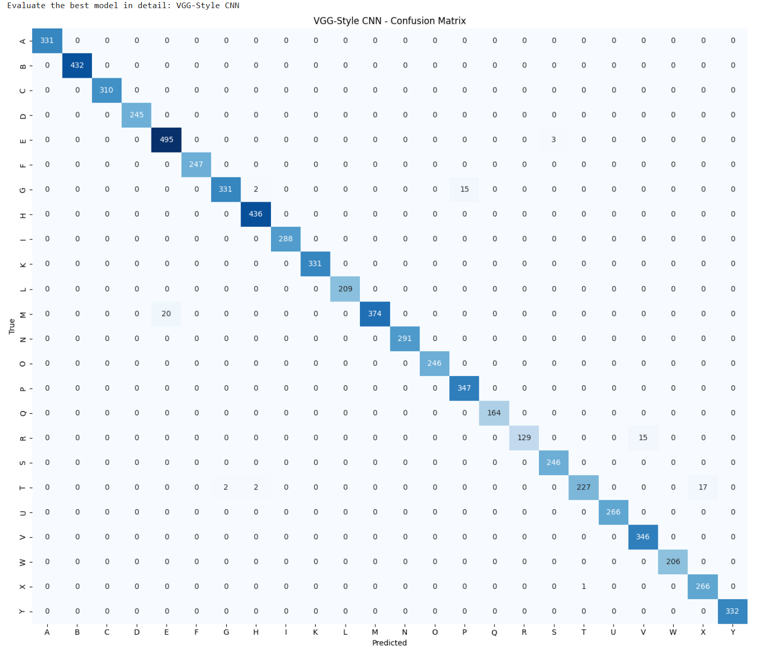
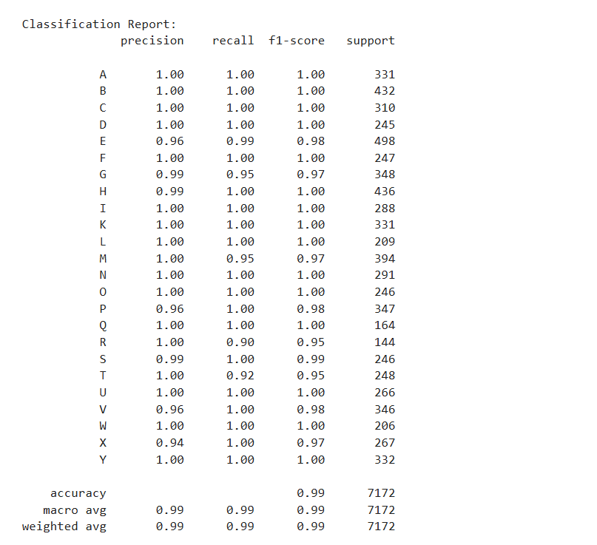
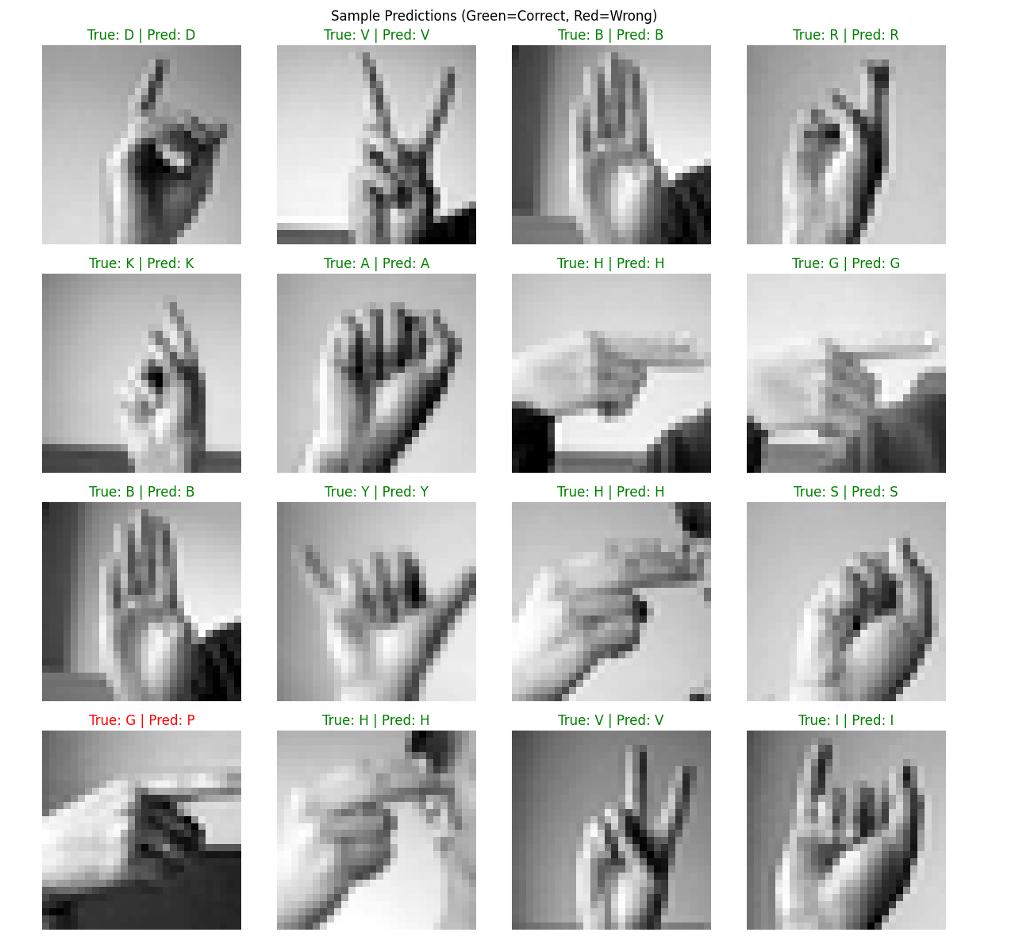

- Reflection
This experiment built a lightweight CNN and an enhanced VGG-style CNN for sign language letter recognition. The VGG-style model reached a test accuracy of 98.93%, which shows that deep convolutional networks can learn subtle features of static gestures well. A few points deserve attention.
The hyperparameter search was run only on the simple CNN. The results can transfer to more complex models, but tuning the VGG model separately might find a better configuration. Deeper networks could have a different optimal pair of batch size and learning rate.
This work also has some limitations. The data came from static images in the MNIST dataset. The dataset already includes some augmentation, yet sign language recognition should be more robust to rotation, translation and scaling (Kaggle, 2026). Adding augmentation like small-angle rotation, translation and brightness adjustment would likely strengthen generalisation and narrow the gap between the training and validation sets. Class confusion tends to happen among letters with similar shapes. Possible improvements include using attention mechanisms, designing weighted loss functions for easily confused categories, or taking higher-resolution input images to capture subtle differences.
The model does not recognize ‘J’ and ‘Z’ because those letters involve motion. Future work could feed frame sequences into a recurrent neural network or use spatio-temporal convolutions to cover all American Sign Language letters.

.5. Reference List
Kaggle. (2026). Sign Language MNIST. Available at: Sign Language MNIST (Accessed: 6 May 2026)
Ioffe, S. & Szegedy, C. (2015) Batch Normalization: Accelerating Deep Network Training by Reducing Internal Covariate Shift. Available at: 1502.03167 (Accessed: 6 May 2026)
Simonyan K & Zisserman A (2015) VERY DEEP CONVOLUTIONAL NETWORKS FOR LARGE-SCALE IMAGE RECOGNITION. Available at: 1409.1556 (Accessed: 6 May 2026)

