Part1
topic：Smalltalk introduction The Language That Shaped Modern Computing
content：
- participant：Lesley, Karley, Jonathan, Jiao
- course：CSCU9Y4 — Stirling College, ChengDu University
Design recommendation：
Background use plain academic style.

Overview
topic：Presentation Overview
content：
- History & Background：
- Core Concepts & Modern Comparison：
- Impact & Applications：
- Learning Experience & Demo：
- Note at the bottom：Each section approximately 2.5 minutes。
Design recommendation：
- Maintain a clear structure and concise text layout.

First part：（History & Background）
- Smalltalk origin
  - topic：Origin of Smalltalk
  - content：Developed by Alan Kay and his colleagues in 1972, Smalltalk is the world’s first object-oriented programming language. It was originally envisioned as a computer programming tool for children of all age groups. The language has undergone multiple version iterations. Key Quote: "The best way to predict the future is to invent it" — Alan Kay
- history：
2.1 topic: Language Evolution
  - content: 1967, Smalltalk-72: Pioneered the core concepts of object-oriented programming languages. 1976, Smalltalk-76: Introduced bytecode virtual machine and one-time compilation mechanism. 1980, Smalltalk-80: Became a widely adopted version and launched for commercial use.
Design recommendation：
- Adopt timeline icons to visually highlight the evolutionary history of Smalltalk.
Part2
Overall objective:
Create a 3-page PPT to clearly explain the two core mechanisms of Smalltalk (everything is an object, message passing), compare it with Python, and showcase its grammatical features as well as its impact on modern languages/systems.
Production Process:
Read the paragraphs in the reference materials [1][2][3] that deal with the object model, message passing, and grammar.
Write a comparative text, ensuring that there are clear statements for each dimension regarding Smalltalk and Python.
Create a 3-page PPT, maintaining simplicity.
Add the reference page and verify the accessibility of the URL
Key design decision:
Abandon the table and switch to a text list: Make the comparison more readable and avoid the font size being too small when projecting the table. Reference integration: At the bottom (or end) of each page, cite the corresponding references to demonstrate academic support.

Part3
Download Squeak.
Left-clicking on a blank background is Smalltalk's unique communication
method.
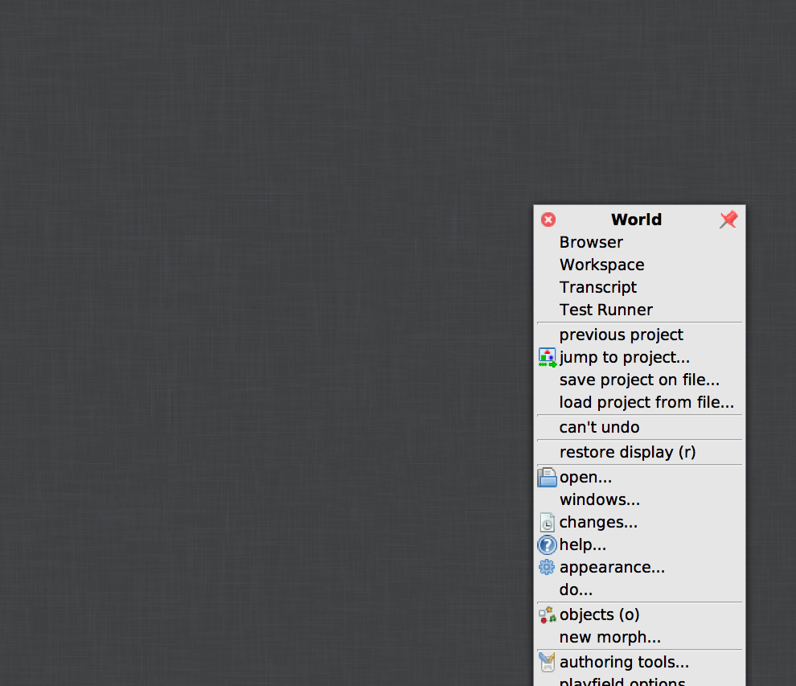
A Word document appears.
Click "tools," then "workspace." This is where we write temporary code.
Next, click "Tools" to open the Workspace.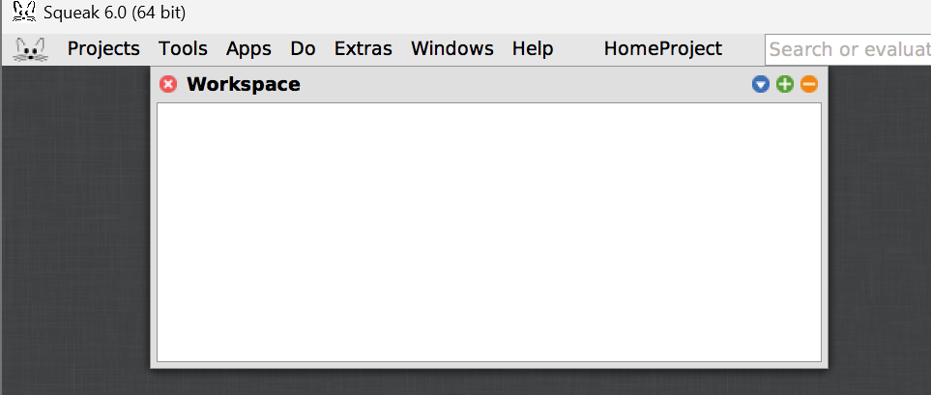
In the Workplace, type `Transcript show: 'Hello World'; cr.`. Select this line and press Ctrl + D to run the code. You will then see the output in the Workplace.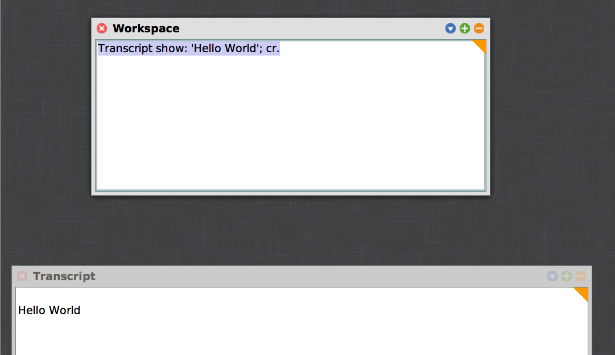
Ingalls, D., Kaehler, T., Maloney, J., Wallace, S. and Kay, A. (1997) 'Back to the future: the story of Squeak, a practical Smalltalk written in itself', ACM SIGPLAN Notices, 32(10), pp. 318–326. doi: 10.1145/263700.263754.
Ingalls, D.H.H. (1981) 'Design principles behind Smalltalk', Byte, 6(8), pp. 286–298.Avaliable at ：https://worrydream.com/refs/Ingalls_1981_-_Design_Principles_Behind_Smalltalk.pdf
Maloney, J.H. and Smith, R.B. (1995) 'Directness and liveness in the morphic user interface construction environment', Proceedings of the 8th annual ACM symposium on User interface and software technology (UIST '95). pp. 21–28. doi: 10.1145/215585.215636.
Deutsch, L.P. and Schiffman, A.M. (1984) 'Efficient implementation of the Smalltalk-80 system', Proceedings of the 11th ACM SIGACT-SIGPLAN symposium on Principles of programming languages. New York: Association for Computing Machinery, pp. 297–302. doi: 10.1145/800017.800542.
Part4

I am responsible for the fourth part of the PPT: Application Areas and Summary.
First, I reviewed the relevant literature on Smalltalk, and organize the historical applications, modern uses and influence;
Then I wrote the content and create the PPT pages, along with the Squeak interface diagram;
finally, I cited the references as required, check the content with the team and complete the final version.

