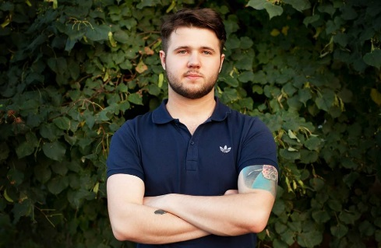

**Holovko Sasha**

julienk53@gmail.com

Tel.: 054 527 26 72

**Desired position:** Motion, web and graphic designer

**About:**

Age: 26

Place of birth: Dnipro, Ukraine

Citizenship: Ukranian

**Languages:**

Russian — Native

Ukraine — Native

English — Intermediate

Hebrew — B

**Education:**

Master: 2008-2013

Oles Honchar Dnipro National University

Educational programme: Biology, ecology and medicine

GPA: 75 of 100

**Skills:**

• Adobe Photoshop, Adobe Illustrator, Adobe After Effects, Cinema 4d

• FL Studios, Cubase, Studio One

• MS Office

• I have diploma of IBA

**Experience:**

More than 3 years in web-design. I’ve been working at big Ukraine web studios. Also have been working like freelancer

**Extracurricular activities:**

*Additional information:* Work barmen more than 5 years, play in Jazz band,

*Personal qualities:* **I want to grow up in design,** Accurate, quick study, disciplined, resilient, no bad habits

*Hobbies:*Music, writing lyrics, painting, football, קרב מגע, tattoos, comics Marvel & DC

*Driving license:* Category B