

Forensics environment for aiding the analysis of security IR artifacts

30 November 2021

<Consultant name>
AWS Professional Services

Developed for:
<Customer name>

Disclaimer
Disclaimers. The following applies to this document and all other documents, information, data, and responses (written or verbal) provided by Amazon Web Services, Inc. or any of its affiliates (collectively, "AWS") in connection with responding to this request and other related requests (collectively, this "Response"): This Response is expressly (a) informational only and provided solely for discussion purposes, (b) non-binding and not an offer to contract that can be accepted by any party, (c) provided "as is" with no representations or warranties whatsoever, and (d) based on AWS's current knowledge and may change at any time due to a variety of factors such as changes to your requirements or changes to AWS's service offerings. All obligations must be set forth in a separate, definitive written agreement between the parties. Neither party will have any liability for any failure or refusal to enter into a definitive agreement. All use of AWS's service offerings will be governed by the AWS Customer Agreement available at http://aws.amazon.com/agreement/ (or other definitive written agreement between the parties governing the use of AWS's service offerings) (as applicable, the "Agreement"). If the parties have an applicable Nondisclosure Agreement ("NDA"), then the NDA will apply to all Confidential Information (as defined in the NDA) disclosed in connection with this Response. AWS's pricing is publicly available and subject to change in accordance with the Agreement. Pricing information (if any) provided in this Response is only an estimate and is expressly not a binding quote. Fees and charges will be based on actual usage of AWS services, which may vary from the estimates provided. Nothing in this Response will modify or supplement the terms of the Agreement or the NDA. No part of this Response may be disclosed without AWS's prior written consent.

Table of Content

Table of Contents
Introduction 3
Purpose of the environment 3
Overview 4
Prerequisites 5
Setup 6
Ongoing usage 7
Memory and disk image acquisition 7

Introduction
This document describes the process of building a forensics environment for gathering artifacts and performing analysis to aid current security incident response. Due to the temporary nature of the incident analysis environment, analysts will be able to stand up multiple copies to use it for various purposes, e.g. training, actual analysis that can be even run in parallel on different samples or with different settings.

Purpose of the environment
Forensic analysis follows a standard digital forensic process or phases which are acquisition, examination, analysis and reporting. Investigations will be performed on static data (e.g. acquired memory or disk images) as well as dynamic, “live” but segregated systems.
By using this environment, a Security Operations Centre team will be able to improve their security incident response process through:
- Having ability to perform forensics in a segregated environment to avoid accidental compromise of production resources
- Having a standardized, clean environment to perform incident analysis and forensics without the noise of a larger environment
- Having the ability to create multiple analysis environments in parallel
- Focusing SOC resources on incident response and not maintenance and documentation of a cloud forensics environment
- Moving away from manual hands-on process towards an automated one to achieve scalability
- Using scripts for consistency and to avoid repeatable tasks
Additionally, customers will avoid using persistent infrastructure and pay for resources when they need them.

Overview
The environment will consist of 2 main accounts – a Security and a Forensics accounts. The reason for having 2 accounts is to separate them from any other customer accounts to reduce blast radius in case of a failed forensic analysis, ensure the isolation and protection of the integrity of the artifacts being analyzed, and keeping the investigation confidential. Separate accounts also avoid situations where the threat actors might have used all the resources immediately available to your compromised AWS account by hitting service quotas and so preventing you from instantiating an Amazon EC2 instance to perform investigations. Also, having separate Security and Forensic account allows for creating separate roles – a Responder for acquiring evidence and an Investigator for analyzing it. Each of the roles would have access to their separate accounts.

The Security account is where the 2 main Step Functions are created for memory and disk image acquisition. Once executed, those reach to the Member account (an account with the EC2 instances involved in an incident) and execute a set of Lambda functions that will gather either a memory or disk dump. Those artifacts are then stored in the Forensics account.
A Forensics account will hold the artifacts gathered by the Step Functions in the “Analysis artifacts” S3 bucket.
The Forensics account will also have a EC2 Image Builder pipeline that builds an AMI image of a Forensics instance. Currently it’s based on SANS™ SIFT Workstation (https://www.sans.org/tools/sift-workstation/). The build process uses the Maintenance VPC which has connectivity to the Internet.
This can be later used for spinning up EC2 instance for analysis of the gathered artifacts in the Analysis VPC. The Analysis VPC does not have Internet connectivity. By default, the AWS ProServe creates 3 analysis subnets. More subnets can be created (up to 200 which is the quota for number of subnets in VPC) but the VPC endpoints need to have those subnets added for SSM Sessions Manager to work in them.
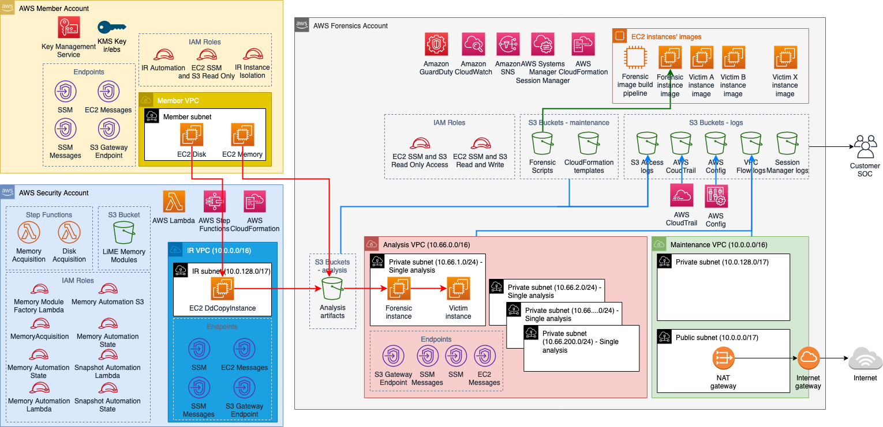

Prerequisites
The following is a list of prerequisites required to build the forensics environment as described in the Overview:
- 2 accounts
  - Security account - can be existing already, preferably fresh
  - Forensic account - preferably fresh
- AWS Organizations set up
- In Member accounts:
  - EC2 role needs to be able to access S3 (Get / List) and be accessible by SSM. It’s suggested to use AWS managed roles:
    - AmazonSSMManagedInstanceCore
    - AmazonS3ReadOnlyAccess
  - VPC Endpoints need to be added to VPC and Subnets in which the target EC2 instances reside. Those endpoints are: S3 (gateway), EC2messages, SSM and SSMMessages
- If the EC2 instances don’t have AWS CLI installed, Internet access will be required for the disk snapshot and memory acquisition to work. In this case the scripts will reach out to the Internet to download the AWS CLI installation files and will install them on the instance in scope.

Setup
To set up the environment follow these steps:
- Get hold of the:
  - Organization ID
  - Security account ID
  - Decide on the Object Lock Retention Period (Def.: a fixed period of time during which an object remains locked. During this period, your object is WORM-protected and can't be overwritten or deleted)
- Deploy the Cloud Formation scripts in the following order:
  - Deploy in the Forensic Account
    - Run the forensic-AnalysisVPCnS3Buckets.yaml in Forensics account
    - Run the forensic-MaintenanceVPCnEC2ImageBuilderPipeline.yaml in Forensics account (this one takes longer (~1h) to create as it already creates the EC2 pipeline and executes it)
    - Set the SSM Session Manager logs to be forwarded to the relevant S3 that was created
  - Deploy in the Security Account
    - Deploy security-ir-disk-automation.yaml
    - Deploy security-ir-memory-automation.yaml
    - Deploy security-LiME-Volatility-factory.yaml. This template will ask you about a few parameters:
      - The VPC and Subnet in which it will create temporary EC2 instances. This VPC will need to have access to the Internet as the temporary EC2 instances will download LiME files from GitHub to be able to create LiME modules.
      - Another parameter asked for are the AMI IDs for which you want to create LiME modules.
For example as of 2021.10:
ami-074cce78125f09d61,ami-00399ec92321828f5,ami-0b9064170e32bde34,ami-0d563aeddd4be7fff
would create LiME modules for: Amazon Linux 2, Ubuntu Server LTS: 16, 18, 20
NOTE: After the CF template completes, there will be EC2 instances running to create the actual LiME modules. It will take some time after the CF template completed.
    - Deploy security-IR-vpc.yaml
  - Deploy in the Forensic Account:
    - forensic-artifact-s3-policies.yaml
  - In each of Member accounts, deploy member-ir-automation.yaml

Ongoing usage

Memory and disk image acquisition
In order to perform a memory or disk image acquisition:
- Log in to the Security Account and go to the Step Functions service
- Select “State machines” from the menu:
- From the list of available “State machines” select the one which you intent to run – either “DiskAcquisition” or “MemoryAcquisition”:
- On the new screen you will be able to see a list of previous executions at the bottom. To start a new execution of the step machine, click the “Start execution” button on the top:
- In the pop-up form, fill out the required details. The “Name” field of the execution if optional but helps to identify previous executions (as seen on screen above in point 4.)
The “Input” field, although described as optional, is in fact required by the Memory and Disk Acquisition state machines. It provides required parameters for the underlying scripts to run successfully. The format used is JSON.
The following parameters are used:
  - CaseId – String for case ID. It can be anything that helps you map it to your security incident management system.
  - InstanceId – the ID of the instance on which you intend to perform the memory or disk acquisition
  - Account – the Member account number where the instance is running
  - Region – the region name where the instance is running
  - RetainArtefacts – should the volume snapshots be also left in the Security account after they have been processed and stored in the Forensic Account in the IR-Artifacts bucket
An example execution JSON:
{
"CaseId": "INC456789",
"InstanceId": "i-3f182ce62a7962a53",
"Account": "234567890123",
"Region": "us-east-2",
"RetainArtefacts": "true"
}

- After the necessary parameters have been provided, press the “Start execution” button on the bottom right.
- As the state machine execution progresses, you can check the details of each step. Click on a completed step (marked in green) and then click the link to see the CloudWatch Logs. This functionality is useful in case of a need to troubleshoot.
- After a successful execution of the state machine, the artifacts can be found in the Forensics Account in the “<account number>-ir-artifacts” S3 bucket.
The artifacts will be in the folder named after the CaseId parameter:

