# **ABSTRACT**

With the development of smart phones, tablets and computers, people prefer accomplishing their daily task on these devices. Mobile phones are nowadays far more than merely devices to communicate with. Smartphones are products that helps to make our work and everyday life activities easier. This is mainly because they are portable and simple to use. Based on technology like AI, sensors, cloud, online meeting and e-learning applications, learning with the mobile phones or computers has become a possibility. This project deals with development and implementation of an e-learning application for Students especially IT and Computer Science students who finds it difficult to program due to the inadequate programming learning materials. Student students finds it difficult to learn programming because they use the local way which is coding on paper. In the context of this project an e-learning platform is developed which contains the basics of various programming language and compiler that will help learners to try their hand on what they have learnt. The application is capable of teaching student and asking question pertaining to their area of study. There are experts of the platform that will guide studiers if they are facing any challenges. The application was designed and developed on a web based using the incremental model methodology. CSS and bootstrap were used for the main interface; php was use for the back end.

Table of Contents

ABSTRACT i

LIST OF FIGURES iii

ABREVIATIONS iv

CHAPTER ONE 1

**1.1 BACKDROUND** 1

**1.2 STATEMENT OF THE PROPLEM** 1

**1.3 OBJECTIVES OF THE STUDY** 2

**1.4 RESEARCH QUESTIONS** 2

**1.5 SCOPE OF THE STUDY** 2

**1.6 ORGANISATION OF THE WORK** 2

**Chapter one Introduction** 3

**Chapter two Literature review** 3

**Chapter three Methodology** 3

**Chapter four Design and Development** 3

**Chapter five Conclusion and Recommendation** 3

CHAPTER TWO 4

LITERATURE REVIEW 4

**2.1 RESEARCH ON SUBJECT AREA** 4

2.1.1 WHAT IS E-LEARNING DEVELOPMENT? 6

2.1.2 QUESTIONS TO ASK ABOUT AN E-LEARNING PLATFORM 7

2.1.3 GENERAL BENEFITS OF E-LEARNING 9

CHAPTER THREE 16

METHODOLOGY 16

**3.1 RESEARCH DESIGN** 16

3.1.1 STUDY AREA 17

3.1.2 OBSERVATIONS 17

3.1.3 INTERVIEW 17

**3.2 SOFTWARE DEVELOPMENT LIFE CYCLE** 18

FIGURE 3.1 INCREMENTAL MODEL DIAGRAM 20

**3.3 RATIONAL BEHIND INCREMENTAL METHOD** 21

**3.4 PROJECT WORK PLAN** 21

**3.5 REQUIREMENT ELICITATION** 21

REQUIREMENT ELICITATION DIAGRAM 22

**3.6 REQUIREMENT GATHERING** 23

**3.7 REQUIREMENT ANALYSIS** 23

**3.8 DEVELOPMENT PACKAGES AND DEVICES** 24

3.9 RATIONALE BEHIND THE SECLECTED PLATFORM 25

3.10 SUMMARY 26

CHAPTER FOUR 27

DESIGN AND IMPLEMENTATION 27

**INTRODUCTION** 27

**4.1 LIFE CYCLE OF THE SYSTEM** 27

**4.2 SYSTEM DESIGN** 27

FLOW CHART DIAGRAM OF APPLLICATION 29

4.2.1 ARCHITECTURAL DESIGN OF THE APPLICATION 30

ARCHITECTURAL DESIGN OF THE APPLICATION 31

USE CASE DIAGRAM OF APPLICATION 33

**USE CASE DESCRIPTION.** 34

FIGURE 4.4: USER REGISTRATION INTERFACE 35

FIGURE 4.5 THE LOGIN INTERFACE OF THE APPLICATION 36

FIGURE 4.6 FEEDBACK INTERFACE 37

FIGURE 4.7 THE STAFFS INTERFACE 38

FIGURE 4.8 ADMIN INTERFACE 39

FIGURE 4.9 COURSE ENROLMENT INTERFACE 40

**4.3 SPECIFIC OBJECTIVES ACHIEVEMENTS** 41

4.4 SUMMARY 41

CHAPTER FIVE 42

**5.1 SYSTEM TESTING** 42

**5.2 EVALUATION OF THE APPLICATION** 42

5.2.1 FUNCTIONAL REQUIREMENT 42

5.2.2 NON-FUNCTIONAL REQUIREMENT 43

5.3 SUMMARY OF MAIN FINDINGS 43

**5.4 CONCLUSION** 44

**5.5 RECOMMENDATION** 44

**5.6 FUTURE WORKS** 44

REFERENCES 45

# **LIST OF FIGURES**

FIGURE 3.1 INCREMENTAL MODEL DIAGRAM 20

REQUIREMENT ELICITATION DIAGRAM 22

REQUIREMENT ELICITATION DIAGRAM 22

FLOW CHART DIAGRAM OF APPLLICATION 29

4.2.1 ARCHITECTURAL DESIGN OF THE APPLICATION 30

ARCHITECTURAL DESIGN OF THE APPLICATION 31

USE CASE DIAGRAM OF APPLICATION 33

USE CASE DESCRIPTION. 34

FIGURE 4.4: USER REGISTRATION INTERFACE 35

FIGURE 4.5 THE LOGIN INTERFACE OF THE APPLICATION 36

FIGURE 4.6 FEEDBACK INTERFACE 37

FIGURE 4.7 THE STAFFS INTERFACE 38

FIGURE 4.8 ADMIN INTERFACE 39

FIGURE 4.9 COURSE ENROLMENT INTERFACE 40

# **ABREVIATIONS**

APP- Application

API- Application Programming Interface

DB – Database

EMAIL- Electronic mail

GB – Gigabyte

GHz- Gigahertz

GUI- Graphical User Interface

HTML- Hypertext Mark-up Language

MOLEG – Mobile Technology for Community

MySQL – My Structure Query Language

OS- Operation System

PC- Personal Computer

PHP – Hypertext Pre-processor

XML – Extensible Mark-up Language

UENR – University of energy and natural resource

HTML – Hypertext mark-up language

JSON – JavaScript Object Notation

AJAX – Asynchronous JavaScript

SDLC – System development life cycle

RAM – Random Access Memory

UML – Unified Model language

CSS – Cascading Style sheets

BS4 – Bootstraps 4

IDE – Integrated Development Environment

PS – Position System

LMS – Learning Management system

# **CHAPTER ONE**

INTRODUCTION

## **1.1 BACKDROUND**

These days teaching and learning and acquiring skills has become very easy and efficient with use of e-learning platform and APPs. An e-learning platform is an integrated set of interactive online services that provide trainers, learners, and others involved in education with information, tools and resources to support and enhance education delivery and management. The StuCode is a web base application that assist students to learning programming in effective and efficient way. The purpose of this project includes the development of a web application containing a programming courses, programming experts, awarding of certificates and skill acquisition. The application support only English. Users of the system can students, programmers and the administrator who manages the system. The implementation of this system requires solutions to a number of problems. Several big projects have shown that the implementation requires the preparation of prototypes and models which form the basis for the construction of the system. The system is not only to satisfy e-learning but also enlighten student how they can acquire good programming skill.

## **1.2 STATEMENT OF THE PROPLEM**

Students and other individuals are not doing well in programming. They do not understand the concept of programming and get freighted. The teaching and learning of programming is done in the traditional way (paper coding) which is not effective and efficient. The mode of delivery pertaining teaching programming is not practical oriented.

## **1.3 OBJECTIVES OF THE STUDY**

#### 1.3.1 General objective

The main objective of the project is to e-learning application that can improve learning of programming.

#### **1.3.2 Specific objectives**

* To make programming easy
* To provide programming skills.
* To make programming practical oriented.

## **1.4 RESEARCH QUESTIONS**

* How can application make programming easier?
* How an e-learning application can be used to provide programming skills?
* How an e-learning application can make programming practical oriented?

## **1.5 SCOPE OF THE STUDY**

The scope provides the boundary of the research in term of investigation, content, and methodology, geographical and theoretical coverage. This project is basically designed for anybody that have internet access and can go online. There are a lot of programming languages available, in this project we are focusing web developing programming languages.

## **1.6 ORGANISATION OF THE WORK**

The organisation of the project is categorised into five chapters, namely the introduction, the literature review, the methodology, the implementation, conclusion and recommendation.

**Chapter one Introduction:** this is the first chapter of the whole project documentation. It entails the background of the study, the statement of problem, the objective and research questions, the importance of the study, the scope and limitation of the study.

**Chapter two Literature review:** this is the second chapter. In this chapter various related work which have being done elsewhere are studied, discussed, reviewed and evaluated. Researches are also done on the subject area.

**Chapter three Methodology:** this is the third chapter. The chapter provides detail description of the methods, procedures, instruments, collecting and analysing data. It is a detail of what the project comprises of, methods applied for design, system architecture, hardware and software specification are clearly stated in this chapter.

**Chapter four Design and Development:**This is the fourth chapter. The chapter reports on the design and implementation, testing and evaluation of the project. Findings of the project are also discussed.

**Chapter five Conclusion and Recommendation:** This is the last chapter. The chapter concludes the project documentation and makes some recommendation that was found in the study and for further works.

# **CHAPTER TWO**

# LITERATURE REVIEW

**INTRODUCTION**

In this chapter, research review and analysis of existing works related to the subject are explored and cited. It makes vivid theoretical framework guiding the study and the relationship of the proposed research for the purposes of good representation and critical review of existing literature.

## **2.1 RESEARCH ON SUBJECT AREA**

**Understanding e-learning Platforms**

The arena of e-learning has grown the popularity, and for the right reasons. Over the past few years, spontaneous learning software has seen leaps in contribution a whole learning experience that is fun, interactive, and ultimately appealing. An online learning platform is an integrated set of interactive online services that provide trainers, learners, and others involved in education with information, tools and resources to support and enhance education delivery and management. One type of e-learning platform is a learning management system (LMS).

**Understanding E-learning development**

E-Learning platforms are a new method of teaching distant audiences. They have their own design and development processes in creating effective teaching courses. E-learning development takes a look at adult learning principles, learning styles and instructional design principles.

There are many e-learning companies out there that offer learning platforms. Some of these platforms allow you to host and sell online courses, allowing you to run your own business. Other platforms simply offer an interface in which users can interact with your content, but might not be the best fit for your audience.

**The purpose of e-learning**

The purpose of a successful e-learning platform is that it creates a robust learning experience that feels like a classroom experience, offering the old-style classroom characteristics (like instructor-student interaction, Q&As, discussion, games, collaborative projects, quizzes, etc.) but either online or through a device (e.g., a laptop, desktop, tablet or mobile.) These significant learning environments are accomplished through a learning platform’s features and tools that create the level of interaction and engagement students need.

Just as there are many learning styles for different types of learners, the learning platform you choose should be able to host different content formats to address your learner’s specific learning styles. Some examples of content formats include articles, interviews, webinars, charts, PowerPoint presentations, simulations and video, but these are just a select few examples of content formats that can be used in E-Learning.) Learning platforms should also include content modules, learning modules, evaluation modules, and communication modules, all of which we discuss in this article on Important Modules for an Efficient Learning Management System. These modules allow for your training program to incorporate a variety of teaching styles for every learner, and allows for learners to boost their performance level and knowledge-retention levels.

### 2.1.1 WHAT IS E-LEARNING DEVELOPMENT?

E-Learning development is the process of creating technology-based education. The term was originally used to define automated learning systems that allowed students to learn on their own time at their own speed via a computer. The term that proceeded E-learning was, in fact, computer-based training, or CBT.

Today E-Learning encompasses many technologies used for the purposes of training and instruction. Simulations, gaming, mobile devices, GPS technologies, and many more can used for the development of E-Learning experiences. They can also be blended together, creating a multimedia learning experience.

**E-Learning Developers Revolutionize the Learning Experience**

With the new technologies available to us today, the term E-Learning has come to be all-inclusive of any instruction delivered using technology. This would include a live instructor-led session delivered around the world via common tools like Webex, GoToMeeting, or other conference tools.

The development of E-Learning requires a mix of skills: project management, graphic design, instructional design, programming, media production, creative writing, translation, to name a few. While most E-Learning developers begin their careers in other technical fields, some are tech savvy former school teachers applying their skills in the new field of E-Learning development. Specializing in only one area of E-Learning development will limit one’s opportunities significantly. It is far better to have a solid understanding of all E-Learning development skills required to produce instructional media.

E-learning Platforms are considered to be the missing bridge between current education improvements and effective uses of technology. Typically, an e-learning platform encourages instructors to guide and manage employee achievement more effectively by contextualizing the learning experience itself in a consistent and creative way. Learning companies agree that technology alone will not make significant changes to their company. Rather, technology must be comprehensively and consistently integrated in order to transform the way people – more specifically employees – learn.

Because of the heavy focus on e-learning in the last five years, an e-learning platform is being adopted as the combination of Learning and Performance Management Systems.

### 2.1.2 QUESTIONS TO ASK ABOUT AN E-LEARNING PLATFORM

Circling back to learning platforms, let’s take a look at some of the important questions to answer when assessing your LMS options.

What are your learner’s needs?

Learners are the central, focal point of your training program, and understanding what they expect to achieve at the end of your training program should be your main goal. Do they want to learn a new skill, like a coding language, or do they want training in specific business process?

Depending on your industry and business objectives, you will want an LMS that offers features that address your learners’ needs. Understanding this aspect is important as it defines how you organize and deliver information throughout the course. This process of understanding how your training content and course design affects learning is called E-learning development. Continue reading for more on E-learning development.

If an organization offers a specific training program that requires student-teacher interaction, like teaching foreign languages, or an online college course, an LMS that supports the process of custom course creation, tasking and uploading assignments, comments, etc. would best meet your learner’s needs.

Is your LMS Mobile-Friendly?

Almost everyone carries their mobile phones with them at all times! No matter your industry, learners prefer to have accessibility to training content on-the-go, so that they can have complete flexibility of their self-learning cycle. Conduct research and see what percentage of learners within your industry would like to have training available to them “outside” of using a laptop or desktop. If the percentage is above 30%, you’ll want to make sure that the LMS you choose is compatible with mobile phones.

Does your LMS offer integrations with features and systems?

If you’re looking to consolidate the learning experience for the user within one portal, it is important that your E-Learning platform offer easy app or feature integrations so that the learner doesn’t have to repeat the same steps or can access other platforms within the same portal.

Will you be overpaying for LMS features you don’t want?

In other words, an LMS that offers high-end features that do not meet the needs of your training program is a waste of money and time. Furthermore, the ultimate downfall of having an over complicated LMS is that it complicates the learning experience for the user and most likely leads to frustration and confusion.

Does the LMS support your content?

Since an LMS is created to host courses and course content, this checkbox should be clearly marked as a “yes” when exploring different learning platforms. Some of the E-Learning formats we mentioned above were audio, and video but also include PDFs, XML, MP3s, MP4s, SCORM, AICC, certificates and more. You will want to create a list of the content formats used in your courses and check that your preferred LMS supports them.

**Is your LMS reliable and secure?**

One of the more important details to pay attention to when choosing an LMS is how it handles sensitive information. A security breach could cost your organization its reputation and brand image. Ensuring that the LMS has the right security protocols, firewalls and SSL is vital in protecting your content and user’s personal data.

Whether you’re a small-business, an enterprise or wanting to start your own E-Learning business, addressing these questions will ensure that you can find the right LMS for your training program.

In addition to selecting the right learning platform for your training, your training material must appeal to your audiences so that your learners keep coming back. Understanding the E-Learning development process is important for creating course content that is specific to your target learner.

### 2.1.3 GENERAL BENEFITS OF E-LEARNING

Implementing a learning management system offers multiple advantages.

**Extra time for trainers**

Trainers often have an overload of work. Instead of assisting one or two new employees, they have to teach large groups. As a result, many of these professionals conduct general lectures that only cover the basics and do not help new hires understand the complexity of certain subjects.

Learning management systems or e-learning platforms always provide valuable assistance to trainers during hiring periods. The HRM Guide reports that many systems can include reporting tools so that trainees can only contact superiors when they are struggling with certain lessons. This ensures that educators only have to assist with specific issues rather than cover every procedure.

**Secure and easy exchange of learning data for administrators**

Each e-learning platform is a secure tool and robust server and facilitates uploading, storing and sharing of learning resources in the form of courses, assessments, documents and manuals or guides that complement a company’s learning program. These online resources can be integrated as a repository for learners to access information just-in-time of need or as performance-support tools during a face-to-face learning session.

**A wide array of learning channels and media formats**

Traditional learning (for example conventional seminars) is limited to verbal trainings or written instructions by trainers. Thanks to an advanced learning management system, learnings are able to access a wide array of learning elements in different media formats (HTML, videos, audio, text files…). This serves as a knowledge repository for a large amount of information which will establish a thorough and engaging learning experience for employees.

When considering the overall management of administration and training processes, learning platforms, or LMS (Learning Management System), can offer so much. Advantages include supported face-to-face learning, and online and blended learning solutions which facilitate and improve upon traditional educational methods. LMS can also save organization’s time and money by allowing the easy administration of large amounts of information in a user friendly, web-based environment.

With a good learning management system, you can effectively manage sign ups/registration, users, students, courses, online content, tutors, supervisors, calendars, hours, groups, access, notifications, communication/messages, certificates and reports. A great advantage and benefit for any educational institution or business.

**Saving time and money**

The use of LMS or learning platforms to create, manage and carry out educational and training programs saves businesses hours of time when compared to traditional methods. LMS allow the organization, level of atomization and programming in line with the needs of the learners and employees. The use of online classrooms reduces costs most of all in businesses where on many occasions employees have needed to travel for training sessions and stay in hotels etc. Thanks to LMS, businesses and educational institutions save on costs which they can then allocate to other resources. Online classrooms allow the simultaneous training of people studying from different geographical locations, and these courses can then be used again and again with new groups of learners.

**Efficient management**

Learning platforms allow effective complete overall control of administration, atomization, communication with users, teachers and trainers, and of course content management. They allow efficient management of registrations/sign ups, and creation of groups and courses. The roles of tutors, students, supervisors and administrators can all be managed on the LMS, and notifications, reminders and messages to users can be administered easily. It can used as a powerful tool which allows the creation and management of content and subjects in a simple and intuitive way. Students can upload and share content and work or projects with their teachers and fellow learners, which in turn is stored in a database.

**Easy access to information**

All of the information is structured in an organized way in the same place, making it accessible to all users. Courses, calendars, multimedia content, archives and evaluations are accessible in just one click. All learners have access to learning content and materials at any time and from any place where they have internet access.

**Personalization**

Learning platforms also allow each institution or organization complete personalization. The corporate image and brand can be incorporated into the platform and different elements and features can be tailored to the company or organization’s taste. They can be multi language platforms, or monolingual. What’s more is different portals and user IDs can be created without the need for additional installations, and can function simultaneously with web access. The possibilities are endless and could also include systems for the evaluation of learners or exams/testing.

**Up to date and immediate content**

Learning Management Systems allow administrators instant access to update the content of courses, or to add materials and resources for students for immediate access.

**Advanced reporting**

These innovative management systems allow the creation, personalization and download of detailed reports outlining the progress of the learners, groups, completion of work, time taken etc. which allows easy evaluation of their progress either as a group or individually.

**Multimedia learning**

The systems allow businesses and educational institutions to create multimedia learning content which is comprehensive and practical, using video, images, audio and text which all serve as great tools in learning new skills or information. Learners can also communicate with their trainers or teachers and their classmates via chat platforms and online forums, creating a more collaborative, interactive, attractive and personal learning environment.

**Improved communication**

LMS facilitate communication and collaboration between people, whether it be students and teachers or administrators and employees, or between all users of a platform with a permanently open channel of communication. They facilitate the overall management of communication: global or individual emails, messages, forums and agenda. An environment where the user can find all the important or vital information in just one screen.

**Sales and commercialization**

Finally, LMS can generate profit for businesses and institutions thanks to the sales of online courses via e-commerce, which can be managed and automated on the platform and paid for by credit card or bank transfer. Students can sign up to a course and pay easily online. There is no limit to the number of courses a student can sign up to, and no limit to the growth in student numbers and courses provided.

Without a doubt, learning platforms are a powerful 360º tool which so many businesses and educational institutions should consider for their unlimited benefits. With good implementation they can generate great results in training and educational growth. Click to find out more about learning through CAE’s LMS fully integrated with SCORM course compatibility, student community, and virtual classroom all under one platform, providing a unique learning virtual environment.

As a consequence, the dominant learning technology employed today is a type of system that organizes and delivers online courses---the learning management system (LMS). This piece of software has become almost ubiquitous in the learning environment; companies such as WebCT, Blackboard, and Desire2Learn have installed products at thousands of universities and colleges and are used by tens of thousands of instructors and students. The learning management system takes learning content and organizes it in a standard way, as a course divided into modules and lessons, supported with quizzes, tests and discussions, and in many systems today, integrated into the college or university's student information system.

E-learning platforms are tools that any company or educational centre should use today. The reason? Today more than ever, education requires modernization and, above all, adaptation to the needs of today’s market, which demands more educational technology as well as flexibility and accessibility.

Assessment is one of the central aspects of the learning experience. A good assessment and feedback can successfully determine the course of students’ development and progress. An inaccurate one, on the other hand, may create blocks to learning that are difficult to overcome.

Thanks to pedagogic advances over the last decades, the links between learning, assessment, and feedback are now better understood and accounted for. Apart from students, teachers and practitioners are also deeply concerned with the process of assessment. Not only does it constitute a significant part of their workload, but it also mirrors their specific approach to teaching. It reflects each teacher’s understanding of how to best impart knowledge and to verify that this goal has been achieved.

The introduction and greater availability of technologies has impacted how education and assessment is conducted. From reduced testing times and costs to individualized tests, automated feedback and scoring, digitalization has created a revolution in educational institutions. And, within the context of greater inclusion and accessibility, technology has also created significant improvements for students that have had difficulties within more traditional forms of teaching.

Moreover, as social circumstances sometimes limit our ability to travel or attend in person, technology has also made education possible where it would previously have been impeded due to distance or time zones. This creates the need for learning institutions to consider the benefits of e-learning platforms that allow them to offer high-quality education, while also meeting organizational objectives. The goal of this whitepaper is to demonstrate how an online learning assessment platform such as Pedagoo can serve both of these purposes.

# **CHAPTER THREE**

# METHODOLOGY

**INTRODUCTION**

This chapter presents the technique and tools that were used for the successful accomplishment of the project. The chapter defines the system development life cycle and the particular SDLC model used for the project and the rationale behind the selected model. This also include the project work plan, requirement elicitation, requirement capturing, requirement analysis, development packages and devices, rationale behind the selected platform (windows, iOS, android), research design,software development life cycle. To effectively model the problem and solve the problem to achieve our objectives, information was gathered form the students via interviews. In addition, some data and references were obtained from the internet. The section also accounts for the methods applied to achieve the objectives of the proposed system.

## **3.1** **RESEARCH DESIGN**

The research design refers to the overall strategy that you choose to integrate the different components of the study in a coherent and logical way, thereby, ensuring you will effectively address the research problem; it constitutes the blueprint for the collection, measurement, and analysis of data

Qualitative research was used for the research. This involve collecting, analysing and interpreting data by observing what people do and speak. A survey was conducted know whether people truly need an online electronic hub. This involved the use of questionnaires and interviews on Ghana telecom as area of study. The data obtain was free from errors (data which is complete, comprehensive, consistent and reliable) so as to minimize any form of biases in data and maximize reliability of the study. The design focused its attentions on what the study is about and why is it being made; what technique of gathering data will be adopted, selecting the sample, collecting the data, processing and analysing the data, reporting findings.

### 3.1.1 STUDY AREA

This study was conducted at the Ghana telecom main campus. Student and other people were interviewed.

### 3.1.2 OBSERVATIONS

During the study the following was were observe

* It was observed that when hears about programming they get frightened.
* It was also observed that people usually ask for a platform that can help them learn programming
* The team also noticed that some of the student wanted to learn web development but they do not know how to start.

### 3.1.3 INTERVIEW

After the observation students and other people were interview to determine whether they are facing problem pertaining to how to learn programming. After the interview the team were able to obtain the following information.

* Most of the student from the sample we took confirmed that they are really facing problem pertain to learning and understanding programming.
* The team was also informed that students who were interested in programming wanted a plat form learning and practising what they learned.
* Some students also complained that they don’t have enough money to pay for the online course available now.

## **3.2 SOFTWARE DEVELOPMENT LIFE CYCLE**

System development life cycle is the process of determine how an information system can support business needs, designing the system building it, and delivering it to users.

The incremental model was selected to make this project complete and also make the work a success. The incremental model was a combined element of the waterfall model in an interactive way. The model applies linear sequence in an ascending order. Each linear sequence produces deliverable (A deliverable is a tangible or intangible good or service produce as a result of a product that is intended to be delivered to a customer internal or external).

In incremental model, project requirements are divided into multiple modules and each module is developed separately. Finally, developed modules are integrated with other modules. During development of each module, waterfall model is followed. Modules are integrated as additional features one after the other to make a single unit.

Each development functionality gets delivered to the end users one after the other. Each incremental model is always a base feature and other features are added in next increment with new release. In case users request to add any feature after review of first release. Another increment is carried out till a complete system is developed. When an incremental module is used, the increment is often one part of the system used by the users to test and evaluate the system after a feature is developed. Every increment addresses the modification of the whole system for the betterments to meet the needs of users and the delivery of additional features and functionalities. The process is repeated by following the delivery of each incremental, until a complete application is produced.

### FIGURE 3.1 INCREMENTAL MODEL DIAGRAM

*Source: google pictures*

Figure 3.1 Incremental model*.*

## **3.3 RATIONAL BEHIND INCREMENTAL METHOD**

* It is interactive in nature. This is because it focuses on an operational product with each incremental. It also provides a needed set of functionalities while delivering additional components later.
* Easier to manage risk because all risks are identified and rectified during integration.
* In the incremental model user can evaluate each piece built and give a feedback.
* It very easy to test and debugs during small integration.

Errors are easily identified.

## **3.4 PROJECT WORK PLAN**

This section describes the timeline from requirement gathering to implementation. This project was completed within a period of six months. The activities involve were shared among the various months of the project operation.

## **3.5 REQUIREMENT ELICITATION**

Requirement elicitation is the practice of collection the requirement of a system from users, customers and other stakeholders. The practice is also referred as “requirement gathering”. This is where the team acquired and gathered information to determine the user requirements and then the system requirement.

### REQUIREMENT ELICITATION DIAGRAM

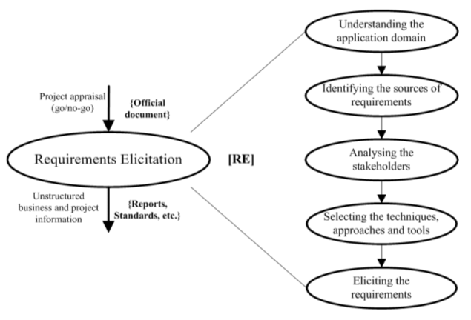

Figure 3.2 Requirements Gathering Process cycle*.*

*Source: pictures*

## **3.6 REQUIREMENT GATHERING**

A user requirements capture is a research exercise that is undertaken early in a project life-cycle to establish and qualify the scope of the project. The aim of the research is to understand the service from a user's perspective, and to establish users' common needs and expectations.

Interviews and observation were used to capture the relevant data necessary for the development of the system. The information obtained from the interview and the observation provided the research information for the unit’s operations. This significant information was solicited form the unit to enable us to execute the project successfully.

## **3.7 REQUIREMENT ANALYSIS**

Requirement Analysis, also known as Requirement Engineering, is the process of defining user expectations for a new software being built or modified. In software engineering, it is sometimes referred to loosely by names such as. requirements gathering or requirements capturing.

The developers analysed the information from the requirement capturing phase and deducted the functionality necessary for the system. The following are the functionality of the system.

* The application should have an interactive user interface to allow easy interaction between the users and the application.
* It should have programming course on it.
* The application should provide its users to way to contact an expert for any challenges.
* The application should have a feature learner can run their code after coding.
* The application should provide user the with notice updates.

## **3.8 DEVELOPMENT PACKAGES AND DEVICES**

Software and Hardware tools for Implementation

* Microsoft Visio 13 and 19: Used for drawing diagrams (use case, entity relations, system architecture, etc.)
* visual studio code: It is a text editor used for html programming; it was used for the designing of the noticeboard feature.
* Xamp: Software for running the application for test and evaluations

Programming Languages

* HTML is the standard mark-up language for creating Web pages.
* PHP is a server scripting language, and a powerful tool for making dynamic and interactive Web pages.
* JavaScript is the programming language of HTML and the Web.
* CSS is a language that describes the style of an HTML document.

Bootstrap is the most popular HTML, CSS, and JavaScript framework for developing responsive, mobile-phone websites.

Operation Systems

* Microsoft Windows Operation System
* Android Operation System (Linux)
* iOS

Hardware Tools

* Laptops
* Desktops
* Phones

## 3.9 RATIONALE BEHIND THE SECLECTED PLATFORM

Android is the main OS platform used in this project work. Below are the reasons why we chose android instead of another OS.

* Android platform is less expensive for developing application and no need to buy external devices not like the Mac and an iPhone, since the android operation system is an open platform. Currently there is a large variety of operating systems for smartphones. However, two systems cover almost 80% of the entire market as on the one hand there is Google’s operating system Android. And on the other hand, iOS developed and distributed by Apple Inc. The only other operating system at this moment that has over 5% market share is the BlackBerry OS developed by RIM18. Given the fact that the target group of this platform is business users it also does not fit this project.
* Since the app is an online shopping. The project is carried out with the intention of making buying and selling very easy and faster and better way of delivering goal and services. Therefore, android which has a larger user base is chosen as the appropriate platform.
* Android has a better support for integrating with Google’s tools and services such as Gmail, Google map, Google search and Google translate.
* Android is based on Linux operation system. The APP is easier to improve with embedded Linux in the future. Moreover, this feature increases the security of the android OS. To continues this project work on the Android platform, developers have more programming rights and permissions on mobile device as compared to IOS
* iOS (formerly iPhone OS) is a mobile operating system created and developed by Apple Inc. exclusively for its hardware
* XAMPP helps a local host or server to test its website and clients via computers and laptops before releasing it to the main server. It is a platform that furnishes a suitable environment to test and verify the working of projects based on Apache, Perl, MySQL database, and PHP through the system of the host itself

## 3.10 SUMMARY

This chapter presented on the method and tools that were used for the successful completion of the project. The chapter described the system development life cycle and the particular SDLC model used for the project and the rationale behind the selected model. This also include the project work plan, requirement elicitation, requirement capturing, requirement analysis, development packages and devices, rationale behind the selected platform (android), research design and software development life cycle.

# **CHAPTER FOUR**

# DESIGN AND IMPLEMENTATION

## **INTRODUCTION**

This chapter is to ensure that the project objectivity is successfully implemented to achieve the purpose of which the project was embarked. It also shows how the system is implemented and how the design is successfully achieved. The implementation of the online shop system was developed using HTML and PHP programming language with visual studio code text editor. The main interface of the application was developed using bootstrap and CSS.

## **4.1 LIFE CYCLE OF THE SYSTEM**

The life cycle of the system involves the series of steps user perform as they go through user interfaces when using the system. The application is user-friendly even for novice users. It aids in buying and selling of product that are delivered to the customers.  
First of all, after installing the application the user has to grant the permission to access the device location. After that the main interface of the application is appears showing all kind of products that are available on the application. User can browse through the application or search for a specific item. The person then goes through the product ordering process.

## **4.2 SYSTEM DESIGN**

The application for online shopping was design on user centred. The system was built through communication between developers and users to know and understand exactly what users are expecting from the system. The system was designed to meet the expectation of the users. The system comprises of two different users which includes, the admin who uploads the content and user and the staffs who are the main users of the system.

### FLOW CHART DIAGRAM OF APPLLICATION

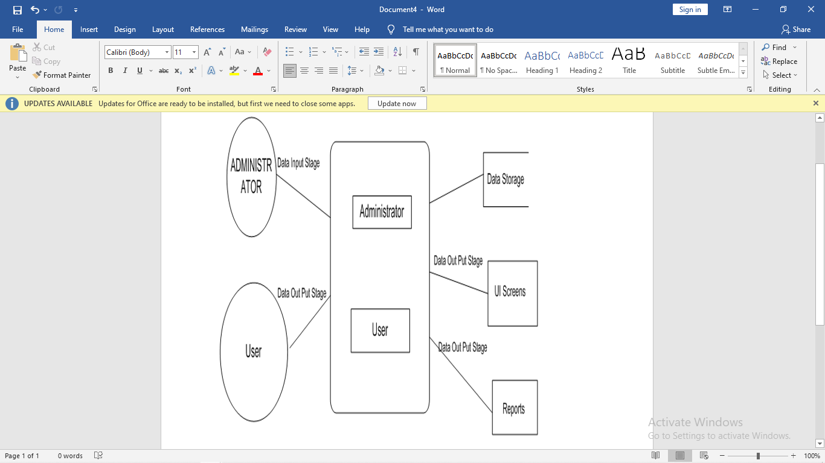

*Source: google pictures*

Figure 4.1 Flow chart diagram of application.

Figure 4.1 describes the flow chart of the system. It explains the steps involve in accessing the system and how data flows. The admin upload pictures of the products and their respective details into the database. The admin has the access to all user information and other staff and orders. The user section load from the database and display the products and their respective details. The user will then have to register before placing an order.

### 4.2.1 ARCHITECTURAL DESIGN OF THE APPLICATION

The diagram (figure 4.0) shows the system architecture design of the system. It indicates the various modules the and the various section that can be accessed and the processes involved in the system. The interface has two different pages that is the administrator section and the customer’s section.

The administrator feeds the database with the information where the application loads its contents. The user after creating an account has access to limited content the admin uploads.

### ARCHITECTURAL DESIGN OF THE APPLICATION

Source: *google pictures*

Figure 4.2 Architectural design of application

The figure 4.2 depicts the architecture of the application which consists of the admin, File storage, Mobile client, user and the Browser client. All files and data are uploaded into the database by the admin using the admin panel. The data is then fetched from the database and displayed in the user interface by the web browser.

**USE CASE DIAGRAM OF APPLICATION**

Use case diagram describes how an external user triggers an event to which the system must respond. A use case diagram is constructed to show the required functionality of the system in the analysis phase and to specify the actual behaviour of the system in the design phase. A used case has a name, brief description and primary actor.

### USE CASE DIAGRAM OF APPLICATION

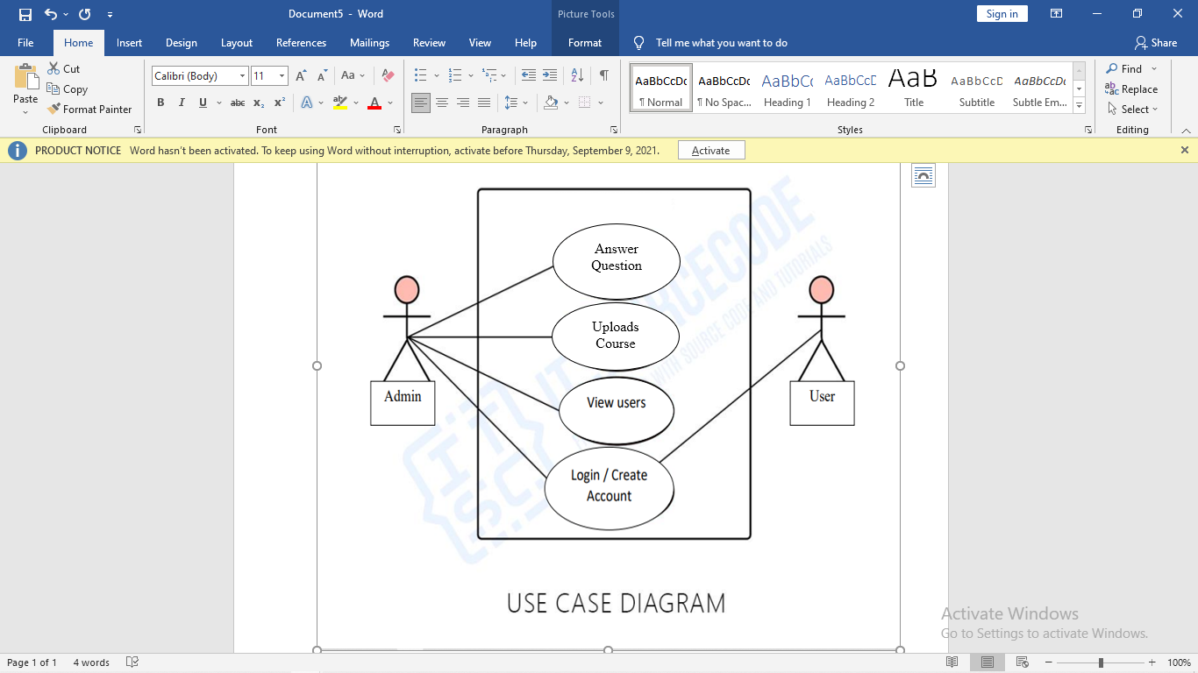

*Source: google pictures*

Figure 4.3 use case diagram of application

### **USE CASE DESCRIPTION.**

**Use case**: Admin

**Actor**: Administrator

**Description**: The administrator manages users’ information, uploads course contents. The admin also answers questions of the students learning the platform.

**Use case**: User

**Actor**: Students

**Description**: Creates account then login with his or her credentials. After that he or she enrols in course.

### FIGURE 4.4: USER REGISTRATION INTERFACE

Figure 4.4 show the user registration interface of the application. On this interface the user enters the name, email, password and gender then click the register button for registration. If the password and the confirm password do not march an alert is displayed for the user to check the password to march them. If the user is already registered, he or she can go ahead and click on the already have an account link to go to the login page

### FIGURE 4.5 THE LOGIN INTERFACE OF THE APPLICATION

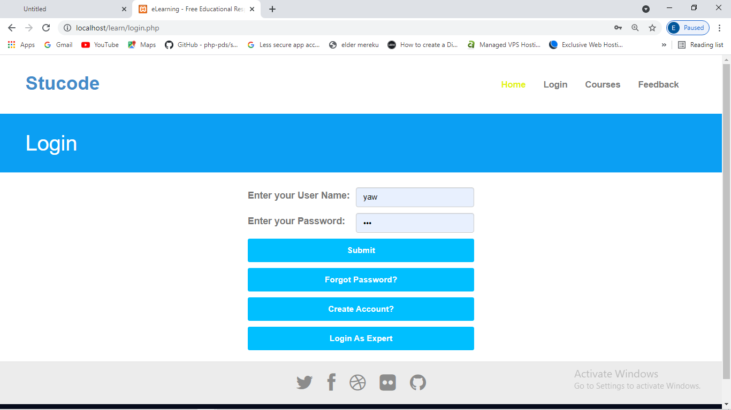

In figure 4.5 is the display of the login interface. The user has to login with email and password to get access to the features of the application such as enrolling of course and asking questions. If a user forgets his or her password. The forget password feature helps the user to reset his or her password by sending password reset link to the registered email that will lead the user to reset his or her password.

### FIGURE 4.6 FEEDBACK INTERFACE

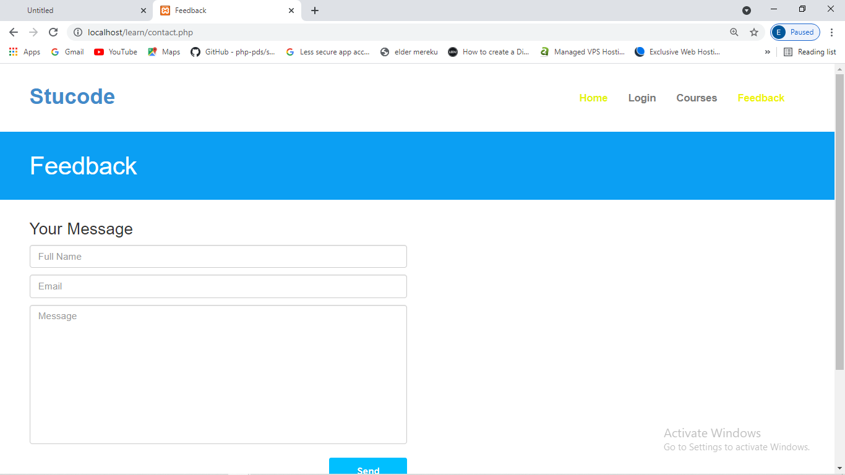

Figure 4.6 show the feedback interface where students on the platform send feedback and challenges, they face to the experts to address it for them.

### FIGURE 4.7 THE STAFFS INTERFACE

The staff interface helps the experts on the platform to view questions posted by the users of the platform they then proceed to the answering of the question.

### FIGURE 4.8 ADMIN INTERFACE

The admin panel provide a lot of features to the administrator. With the admin panel, new staff can be added to the platform. Again, the administrator can add new coarse to the platform. The administrator can use the admin panel to check orders, feedbacks, manager staffs and user then read suggestions.

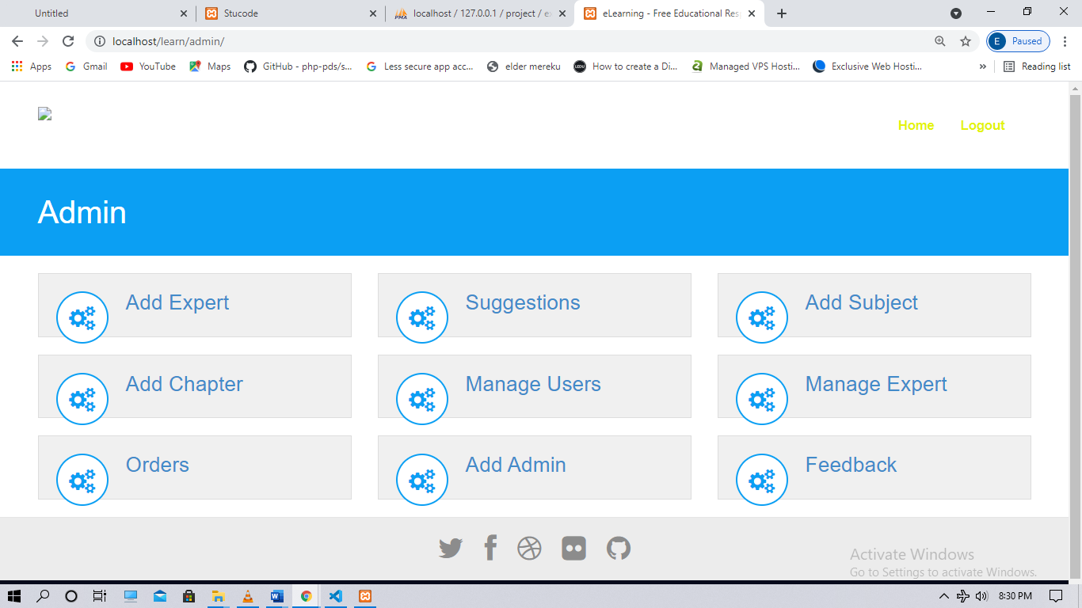

### FIGURE 4.9 COURSE ENROLMENT INTERFACE

Figure 4.10 show the course enrolment interface. This is where students take their programming user select courses by clicking of the course and enrol into it.

## **4.3 SPECIFIC OBJECTIVES ACHIEVEMENTS**

* With the system the was able to achieve a e-learning platform that help student learn programming and practising what the on the platform.
* Students can ask expert on the platforms when facing some challenges pertaining to the course he or she is offering.
* A better and much more efficient way of teaching programming was achieved.

## 4.4 SUMMARY

This chapter presented how the project objectivity was successfully implemented to achieve the purpose of the system as required by its end users. It also presented on the system implementation and how the purpose for which the system was design was successfully achieved.

# **CHAPTER FIVE**

**INTRODUCTION**

This chapter deliberates on the achievement of objectives stated in the project. The main aim of the project was to develop and implement a web application system for easier, effective and efficient of buying and selling

## **5.1 SYSTEM TESTING**

In this phase, the system was tested several times with the prototypes pertaining to uploading course content, enrolling on a programming course, asking question, awarding of certificates, administrator access and management. This was done by performing series of evaluation and operation in terms of the features of the application. Tests performed prove the application has no bugs.

## **5.2 EVALUATION OF THE APPLICATION**

During the evaluation period, the system was tested several times by uploading course content, enrolling on a programming course, asking question, awarding of certificates, administrator access and management. Few people were all given the opportunity to use the application just to attain a feedback. After running several tests on the application all errors and bugs were rectified. After the evaluation the developing team came up with some system requirements.

### 5.2.1 FUNCTIONAL REQUIREMENT

Having elicited for the requirement, the team analysed the information and deduce the below requirements that the navigation application is capable of;

* The system should be able to register three different type of users that is the administrator, experts and the students
* It the system has different type and course of available which a user can browse through and study.
* The system should give login in access and logout access.

### 5.2.2 NON-FUNCTIONAL REQUIREMENT

This requirement of the system defines the system properties and the constrains under which the system works. The following are requirement that should be available before the application perform to its expectation.

* Internet access for the Smartphones or computer
* Smartphone with Android OS or iOS.
* Storage for the installation of the APP.
* Availability of google play services.
* GPS location provider built in phone.

## 5.3 SUMMARY OF MAIN FINDINGS

* Base the on the challenges people face in terms buying and selling the electronic hub web application has provided a platform that is much easier, faster and more efficient.
* The application was design with a very simple interactive user interface for every one including novice users.

## **5.4 CONCLUSION**

The project was designed, developed and implemented successfully and almost all goals were achieved. The application is beneficial to the users and will a massive improvement on the life of people.

## **5.5 RECOMMENDATION**

* Base on users responds on interview questions and developer ‘s analysis of the application, it was recommended to train novice users should be trained on how to download and install the application even though the app user interface was a simplicity.
* It was also navigation system where users can track their products.

## **5.6 FUTURE WORKS**

* In the future the project will be focused using voice inputs.
* The project will also focus using facial recognition and thumb print as login and creating of accounts credentials.
* The project will focus on adding new programming language with their compilers.

## REFERENCES

Tutorials point online available at [www.tutorialspoint.com/system_analysis_](http://www.tutorialspoint.com/system_analysis_and)

[Accessed 19/7/8021]

Google developers online available at google-developer-training.github.io/android

[Accessed 19/8/2021]

Android documentation for developers online available at <https://developer.android.com/> [Accessed 28/8/2021]

Course Hero available online <https://www.coursehero.com/file/p5vue4i/> [Accessed 12/9/2021]

Implementation Of E-Learning: A Case Study Of Three Schools available online <https://www.academia.edu/3051633/Impleme> [ Accessed 15/9/2021]

NORMA E-research [http://trap.ncirl.ie/606/1/Libby_Barrett](http://trap.ncirl.ie/606/1/Libby_Barrett_-_PM_Dissertation_-_Final_Version.pdf)

[ Accessed 15/9/2021]

LCI Mag available online <https://lcimag.com/2017/02/important-que>

[ Accessed 10/9/2021]

Toronto available online <http://www.cs.toronto.edu/~jm/340S/02/PD>

[Accessed 11/9/2021]

E-thesis available online <http://ethesis.nitrkl.ac.in/2057/1/Thesi> [Accessed 15/9/2021]

GitHub available online <https://github.com/forza11879/JSON-AJAX>

[Accessed 15/9/2021]

Teaching- learning available online <https://www.teaching-learning.utas.edu.a> [Accessed 15/9/2021]

Flip classes available online <https://www.flipclasses.com/lt/dienorati>

[Accessed 15/9/2021]

Research gate available online <https://www.researchgate.net/post/What_a> [Accessed 15/9/2021]

The guardian available online [https://www.theguardian.com/education/20](https://www.theguardian.com/education/2019/feb/22/are-university-campuses-turning-into-mini-smart-cities) [Accessed 15/9/2021]

Academia available online [https://www.academia.edu/5313087/CHAPTER](https://www.academia.edu/5313087/CHAPTER_THREE_RESEARCH_METHODOLOGY_Introduction) [Accessed 15/9/2021]

SlideShare available online [https://www.slideshare.net/micmic530/obj](https://www.slideshare.net/micmic530/objectives-of-the-proposed-system) [Accessed 15/9/2021]

**APPENDICES**

<html>

<head>

    <meta charset="utf-8">

    <meta name="viewport" content="width=device-width, initial-scale=1.0">

    <meta name="description" content="eLearning is a modern and fully responsive Template by WebThemez.">

    <meta name="author" content="webThemez.com">

    <title>Stucode </title>

    <link rel="favicon" href="assets/images/favicon.png">

    <link rel="stylesheet" media="screen" href="http://fonts.googleapis.com/css?family=Open+Sans:300,400,700">

    <link rel="stylesheet" href="assets/css/bootstrap.min.css">

    <link rel="stylesheet" href="assets/css/font-awesome.min.css">

    <!-- Custom styles for our template -->

    <link rel="stylesheet" href="assets/css/bootstrap-theme.css" media="screen">

    <link rel="stylesheet" type="text/css" href="assets/css/da-slider.css" />

    <link rel="stylesheet" href="assets/css/style.css">

    <!-- HTML5 shim and Respond.js IE8 support of HTML5 elements and media queries -->

    <!--[if lt IE 9]>

    <script src="assets/js/html5shiv.js"></script>

    <script src="assets/js/respond.min.js"></script>

    <![endif]-->

</head>

<body>

    <?php

        include "nav.php";

    ?>

    <header id="head" class="secondary">

        <div class="container">

            <div class="row">

                <div class="col-sm-8">

                    <h1>HTML</h1>

                </div>

            </div>

        </div>

    </header>

        <div class="container-fluid" style="margin-top:10px;margin-left:82px;margin-right:450px;">

            <h1>HTML Fundamentals</h1><br><label>Interested in learning how to design a website using HTML tags, elements, and attributes? Then this learning game is for you! Our interactive HTML tutorial is comprised of carefully selected videos, quizzes, and checkpoints to ensure that you learn as much as possible, while also having as much fun as possible. This is accomplished through a series of entertaining exercises, along with plenty of hands-on practice in writing actual HTML code.You will also learn the fundamentals of web design, collect colorful points, and compete with other learners throughout the world.Our videos are informative and concise, our checkpoints are enjoyable and your learning is guaranteed.Learn while playing and play while learning with our HTML Tutorial! Whether you want to further your career or simply gain a new skill, this tutorial will work for you.</label><button onclick="location.href='../html/chapter1.php'" class="btn btn-block">Start Learing>></button>

        </div>

        <div class="container-fluid" style="margin-left:82px;margin-right:450px;">

            <h1>Chapters :</h1><ol><li>Chapter 1: What is HTML?</li>

            <li>Chapter 2: Write HTML Using Notepad TextEdit</li><li>Chapter 3: HTML Headings</li><li>Chapter 4:HTML Attributes </li>

            <li>Chapter 5:HTML Horizontal Rules</li><li>Chapter 6: HTML Text Formatting</li><li>Chapter 7: The HTML<?php $str='<q>'; echo htmlspecialchars($str); ?> element defines a short quotation.</li>

            <li>Chapter 8: HTML Comment Tags</li><li>Chapter 9: Chapter 9:HTML Lists</li><li>Chapter 10: The<?php $str='<div>'; echo htmlspecialchars($str); ?> Element</li>

            <li>Chapter 11: HTML Iframes</li><li>Chapter 12: The<?php $str='<form>'; echo htmlspecialchars($str); ?> Element</li>

            <li>Chapter 13: The<?php $str='<select>'; echo htmlspecialchars($str); ?> Element</li>

            <li>Chapter 14: Input Type Text</li>

            </ol><button onclick="location.href='purchase.php'" class="btn btn-block">Purchase Now>></button><br>

            <button onclick="location.href='../download/index.php'" class="btn btn-block">Download free E-Books</button><br>

        </div>

    <?php

        include "footer.php";

    ?>

</body>

</html>

<html>

<head>

    <meta charset="utf-8">

    <meta name="viewport" content="width=device-width, initial-scale=1.0">

    <meta name="description" content="eLearning is a modern and fully responsive Template by WebThemez.">

    <meta name="author" content="webThemez.com">

    <title>Stucode </title>

    <link rel="favicon" href="assets/images/favicon.png">

    <link rel="stylesheet" media="screen" href="http://fonts.googleapis.com/css?family=Open+Sans:300,400,700">

    <link rel="stylesheet" href="assets/css/bootstrap.min.css">

    <link rel="stylesheet" href="assets/css/font-awesome.min.css">

    <!-- Custom styles for our template -->

    <link rel="stylesheet" href="assets/css/bootstrap-theme.css" media="screen">

    <link rel="stylesheet" type="text/css" href="assets/css/da-slider.css" />

    <link rel="stylesheet" href="assets/css/style.css">

    <!-- HTML5 shim and Respond.js IE8 support of HTML5 elements and media queries -->

    <!--[if lt IE 9]>

    <script src="assets/js/html5shiv.js"></script>

    <script src="assets/js/respond.min.js"></script>

    <![endif]-->

</head>

<body>

    <?php

        include "nav.php";

        $strconn=mysqli_connect("localhost","root","","project");

        if(!$strconn)

            echo "Connection failed".mysqli_connect_error();

        else{}

        $query = "SELECT Title,Dinfo FROM subject LIMIT 1";

        $result = mysqli_query($strconn,$query);

        /*if($result)

        {

            echo "Sucess";

        }

        else{

            echo "failed";

        }*/

        while($row = mysqli_fetch_array($result))

        {

            $title = $row["Title"];

            $dinfo = $row["Dinfo"];

        }

    ?>

    <header id="head" class="secondary">

        <div class="container">

            <div class="row">

                <div class="col-sm-8">

                    <h1><?php echo $title; ?></h1>

                </div>

            </div>

        </div>

    </header>

        <div class="container-fluid" style="margin-top:10px;margin-left:82px;margin-right:450px;">

            <h1><?php echo $title; ?></h1><br><label><?php echo $dinfo; ?></label><button onclick="location.href='../course/chapter.php'" class="btn btn-block">Start Learing>></button>

        </div>

        <div class="container-fluid" style="margin-left:82px;margin-right:450px;">

            <h1>Chapters :</h1>

            <?php

            $query1 = "SELECT Title FROM chapter WHERE Subject='$title'";

            $result1 = mysqli_query($strconn,$query1);

            /*if($result1)

            {

                echo "success";

            }*/

            while($row = mysqli_fetch_array($result1))

            {

                echo '<ul><li>Chapter :'.$row[0].'</li></ul>';

            } ?>

            <!--<li>Chapter 2: Write HTML Using Notepad TextEdit</li><li>Chapter 3: HTML Headings</li><li>Chapter 4:HTML Attributes </li>

            <li>Chapter 5:HTML Horizontal Rules</li><li>Chapter 6: HTML Text Formatting</li><li>Chapter 7: The HTML<?php $str='<q>'; echo htmlspecialchars($str); ?> element defines a short quotation.</li>

            <li>Chapter 8: HTML Comment Tags</li><li>Chapter 9: Chapter 9:HTML Lists</li><li>Chapter 10: The<?php $str='<div>'; echo htmlspecialchars($str); ?> Element</li>

            <li>Chapter 11: HTML Iframes</li><li>Chapter 12: The<?php $str='<form>'; echo htmlspecialchars($str); ?> Element</li>

            <li>Chapter 13: The<?php $str='<select>'; echo htmlspecialchars($str); ?> Element</li>

            <li>Chapter 14: Input Type Text</li>-->

            <button onclick="location.href='purchase.php'" class="btn btn-block">Purchase Now>></button><br>

            <button onclick="location.href='../download/index.php'" class="btn btn-block">Download free E-Books</button><br>

        </div>

    <?php

        include "footer.php";

    ?>

</body>

</html>