2019

Created by Jonathan Ayala G. and Keyla Mendez Ch.

For Blackwell Electronics

1-7-2019

Market Basket Analysis



**Business Report**

We have made a study on the possible cross-selling patterns between Blackwell Electronics and our associate electronic retailer Electrodinex, to do it, it was prefomed a Markaet Basket Analysis. When performing market basket analysis, it is intended to find relationships between the purchase of some products, that is, the purchasing of a group of products lead to the purchase of a specific product.

The next recommendations will be made based on two criteria:

1. Recommendations of Electrodinex’s portfolio whose inclusion in Blackwell Electronics’s portfolio could boost some of the most important products for Blackwell in terms of percentage of these products in terms of income for the company. Products recommended:

* It has been detected that there are strong statistical measures supporting the fact that a very high percentage of Electrodinex’s customers tend to purchase Monitors from the LG brand when they purchase brand new or second hand Apple Laptops. Blackwell also has these Monitors from the LG brand in its portfolio (Code 159), so it could be very profitable for the company to incorporate Laptops from Apple in Blackwell’s portfolio, not only because this product could potentially boost the sales of Monitors from LG, but because the 30% of Blackwell Electronics’ current income comes from selling Projectors of the Epson brand (Code 157), which is a product belonging to exactly the same category of the named LG Monitos (*Displays* category) and because it is a product with a very attractive margin of profit for the company.
* Following the same logic than the one used during the last recommendation, it is highly advisable that Blackwell incorporate within its products portfolio brand new or second hand Apple Laptops because it could also boost the sales of the Monitors from the Dell brand (Code 158).

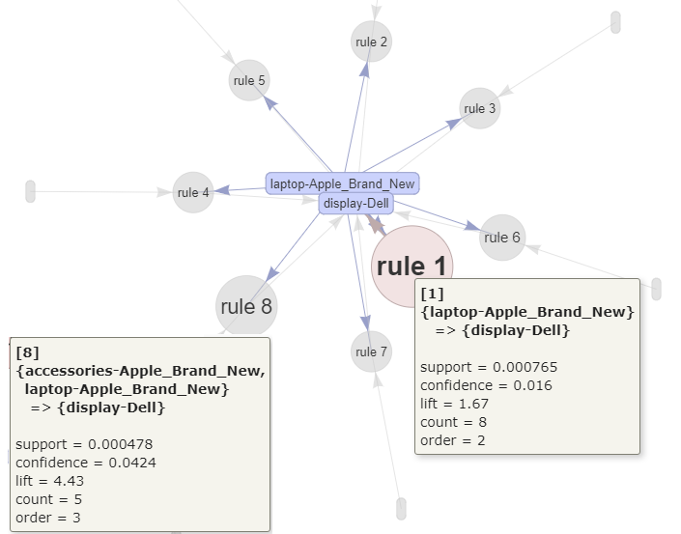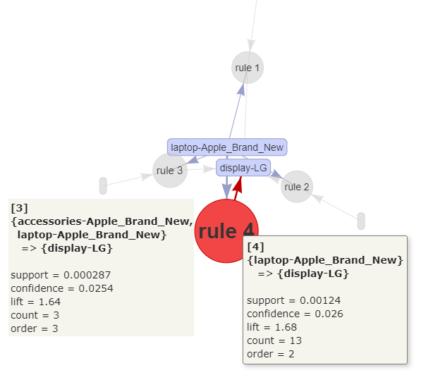

* Connecting with the last proposal, according with the statistical study made, the introduction of Apple Accessories could also boost the sales of the Dell Monitors. It’s important to bear in mind that unlike the LG Monitors, Dell Monitors are a product that were forecasted to be one of the most sold by the studies carried out on previous weeks, which reinforced the proposal of the introduction of these accessories from Apple to Blackwell’s portfolio. The products with code 151 and 152 are products were products recommended in previous studies.
* The Smartphone category represents around the 10% of Blackwell’s income, however the Apple Smartphones only account for less than the 0,5 % out of this 10%, which is an extremely low proportion. That said, given that the new Blackwell’s partner is an Apple specialized store, it would be highly profitable for Blackwell to start offering Extended Warranties over the only Apple Smartphone currently offered in Blackwell’s portfolio because it is known that around the 30% of those who purchase an Extended Warranty tend to buy an Apple Smartphone. This strategy could be boosted by incorporating a wider variety of Apple Smartphone to Blackwell’s portfolio.

1. Recommendations that could lead to sell the products that Blackwell Electronics currently sells in the highest volume. In this case, knowing that the most common selling products in Blackwell Electronics are (by percentage of the total volume): accessories (48%), Game Console (19%), Software (9%) and Smartphones (4%), it could be made some recommendations that could boost the selling of these products, always bearing in mind that the fact of selling these products could lead to some of the Electronidex’s customers to know some of the most profitable products of Blackwell’s portfolio, i.e. Display, Game Console, Smartphone, Tablet, Software, which are highly profitable.

Products recommended:

* Connecting with the first proposal given in this report, it was also detected that those customers who buy Apple Tablets also tend to buy some accessories during the same transaction. According to the study made, this happens in a high proportion of the times when an Apple Tablet is bought, plus it must be taken into account that the acquisition of Apple Tablets to be offered to Blackwell’s clients would boost the sales of a category that provides a high margin of profit but that only accounts by a 8% of the total income of Blackwell Electronics.
* Bearing in mind that the introduction of the Smartwatch would boost the sale of some accessories sold by Blackwell and given that this article would be a newness for Blackwell, it is recommended to introduce it in Blackwell’s portfolio.
* Following the logic made before about the high profitability of Laptops, and given the combination of high profit – high sales volume of *Software* in Blackwell Electronics, it is reinforced the recommendation of introducing Electronidex’s Laptop in our portfolio.

As it could be seen during this Report, there are some purchasing patterns in Electronidex that can help to boost the sales of some of the products of Blackwell Electronics, which makes very appealing the implementation of a Cross-selling strategy of products in Blackwell, furthermore, the analysis of the sales metrics of Electronidex led to discover some interesting similarities between both companies, like the weight of some products within the total volume of items sold.

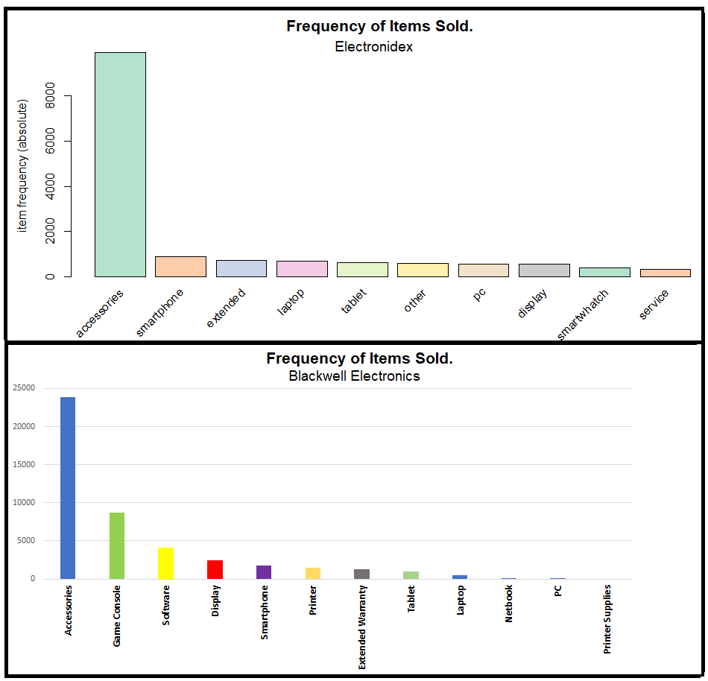

**Annex**

The following are the Top 10 products that add more income to the Electronidex’s income statement.

|  |  |
| --- | --- |
| Product | Total Income |
| 1. Apple MacBook Pro 15 "Core i7 Touch Bar 29Ghz | RAM 16GB | 512GB PCIe SSD | 560 4GB Radeon Pro Space Gray. | 79.019 $ |
| 2. Apple MacBook Pro 15 "Core i7 Touch Bar 28GHz | RAM 16GB | 256GB PCIe SSD | 555 2GB Radeon Pro Space Gray. | 69.214 $ |
| 3. Apple iMac 27 "Core i7 Retina 5K 42GHz | 64GB | 1TB SSD. | 45.654 $ |
| 4. Apple Macbook Pro 13 "Core i7 Touch Bar 35GHz | 16GB | 512GB SSD Space Gray. | 42.793 $ |
| 5. Apple MacBook Air 13 "Core i5 18GHz | 8GB RAM | 256GB SSD. | 41.793 $ |
| 6. Apple MacBook Pro 13 "Core i5 3.1GHz Touch Bar | 16GB | 512GB SSD Space Gray. | 37.533 $ |
| 7. Apple iPhone 64GB Space Gray X. | 37.427 $ |
| 8. Apple MacBook Pro 13 "Core i5 Touch Bar 31GHz | 16GB | 256GB SSD Space Gray. | 33.640 $ |
| 9. Apple Macbook Pro 15 "Core i7 Touch Bar 31GHz | 16GB | 1TB SSD | 560 4GB Radeon Pro Space Gray. | 33.519 $ |
| 10. Samsung 850 EVO SSD Disk 500GB. | 32.814 $ |