**Part 1**

Get a Bowl

Get a Spoon

If we have Cereal

Get Cereal

Otherwise

Get Cereal at store

add Cereal to bowl

If we have milk

Get milk

Otherwise

Get milk at store

add milk to bowl

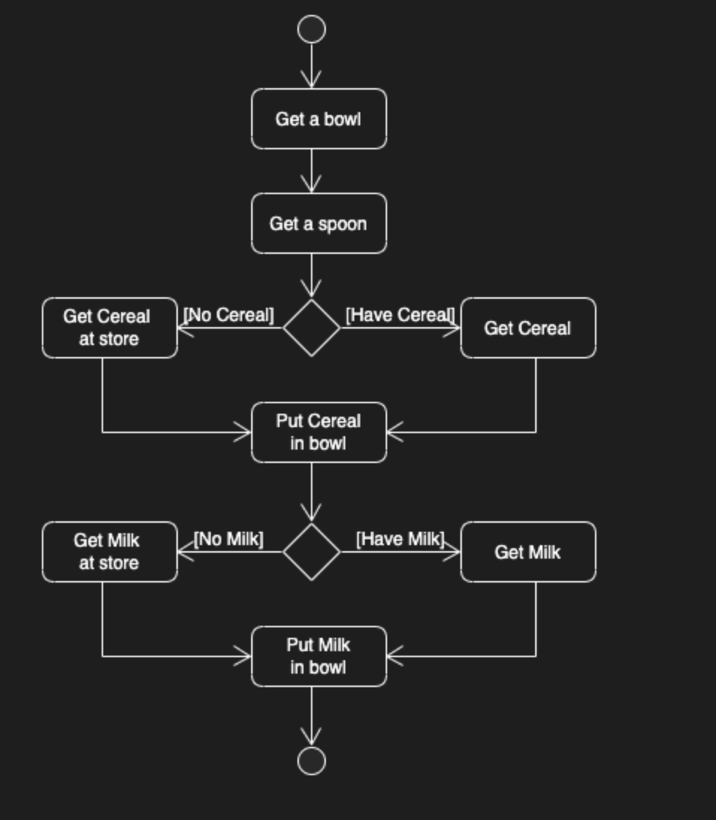

Part2: