# Low- and high-level audio programming using respectively C++ and PureData

This report demonstrates two approaches to program audio applications: a low-level approach using C++, the PortAudio API and the Libsndfile library, and a high-level approach using PureData and the OSC protocol. For the first part of the task, the low-level approach, we have implemented a record-and-playback program, which records sound for 5s before playing it back. For the second part of the task, the high-level approach, we have designed a mixer mixing four pre-recorded .wav files and a live input, with individual controls such as low- and high-pass filters, volume and reverb.

## Introduction

### Why we chose C++/PortAudio/Libsndfile

blablabla.

### Why we chose PureData, OSC

Wdlkvjl wvhwk.

## Record and playback of audio using C++/Portaudio/libsnd

## Programming a mixer in PureData with live remote controls via OSC

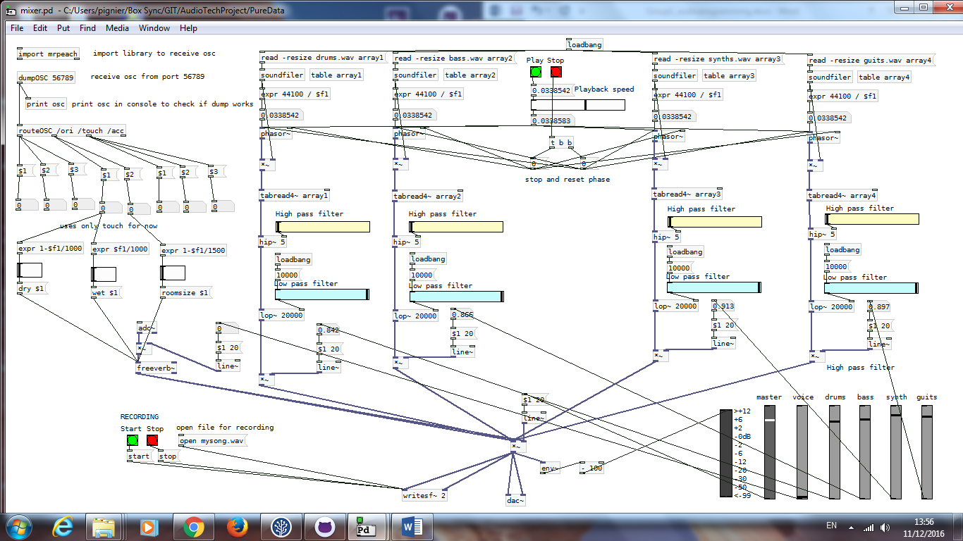

## Possible improvements and conclusion

# Using the template

This chapter describes how the template works, and how you are supposed to use it. The content is mostly self-referential. The template contains two chapters, but the article should be one chapter. So: under the chapter heading there should be a short summary of what the article is about, in one paragraph. Support mechanisms in Word such as *styles*, *captions*, *cross-references*, and automated numbering should be used throughout. This summarising paragraph has the *style* **Chapter introduction**. The chapter heading (the title of your article) must have *style* **Heading 1**, or the numering will not work.

## Section headings have style Heading 2

This template file is called AudioTemplate2015.dot.

### Subesection headings have style Heading 3

This is body text. The first paragraph after a heading should have style **Normal no indent**. This gives a straight left margin on the first line. Note that **Normal no indent** is automatically selected after **Heading 3**.

Body text in the following paragraphs use the style **Normal**. It is selected automatically after **Normal no indent** when you enter a new paragraph (with Enter). Body text has font Garamond, size 11. But, always let the styles control the formatting: font, size, indent, alignment, margins, line spacing etc. Do not format the text yourself, unless the text requires a special typography. If you do, it is much harder to reformat the text later.

### Numbering of items in the text

With automatic numbering of the document it becomes much easier to reuse the articles. So please let Word assign the numbers wherever necessary: sections, figures, tables etc. Don’t number anything manually. This actually makes the writing easier too.

Use **Insert | Caption…** to number figures, tables and exercises. This makes it easy to have the chapter number follow. Every paragraph or inserted object (figures etc) in Word can be equipped with a caption, as follows.

1. Select the paragraph or the object with the mouse.
2. Choose **Insert | Reference… > Caption**.
3. Choose **Figure** or **Table**. Alternatives in Swedish are also found in this template.
4. Press the button **Numbering** and select **Include chapter number**, and choose Arabic numerals throughout. Choose **OK**.

The paragraphs below have been captioned in this way.

Fake figure

Figure 2‑1. Example of an automatically numbered figure and its associated caption text.

|  |  |  |
| --- | --- | --- |
| Fake table |  |  |
|  |  |  |

Table 2‑1. Example of an automatically numbered table, and its associated caption text.

Example 2-1: This is an automatically numbered example. I positioned the cursor at the start of the paragraph, without marking any text. Then I chose **Insert | Reference… > Caption** and selected **Example** to insert a number. Then I applied the paragraph formatting style **Normal no indent** to avoid the boldface font in style **Caption.**

### Numbering of equations

The Caption function is not practical for numbering equations, because a caption is always placed above or below the object to which it refers. Equation numbers should be right-aligned. Below we have an ”equation paragraph” that makes this easier. To insert an equation with numbering on the form *chapternr*.*sequencenr*, follow these steps:

1. Copy the paragraph with the equation, below. To select the whole paragraph, double-click in the left margin.
2. Paste the paragraph at the place where you want the equation.
3. Double-click the equation itself. It is an embedded object, that invokes the Microsoft Equation Editor.
4. In the equation editor, change the equation to what it should be.
5. Click outside the equation. This closes the Equation Editor and returns you to the document.

 (2.1)

The *style* of the above paragraph with the equation is **Numbered equation**. Its formatting contains center tab, right tab, and space above and below the equation. The parnetheses contain a cross-reference to the current chapter number, a full stop, and a field code { **seq** ekv \* Arabic \s 1 }. The option "\s 1" restarts the numbering of the sequence "ekv" every time a paragraph with style **Heading 1** is encountered, that is, the chapter heading. The *style* of this gray-panel paragraph is **In depth** and is intended for advanced material or for curiosities.

Thus, we use the function “numbered sequence” to number equations. To apply automatic numbering to other items, use **Insert** | **Field** -> **Numbering** -> **seq** *sequencename* . The sequence name is something you make up yourself.

### Cross-references

To reference figures, tables and equations, use **Insert | Reference… > Cross-reference**. To reference an unnumbered object, attach a so-called **Bookmark** to the object, and insert a cross-reference to this Bookmark. Then the pagination of the reference will be updated automatically.

### Footer

The page footer is generated automatically; do not edit it directly. Till vänster visas kursnamnet (se **Error! Reference source not found.**). The chapter heading is displayed centered in the footer. The page number preceded by the chapter number is shown to the right. The chapter number will stay at 1 until your article is combined with the others.

### Header

The page header is not intended for display but only as a convenience to those editing the document. The Header is generated automatically. Before printing the file, erase the contents of the Header, or mark it as Hidden Text (Ctrl-Alt H).

### Symbols as reading directives



Little symbols in the margin are nice, but they can be difficult to put in place. This template contains a trick for doing it. Follow these steps:

1. Choose an icon in Tabell 2-1.
2. Make a new paragraph that contains only the corresponding ordinary character in the third column.
3. Place the cursor next to the character.
4. Press Ctrl+§ (the paragraph character near top left on the keyboard).

The keystroke Ctrl-§ is configured to apply the style**Icon at left** to the current paragraph. The paragraph font is Wingdings. To get other icons from the Wingdings font, choose Insert Symbol with the font Wingdings, instead of steps 1 and 2 above.

|  |  |  |  |
| --- | --- | --- | --- |
| Icon | Directive | Char | ASCII |
| 👓 | Advanced | $ | 36 |
| 🕯 | Illuminating | ' | 39 |
| ☝ | Definition | G | 70 |
| 🕱 | Pitfall | N | 77 |

Tabell 2-1: Icons used for reading directives.

## Adapting existing texts

### Applying this template to an existing document

If you have a document that uses the styles Normal, Heading 1, Heading 2, and Heading 3; where Heading 1 is the document heading, then this might work:

1. Open the existing document.
2. Choose **Tools | Templates and Add-Ins… > Templates**
3. Check **Automatically update document styles**.
4. Choose **Attach…**
5. Browse to the file AudioTemplate.dot .

### Pasting existing text from another document

The template settings can easily be upset if text is pasted from other documents. To be on the safe side, don’t use the ordinary **Edit | Paste** (Ctrl-v) but always choose **Edit | Paste special…** > **Unformatted text** . You will have to reapply character formatting, but otherwise undesired styles may be imported from the other document.

### Pre-defined paragraph styles

These styles are specially (re-)defined in AudioTemplate.dot:

|  |  |
| --- | --- |
| **Style name** | **Intended for** |
| Heading 1 | Chapter heading |
| Heading 2 | Subheading |
| Heading 3 | Sub-subheading |
| Chapter introduction | The summary following the chapter heading |
| Normal no indent | Body text in the first paragraph after figures or tables |
| Normal | Body text |
| Numbered equation | Paragraph containing a numbered equation only |
| In depth | Advanced material or curiosity |
| Icon at left | Symbols in the margin |
| Console | Console typing that is entered by the user or is displayed on a screen, programme code. |
| Header | Page header |
| Footer | Page footer |
| Caption | Figure and table captions |
| Reference | Literature references |
|  |  |