Darrieus Vertical-Axis Wind Turbine: Design and Aerodynamic Analysis
A FreeCAD rotor design analyzed with Double Multiple Streamtube theory in QBlade
Jonathan Jacob Ajith, Mechanical Engineering

Summary
I designed a two-blade Darrieus vertical-axis wind turbine (VAWT) of the curved-blade “egg-beater” type in FreeCAD, then set out to predict its performance using Double Multiple Streamtube (DMST) theory. I first implemented a DMST solver from scratch in MATLAB; it did not produce physically valid results. To test whether this was my error or something deeper, I rebuilt the analysis in QBlade, a validated open-source VAWT tool. QBlade diverged in the same way. The conclusion is the substantive finding of this project: the rotor's solidity is too high for DMST to give valid results, so a higher-fidelity method is required. This writeup documents the design, both analyses, and the diagnosis.

The design
The rotor is a two-blade troposkein (egg-beater) Darrieus, designed in FreeCAD. The blades bow outward from a central shaft and meet at the top and bottom, so the radius is largest at the mid-height equator and tapers toward the mounts.
Parameter | Value | Source
Blade count | 2 | Confirmed from CAD model
Chord | 0.067 m | Measured from airfoil part
Blade height | 1.0 m | Inferred from part extents
Max radius | 0.30 m | Inferred — equatorial (widest) radius
Airfoil | NACA 0018 | Symmetric, standard for VAWT blades

Method: from first principles to a validated tool

First-principles MATLAB solver
I implemented a DMST solver in base MATLAB to understand the method directly. It divides the swept area into streamtubes, splits each revolution into an upwind and a downwind pass treated as actuator disks in series, iterates an induction factor for each half, interpolates NACA 0018 lift and drag across the full angle-of-attack range, and integrates the blade torque to a power coefficient. The structure of the method is all there: upwind/downwind coupling, polar interpolation, and torque integration. Running the solver, however, did not produce physically valid results across the tip-speed-ratio range. At this stage I could not tell whether the problem was an error in my own implementation or something inherent to the rotor, so rather than tune the model until it merely looked right, I treated this as the signal to cross-check against a validated tool. The solver is kept in the repository as a documented learning exercise.

Cross-check in QBlade
To determine whether the divergence was a bug in my implementation or something inherent to the problem, I rebuilt the analysis in QBlade, an open-source, actively maintained VAWT tool from TU Berlin. QBlade implements Paraschivoiu's DMST formulation with per-streamtube induction factors and integrates XFOIL for airfoil polar generation plus a 360-degree extrapolation module. I generated a NACA 0018 polar at Re = 2e5, extrapolated it to the full angle-of-attack range, defined the two-blade rotor, and ran the steady DMS simulation across tip speed ratios of 1 to 6.
QBlade's validated solver diverged in the same way my own had: the power coefficient went strongly negative and the streamtube induction factor saturated at 1.0 across the entire downwind half of the rotation, indicating the simple momentum balance had no valid solution there. Lowering the relaxation factor and increasing the iteration count did not change this. Because a validated, independent implementation reproduced the failure, the cause is not an implementation error but a property of the rotor and the method.

Result: the rotor exceeds the DMST validity range
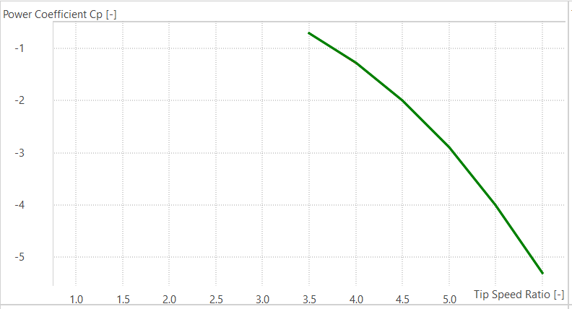
The key finding is that this rotor's solidity places it beyond the range where Double Multiple Streamtube theory gives valid results. With two blades, a 0.067 m chord, and a 0.30 m radius, the solidity (Nc/R) is approximately 0.45. Low-solidity VAWTs, where DMST performs well, typically have solidity around 0.1 to 0.2; values approaching and exceeding roughly 0.3 to 0.4 are documented as the regime where streamtube models break down. The mechanism is visible directly in the results: the upwind half of the rotor extracts so much momentum that the downwind half, modeled as a second actuator disk in the upwind wake, is left with insufficient flow, and its induction factor saturates at unity. The model then predicts the downwind blades absorb rather than produce power, driving the net power coefficient negative.

Fig 1: QBlade DMS power coefficient vs TSR — the non-physical negative values reflect streamtube divergence
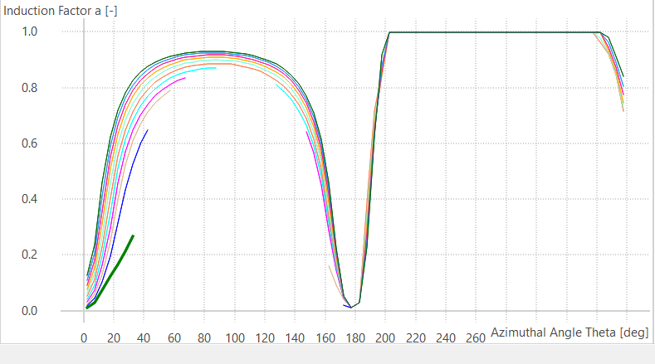
Fig 2: Induction factor vs azimuth — saturation at 1.0 on the downwind pass is the signature of the breakdown.

What I learned
- Low-order models have a validity envelope. DMST is fast and standard for VAWT pre-design, but it is only reliable within a bounded range of solidity and tip speed ratio. This rotor falls outside that range, and no amount of solver tuning recovers a physical result — the limitation is structural, not numerical.
- An independent validated tool is the right way to distinguish a bug from a limitation. My hand-written solver diverging could have been my error; QBlade reproducing the same divergence established that the cause lies in the rotor and the method, which is a much stronger conclusion than either tool alone could support.
- A negative result, correctly diagnosed, is still a result. Knowing that this geometry needs a higher-fidelity method is genuinely useful design information.

Limitations and next steps
- Confirm the true equatorial radius from the CAD model. The radius is currently inferred; a larger true radius would lower the solidity and could bring the rotor back within DMST's valid range, so this is the first thing to check.
- Analyze the rotor with a higher-fidelity method suited to high solidity, such as a vortex model or CFD, which do not rely on the streamtube momentum balance that fails here.
- If a lower-solidity design is acceptable, explore reducing chord or increasing radius and re-running DMST, which would also indicate how sensitive performance is to solidity.

Code and files
The repository contains the FreeCAD design file, the first-principles MATLAB solver (kept as a learning exercise, with its limitations documented), and a QBlade walkthrough for reproducing the validated analysis. https://github.com/jonathanajith21/darrieus-turbine-dmst

