Variable-Stiffness Gait Surface Simulator
A MATLAB dynamics study of walking surfaces, motivated by the AdjuSST adjustable-stiffness treadmill
Jonathan Jacob Ajith, Mechanical Engineering

Summary
This project models the surface a person walks on, such as the platform of a variable-stiffness treadmill, as a second-order mass-spring-damper system, and studies how that surface behaves under load. It builds directly on the two-mass spring system I simulated in MIE 124 (Lab 2), extending that foundation by adding damping, applying it to a real research context, and adding system identification, frequency-response analysis, and an asymmetric-stiffness case. The work is motivated by the AdjuSST adjustable-stiffness treadmill (Price et al. 2024) and uses that system's stiffness range and second-order framing throughout. Built in base MATLAB.

Background and motivation
The Human Robot Systems Lab studies how people adapt their walking when the ground beneath them changes, a question central to rehabilitation. A key tool is the AdjuSST treadmill, whose surface stiffness can be varied, and which the lab characterizes as a second-order spring-mass-damper system. That observation is the starting point for this project: the dynamics that govern the treadmill are the same second-order dynamics I had already worked with in coursework, so I built a simulation that explores them in the lab's context.

Connection to MIE 124
MIE 124 Lab 2 had me analyze a two-mass, three-spring system: deriving the force-balance and equations of motion, assembling the stiffness and mass matrices, solving for displacements, and then simulating the dynamics two ways, a hand-coded Euler integrator and MATLAB's ode45, and comparing them. That lab established the core tools this project relies on: writing equations of motion for spring-mass systems and integrating them with ode45. This project extends that foundation in three ways: it adds a damper (making it a true mass-spring-damper rather than an undamped spring system), it grounds the parameters in a real device, and it goes beyond simulation into characterization and design analysis.

The model
The walking surface is modeled as a mass m on a spring of stiffness k with a damper c. A load F (representing a foot pressing down) drives the system through the equation of motion m·ẍ + c·ẋ + k·x = F, integrated with ode45. The shared simulation routine accepts either a constant load or a time-varying one, so the same engine serves every analysis. Baseline parameters follow the AdjuSST treadmill's range (stiffness 15–300 kN/m).

Phases
Phase 1 — Step response. Apply a step load and observe how the surface deflects and settles. Computes the natural frequency, damping ratio, and static deflection (e.g. 3.9 Hz, ζ = 0.49 underdamped, 25 mm at 30 kN/m). The forward problem: known parameters, predicted behavior.
Phase 2 — System identification. Recover the natural frequency and damping ratio from the response curve alone, using peak-overshoot and logarithmic-decrement methods, without using m, k, c directly. Both methods recovered the true values closely (ζ ≈ 0.49, ≈ 3.9 Hz). This mirrors how the lab characterizes its real treadmill from measured data.

Phase 3 — Frequency response. Examine how the surface responds across input frequencies (gain and phase), locate the resonant peak, and overlay walking and running stride-frequency bands to check that normal gait sits clear of resonance, echoing the frequency-domain view in the AdjuSST paper.

Phase 4 — Asymmetric stiffness. Model a stiff surface under one leg and a compliant surface under the other, the asymmetric-stiffness paradigm the lab uses to drive gait adaptation. Compares the deflection and the per-stride energy each leg's surface absorbs, showing how the two legs experience different mechanics.

Results

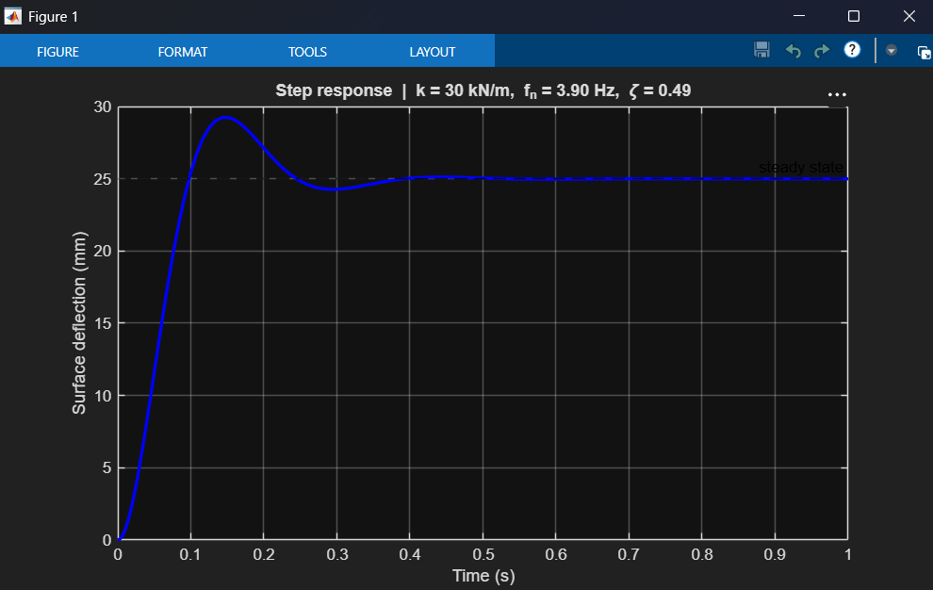

Figure 1 (Phase 1): Step response of the surface under a body-weight load (k = 30 kN/m)

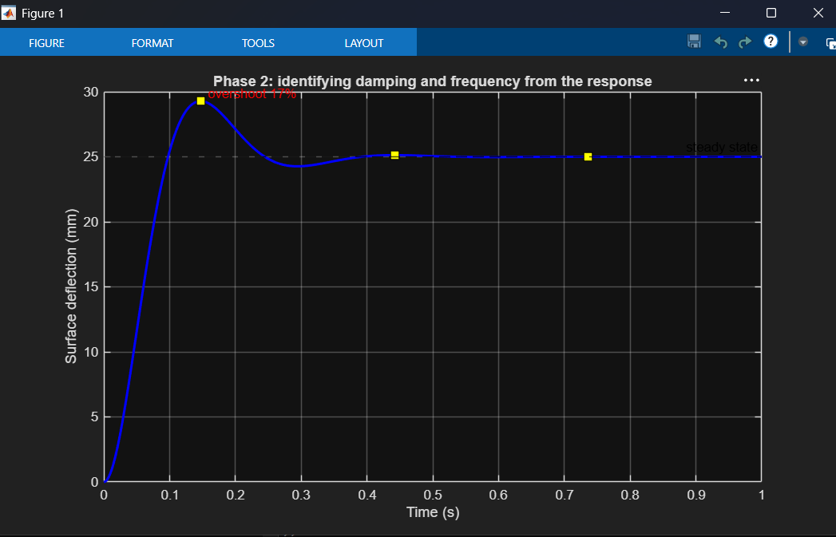

Figure 2 (Phase 2): Recovering damping and natural frequency from the response shape

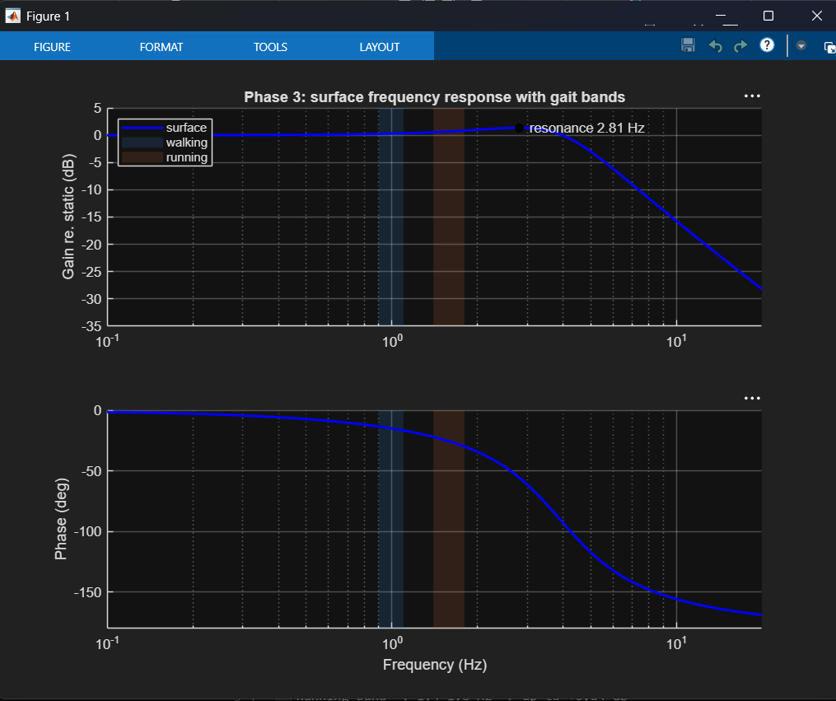
Figure 3 (Phase 3): "Surface frequency response, with walking and running bands below resonance"

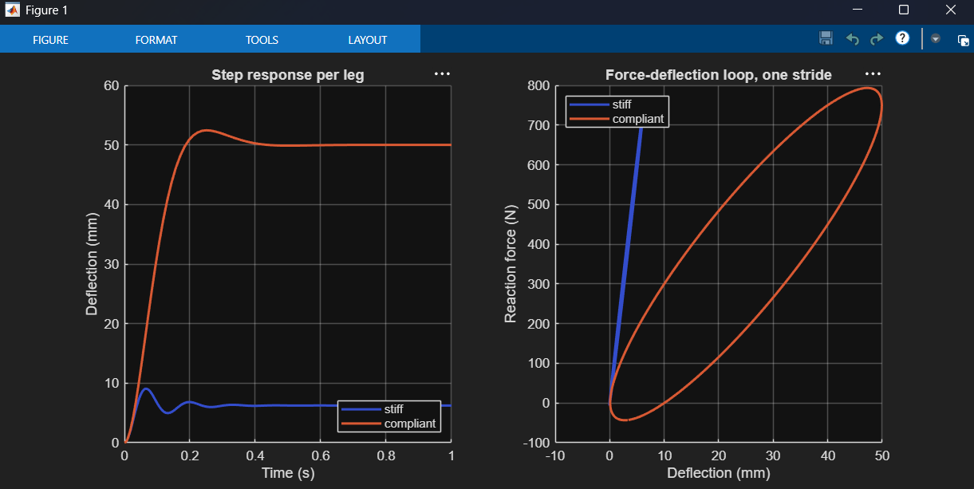

Figure 4 (Phase 4): "Stiff vs compliant surface: deflection and per-stride energy each leg feels"

Limitations and next steps
- Single-axis, lumped model — it captures the surface's vertical dynamics, not the full biomechanics of a walking person.
- Linear spring and damper; a real surface may behave nonlinearly at large deflections.
- Parameters are representative of the AdjuSST range rather than measured from hardware.
- Natural extensions: validate against the published AdjuSST characterization, and add a simple model of the foot/leg interacting with the surface.

Code
Organized as modular MATLAB files: simulate_msd.m (the shared mass-spring-damper engine) and gait_phase_1.m through gait_phase_4.m.

