EJERCICIOS DOCKER

1) Realizar DOCUMENTOS (ejercicios_docker.md) con las instrucciones que se han seguido en cada uno de los siguiente tutoriales online. (elegir a o b)

Ejercicios Oficiales de DOCKER (<https://training.play-with-docker.com/> )

a) Para Administradores:

* [Your First Linux Containers](https://training.play-with-docker.com/ops-s1-hello): In this lab you will explore the basics of running containers.

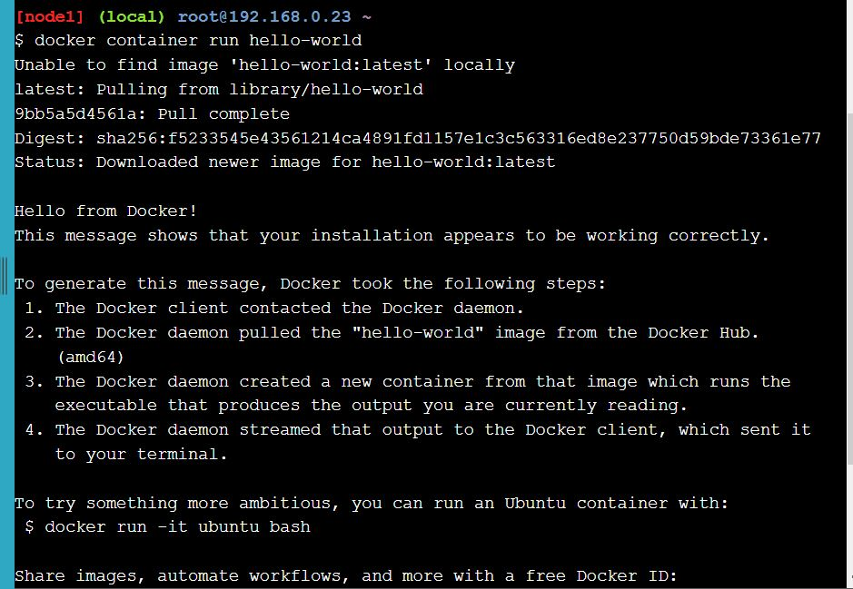

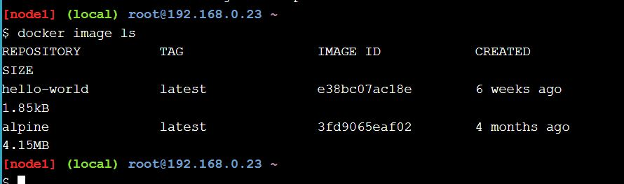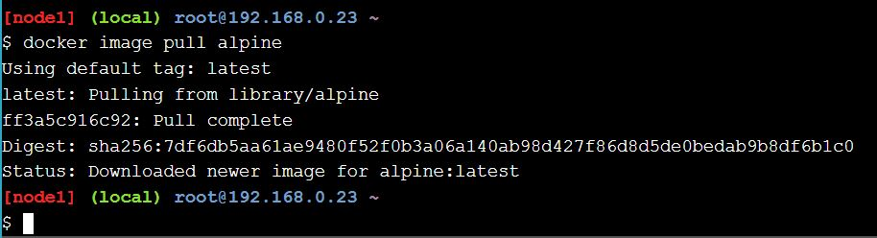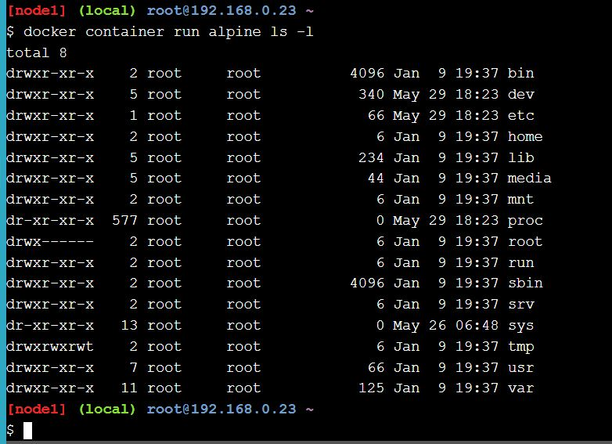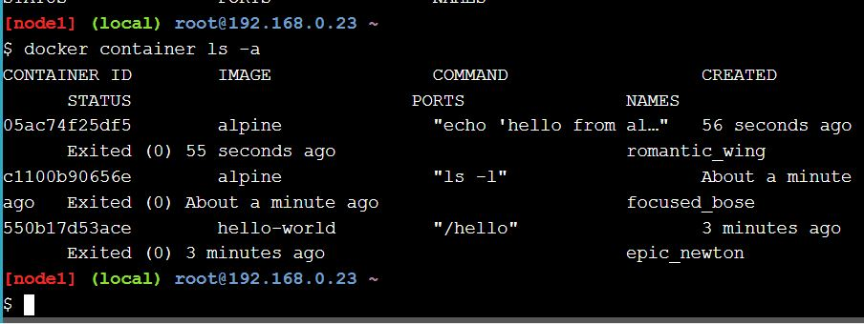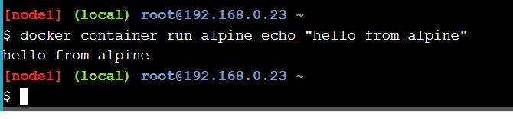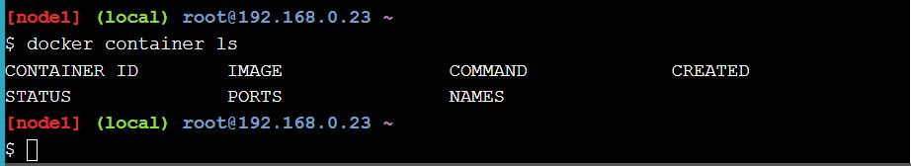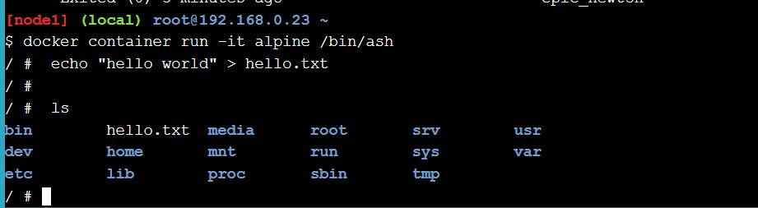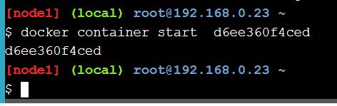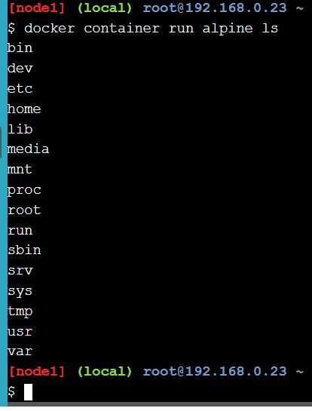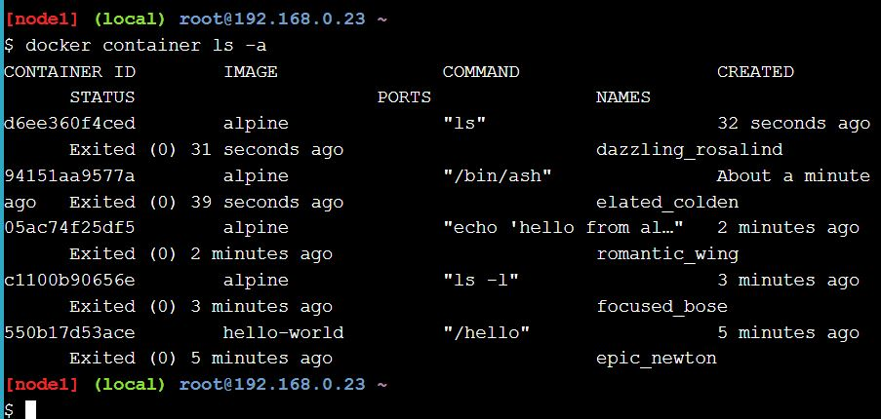

* [Customizing Docker Images](https://training.play-with-docker.com/ops-s1-images): Move on to building your own custom Docker images.
* [Deploy and Managing Multiple Containers](https://training.play-with-docker.com/ops-s1-swarm-intro): Real apps consist of multiple components.

b) Para desarrolladores:

* <https://training.play-with-docker.com/ops-s1-images/>
* [Docker for Beginners - Linux](https://training.play-with-docker.com/beginner-linux)
* [Deploying a Multi-Service App in Docker Swarm Mode](https://training.play-with-docker.com/swarm-stack-intro)

2) Subir documentos .md de los 3 ejercicios a vuestro Github

3) Opcional: Instalar DOCKER en Ubuntu 64 bits

4) Opcional : Realizar el siguiente Tutorial:

<https://hackernoon.com/docker-tutorial-getting-started-with-python-redis-and-nginx-81a9d740d091>