February 2015

# B.C. Government Navigation XML Feed for gov.bc.ca – Terms of Use and Instructions

## About this Service

Web properties, including sites and applications, that have received GCPE approval to create web properties outside of gov.bc.ca and the corporate content management system, CMS Lite, are recommended to use an XML feed of the B.C. Government’s internet site header and footer provided by *Government Communications & Public Engagement (GCPE) – Strategic Initiatives Division (SID) – Corporate Online Services (COS)*, which includes the top three levels of its navigation. This will allow standalone web properties using the feed to automatically update their header/footer elements as per gov.bc.ca. The following describes terms of use, file location and an explanation of the XML feed properties.

## Terms of Use

**By using this Service, the Client agrees to the following Terms of Use**:

* The Client uses this Service at their own risk.
* COS makes no promise of service level or availability of this Service, which is provided on a best efforts basis.
* COS may change this Service and any of its parts at its sole discretion. The Client is responsible for making all necessary changes and updates to their system(s) at their risk and cost.
* COS will make all efforts to provide advanced notice of changes and outages to the Service.
* The Client is responsible for adhering to all B.C. Government policies, regulations, and legislation.
* If applicable, Web properties using this Service, whether sites, applications, forms, surveys, etc., MUST have already obtained GCPE’s approval (via the web property application form found on <http://gww.gcpe.gov.bc.ca/InternetStrategy.html>) to reside outside the gov.bc.ca domain and to not be built using the corporate content management system, CMS Lite.
* This Service includes the necessary XML files, instructions and no more than ½ hour of technical guidance at no cost to the Client, including B.C. Government ministries, agencies, boards, and commissions. All associated costs to COS to provide this guidance (i.e. time over ½ hour, travel) will be covered by the Client.
* In order to use the navigation XML feed, COS requires the Client server IP to be added to COS’ whitelist
* COS requires the Client system(s) to set the automatic request interval to no less than every 15 minutes
* A client-side caching strategy must be implemented by the Client on relevant system(s) – recommended every 24 hours
* COS will throttle server requests based on request volume per hour
* The Client MUST obtain GCPE’s approval (via the web property application form found on <http://gww.gcpe.gov.bc.ca/InternetStrategy.html>) for any manipulation in presentation that strays from the default look and feel of <http://www.gov.bc.ca> or the alternate presentation options described in Appendix A.

## Other Associated COS Services

* Further COS Technical support is available at a cost starting at $100/hr (CDN).
* Bugs can be reported to COS’ Service Desk at [gcpe.servicedesk@gov.bc.ca](mailto:gcpe.servicedesk@gov.bc.ca) and will be addressed at no cost to the Client, once validated by COS. The timing of the delivery of bug fixes will be based on severity, priority, and availability of resources, as determined by COS.

## Bug Severity Definitions:

* **Critical**: Incident/Problem that impacts primary site function(s) and/or renders the system or website unusable, unstable or unresponsive with no workaround. (target investigation response: immediate, 24x7)
* **Severe**: Incident/Problem that impacts primary site function(s), but that has a workaround (target investigation response: 24 hours, business hours)
* **Moderate**: Incident/Problem that impacts non-primary site function(s), and may or may not have a workaround (target investigation response: best efforts, business hours)
* **Minor**: Incident/Problem that requires an enhancement or ‘nice to have’ resolution (target investigation response: best efforts, business hours)
* **Cosmetic**: Incident/Problem that requires cosmetic changes that do not impact functionality (target investigation response: best efforts, business hours)

## XML Location:

* XML with specific pageID is selected
  + <http://www2.gov.bc.ca/gov/nav.page?id=A53FADA0DCA0480498B0DE5DBE396F9D>
* XML without any specifc pageID is selected
  + <http://www2.gov.bc.ca/gov/nav.page>
  + Generates top 3 levels of nodes
* XML feed for the absolute footer
  + <http://www2.gov.bc.ca/templatedata/CMF/footer/data/gov/footer.xml>

## Explanation of XML:

***Navigation item***

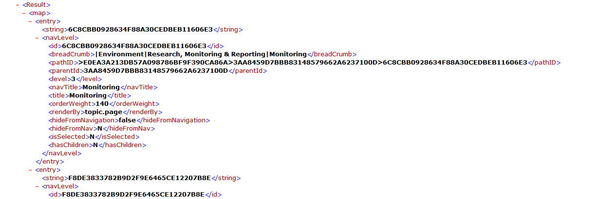

* **string** – pageId
* **id** – pageId
* **breadcrumb** – used to construct breadcrumb for the page
* **pathId** – breadcrumb, tails to the page with its pageId
* **parentId** – parentId of the page
* **level** – level of the page
* **navTitle** – navigation title for the page
* **title** – page title for the page
* **orderWeight** – order weight for the page, used to sort
* **renderBy** – page type that is used to render the page, url for each page is constructed
* **hideFromNavigation** – indicates the need to display/hide
* **hideFromNav** – n/a
* **isSelected** – indicates the page is selected, helps CSS to highlight the selected item(s)
* **hasChildren** – indicates the page has children

***topDest – top destination links on flyout***

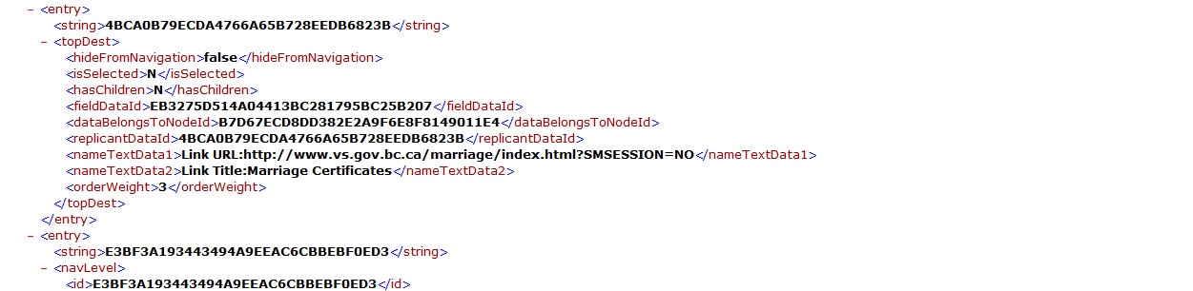

* **string** – n/a
* **hideFromNavigation** – indicates the link needs to display/hide
* **isSelected** – n/a
* **hasChildren** – n/a
* **fieldDataId** – n/a
* **dataBelongsToNodeId** – indicates where theme belongs
* **replicantDataId** – n/a
* **nameTextData1** – url
* **nameTextData2** – link text
* **orderWeight** – order weight of the node, used to sort

## XSLs

* Separated into multiple files to generate each div structure for header/footer
  + For example: top site navigation, topic navigation, bottom site navigation, etc.
* Each XSL has direct references to the topic and theme pages on www2.gov.bc.ca in order to build the navigation
* The XSL make use of CSS classes and Javascript (JS) that are located on the www2.gov.bc.ca site

## CSS and JS files

The following is a list of CSS and JS includes that may or may not be needed depending on how you are constructing the headers and footers:

* <link href="http://www2.gov.bc.ca/iwov-resources/fixed-layout/cmf-main.css" type="text/css" rel="stylesheet" />
* <link xmlns="" type="text/css" href="http://www2.gov.bc.ca/assets/gov/css/reset.css" rel="stylesheet">
* <link type="text/css" href="http://www2.gov.bc.ca/assets/gov/css/layout.css" rel="stylesheet">
* <link type="text/css" href="http://www2.gov.bc.ca/assets/gov/css/main.css" rel="stylesheet">
* <link type="text/css" href="http://www2.gov.bc.ca/assets/gov/css/cmf_footer.css" rel="stylesheet">
* <link type="text/css" href="http://www2.gov.bc.ca/assets/gov/css/cmf_header.css" rel="stylesheet">
* <link type="text/css" href="http://www2.gov.bc.ca/assets/gov/css/cmf_top_site_navigation.css" rel="stylesheet">
* <link type="text/css" href="http://www2.gov.bc.ca/assets/gov/css/cmf_theme_navigation.css" rel="stylesheet">
* <link type="text/css" href="http://www2.gov.bc.ca/assets/gov/css/cmf_topic_navigation.css" rel="stylesheet">
* <link type="text/css" href="http://www2.gov.bc.ca/assets/gov/css/cmf_breadcrumbs.css" rel="stylesheet">
* <link type="text/css" href="http://www2.gov.bc.ca/assets/gov/css/cmf_bottom_site_navigation.css" rel="stylesheet">
* <link type="text/css" href="http://www2.gov.bc.ca/assets/gov/css/cmf_page_tools.css" rel="stylesheet">
* <link type="text/css" href="http://www2.gov.bc.ca/assets/gov/css/cmf_right_column.css" rel="stylesheet">
* <link type="text/css" href="http://www2.gov.bc.ca/assets/gov/css/cmf_theme_body.css" rel="stylesheet">
* <link type="text/css" href="http://www2.gov.bc.ca/assets/gov/css/cmf_topic_body.css" rel="stylesheet">
* <link type="text/css" href="http://www2.gov.bc.ca/assets/gov/css/cmf_static_content.css" rel="stylesheet">
* <link type="text/css" href="http://www2.gov.bc.ca/assets/gov/css/print.css" rel="stylesheet">
* <link type="text/css" href="http://www2.gov.bc.ca/assets/gov/css/jquery.sidr.dark.css" rel="stylesheet">
* <link type="text/css" href="http://www2.gov.bc.ca/assets/gov/css/gov_rwd.css" rel="stylesheet">
* <script type="text/javascript" src="http://www2.gov.bc.ca/assets/gov/js/jquery/jquery-1.7.1.min.js"></script>
* <script type="text/javascript" src="http://www2.gov.bc.ca/assets/gov/js/jquery/jquery.sidr.min.js"></script>
* <script type="text/javascript" src="http://www2.gov.bc.ca/assets/gov/js/misc.js"></script>
* <script type="text/javascript" src="http://www2.gov.bc.ca/assets/gov/js/jquery/jquery.easing.1.3.js"></script>
* <script type="text/javascript" src="http://www2.gov.bc.ca/assets/gov/js/navigation_global.js"></script>
* <script type="text/javascript" src="http://www2.gov.bc.ca/assets/gov/js/jquery/jquery.nestedAccordion.js"></script>
* <script type="text/javascript" src="http://www2.gov.bc.ca/assets/gov/js/jquery/jquerycookie.js"></script>
* <link type="text/css" href="http://www2.gov.bc.ca/assets/gov/css/fancybox/jquery.fancybox.css" rel="stylesheet">
* <link type="text/css" href="http://www2.gov.bc.ca/assets/gov/css/fancybox/widget.css" rel="stylesheet">
* <script type="text/javascript" src="http://www2.gov.bc.ca/assets/gov/js/fancybox/jquery.mousewheel-3.0.6.pack.js"></script>
* <script type="text/javascript" src="http://www2.gov.bc.ca/assets/gov/js/fancybox/jquery.fancybox.js"></script>
* <script type="text/javascript" src="http://www2.gov.bc.ca/assets/gov/js/fancybox/themeID.js"></script>

## XSL Implementation Examples

Some standalone implementations of the XSL templates are provided in the “examples” files provided.

* It is recommended to use these as a guide only. Not all CSS/JS is required to render the output.
* It is recommended to view these in a modern browser (e.g. Chrome, Firefox) although the examples work in IE 8+ as well.
* Same-origin policy restrictions may require that these examples are uploaded to a server, rather than opened on a local machine (i.e. **localhost/cmf_header.xml** or **test.gov.bc.ca/cmf_header.xml**, rather than **FILE://cmf_header.xml**).
* To view an example, simply open the **XML** file that referenced the relevant **XSL** stylesheet.

## Appendix A

The following describes presentation restrictions and exceptions.

* **Web Forms** (surveys, entry/application forms = closed loop processes)
* Can use either standard gov.bc.ca look and feel or alternate layout (Diagram 2)
* Opens in a new window.
* Ensure that once the input loop and submission is complete that the window closes to return to relevant gov.bc.ca page.
* **Mapping, data applications, social media platforms** not supported by CMS Lite and some vanity sites.
* Uses full gov.bc.ca navigation (see Diagram 1)
* Opens in existing window.
* URL appropriate for Gov identity and branding regulations.
* **Static content, government services and information**
* Resides within CMS Lite / gov.bc.ca structure.
* Uses full gov.bc.ca navigation (see Diagram 1)
* All content opens within existing window.

## Diagram 1. Default Layout - XSL Visual Reference

## https://cos.citz.gov.bc.ca/jira/secure/attachment/15175/navigation_feed.jpg

**Diagram 2.** Alternate Layout for Surveys, Forms, applications.

**FOOTER** Height=50 pixels

Links are as per existing gov.bc.ca

**HEADER** Height=70 pixels

BC logo links to www.gov.bc.ca

