

Design Specification

For

TriageTag System



Prepared by:

**Group Name: TriageTag Team**

|  |  |
| --- | --- |
| ***Troy Caplinger***  ***Robert Lang*** | ***caplinger.14@wright.edu***  ***lang.35@wright.edu*** |
| ***Anthony Inman*** | ***inman.22@wright.edu*** |
| ***Jonathan Carpenter*** | ***carpenter.102@wright.edu*** |
| ***Vincent Haenni*** | ***haenni.2@wright.edu*** |

For:

**Project Sponsor: *Wright State University***

Document Tracking Information:

**Document Version: *Design Requirements Ver. 1.0***

**Date: *2016.04.22***

**Final Approval Date: *2016.04.22***

**Final Approval By: *Troy Caplinger*** [***caplinger.14@wright.edu***](mailto:caplinger.14@wright.edu)

***Robert Lang*** [***lang.35@wright.edu***](mailto:lang.35@wright.edu)

***Anthony Inman*** [***inman.22@wright.edu***](mailto:inman.22@wright.edu)

***Jonathan Carpenter*** [***carpenter.102@wright.edu***](mailto:carpenter.102@wright.edu)

***Vincent Haenni haenni.2@wright.edu***

**Table of Contents**

**1. Executive Summary**

**1.1** **Purpose of this document**

**1.2** **Design Scope**

**1.3** **Intended Audience and Document Overview**

**1.4** **Definitions, Acronyms, and Abbreviations**

**1.5** **Document Conventions**

**1.6** **References and Acknowledgments**

**2** **Problem Statement**

**2.1** **Historical Introduction**

**2.2** **Market Analysis**

**2.3** **Alternative Approaches**

**2.4** **Impact of Success**

**3** **Context of Design Solution**

**3.1** **Design Objectives**

**3.2** **Design Assumptions**

**3.3** **Design Requirements**

**3.4** **Design Constraints**

**3.5** **Design Standards**

**3.6** **Design Functionality**

**3.7** **User Characteristics**

**3.8** **Operating Environment**

**3.9** **User Documentation**

**4** **Technical Approach**

**4.1** **Hardware**

**4.2** **Software**

**5** **Appendix: Résumés of Team Members**

# 1. Executive Summary

This document is designed to be an overview of how the TriageTag system is to be used and designed. This document is intended for the Incident Command System (ICS) and National Incident Management System (NIMS) stakeholders and Senior Design I/Team Projects I faculty.

Currently the triage process relies on verbal communication with the injured individual to get important medical information [19].Without communication it can be very difficult to effectively treat the patient and could potentially lead to improper medical treatment or death. If triage personnel have access to relevant medical information, such as pharmaceutical allergies or prior medical conditions, the triage process can become much quicker and more accurate. This in turn leads to better diagnoses and treatments for the patient.

The TriageTag system will allow triage personnel to retrieve firefighters’ medical information that could be used to expedite the triage process and help save the lives of injured firefighters. Firefighters will be equipped with TriageTag radio frequency identification (RFID) tags, which will allow the triage personnel to scan the firefighters’ tags and retrieve medical information such as pharmaceutical allergies, prior existing medical conditions, and blood type from a database.The TriageTag system will allow triage personnel to gain medical information from injured firefighters regardless of whether or not that firefighter is conscious.

The TriageTag system will conform to a defined set of constraints and requirements covering privacy, hardware, and software. The hardware components of our system are the TSL 1128 Bluetooth UHF RFID Reader, Samsung Galaxy Note 5, and the XTREME RFID Rivet Jr Tag. The software components consist of a SQLite database and the TriageTag application.

The TriageTag Team includes a diverse group of electrical engineering and computer science students who possess the right tools to make this system succeed. Market analysis shows that there are several systems already being used successfully that implement parts of the TriageTag system design. The TriageTag system is feasible and if implemented will save firefighter lives.

## Purpose of this Document and Product Overview

The purpose of this document is to explain how the system is to be used and designed. The proposed TriageTag system will be implemented using three commercial off the shelf components (COTS): passive RFID tags that could be securely equipped to necklaces worn by firefighters, a mobile device with access to firefighter’s medical records, and an RFID scanner. In addition to the COTS, there will be a local database on the mobile device and a master database in a server at the firehouse. Each firefighter will be equipped with a RFID tag that will store an identification signal, unique to each individual firefighter. The RFID scanner will then send a signal to supply power for the RFID tag to transmit the identification signal. The scanner will then transmit the RFID tag’s unique identification signal to the mobile device via bluetooth connection. The mobile device will then use the information from the scanner to query the local database stored on the mobile device. The master database will allow firefighters to update and modify their existing medical information and will synchronize with the local database on the mobile device.

## Design Scope

The TriageTag system will be made up of five components: RFID tags that can be fastened to necklaces worn by firefighters, a mobile device, an RFID scanner that can access firefighter’s medical records, a local database stored on the mobile device, and a master database stored on a server at the firehouse. The TriageTag system will only include software running on the server and mobile device, but not the hardware of the server itself. Each firefighter will be equipped with a TriageTag RFID tag that will store an identification number unique to each individual firefighter. The TriageTag RFID tag can then be scanned by medical personnel to retrieve and view the firefighter's medical records with the TriageTag mobile device.

The purpose of the TriageTag system is to aid medical personnel in treating injured firefighters. The system allows medical personnel to have quick, secure access to a firefighters medical records. The goal of the system is to improve the medical care of firefighters.

*The following are within the scope of the project:*

* Selection of COTS RFID scanner, RFID tags, and mobile device to ensure interoperability between the RFID scanner and RFID tags as well as the RFID scanner and mobile device
* Creation of database that holds medical information for 200 firefighters
* Creation of database that encrypts medical information stored on local and master databases in accordance with AES specifications [6]
* Ensure local database synchronizes with master database

*The following are not within the scope of the project:*

* A training course for usage of the TriageTag system
* The creation and distribution of training or custom documentation for the TriageTag system
* The necklace which the RFID tag will be attached to
* Gathering and inputting firefighter medical information

## Intended Audience and Document Overview

The intended audience of this Design Specification document are ICS and NIMS stakeholders. Additionally, the Wright State University faculty for Senior Design I/Team Projects I: Ms. Brandy Foster, Mr. Eric Buck, and Dr. Fred Garber are also part of the intended audience.

It is recommended that the ICS and NIMS stakeholders read all of section 1, the introduction of 2, 2.4, 3.1, 3.2, 3.6, and all of section 4. Course faculty should read the entire document.

## Definitions, Acronyms, and Abbreviations

***Acronyms:***

RFID Radio Frequency Identification

GUI Graphical User Interface

COTS Commercial Off The Shelf

NIMS National Incident Management System

ICS Incident Command System

ACL Access Control List

AES Advanced Encryption Standard

XML Extensible Markup Language

***Definitions:***

**Chemical Resistant:** Resistant to Water, Motor Oil, Hydraulic Oil, Dishwashing Detergent, Windex, Gasoline, Isopropyl Alcohol, Mineral Spirits, Acetone, Bleach, 409 Cleaner or Fantastic All Purpose Cleaner, Methyl Ethyl Ketone (MEK), and Machine Oil

**Compatible:** The TriageTag scanner and mobile device will be able to communicate wirelessly.

**Medical Record:** a list of fields pertaining to one firefighter’s medical information.

**Open Source Operating System:** An operating system whose code is available to be read and modified by he general public free of charge.

**Passive RFID Tag:** an RFID tag that is energized by an RFID scanner to emit a signal to uniquely identify the tag. The use of RFID tag in this document refers to passive RFID technology.

**Red Tag:** The traditional triage tag level that indicates immediate medical attention is required.

**Synchronization:** The process of establishing consistency between the TriageTag local database and TriageTag master database by updating the TriageTag local database with a copy of the TriageTag master database.

**TriageTag Application:** The software component of the TriageTag system.

**User Authentication:** A security mechanism that allows users to have different levels of privilege, thereby allowing a particular user to only access a defined set of features.

## Document Conventions

The underlined terms in this document are defined in section 1.4. Only the first instance of the term in the document is underlined. All acronyms are listed in section 1.4 and are introduced the first time they are used in text. In this document, the use of RFID tags refers to passive RFID tags. A definition of this technology can be found in section 1.4, under definitions. Requirements, constraints, and standards use the following numbering scheme, X.X.X.XXX.

## References and Acknowledgments

[1] East Jordan EMS. (2016). *Charlevoix County Medical Control Authority State Model Protocol* . [Online]. Available: http://www.ejems.com/Protocols/MCI/mass%20cas.htm [Date Accessed: March 21, 2016]

[2] McCallion, Theresa. (2011, August 31). *EMS Providers Recall 9/11*. Journal of Emergency Medical Services. [Online]. Available: http://www.jems.com/articles/print/volume-36/issue-9/september-11/ems-providers-recall-911.html [Date Accessed: March 21, 2016]

[3] Petfinder. (2016). *Pet Microchip FAQs*. [Online]. Available: https://www.petfinder.com/dogs/lost-and-found-dogs/microchip-faqs/ [Date Accessed: March 21, 2016]

[4] Cascade Engineering. (2014). *XTREME RFID Rivet Jr Tag*. [Online]. Available: http://xtremerfid.com/xtreme-tag%C2%AE-rivet-jr [Date Accessed: April 6, 2016]

[5] Cattlesoft, Inc. (2016). *A Better Cattle Identification Solution*. [Online]. Available: http://www.cattletags.com/ [Date Accessed: March 21, 2016]

[6] National Institute of Standards and Technology. (November 26, 2001). *FIPS PUBS 197 Advanced Encryption Standard*. [Online]. Available: http://csrc.nist.gov/publications/fips/fips197/fips-197.pdf [Date Accessed: April 4, 2016]

[7] Technology Solutions Ltd. (2013). *1128 Bluetooth UHF RFID Reader*. [Online]. Available: http://www.barcodediscount.com/pdf/TSL/1128.pdf [Date Accessed: March 21, 2016]

[8] Samsung Electronics Co., Ltd. (2016). *Samsung Galaxy Note 5*. [Online]. Available: http://www.samsung.com/us/explore/galaxy-note-5-features-and-specs/?cid=ppc- [Date Accessed: March 30, 2016]

[9] International Organization of Standards. (2016). *ISO/IEC 18000-63:2015*. [Online]. Available: http://www.iso.org/iso/home/store/catalogue_ics/catalogue_detail_ics.htm?csnumber=63675 [Date Accessed: March 30, 2016]

[10] Underwriters Laboratory LLC. (2015). *UL 60950-1*. [Online]. Available: http://ulstandards.ul.com/standard/?id=60950-1_1 [Date Accessed: March 30, 2016]

[11] DSM&T Co. (2016). *IP Rating Chart*. [Online]. Available: http://www.dsmt.com/resources/ip-rating-chart/ [Date Accessed: March 30, 2016]

[12] Federal Register National Archives and Records Administration. (October 1, 2007). *45 CFR 160*. [Online]. Available: https://www.gpo.gov/fdsys/pkg/CFR-2007-title45-vol1/pdf/CFR-2007-title45-vol1.pdf [Date Accessed: April 1, 2016]

[13] Federal Register National Archives and Records Administration. (October 1, 2007). *45 CFR 162*. [Online]. Available: https://www.gpo.gov/fdsys/pkg/CFR-2007-title45-vol1/pdf/CFR-2007-title45-vol1.pdf [Date Accessed: April 1, 2016]

[14] Federal Register National Archives and Records Administration. (October 1, 2007). *45 CFR 164*. [Online]. Available: https://www.gpo.gov/fdsys/pkg/CFR-2007-title45-vol1/pdf/CFR-2007-title45-vol1.pdf [Date Accessed: April 1, 2016]

[15] IEEE Standards Association. (2016). *IEEE Standard 1451.7-2010*. [Online]. Available: https://standards.ieee.org/findstds/standard/1451.7-2010.html [Date Accessed: April 1, 2016]

[16] IEEE Standards Association. (2016). *IEEE Standard 1073-1996*. [Online]. Available: https://standards.ieee.org/findstds/standard/1073-1996.html [Date Accessed: April 4, 2016]

[17] University of Southern California Information Sciences Institute. (September 1981). *Transmission Control Protocol*. [Online]. Available: https://tools.ietf.org/html/rfc793 [Date Accessed: April 4, 2016]

[18] Department of Homeland Security. (September 2013). *TechNote RFID Triage Tags*. [Online]. Available: http://www.firstresponder.gov/SAVER/Documents/RFID-Triage-Tags-TN_0913-508.pdf [Date Accessed: April 18, 2016]

[19] Aronsky, Dominik. Jones, Ian. Raines, Bill. Hemphill, Robin. Mayberry, Scott R. Luther, Melissa A. Slusser, Ted. (2008). *An Integrated Computerized Triage System in the Emergency Department*. [Online]. Available: http://www.ncbi.nlm.nih.gov/pmc/articles/PMC2656061/ [Date Accessed: April 8, 2016]

[20] Zetetic LLC. (2015). *Full Database Encryption for SQLite*. [Online]. Available: https://www.zetetic.net/sqlcipher/ [Date Accessed: April 22, 2016]

[21] Canonical Ltd. (2016). *Download Ubuntu Desktop*. [Online]. Available: http://www.ubuntu.com/download/desktop [Date Accessed: April 22, 2016]

# Problem Statement

When dealing with mass casualty or large scale disaster events, firefighters are among the first to respond to these situations. If a firefighter becomes injured at one of these catastrophes, he or she will likely be treated by triage personnel who are not familiar with any of their medical history or information . Currently, the most reliable method that firefighters can use to communicate this information is verbally [19]. While this method may be effective, it is not always an option. This is true if the firefighter becomes unconscious or is too injured to communicate verbally. The TriageTag system is designed to solve this problem.

## Historical Introduction

The TriageTag System is designed to assist with the treatment of firefighters during a mass casualty event. One of the most recent mass casualty events in the United States is the collapse of the World Trade Center Towers on September 11, 2001. Previously, firefighters would run right past EMS crews with an injured firefighter, not knowing exactly where to take them [2]. The TriageTag System would solve this problem, because firefighters equipped with TriageTag tags could be taken to triage centers on site where EMS crews would have ready access to their medical information. There is already an existing triage tagging system established for dealing with mass casualty events as shown in Figure 1.

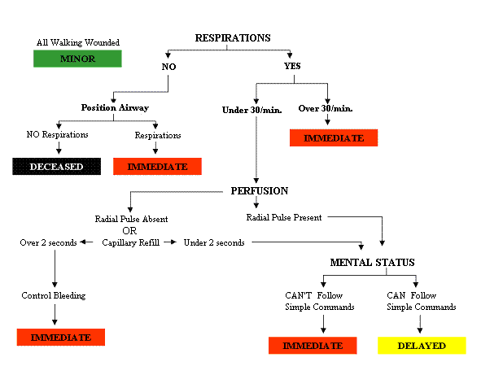

Figure 1: START Triage Tagging System [1]

The TriageTag System will be able to integrate smoothly into this existing system, because it will assist in the treatment of any firefighter who receives a red tag and needs immediate medical attention. With quick access to the medical information that the TriageTag system will provide, triage personnel can have more confidence in treating the injuries of firefighter in route and at treatment facilities. This will be true even if the firefighter is unable to communicate their medical information verbally, because all the triage personnel have to do is scan the firefighter’s TriageTag RFID tag and their information will be displayed on a mobile device.

## Market Analysis

This product is being designed primarily for use by firefighters, but it could also be used by any organizations that work or operate in a high risk environment. These organizations could include the military, search and rescue teams such Federal Emergency Management Agency (FEMA) or The National Association for Search And Rescue (NASAR), and police departments. There is currently one other system that uses RFID tags within the triage process. The RFID triage system is implemented similarly to traditional triage where victims are assessed into triage categories [18]. Triage personnel assign categories to each injured person and the number and severity of these injuries is relayed to the incident commander [18].

Another system with similar components to the TriageTag system deals with missing pets. To identify lost pets, passive RFID tags are placed under the skin of the pet [3]. An identification number is read from the RFID tag using an RFID scanner, which corresponds to an entry to a database [3]. This database entry has information on the pet owner, including contact information and their address [3]. Information on a price of the total system is not available, but cost per tag is estimated to be approximately $45.00 [3].

Electronic cattle management is system that uses RFID tags to track different characteristics of cattle owned by farmers [5]. This system is more dynamic than the TriageTag system, as it allows modification of information to the local database [5]. However, this system is similar to TriageTags as it allows information to be accessed by the user by scanning the RFID tags [5]. The cost to implement this system to manage 100 active animals, is approximately $1659.00 [5].

## Alternative Approaches

An alternative approach that was discussed during the initial phases of the system design was to allow triage personnel to be able to update and add information to the local database on site. Eventually, it was decided that this design did not add any significant functionality. If triage personnel were allowed to edit the medical information on site, then it would add a layer of complexity to designing the system that did not greatly improve the performance. Instead of only having to update the master database, the TriageTag system would need a way for the local database to update the master database. After the initial scan and access of pertinent medical information, triage and medical personnel would already have any information that would have been updated in the local database. This lead to the development of requirement 3.3.1.070.

## Impact of Success

The TriageTag system will allow triage personnel to lookup medical information for firefighters within the the TriageTag database and aid in the medical care of firefighters injured in catastrophic events. The Triage personnel will have to scan the TriageTag RFID tags located on firefighters using the TriageTag scanner and a unique signal corresponding to that firefighter will be returned to the scanner. The unique signal will allow the user to retrieve medical information pertaining to that firefighter.

Currently the majority of RFID based products are used for inventory or asset tracking and accountability. The only systems similar to the TriageTag system are used for tracking the number and severity of firefighter injuries and the location of pets and livestock. The TriageTag system is unique in that its primary focus isn’t on tracking the firefighters, but the storage and retrieval of medical information as a means to expedite the triage process. The uniqueness of this system would give us a large market share considering there are few competing systems. The TriageTag system will give triage personnel immediate access to important medical information and will greatly impact the quality of care given to injured firefighters.

# Context of Design Solution

## Design Objectives

We propose to integrate RFID technology into the medical triage process to allow triage personnel to access firefighter medical records without patient communication.

***Design Objectives:***

1. Allow triage personnel to identify injured firefighters using RFID technology.
   * Firefighters will be equipped with a TriageTag RFID tag. Upon interrogation by the TriageTag RFID scanner, the TriageTag RFID tag will emit a signal that is unique to the TriageTag system. This unique signal will then correspond to the specific firefighter’s medical records.
2. Allow firefighters to input and modify their personal medical information located on the TriageTag master database.
   * Firefighters will log into the TriageTag master database to access their medical information profile. Each firefighter will have a unique username and password for access to their medical information profile. Once the firefighter accesses their medical information profile, information can be added and modified.
3. Allow triage personnel to access injured firefighters’ medical records via the TriageTag mobile device.
   * The TriageTag scanner will receive an identification signal from a injured firefighter’s TriageTag RFID tag. This unique identification signal will then be transferred to the TriageTag mobile device. The triage personnel will log into the TriageTag mobile device to access the TriageTag local database located on the mobile device. The triage personnel will then use the unique identification number to access the firefighter’s medical information profile.
4. Allow TriageTag local database to synchronize data with the TriageTag master database.
   * Since all medical information profiles will only be modified on the master database, the local database’s data must be synchronized with the master database. This synchronization process will ensure that triage personnel have the most up to date medical information.

## Design Assumptions

1. The master database will be stored on a server provided by the firehouse.

2. The server provided by the firehouse will meet the minimum specification to run Ubuntu 16.04 LTS.

* 2 GHz dual core processor or better [21]
* 2 GB system memory [21]
* 25 GB of free hard drive space [21]
* Either a DVD drive or a USB port for the installer media [21]
* Network interface controller with minimum of 100 Mbits/s Ethernet [21]

3. The firehouse will provide the following peripheral devices: a monitor, keyboard, and mouse.

4. The TriageTag scanner will be a TSL 1128 Bluetooth UHF RFID Reader [7].

5. The TriageTag mobile device will be a Samsung Galaxy Note 5 [8].

6. The TriageTag RFID tags will be XTREME RFID Rivet Jr Tag [4].

7. Firefighters will work in harsh environments, which could consist of high humidity, high temperature, or water saturation.

8. The on-site triage centers will be dry and conditioned areas.

## Design Requirements

***3.3.1 User Interfaces***

3.3.1.010: The TriageTag mobile device shall display a graphical user interface (GUI).

3.3.1.020: The TriaeTag mobile device shall allow authorized medical personnel to retrieve medical information.

3.3.1.030: The GUI shall have a button to initiate the synchronization of the TriageTag local database with the TriageTag master database.

3.3.1.040: The GUI shall have a button to allow the user to add new firefighters into the TriageTag database.

3.3.1.050: The user interface shall allow the user to update information for firefighters already within the TriageTag system.

3.3.1.060: The user interface shall allow the triage personnel to retrieve medical records from the local database.

3.3.1.070: The user interface shall allow a user access to features corresponding to their priviledge level.

***3.3.2 Software Interfaces***

3.3.2.010: The user interface shall allow the operator to initiate the synchronization process between the local database and master database.

***3.3.3 Communication Interfaces***

3.3.3.010: The TriageTag RFID system shall conform to ISO/IEC 18000-63:2015.

3.3.3.020: The TriageTag scanner shall communicate with the TriageTag mobile device.

3.3.3.030: The TriageTag scanner shall transmit energy wirelessly to energize the TriageTag RFID tags.

3.3.3.040: The TriageTag mobile device shall be electronically compatible with the TriageTag scanner.

3.3.3.050: The mobile device shall be capable of wireless communications.

***3.3.4 Performance***

3.3.4.010: The TriageTag RFID scanner shall read RFID tags with a maximum separation distance of no more than 20 meters.

3.3.4.020: The TriageTag TriageTag mobile device shall operate using an internal, rechargeable energy storage device with a minimum capacity of 2500mAh.

***3.3.5 Safety***

3.3.5.010: The TriageTag system shall conform to UL 60950-1.

***3.3.6 Security***

3.3.6.010: The TriageTag application shall utilize user authentication to access the master database.

3.3.6.020: The TriageTag application shall utilize user authentication to access a local database.

3.3.6.030: TriageTag RFID tags shall transmit an identification signal unique to the TriageTag system.

***3.3.7 Functional Requirements***

3.3.7.010: TriageTag system shall include at least 1 passive RFID tag.

3.3.7.020: TriageTag system shall include a single master database stored on a local server.

3.3.7.030: The master database shall store medical record(s).

3.3.7.040: Medical records shall be modifiable.

3.3.7.050: The mobile device shall have a memory capacity of at least 1GB.

3.3.7.060: TriageTag system shall include at least 1 TriageTag RFID scanner.

3.3.7.070: Each TriageTag mobile device shall have a local copy of the master database.

3.3.7.080: TriageTag system shall include at least 1 TriageTag mobile device.

3.3.7.090: The TriageTag mobile device shall run the TriageTag application.

## Design Constraints

***3.4.1 Design Constraints***

3.4.1.010: RFID tag will maintain full functionality in temperatures ranging from -20ºF to 180ºF.

3.4.1.020: RFID tag will have an Ingress Protection Rating (IP) of 55.

3.4.1.030: RFID tag will be passive-energized by RFID scanner.

3.4.1.040: RFID tag will be maximum of 5 centimeters long, 5 centimeters wide, and 2 centimeters thick.

3.4.1.050: The database will be able to manage more than 100 personnel records and not more than 200.

***3.4.2* *Implementation Constraints***

3.4.2.010: All aspects of the system will conform to the Health Insurance Portability and Accountability Act (HIPAA).

3.4.2.020: The RFID tag and scanner will conform to all Federal Communications Commission (FCC) radio spectrum allocation regulations for RFID devices.

3.4.2.030: The TriageTag application will be deployable on an open source operating system.

3.4.2.040: The TriageTag system will employ COTS.

3.4.2.050: All medical records will be encrypted according to the AES.

3.4.2.060: Refer to Design Requirements 3.3.3.010.

## Design Standards

3.5.1.010: Refer to Design Requirements 3.3.3.010 [9].

3.5.1.020: Refer to Design Requirements 3.3.5.010 [10].

3.5.1.020: Refer to Design Constraints 3.4.1.020 [11].

3.5.1.030: TriageTag system will conform to HIPAA Security Rule 45 C.F.R. §§ 160 [12].

3.5.1.040: TriageTag system will conform to HIPAA Security Rule 45 C.F.R. §§ 162 [13].

3.5.1.050: TriageTag system will conform to HIPAA Security Rule 45 C.F.R. §§ 164 [14].

3.5.1.060: TriageTag system will conform to IEEE Standard 1451.7-2010 [15].

3.5.1.070: TriageTag system will conform to IEEE Standard 1073-1996 [16].

3.5.1.080: TriageTag system will conform to Advanced Encryption Standard (AES) [6].

3.5.1.090: TriageTag system will conform to Transmission Control Protocol (TCP) [17].

## Design Functionality

1. The TriageTag system will allow the triage personnel to scan TriageTag RFID tags.

* The TriageTag RFID tags contain the unique I.D that distinguishes one firefighter from the next.
* The TriageTag Scanner will be used to retrieve the unique I.D from the tags and transmit that unique I.D to the mobile device.

1. The TriageTag system will allow the triage personnel to retrieve medical information for firefighters within the TriageTag database.

* Triage personnel logged into the TriageTag application running on the TriageTag mobile device will be able to access the medical records corresponding to the firefighters RFID tag being scanned.

1. The TriageTag system will allow the firefighters to add/modify new personnel records to the TriageTag master database.

* Firefighters will add their own new personal records to the TriageTag master database, which is located at the local firehouse.
* Firefighters will be able to modify their own medical and personal records within the master database. All modification will be done at the local firehouse.

## User Characteristics

This system will have 2 classes of users. The first class of user is the firefighters. They will be using the system actively by updating their medical information in the TriageTag master database as needed and passively using the system by wearing TriageTag RFID tags. The other class of user will be the triage personnel using the TriageTag scanner and TriageTag mobile device. They will be using the system actively to scan firefighters’ TriageTag RFID tags and then accessing a local copy of the TriageTag master database to view medical information. The most important user class to satisfy will be triage personnel.

## Operating Environment

The TriageTag system has two systems that will operate in different environments. The first system involves the RFID tag itself, which will be worn underneath firefighters’ fire protection gear and clothing. These tags will be worn when firefighters are deployed to perform their duties. The tags will need to operate in environments that could potentially be in a state of high humidity, high temperature, or water saturation. The second system is the RFID scanner and mobile device operated by triage personnel in the medical center. This environment will be in a dry, covered area with little to no environmental factors affecting the RFID scanner and mobile device.

## User Documentation

No training or custom user documentation will be provided with the TriageTag system. The only user documentation that will be included with the TriageTag system are the documents that come with the COTS equipment.

# Technical Approach

The TriageTag system involves both hardware and software components. The hardware components are the TriageTag: mobile device, RFID scanner, and RFID tags. The mobile device and RFID scanner will be operated primarily by triage personnel and will be geared towards ease of use. Firefighters will be the the primary users of the RFID tags and the tags will be geared towards durability and reliability. The software components of the system are the master database stored on a server in the firehouse and the local database stored on the mobile device. Users of the of the master database will be firefighters that need to add/modify their information. The system flowchart is shown in Figure 2.

SystemDesign.png

Figure 2: TriageTag System Design

Source: Author Jonathan Carpenter

## Hardware

1. The TriageTag scanner.
   1. TSL 1128 Bluetooth UHF RFID Reader.
      1. Key features
         1. Bluetooth connectivity [7]
         2. Battery operated for portability [7]
         3. Conforms to Ingress Protection standard IP54 [7]
         4. Nominal read range up to 4 meters [7]
         5. Output power: 10mW to 800mW [7]
         6. Operational frequency range: 902 MHz to 928 MHz [7]
      2. Requirements satisfied
         1. Design Requirements 3.3.5.010
         2. Design Requirements 3.3.4.010
         3. Design Requirements 3.3.3.030
         4. Design Requirements 3.3.3.010
         5. Design Requirements 3.3.3.020
         6. Design Requirements 3.3.7.060
2. The TriageTag Mobile Device

# Samsung Galaxy Note 5

* + 1. Key features
       1. Android 5.1.1 Lollipop operating system[8]
       2. Internal memory up to 64 GB[8]
       3. Bluetooth connectivity[8]
       4. Wi-Fi enabled[8]
       5. Stylist[8]
       6. Lithium Ion rechargeable battery with 3000mAh capacity[8]
    2. Requirements satisfied
       1. Design Requirements 3.3.7.100
       2. Design Requirements 3.3.3.020
       3. Design Requirements 3.3.4.020
       4. Design Requirements 3.3.3.040
       5. Design Requirements 3.3.7.050
       6. Design Requirements 3.3.7.070

1. The TriageTag RFID Tag

### XTREME RFID Rivet Jr Tag

* + 1. Key features
       1. RF Protocol: ISO 18000 [4]
       2. Readable/Writable [4]
       3. Read range: up to 4.3 Meters (Typical) [4]
       4. Write range: up to 2.4 Meters (Typical) [4]
       5. Operational temperature: -40C to 85C [4]
       6. Chemical Resistant [4]
       7. Ingress Protection rating: IP69K [4]
    2. Requirements satisfied
       1. Design Requirements 3.3.3.040
       2. Design Requirements 3.3.6.030
       3. Design Requirements 3.3.7.010
       4. Design Requirements 3.3.7.050

## Software

**4.2.1 Use Cases**

The following use cases illustrate how the a users of the TriageTag system can retrieve medical data, synchronize the mobile device’s database with the server’s database, and edit medical information.

**Use Case 1: Retrieving Medical Data**

Description: A triage personnel needs to retrieve the medical data of an injured firefighter. Figure 3 shows the retrieval of medical data.

Actors: Injured Firefighter, Medical Personnel

Assumptions: Medical personnel are using mobile device to perform the following operations

Flow of events:

1. Medical personnel fills out the username text field with their username
2. Medical personnel fills out the password text field with their password
3. Medical personnel presses login button
4. Medical personnel presses scan tag button
5. Medical personnel scans RFID tag on injured firefighter with RFID scanner
6. Medical personnel retrieves medical data

UseCase1.png

Figure 3: Medical data retrieval

Source: Author Jonathan Carpenter

**Use Case 2: Synchronizing Mobile Device with Master Database**

Description: A mobile device operator needs to update the mobile device with recent changes to the medical data stored on the server. Figure 4 shows the synchronization process.

Actors: Mobile device operator

Assumptions: Mobile device operator is within wifi range of server

Flow of events:

1. Mobile device operator fills out the username text field with their username
2. Mobile device operator fills out the password text field with their password
3. Mobile device operator presses login button
4. Mobile device operator presses synchronize button
5. Mobile device synchronizes with master databaseSynchronizeDesign.png

Figure 4: Synchronize Mobile Device

Source: Author Jonathan Carpenter

**Use Case 3: Editing Medical Information**

Description: A firefighter needs to update their medical information. Figure 5 shows a firefighter updating medical records.

Actors: Firefighter

Assumptions: Firefighter performs the following operations on the server

Flow of events:

1. Firefighter fills out username text field
2. Firefighter fills out password text field
3. Firefighter clicks login button
4. Firefighter clicks edit medical records button
5. Firefighter edits medical records
6. Firefighter clicks save button

UseCase3.png

Figure 5: Editing Medial Data

Source: Author Jonathan Carpenter

**4.2.2 User Interface Design**

Figure 6 shows the design of the user interface for the TriageTag application running on the mobile device and server. This interface will be navigated to perform scanning of RFID tags, editing medical records, or synchronizing the mobile device with the master database. Some of the functions displayed in the user interface will only be accessible to users with the appropriate level of privilege. Table 1 and 2 display an ACL illustrating the different levels of privilege.

InterfaceDesign.png

Figure 6: User interface diagram

Source: Author Jonathan Carpenter

**4.2.2.1 Requirements Satisfied**

Design Requirements 3.3.1.010

Design Requirements 3.3.1.030

Design Requirements 3.3.1.040

Design Requirements 3.3.1.050

Design Requirements 3.3.1.060

Design Requirements 3.3.1.070

Design Requirements 3.3.2.010

Design Requirements 3.3.7.090

**4.2.3 Access Control List**

Users operating the TriageTag application will have different levels of privilege to ensure only particular users of a given type may perform a set of permitted operations. The TriageTag application will run on both the server and the mobile device. The ACL on the mobile device will be different from the ACL on the server. Table 1 and 2 illustrate the various levels of privilege on the mobile device and server, respectively.

|  |  |  |  |
| --- | --- | --- | --- |
| Users | Scan Tag | Medical Data | Synchronize |
| Super User | Allow | Read | Allow |
| Firefighter | Deny | Deny | Allow |
| Medical Personnel | Allow | Read | Allow |

Table 1: Mobile device TriageTag application ACL

Source: Author Jonathan Carpenter

|  |  |  |  |
| --- | --- | --- | --- |
| Users | Scan Tag | Medical Data | Synchronize |
| Super User | Deny | Read, Edit | Deny |
| Firefighter | Deny | Read, Edit | Deny |
| Medical Personnel | Deny | Read | Deny |

Table 2: Server TriageTag application ACL

Source: Author Jonathan Carpenter

**4.2.3.1 Requirements Satisfied**

Design Requirements 3.3.1.020

Design Requirements 3.3.6.010

Design Requirements 3.3.6.020

**4.2.4 Database**

The TriageTag application on the server will utilise a master database that will store medical information of firefighters. The TriageTag application on the mobile device will utilise a local database that is a copy of the master database. The local database will synchronize with the master database to maintain the most up to date information. The mobile device must be on the same network as the server in order to synchronize. The database will be a SQLite database using the SQLCipher API to provide 256-bit AES encryption [20].

The database will provide a mapping of firefighter accounts to extensible markup language (XML) files. The XML files will contain the medical information of firefighters. Medical professionals will retrieve these XML files upon scanning a firefighters RFID tag. The XML files will be modifiable by the mapped user account. See figure 7 for a mock-up what the medical professional will see displayed on the mobile device after retrieving the medical information of a firefighter after scanning a tag.

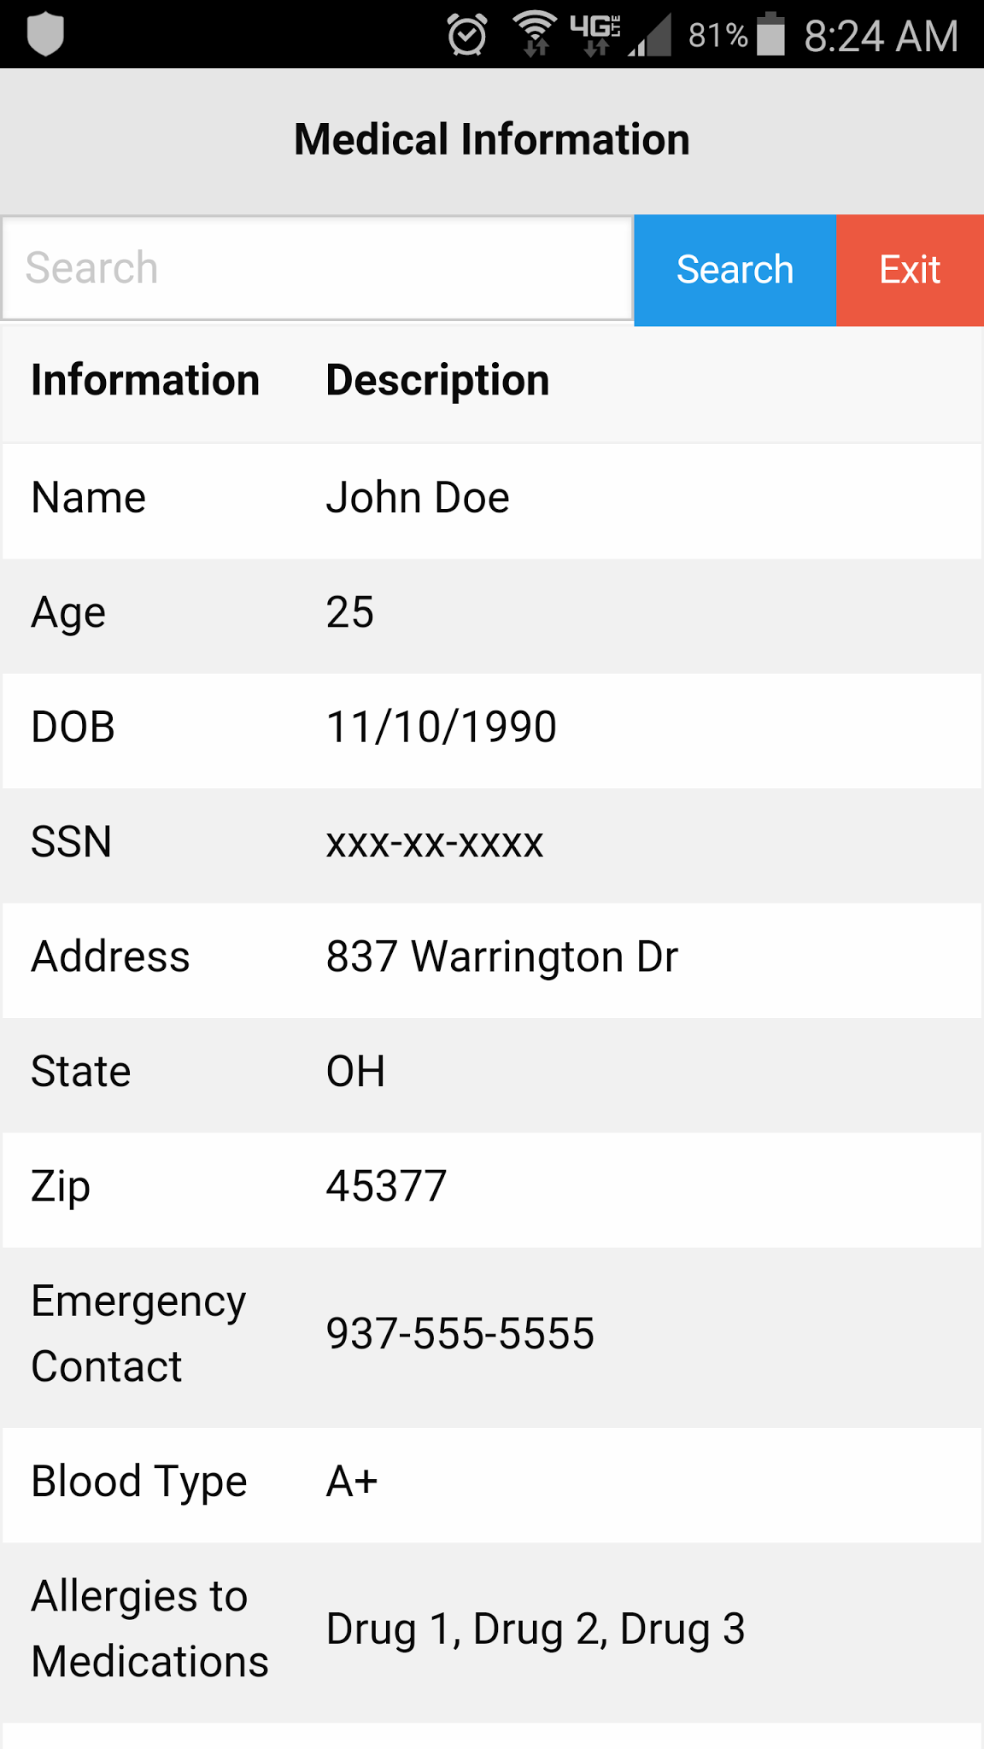

Figure 7: Mock-up display of medical information

Source: Author Jonathan Carpenter

**4.2.4.1 Requirements Satisfied**

Design Requirements 3.3.2.010

Design Requirements 3.3.7.020

Design Requirements 3.3.7.030

Design Requirements 3.3.7.040

Design Requirements 3.3.7.070

**4.2.5 TriageTag Application**

The TriageTag application will run on both the mobile device and the server. The application will be cross platform to run on two different operating systems. The mobile device will be running Android 5.1.1 Lollipop and the server will be running Ubuntu 16.04 LTS. The provided server must meet the minimum requirements of the Ubuntu operating system to run the TriageTag application as described in the second item section 3.2.

# Appendix: Résumés of Team Members

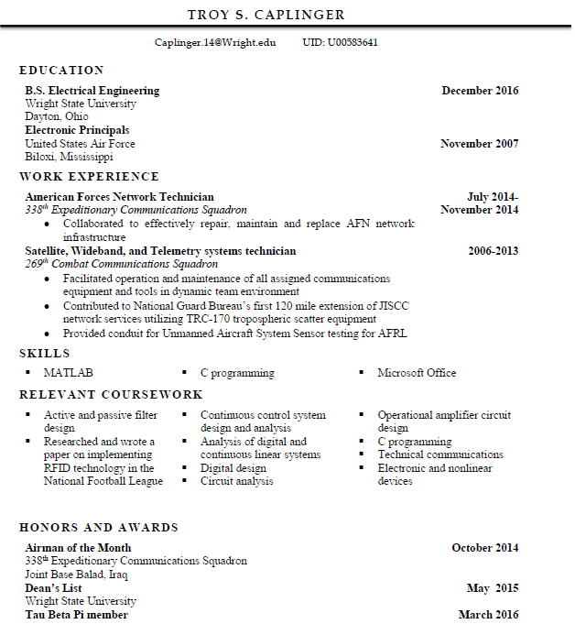

Source: Author; Troy Caplinger

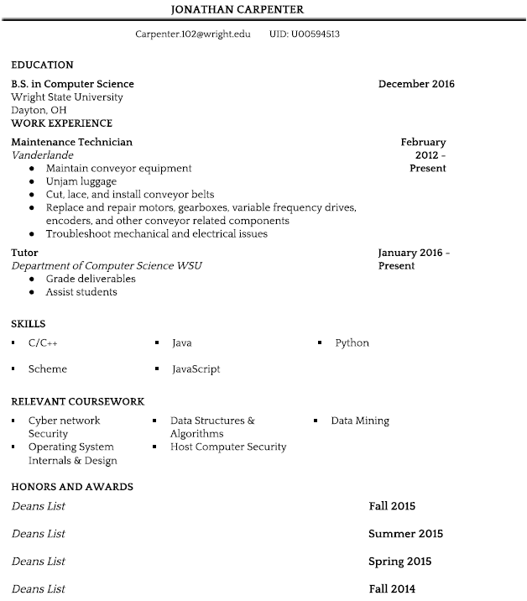

Source: Author; Jonathan Carpenter



Source: Author; Robert Lang



Source: Author; Anthony Inman



Source: Author; Vincent Haenni