**Getting started with SQLite on Windows**

1. Navigate to download link <https://sqlite.org/download.html>

* Download precompiled binaries for window; sqlite tools
* Create sqlite folder on your C drive
* Copy sqlite3.exe file to that directory

2.) Creating a test database

* Open cmd.exe
* Navigate to your sqlite folder
* Type: **sqlite3 test.db** (This creates a new database name test)

3.) Create a table within test.db refer to screenshot below

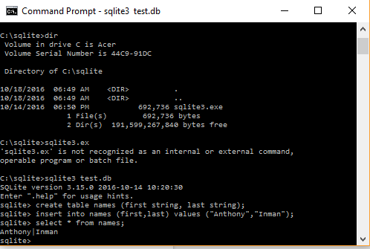

* The create table command is used to create a table named “names”
* This table has two fields first and last
* To insert data you must run the **insert into** [**tablename]** command.
  + First part of the command is the fields you would like to insert into.
  + The second part are the values you would like to insert into those fields.

4.) Test that your data is now in the table by running a **Select * from names**

* Select command grabs data from table.
* The (*) says to grab all fields from the table
* The screenshot shows that the command returns Anthony Inman.

To quit sqlite just run **.quit** and you will be returned to your top level directory. If you now run the DIR command in the command line you will notice there is now a **test.db** file.