**Group Name: TriageTag Team**

**Date of Meeting: 11/8/16**

**Location of Meeting: Student Success Center Room 014**

**Start and End Times: 8:00am – 9:20am**

**Members Attending: Troy Caplinger, Vincent Haenni, Jonathan Carpenter, Anthony Inman**

**Members Not Attending: None**

**Guests Attending: None**

**Review of Current and Pending Milestones**

Discussion of ordering parts through Kayleigh and about acquiring a computer that meets baseline specifications.

**Summary of Progress on Action Items Due At This Meeting (Member Reports)**

Due today:

Anthony:

* Creation of SQL Lite database

Jonathan:

* Complete front end of user interface

Troy:

* Complete test document

Vince

* Acquire laptop and find lab space

Verdict on personal reports:

* All personal reports deemed suitable by group.

**Discussion of Current Group Status WRT Current and Pending Milestones**

Current Milestones

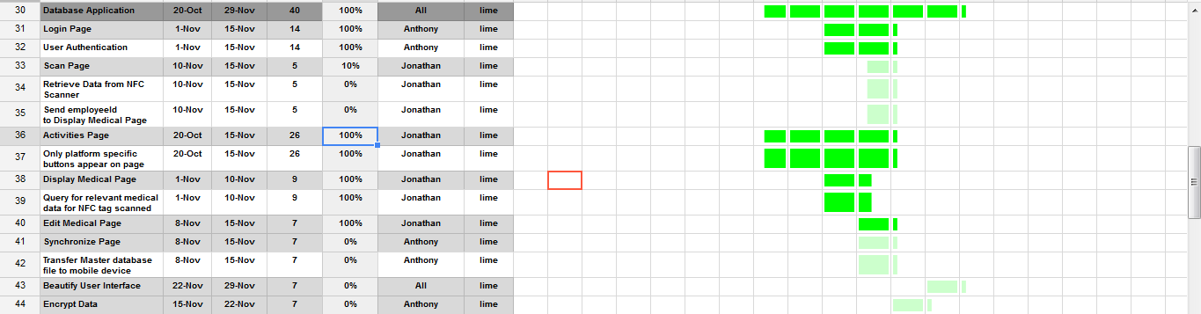

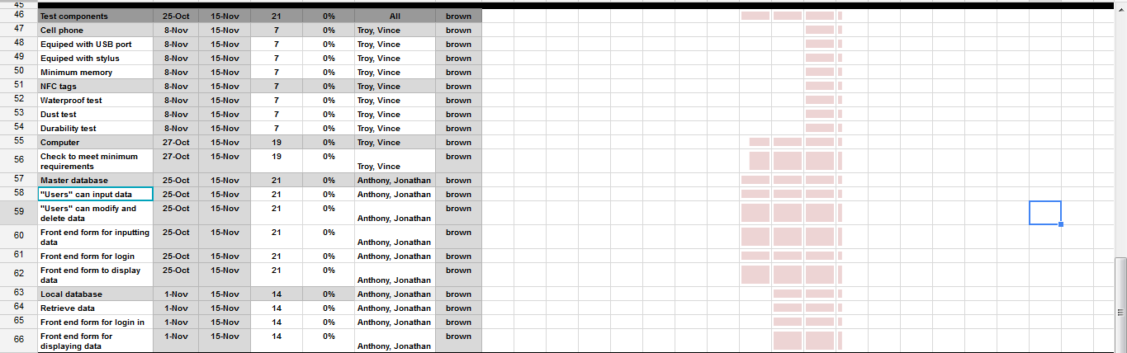

**Decisions with Respect to LONG TERM WHOLE GROUP GOALS.**

The group goal is to be done with everything except for modifying the visual attractiveness of our application by Nov. 22, 2016.

**Discussion of Action Items and Action Item Assignment for Next Meeting**

Anthony:

* Task 0 Database App._Login Page Nov 1: Due Nov 15
* Task 1 Database App. Nov_User Auth Nov 1: Nov 15

Vince:

* Task 2 Test components_Cell Phone Nov 8: Due Nov 15
* Task 3 Test components_NFC tags Nov 8: Due Nov 15
* Task 4 Test components_Computer Nov 8: Due Nov 15

Jonathan:

* Task 5 Database App._Display medical Page Nov 1: Due Nov 15 (tentative)
* Task 6 Database App._Scan Page Nov 1: Due Nov 15 (tentative)
* Task 7 Database App._Edit Medical page Nov 1: Due Nov 15
* Task 8 Database App._Activities page Nov 1: Due Nov 15

Troy:

* Task 2 Test components_Cell Phone Nov 8: Due Nov 15
* Task 3 Test components_NFC tags Nov 8: Due Nov 15
* Task 4 Test components_Computer Nov 8: Due Nov 15