**Group Name: TriageTag Team**

**Date of Meeting: 11/15/16**

**Location of Meeting: Student Success Center Room 014**

**Start and End Times: 8:00am – 9:20am**

**Members Attending: Troy Caplinger, Vincent Haenni, Jonathan Carpenter, Anthony Inman**

**Members Not Attending: None**

**Guests Attending: None**

**Review of Current and Pending Milestones**

The NFC tags which we originally ordered were not the right tags and did not work properly with the readers we have. We discussed the of reordering of tags via Kayleigh as well as possible timeline adjustment. Reordered tags should be arriving by Wednesday Nov. 16 at the latest. The correct tags arrived on Tuesday Nov 15. We retrieved them from Kayleigh and gave her the wrong set of tags which she will be able to return to the vendor.

**Summary of Progress on Action Items Due At This Meeting (Member Reports)**

Due today:

Anthony:

* Task 0 Database App._Login Page Nov 1: Due Nov 15
* Task 1 Database App. Nov_User Auth Nov 1: Nov 15

Vince:

* Task 2 Test components_Cell Phone Nov 8: Due Nov 15
* Task 3 Test components_NFC tags Nov 8: Due Nov 15
* Task 4 Test components_Computer Nov 8: Due Nov 15

Jonathan:

* Task 5 Database App._Display medical Page Nov 1: Due Nov 15 (tentative)
* Task 6 Database App._Scan Page Nov 1: Due Nov 15 (tentative)
* Task 7 Database App._Edit Medical page Nov 1: Due Nov 15
* Task 8 Database App._Activities page Nov 1: Due Nov 15

Troy:

* Task 2 Test components_Cell Phone Nov 8: Due Nov 15
* Task 3 Test components_NFC tags Nov 8: Due Nov 15
* Task 4 Test components_Computer Nov 8: Due Nov 15

Verdict on personal reports:

Task 3, 5, and 6 were not completed. Task 3 was not completed because it was discovered that our vendor who was supplying the tags sent us the wrong set of tags. Tasks 5 and 6 were not completed because we had to reorder our tags and needed them to perform those tasks.

**Discussion of Current Group Status WRT Current and Pending Milestones**

Current Milestones

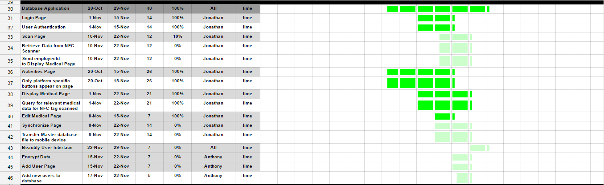

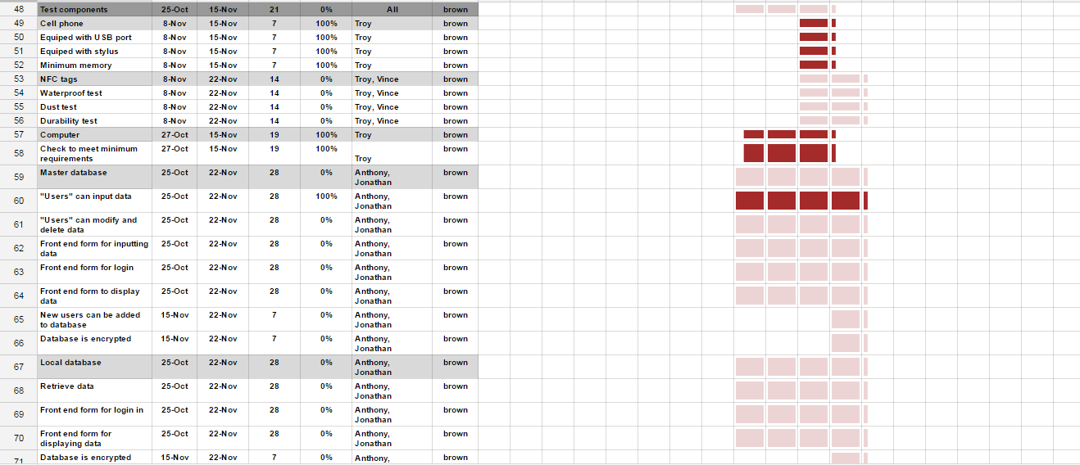

**Decisions with Respect to LONG TERM WHOLE GROUP GOALS.**

The group goal is to be done with everything except for modifying the visual attractiveness of our application by Nov. 22, 2016.

**Discussion of Action Items and Action Item Assignment for Next Meeting**

Anthony:

* Task 0 Encrypt Data: Due Nov 22
* Task 1 Add New User Page: Due Nov 22

Vince:

* Task 2 NFC Tag Dust Ingress Test: Due Nov 22
* Task 3 NFC Tag Durability Test: Due Nov 22

Jonathan:

* Task 4 Scan Page: Due Nov 22
* Task 5 Synchronize Page: Due Nov 22

Troy:

* Task 6 NFC Tag Waterproof Test: Due Nov 22