Revisar el readme.txt, pantallazos.

Algunas modificaciones

En vez de usar gluperspective ahora usamos las

////////////////// Projection Matrix ///////////////////////////////////////

Mat projMat = Mat::zeros(4, 4, CV_64FC1);

float zfar = 10000.0f, znear = 0.1f;

projMat.at<double>(0, 0) = 2 * cameraMatrix.at<double>(0, 0) / tempimage.size().width;

projMat.at<double>(0, 1) = 2 * cameraMatrix.at<double>(0, 1) / tempimage.size().width;

projMat.at<double>(0, 2) = -1 + (2 * cameraMatrix.at<double>(0, 2) / tempimage.size().width); // en la diapo del profe es su negativo se equivoco

projMat.at<double>(1, 1) = 2 * cameraMatrix.at<double>(1, 1) / tempimage.size().height;

projMat.at<double>(1, 2) = -1 + (2 * cameraMatrix.at<double>(1, 2) / tempimage.size().height);// en la diapo del profe es su negativo se equivoco

projMat.at<double>(2, 2) = -(zfar + znear) / (zfar - znear);

projMat.at<double>(2, 3) = -2 * zfar*znear / (zfar - znear);

projMat.at<double>(3, 2) = -1;

double projectionMatrix[16];

//La matriz projMat sacamos su transpuesta y lo metemos todo a un arreglo

for (int i = 0; i < 4; i++)

for (int j = 0; j < 4; j++)

projectionMatrix[4 * j + i] = projMat.at<double>(i, j);

glMatrixMode(GL_PROJECTION);

glLoadIdentity();

glViewport(0, 0, tempimage.size().width, tempimage.size().height);

glLoadMatrixd(projectionMatrix);

Revisen las diapos del profe

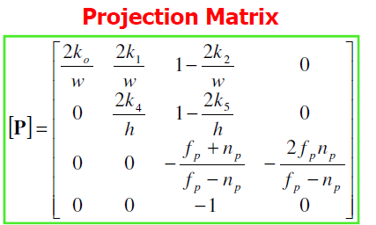

Aquí el profe esta equivocado es 2k2/w-1 en vez de 1-2k2/w y 2k5/h-1 en vez de 1-2k5/h

<http://code.opencv.org/projects/opencv/wiki/Posit>

<http://spottrlabs.blogspot.pe/2012/07/opencv-and-opengl-not-always-friends.html>

Para la matriz viewmodel

Mat viewMatrix = cv::Mat::zeros(4, 4, CV_64FC1);

solvePnP(corners, imgpoints, cameraMatrix, distCoeffs, rvec, tvec);

Rodrigues(rvec, rotation);

for (int row = 0; row < 3; ++row) {

for (int col = 0; col < 3; ++col)

viewMatrix.at<double>(row, col) = rotation.at<double>(row, col);

viewMatrix.at<double>(row, 3) = tvec.at<double>(row, 0);

}

viewMatrix.at<double>(3, 3) = 1.0f;

cv::Mat cvToGl = cv::Mat::zeros(4, 4, CV_64F);

cvToGl.at<double>(0, 0) = 1.0f;

cvToGl.at<double>(1, 1) = -1.0f;

cvToGl.at<double>(2, 2) = -1.0f;

cvToGl.at<double>(3, 3) = 1.0f;

viewMatrix = cvToGl * viewMatrix;

Mat glViewMatrix;

transpose(viewMatrix, glViewMatrix);

glMatrixMode(GL_MODELVIEW);

glLoadIdentity();

glLoadMatrixd(&glViewMatrix.at<double>(0, 0));

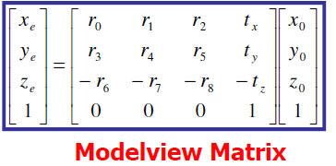

Fuente diapo del profe