A comparison
of
Microservice vs. Monolithic Architectures
On
Chat Based
Message System

Team Members
Jonathan Allen
Luan Trinh

Repo Location:
https://github.com/jonathanfallen/ds5306-PR2

System Overview
This project implements and evaluates a distributed chat system using a microservice-based architecture and compares it against a monolithic architecture under varying workloads.
The goal of the system design is to ensure modularity, scalability, and fault isolation while supporting core chat application functionality.

Architecture Design
The primary implementation follows a Microservices architecture, where system functionality is divided into independent services:
- Login Service
- Chat Service
- Gateway Service
- gRPC Load Balancer
- Login Database
- Chatroom Database
Each service runs inside its own Docker container. Multiple replicas of key services (login, chat, gateway) are deployed to support horizontal scaling.
For comparison purposes, a Monolithic architecture was also implemented, in which all application logic is consolidated into a single container that interacts with shared database components.
This architectural contrast allows evaluation of distributed decomposition versus centralized execution.

Communication Model
The system uses gRPC (Remote Procedure Call) as the communication model between services.
Request flow:
Client → Gateway → Login/Chat Service → Database
The system supports both:
- Unary RPC (for login, create room, join room, send message)
- Server-side streaming RPC (for real-time message subscription)
Reasons for choosing gRPC:
- Efficient binary serialization via Protocol Buffers
- Strongly typed service contracts
- Low-latency inter-service communication
- Native streaming support
- Built-in scalability for distributed systems
This directly satisfies the project requirement of using an RPC-based communication model.

Functional Requirements
The system supports the following six functional requirements:
The microservice architecture and gRPC communication model directly support the following six functional requirements:

1. User Login / Identity
The Login Service handles authentication requests using unary RPC calls.
Authentication is isolated from messaging logic, improving modularity and fault containment.

2. Create Room
The Chat Service provides an RPC endpoint to create new chat rooms.
This operation interacts only with the chatroom database, preserving service separation.

3. Join Room
Users join rooms via the Chat Service.
Room membership is managed independently from login functionality, reducing cross-service coupling.

4. Send Message
Messages are sent using unary RPC calls to the Chat Service.
The microservice design ensures message routing logic is isolated from authentication logic.

5. Real-Time Receive (gRPC Streaming)
Real-time subscription is implemented using gRPC server-side streaming.
Clients maintain an open streaming connection to receive messages in real time.
This capability is enabled specifically by the RPC communication model and would be more complex to implement efficiently without streaming support.

6. Message History
The Chat Service provides an RPC endpoint to retrieve the last N messages.
Message history is stored in a dedicated database and accessed independently of login operations.

Evaluation Report

Contents
Evaluation Report 3
Executive Summary 4
Key Findings 4
Experimental Hardware Environment 6
Hardware Platform 6
Operating System 6
Containerization and Runtime Environment 6
Docker Resource Allocation 6
Workload Specification 8
Scenario A: Login Behavior 8
Scenario B: Chat Message Behavior 9
Case Study A: 1 Node Micro vs. Mono 10
Experimental Node Configuration 10
Deployment Topology 10
1 Node - Login Throughput vs. Load - Analysis and Interpretation 11
1 Node - Login Average latency vs. Load - Analysis and Interpretation 12
1 Node – Chat Message Throughput vs. Load - Analysis and Interpretation 14
1 Node – Chat Message Average Latency vs. Load - Analysis and Interpretation 15
Case Study B: 4-node Micro -vs- Mono 17
Experimental Node Configuration (4-Node Deployment) 17
Deployment Topology 17
4 Node – Login Throughput vs. Load - Analysis and Interpretation 18
4 Node – Login Average Latency vs. Load - Analysis and Interpretation 20
4 Node – Chat Message Throughput vs. Load - Analysis and Interpretation 22
4 Node – Chat Message Latency vs. Load - Analysis and Interpretation 24
Aggregate Analysis Login Latency Comparison 26
Aggregate Analysis Chat Message Latency Comparison 28
Speedup Comparison Mono vs 1N/4NNode Micro 30
System Design Tradeoffs 32
Monolith Strengths 32
Monolith Weaknesses 32
Microservice Strengths 32
Microservice Weaknesses Shown by Our Data 32
Overall Conclusion 33
Tables: 1 Node Micro -vs- Mono 34
Tables: 4 Node Micro -vs- Mono 36

Executive Summary
This project implemented a chat messaging system using Microservice Architecture and compared its performance and scalability against Monolithic Architecture. The evaluation focused on throughput and latency under varying workloads across two primary behaviors: Login and Chat Messaging.
The experimental methodology consisted of two phases:
1-Node Microservice vs. Monolithic comparison
4-Node Microservice vs. Monolithic comparison
This approach allowed us to isolate and understand microservice architecture’s horizontal scaling effects vs. monolithic architecture.

Key Findings

1-Node Microservice
When deployed on a single node, the microservice architecture:
Provided no measurable throughput improvement
Exhibited a higher average latency
Introduced additional distributed system overhead without scaling benefits
Summary: At a small scale, architectural complexity outweighed performance advantages.

4-Node Microservice
When horizontally scaled to four nodes, the microservice architecture demonstrated:
- Significant improvement in login latency
- Improved chat stability at peak concurrency
Summary: Scaling mitigated distributed overhead and improved resilience under stress.

Monolithic Architecture
Across all test conditions, the monolithic architecture:
- Maintained consistently stable performance
- Delivered the lowest messaging latency
Summary: The monolith performed exceptionally well at low to moderate loads and remained competitive even under high concurrency.

Overall Conclusion
Microservices do not inherently improve performance at a small scale. Their benefits emerge under horizontal scaling and high concurrency, where stability becomes critical.
The monolithic architecture remains highly efficient and stable for single-node deployments. However, microservices demonstrate advantages in scalability and resilience when properly distributed across multiple nodes.

Experimental Hardware Environment

All performance evaluations were conducted on a dedicated workstation to ensure controlled and reproducible results. The hardware and software configuration are detailed below.

Hardware Platform
- System Model: Dell Precision 5680
- Processor: Intel Core i7-13700H
  - 14 physical cores
  - 20 logical processors
- System Memory: 32 GB RAM

Operating System
- Platform: Windows 11 Pro
- Build Version: 26200

Containerization and Runtime Environment
All services were deployed using containerized infrastructure to ensure consistent execution environments across experiments.
- Container Platform: Docker Desktop
- Virtualization Backend: Windows Subsystem for Linux 2 (WSL2)
- Docker Engine Version: 29.2.1

Docker Resource Allocation
Docker Desktop was configured with the following limits:
- CPU Allocation: 20 logical CPUs
- Memory Allocation: 15.41 GiB
These constraints were applied uniformly across all experimental runs to ensure consistent provisioning for both microservice and monolithic deployments.

Workload Specification
To evaluate system performance and scalability, a standardized workload model was defined and applied across all experiments. The objective was to maintain comparable experimental parameters and highlight the effects of the architecture under test.
Two primary workflow behaviors were evaluated:
- User Login Behavior
- Chat Message Behavior
These behaviors were selected to represent both authentication-intensive and high-throughput messaging workloads.
The chat-room creation workflow was excluded from detailed analysis. Preliminary evaluation indicated that this operation primarily exercised database interaction rather than architectural characteristics. It was determined to be not a good showcase of architectural differences and is therefore not discussed further.

Scenario A: Login Behavior
This scenario evaluates authentication performance under increasing concurrency levels.
Each workload configuration was executed for a fixed duration of 120 seconds to ensure consistent throughput and latency measurements.
Concurrent Users | Duration (seconds)
10 | 120
100 | 120
1000 | 120
5000 | 120

Scenario B: Chat Message Behavior
This scenario evaluates sustained message throughput and latency under varying levels of concurrent users.
Each workload configuration was executed for a fixed duration of 120 seconds to ensure uniform measurement conditions.
Concurrent Users | Duration (seconds)
10 | 120
100 | 120
1000 | 120
5000 | 120

Considerations and Notes
- All scenarios were executed under identical runtime constraints.
- Test duration was fixed to eliminate time-based variability.
- Load levels were increased logarithmically to evaluate scalability behavior.
The 120-second window provides sufficient time for:
- System warm-up effects to disappear (This is often an issue with web apps), and was the primary motivation
- Load generation to reach steady-state behavior

Case Study A: 1 Node Microservice vs. Monolithic

Experimental Node Configuration
All experiments were conducted using the following deployment configurations to compare microservice and monolithic architectures under controlled conditions.

Deployment Topology
Microservice Deployment | Monolithic Deployment
1 × chat-service | 1 × monolith-service
1 × chatroom-service | 1 × login-db-service
1 × gateway-service
1 × login-service
1 × login-db-service
1 × chatroom-db-service

In the microservice deployment, application responsibilities were decomposed into independent services, each running in its own container. Separate database instances were maintained for the login and chatroom domains to preserve service isolation.
In contrast, the monolithic deployment consolidated application logic into a single service container, interacting with a single login database instance.

Containerization and Orchestration
All services were containerized using Docker and orchestrated via Docker Compose to ensure consistent environment provisioning across experimental runs. Microsoft PowerShell scripts were created and run to automate the test scenarios.

1 Node - Login Throughput vs. Load - Analysis and Interpretation

Summary
This chart measures system throughput for the Login workflow under varying levels of concurrent users in a single-node deployment.
Throughput, measured in transactions per second (TPS) or requests per second (req/sec), is the number of login operations successfully processed per second during the test.
The x-axis shows the number of concurrent users (load), and the y-axis shows the corresponding throughput achieved by each architecture (Monolithic vs Microservice).
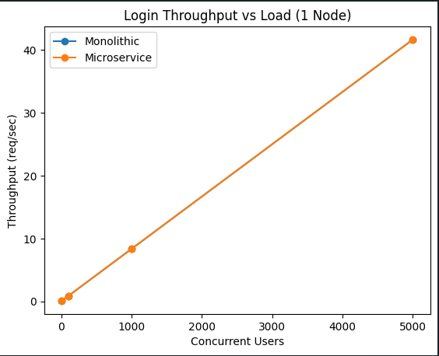

Interpretation
The results show that throughput increases proportionally with user load for both architectures. This chat suggests that, in a single-node environment, microservices do not provide a throughput advantage over monolith.

1 Node - Login Average latency vs. Load - Analysis and Interpretation

Summary
This chart shows the average login response time as the number of users increases on a single machine. Latency is measured in milliseconds and shows how long each login request takes on average during the 120-second test.
As the number of users increases from 10 to 1000, the average response time increases for both systems. At 5000 users, latency drops slightly compared to 1000 users, showing the system stabilizing under steady load.
At every load level, the microservice version takes longer on average than the monolithic version.
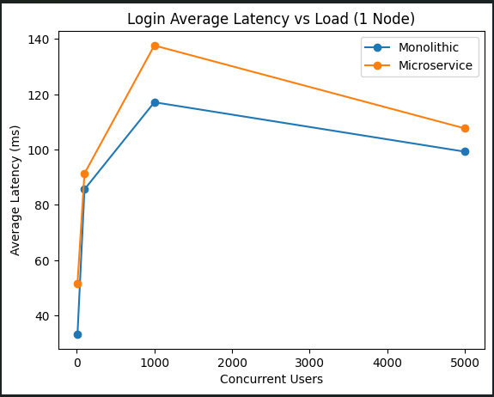

Interpretation
When everything runs on a single machine, the microservice setup is consistently a bit slower, usually about 10-20 milliseconds per request. That extra delay is likely to come from the services having to communicate with each other and marshaling data back and forth.
This shows that simply splitting an application into multiple services does not automatically make it faster when everything runs on a single machine.

1 Node – Chat Message Throughput vs. Load - Analysis and Interpretation

Summary
This chart shows how many chat messages per second each system can handle as the number of users increases on a single node. Throughput is measured in messages per second and reflects the system’s ability to process send message operations under load.
Both the monolithic and microservice architectures scale almost identically as the user count increases from 10 to 5000 users. At the highest load level, the microservice version is slightly lower, but the difference is minimal.
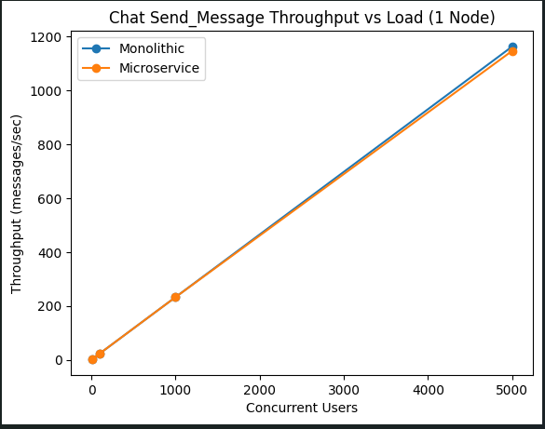

Interpretation
The results show that on a single machine, breaking the system into microservices does not improve messaging throughput. In short, on one node, architecture does not increase throughput. Scaling benefits would require distributing services across multiple machines rather than simply separating them into containers.

1 Node – Chat Message Average Latency vs. Load - Analysis and Interpretation

Summary
This chart shows the average time to send a chat message as the number of users per node increases. Latency is measured in milliseconds and represents the average time it takes for each sent message request during the test.
Up to 1000 users, the microservice version is consistently slower than the monolithic version, roughly three to four times higher. At 5000 users, the difference becomes much larger. Microservice latency jumps significantly, while monolithic latency surprisingly actually decreases slightly.
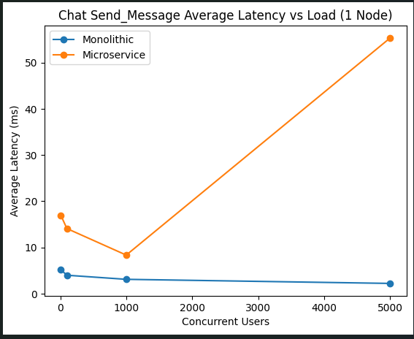

Interpretation
The monolithic system remains stable and maintains very low message latency even as load increases. The microservice version shows increasing latency, with a sharp increase at 5000 users. This suggests instability or a bottleneck in the microservice design under heavy message load. The likely cause is added service-to-service communication (login-to-message-send) overhead and coordination costs that become more pronounced at higher concurrency.
On a single node, the monolithic architecture handles the messaging more efficiently. The microservice design introduces overhead that becomes more visible as load increases.

Case Study B: 4-node Microservice -vs- Monolithic

Experimental Node Configuration (4-Node Deployment)
Experiments were conducted using the following scaled deployment configuration to evaluate horizontal scaling effects in the microservice architecture.

Deployment Topology
Microservice Deployment | Monolithic Deployment
4 × chat-service | 1 × monolith-service
4 × chatroom-service | 1 × login-db-service
4 × gateway-service
4 × login-service
1 × login-db-service
1 × chatroom-db-service
In the microservice deployment, core application services were replicated four times to simulate horizontal scaling within a single host environment. Database instances were not replicated and remained single-instance services. This is an important architectural point as it certainly contributes to bottleneck behavior and is a point for improvement in future.
In contrast, the monolithic deployment remained unchanged, consisting of a single application service container interacting with a single login database instance.

Containerization and Orchestration
All services were containerized and orchestrated using Docker Compose to ensure consistent deployment across experimental runs.

4 Node – Login Throughput vs. Load - Analysis and Interpretation

Summary
This chart shows login throughput as the number of concurrent users increases, with the microservice architecture scaled to 4 nodes. Throughput is measured in requests per second and reflects how many login operations the system can process under load.
Across all tested load levels, the monolithic and 4-node microservice deployments produce identical throughput results.
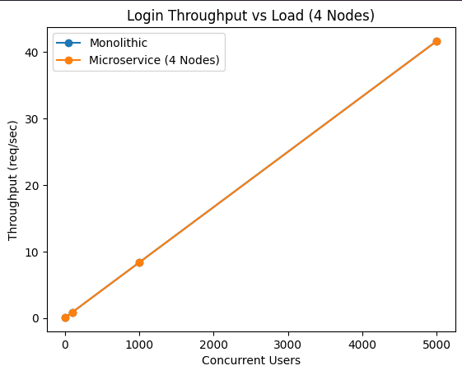

Interpretation
The key takeaway is that horizontal scaling did not increase login throughput relative to the monolith. Even with four replicated microservice instances, the system processes the same number of login requests per second. This was a surprising result. It was expected that distributing services across multiple nodes would improve throughput. Instead, the data shows no measurable gain. The likely explanation is that login is not a throughput bottleneck in this system. Since login does not heavily stress the system, adding more service instances does not increase overall capacity. In short, horizontal scaling did not improve login throughput because login was never the limiting factor to begin with.

4 Node – Login Average Latency vs. Load - Analysis and Interpretation

Summary
This chart shows the average login response time as user load increases, with the microservice architecture scaled to 4 nodes. Latency is measured in milliseconds and represents the average time each login request takes during the test period.
At 100, 1000, and 5000 users, the 4-node microservice deployment consistently shows lower average latency than the monolithic deployment. The difference becomes especially noticeable at higher loads. For example, at 5000 users, the monolith averages about 99 ms, while the 4-node microservice averages about 60 ms.
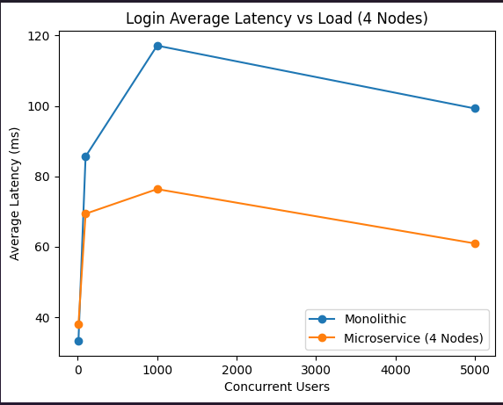

Interpretation
Unlike the throughput results, latency clearly improves when the microservice architecture is horizontally scaled. With four replicated service instances, request handling is more evenly distributed, reducing contention and queueing delays. This is an important result because it demonstrates a real architectural benefit of horizontal scaling. While scaling did not increase login throughput, it significantly improved response time under moderate and high loads. In short, adding service replicas reduces per-instance pressure, lowers average latency, and improves responsiveness. This is the first clear performance advantage observed from scaling microservice architecture.

4 Node – Chat Message Throughput vs. Load - Analysis and Interpretation

Summary
This chart shows how many chat messages per second the system can process as the number of users increases when the microservice architecture is scaled to four nodes. Throughput is measured in messages per second and reflects overall system capacity for the send message operation.
Across all load levels, the monolithic and 4-node microservice deployments produce nearly identical throughput results. Even at 5000 users, both architectures reach almost the same message processing rate.
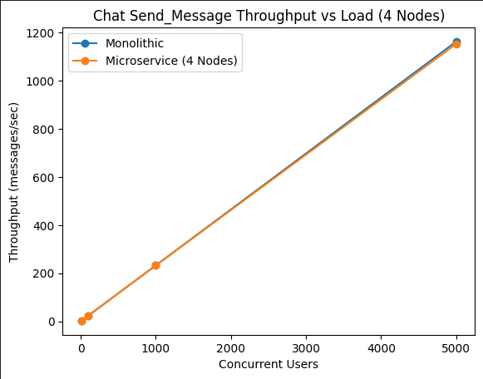

Interpretation
Horizontal scaling did not increase chat message throughput relative to the monolith. Even with four replicated microservice instances, the system processes roughly the same number of messages per second.
This suggests that throughput is limited by something shared across both architectures, such as the database, gateway, workload generator (test harness), or overall host machine resource limits. In short, while horizontal scaling improved latency in some cases, it did not increase maximum message throughput in this configuration.

4 Node – Chat Message Latency vs. Load - Analysis and Interpretation

Summary
This chart shows the average time it takes to send a chat message as user load increases when the microservice architecture is scaled to four nodes. Latency is measured in milliseconds and reflects how long each sent message request takes on average.
Across all load levels, the monolithic system maintains very low and stable latency. The 4-node microservice deployment improves compared to the 1-node case, but it remains consistently higher than the monolithic implementation. At 1000 users, for example, the monolithic architecture averages about 3 ms while microservice architecture averages about 12.8 ms. At 5000 users, monolithic architecture is around 2.2 ms while the microservice architecture rises to roughly 38.6 ms.
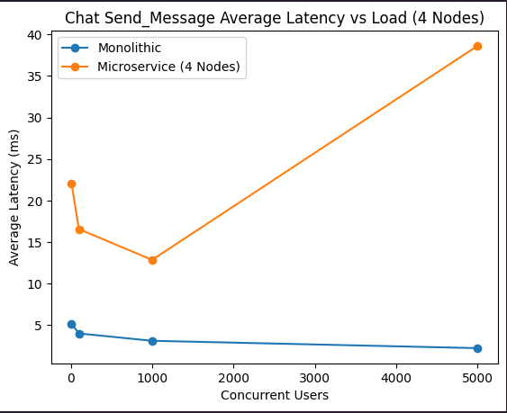

Interpretation
Even after scaling to four nodes, the microservice architecture continues to incur overhead compared to the monolithic architecture. However, unlike the 1-node case, latency does not spike into extreme values. It remains controlled and more predictable. This suggests that horizontal scaling reduced the instability seen earlier, but it did not eliminate the inherent communication and coordination overhead of the microservice design. In short, scaling improved stability, but the monolithic architecture still delivers the lowest messaging latency under all tested loads.

Aggregate Analysis Login Latency Comparison

Summary
This chart compares the average login latency across three configurations: Monolithic (1 Node), Microservice (1 Node), and Microservice (4 Nodes). It shows how response time changes as concurrent users increase from 10 to 5000.
At low load (10 users), the monolithic architecture is fastest, followed closely by the 4-node microservice. The 1-node microservice is the slowest. Starting at 100 users and above, the 4-node microservice becomes the fastest configuration and maintains the lowest latency through 5000 users.
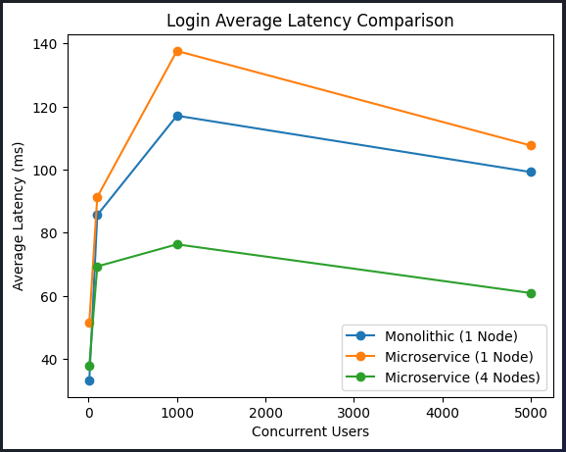

Interpretation
The key result is that horizontal scaling changes the performance outcome. While the 1-node microservice consistently performs worse than the monolith, scaling to 4 nodes reduces contention and lowers average latency significantly. At 100 users and higher, the 4-node microservice outperforms the monolith. This confirms that architectural benefits only appear when services are distributed. In simple terms, breaking the system into microservices alone does not help. But once those services are scaled across multiple instances, latency improves and the architecture begins to show real performance advantages.

Aggregate Analysis Chat Message Latency Comparison

Summary
This chart compares the average latency of chat messages across three configurations: Monolithic (1 Node), Microservice (1 Node), and Microservice (4 Nodes). It shows how response time changes as user load increases from 10 to 5000 concurrent users. The monolithic system maintains very low and stable latency across all loads. The 1-node microservice performs worse at every level and shows a sharp spike at 5000 users. The 4-node microservice improves over the 1-node version, especially at high load, but still lags the monolithic architecture.
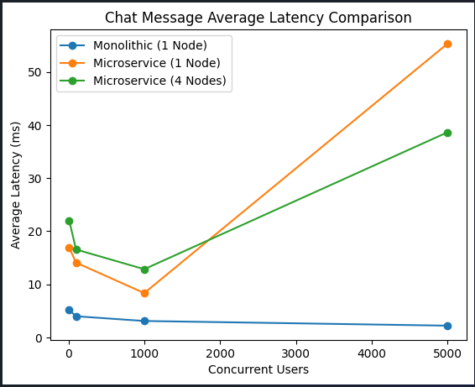

Interpretation
The monolithic architecture consistently delivers the lowest message latency. The 1-node microservice shows instability at high load, with latency jumping to over 55 ms at 5000 users.
When scaled to four nodes, the microservice becomes more stable and reduces latency under heavy load, dropping from 55 ms to about 38 ms at 5000 users. However, it still does not outperform the monolith, which remains around 2 ms.
This shows that horizontal scaling helps control instability in the microservice design, but it does not eliminate the inherent overhead of service-to-service communication. The monolithic architecture remains more efficient for the messaging path in this setup.

Speedup Comparison Monolithic vs 1 and 4 Node Microservice
Summary
This chart compares the performance impact of horizontal scaling by showing speedup relative to a single-node baseline. The monolithic line remains flat at 1.0 because it was not scaled. The microservice lines show how performance changes as we scale from 1 to 4 nodes for both login and chat workloads.
The login workload shows consistent speedup across all load levels, with the greatest improvement around 1000 users. The chat workload behaves differently, showing reduced performance at lower loads and improvement only at the highest concurrency level.
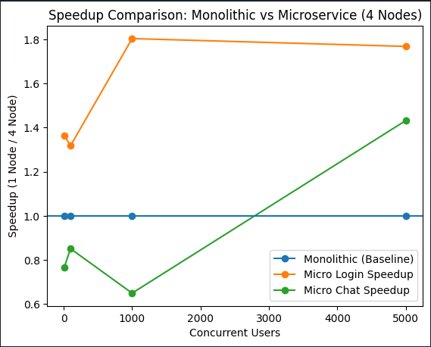

Interpretation
The flat monolithic line serves as a baseline reference. Since it was not scaled horizontally, its speedup remains at 1.0 across all loads. The microservice login path consistently benefits from horizontal scaling. Speedup remains above 1.0 across all load levels, indicating improved response time when services are replicated. The strongest gain occurs at mid-level load, suggesting better request distribution. The microservice chat path shows mixed results. At light and moderate loads, scaling slightly hurts performance because distributed overhead dominates. Only at high load does the speedup exceed 1.0, indicating that scaling becomes beneficial under heavy concurrency. Overall, the graph clearly shows that horizontal scaling helps when the workload puts sufficient pressure on the system. On a small scale, microservice overhead outweighs the benefits. Real architectural advantages appear only under sustained or high load conditions.

System Design Tradeoffs

Monolith Strengths
- Lower latency in critical paths.
Fewer network hops, fewer queues, and fewer serialization steps. Our chat message path stayed very fast and stable.
- Predictable behavior under loads
The monolith remained stable as the load increased, without large spikes in response time.
- Operational simplicity
It is a single deployable unit. Debugging, tracing, and deployment are simpler with fewer failure points.

Monolith Weaknesses
- Reduced scaling flexibility
Scaling the monolith means scaling everything together, even if only one feature needs more capacity.
- Increased change risk
A large, shared codebase and single deployment increase risk as the system grows.

Microservice Strengths
- Independent scaling and isolation
Our 4-node results show that scaling services can improve responsiveness and stability under load, especially for login. Replicas reduce contention and spread work.
- Fault isolation
With proper timeouts and backpressure, failures can be limited to a single service.

Microservice Weaknesses Shown by Our Data
- Latency overhead
Even with 4 nodes, messaging latency remained higher than the monolith.
- High load instability in 1 node setup
In the single-node setup, microservices experienced errors and instability at high load when the database reached its limits.
- More moving parts
More services mean more configuration, monitoring, networking, and potential failure points.

What Likely Limited Throughput in Our Setup
Throughput did not increase with 4 nodes. Possible bottlenecks include:
- Load generator limit (the test harness)
- Database throughput limits (a single shared database likely introduced bottlenecks)
- Shared CPU or network limits under Docker

Overall Conclusion

1Node Microservice
Under a single node, microservices offered no throughput advantage and only added latency. It slowed responses due to extra communication and processing steps.
Under high load on a single node, the microservice system showed clear signs of stress. Latency spiked, errors appeared, and the system became unstable, while the monolith remained steady. This shows that microservices alone do not prevent overload when everything runs on one machine.

4Node Microservice
When scaled to four nodes, the microservice design improved in meaningful ways. Login latency dropped, errors decreased, and the system remained stable under heavy load. However, overall throughput still did not exceed that of the monolithic architecture, and messaging latency remained higher than the monolith's even after scaling.
The key takeaway is simple. Microservices improve stability and resilience under load when they are distributed and scaled. They do not automatically increase throughput or reduce latency at a small scale. Microservices provide scaling strength, not raw performance gains.

Tables: 1 Node Micro -vs- Mono

1 Node Login Throughput vs. Load
Load | Mono TPS | Micro TPS*
10 | 0.083 | 0.083
100 | 0.833 | 0.833
1000 | 8.33 | 8.33
5000 | 41.67 | 41.67
*TPS – Transactions per second

1 Node Login Avg latency vs. Load
Load | Mono Avg (ms) | Micro Avg (ms)
10 | 33.2 | 51.6
100 | 85.6 | 91.4
1000 | 117.1 | 137.7
5000 | 99.3 | 107.7

1 Node Chat Message Throughput vs Load
Load | Mono TPS | Micro TPS
10 | 2.33 | 2.33
100 | 23.21 | 23.23
1000 | 232.54 | 232.45
5000 | 1163.5 | 1147.4

1 Node Chat Message Avg Latency vs Load
Load | Mono Avg (ms) | Micro Avg (ms)
10 | 5.17 | 16.92
100 | 3.99 | 14.09
1000 | 3.10 | 8.35
5000 | 2.22 | 55.32

Tables: 4 Node Micro -vs- Mono

4 Node Login Throughput vs. Load
Load | Monolithic TPS | Microservice (4 Node) TPS*
10 | 0.083 | 0.083
100 | 0.833 | 0.833
1000 | 8.33 | 8.33
5000 | 41.67 | 41.67
*TPS – Transactions per second

4 Node Login Average Latency vs Load
Load | Monolithic Avg (ms) | Microservice Avg (ms)
10 | 33.23 | 37.85
100 | 85.63 | 69.35
1000 | 117.14 | 76.35
5000 | 99.27 | 60.91

4 Node Chat Message Throughput vs Load
Load | Monolithic TPS | Microservice (4 Node) TPS
10 | 2.33 | 2.33
100 | 23.21 | 23.26
1000 | 232.54 | 232.32
5000 | 1163.50 | 1153.56

4 Node Chat Message Average Latency vs Load
Load | Monolithic Avg (ms) | Microservice Avg (ms)
10 | 5.17 | 22.04
100 | 3.99 | 16.56
1000 | 3.10 | 12.85
5000 | 2.22 | 38.63

ChatGPT and AI Lessons Learned

Using AI was a force multiplier in completing this project. It removed the need to know deeply the programming languages chosen to get started implementing a technology stack. In this project, I chose NodeJS for the components I implemented, but I don’t have much experience with it. My experience with other technologies, however, allowed me to debug any issues that arose with AI support.
Using AI for translating and adapting my preferred language (Python) into Node.js to align with my team’s implementation
AI does not remove the need for strong debugging skills. AI can generate a lot of code very quickly, but determining the root cause of issues in your circumstances is a vitally important skill.
AI often “hallucinates”. Because of how the engines are tuned and the rapid changes in technology, you cannot assume that any AI solutions are technically correct and valid, as they may be working from old information (particularly with documentation)
It is vitally important to structure your input queries when you get started so that the AI can generate something useful very quickly. Poorly worded queries can create a churn effect as people try to figure out how to implement something quickly.
AI can help remove the need to implement boilerplate code. A lot of work is often boilerplate and pure overhead to solving a technical problem. For example, performing SQL selects or inserting data into databases. AI can reduce the burden of such boilerplate code.

