**BACHELOR OF COMPUTER SCIENCE**

**SCHOOL OF COMPUTER SCIENCE**

**BINA NUSANTARA UNIVERSITY**

**JAKARTA**

**ASSESSMENT FORM**

**Course: SCIE6063001– Computational Physics**

**Method of Assessment: Case Study**

**Semester/Academic Year :** 3/2023 – 2024

**Name of Lecturer : Agung Trisetyarso, S.Si., M.Si., Ph.D.**

**Date : January 6, 2024**

**Class : LB01**

**Topic :** **Voltage and Current**

**Resistance and Capacitance**

**Circuits Design & Analysis**

**Induction and inductance**

**Electromagnetic Oscillation and Alternating Current**

|  |  |
| --- | --- |
| **Group Members :** | 1 Jonathan Alvindo Fernandi  2_________________________________  3_________________________________  4_________________________________  5_________________________________  6_________________________________  7_________________________________  8_________________________________ |

**Student Outcomes:**

(SO 1) Mampu menganalisis masalah komputasi yang kompleks dan mengaplikasikan prinsip komputasi dan keilmuan lain yang sesuai untuk mengidentifikasi solusi.

*Able to analyze a complex computing problem and to apply principles of computing and other relevant disciplines to identify solutions*

**Learning Objectives:**

(LObj 1.2) Mampu menerapkan prinsip komputasi dan disiplin ilmu terkait lainnya untuk mengidentifikasi solusi.

*Able to apply principles of computing and other relevant disciplines to identify solutions*

| **No** | **Assessment criteria** | **Weight** | **Excellent (85 - 100)** | **Good (75-84)** | **Average (65-74)** | **Poor (0 - 64)** | **Score** | **(Score x Weight)** |
| --- | --- | --- | --- | --- | --- | --- | --- | --- |
| 1 | Ability to use potential method, serial, and parallel connection concept to provide the solution. | **50%** | Able to solve in both numerical and computational approaches well  without errors. | Able to solve in both numerical and computational approaches well  with some errors. | Able to solve in either numerical or computational approaches well  with some errors | Able to solve in either numerical or computational approaches with major errors, or not able to solve at all. |  |  |
| 2 | Ability to solve problems in topics of Voltage and Current, Resistance and Capacitance, Electromagnetic Oscillation and Alternating Current | **50%** | Able to solve in both numerical and computational approaches well  without errors. | Able to solve in both numerical and computational approaches well  with some errors. | Able to solve in either numerical or computational approaches well  with some errors | Able to solve in either numerical or computational approaches with major errors |  |  |
|  | **Total Score:** ∑(Score x Weight) | | | | | | |  |

Remarks:

**ASSESSMENT METHOD**

Instructions

Individual Assignment

Answer these problems in numerical approach and computational approach using Python Power Electronics. Beside your numerical answer, attached your circuit topology, parameters, and simulation output graph. Submit your answer in .PDF format

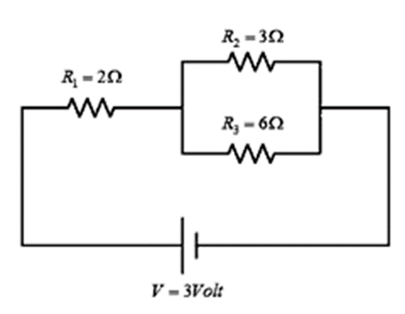**Problem 1**

From the following circuit, proof your manual calculation using PPE simulation to calculate parameters below:

1. Total current flow in the circuit

2. Potential difference at each end of the resistance

3. The amount of current that passes through resistance 2 and resistance 3

Answer:

1. Numerical Approach
2. Total current flow in the circuit

R1 = 2 Ω

R2 = 2 Ω

R3 = 2 Ω

V = 3 V

1. Resistor total
2. Resistor paralel

$\frac{1}{Rp}=\frac{1}{R2}+\frac{1}{R3}$

$\frac{1}{Rp}=\frac{1}{3}+\frac{1}{6}$

$\frac{1}{Rp}=\frac{1}{2}$

Rp = 2 Ω

1. Resistor seri

Rs = R1 + Rp

Rs = 2 + 2

Rs = 4 Ω

Rt = Rs

Rt = 4 Ω

1. Total current

It = $\frac{V}{Rt}$

It = $\frac{3}{4}$

It = 0,75 A

1. Potential difference at each end of the resistance

It = 0,75 A

R1 = 2 Ω

Rp = 2 Ω

V1 = It · R1

V1 = 0,75 · 2

V1 = 1,5 V

V2 = It · Rp

V2 = 0,75 · 2

V2 = 1,5 V

V3 = It · Rp

V3 = 0,75 · 2

V3 = 1,5 V

1. The amount of current that passes through resistance 2 and resistance 3

V2 = 1,5 V

R2 = 3 Ω

V3 = 1,5 V

R3 = 6 Ω

I2 =

I2 =

I2 = 0,5 A

I3 =

I3 =

I2 = 0,25 A

1. 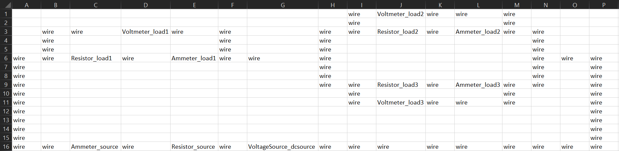Computational Approach using PPE
2. Circuit topology
3. Circuit parameters

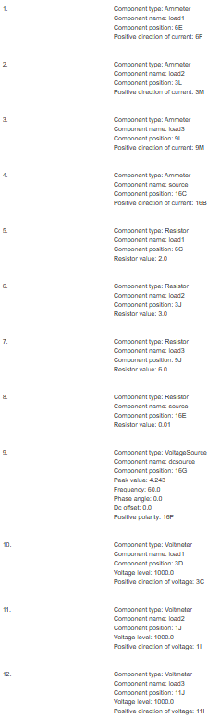Ammeter positive direction of current: searah jarum jam

Resistor_source value = 0.01 Ω (bernilai rendah guna menjaga stabilitas tegangan dan arus)

VoltageSource_dcsource peak value = V · $\sqrt{2}$

VoltageSource_dcsource peak value = 3 · $\sqrt{2}$

VoltageSource_dcsource peek value = 4,243 V

Voltmeter_load voltage level = 1000 V (memerlukan tegangan tinggi)

1. Simulation output graph
2. Total current flow in the circuit

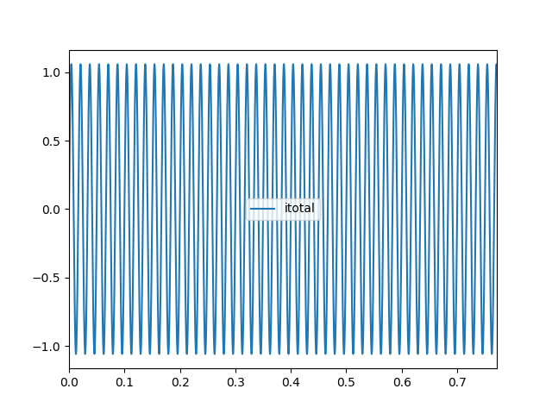

1. Potential difference at each end of the instance

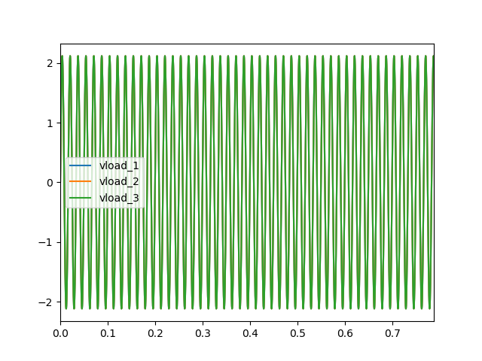

1. The amount of current that passes through resistance 2 and resistance 3

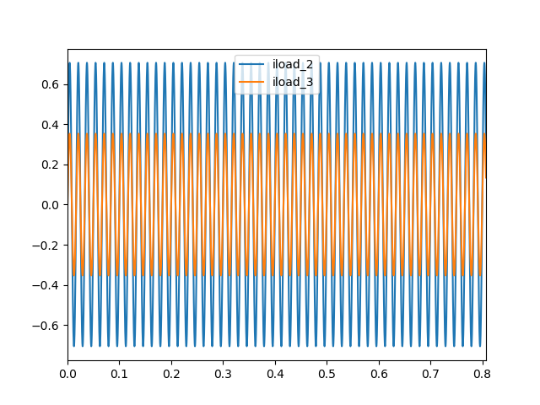PPE simulation files: <https://drive.google.com/drive/folders/1SmjqZFVOmJM8qQlxkeFPpewiryQ_RpOb?usp=sharing>

**Problem 2**

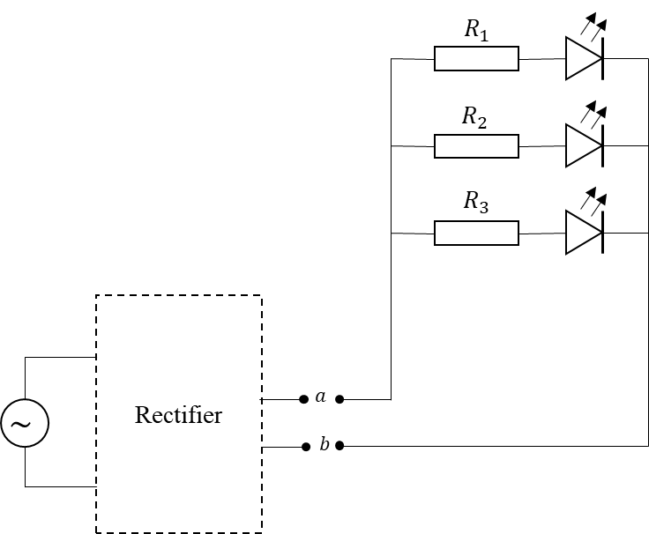

You are planning to conduct a small electronic project. You are planning to make a simple LED circuit (see diagram). The circuit contains three green LED lights that connected using parallel connections. From the LED specification sheet, you know that the LED will works on a minimum voltage of 2 $V$. Also, you gain information that the LED will break if the current that flow through it exceed 20 $mA$. For that, you need to use some resistor to limit the current that flow through the LED.

To power the circuit, you are planning to use a micro hydro generator that you already have. However, you realize that you need to convert the current from AC to DC so you can light up the LED. But you don’t have the proper converter at the moment. So, you decide to make your own rectifier, ***a basic RLC rectifier***, from only the components you have (see table) at hand. Assume that your component supply is large enough, so you can use any number of each component.

Assume that your LED does not have any internal resistance. The LED circuit will be connected to the rectifier at point $a$ and $b$ (see diagram). The generator has an output of 5 $V$ with frequency of 20 $Hz$. **So, what is your solution for the basic RLC rectifier?** Assume that each component on the table (including the EMF) has internal resistance of 0.1 $Ω$.

| **No** | **Component** | **Value** |
| --- | --- | --- |
| 1 | Resistor | $$3 Ω$$ |
| 2 | $$24 Ω$$ |
| 3 | $$36 Ω$$ |
| 4 | $$100 Ω$$ |
| 5 | $$130 Ω$$ |
| 6 | $$220 Ω$$ |
| 7 | $$510 Ω$$ |
| 8 | Capacitor | $$1.0 μF$$ |
| 9 | $$3.3 μF$$ |
| 10 | $$22 μF$$ |
| 11 | Inductor | $$2 μH$$ |
| 12 | $$5.1 μH$$ |
| 13 | $$2 mH$$ |
| 14 | $$400 mH$$ |

Answer:

1. Numerical Approach

Minimum voltage for the LED to work = 2 V

LED maximum current = 20 mA

LED maximum current = 20 · 10-3 A

LED maximum current = 0,02 A

Generator output voltage = 5 V

Frequency = 20 Hz

Internal resistance = 0,1 Ω

Resistors, capacitors, and inductors values:

| **No** | **Component** | **Value** |
| --- | --- | --- |
| 1 | Resistor | $$3 Ω$$ |
| 2 | $$24 Ω$$ |
| 3 | $$36 Ω$$ |
| 4 | $$100 Ω$$ |
| 5 | $$130 Ω$$ |
| 6 | $$220 Ω$$ |
| 7 | $$510 Ω$$ |
| 8 | Capacitor | $$1.0 μF$$ |
| 9 | $$3.3 μF$$ |
| 10 | $$22 μF$$ |
| 11 | Inductor | $$2 μH$$ |
| 12 | $$5.1 μH$$ |
| 13 | $$2 mH$$ |
| 14 | $$400 mH$$ |

$\frac{1}{Rp}=\frac{1}{R1}+\frac{1}{R2}+\frac{1}{R3}$

$\frac{1}{Rp}=\frac{1}{1}+\frac{1}{1}+\frac{1}{1}$

$\frac{1}{Rp}=3$

Rp = $\frac{1}{3}$ Ω

1. Resistor value
2. 3 Ω Resistor

R = $\frac{1}{3}$· 3

R = 1 Ω

I = $\frac{V}{R}$

I = $\frac{2}{1}$

I = 2 A (tidak dapat digunakan karena I > 0,02 A)

1. 24 Ω Resistor

R = $\frac{1}{3}$· 24

R = 8 Ω

I = $\frac{V}{R}$

I = $\frac{2}{8}$

I = 0,25 A (tidak dapat digunakan karena I > 0,02 A)

1. 36 Ω Resistor

R = $\frac{1}{3}$· 36

R = 12 Ω

I = $\frac{V}{R}$

I = $\frac{2}{12}$

I = 0,167 A (tidak dapat digunakan karena I > 0,02 A)

1. 100 Ω Resistor

R = $\frac{1}{3}$· 100

R = 33,333 Ω

I = $\frac{V}{R}$

I = $\frac{2}{33,333}$

I = 0,06 A (tidak dapat digunakan karena I > 0,02 A)

1. 130 Ω Resistor

R = $\frac{1}{3}$· 130

R = 43,333 Ω

I = $\frac{V}{R}$

I = $\frac{2}{43,333}$

I = 0,046 A (tidak dapat digunakan karena I > 0,02 A)

1. 220 Ω Resistor

R = $\frac{1}{3}$· 220

R = 73,333 Ω

I = $\frac{V}{R}$

I = $\frac{2}{73,333}$

I = 0,027 A (tidak dapat digunakan karena I > 0,02 A)

1. 510 Ω Resistor

R = $\frac{1}{3}$· 510

R = 170 Ω

I = $\frac{V}{R}$

I = $\frac{2}{170}$

I = 0,012 A (dapat digunakan karena I ≤ 0,02 A)

R1 = R2 = R3 = 510 Ω

1. Generator resistor
2. 3 Ω Resistor

I = $\frac{V}{R}$

I = $\frac{5}{3}$

I = 1,667 A (tidak digunakan karena I kurang mendekati 0,02 A)

1. 24 Ω Resistor

I = $\frac{V}{R}$

I = $\frac{5}{24}$

I = 0,208 A (tidak digunakan karena I kurang mendekati 0,02 A)

1. 36 Ω Resistor

I = $\frac{V}{R}$

I = $\frac{5}{36}$

I = 0,139 A (tidak digunakan karena I kurang mendekati 0,02 A)

1. 100 Ω Resistor

I = $\frac{V}{R}$

I = $\frac{5}{100}$

I = 0,05 A (tidak digunakan karena I kurang mendekati 0,02 A)

1. 130 Ω Resistor

I = $\frac{V}{R}$

I = $\frac{5}{130}$

I = 0,038 A (tidak digunakan karena I kurang mendekati 0,02 A)

1. 220 Ω Resistor

I = $\frac{V}{R}$

I = $\frac{5}{220}$

I = 0,023 A (tidak digunakan karena I kurang mendekati 0,02 A)

1. 510 Ω Resistor

I = $\frac{V}{R}$

I = $\frac{5}{510}$

I = 0,01 A (tidak digunakan karena I kurang mendekati 0,02 A)

rload = 220 Ω

1. Computational Approach using PPE
2. Circuit topology



1. Circuit parameters

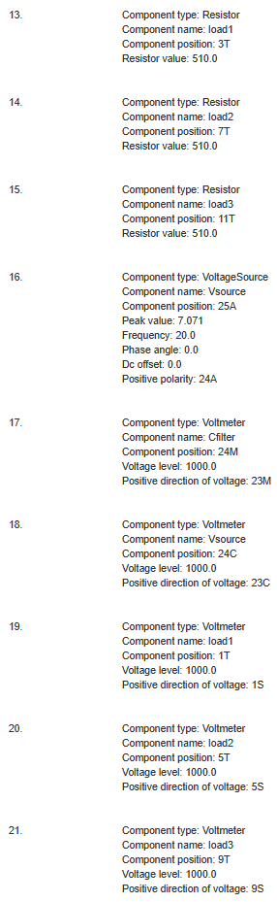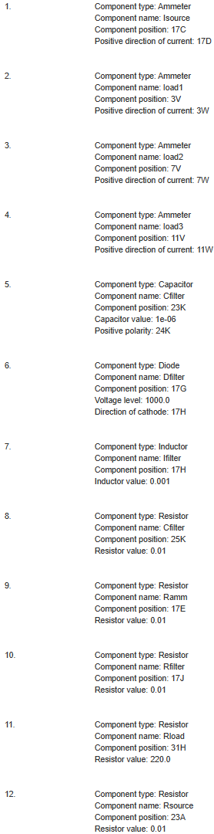Ammeter positive direction of current: searah jarum jam

Capacitor_Cfilter value = 1 uF

Capacitor_Cfilter value = 1 · 10-6 F

Capacitor_Cfilter value = 1e-06 F

Diode voltage level = Voltmeter voltage level = 1000 V (memerlukan tegangan tinggi)

Diode direction of cathode: searah jarum jam

Voltmeter positive direction of voltage: berlawanan arah jarum jam

Inductor value = 1 mH

Inductor value = 1 · 10-3 H

Inductor value = 0,001 H

Resistor value = 0,01 Ω (bernilai rendah guna menjaga stabilitas tegangan dan arus)

VoltageSource peak voltage = V · $\sqrt{2}$

VoltageSource peak voltage = 5 · $\sqrt{2}$

VoltageSource peak voltage = 7,071 V

1. Simulation output graph
2. Voltage at each resistance

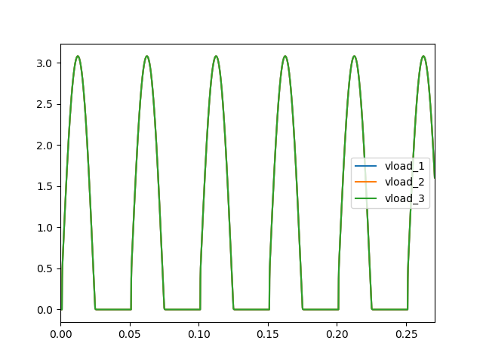

1. The amount of current at each resistance

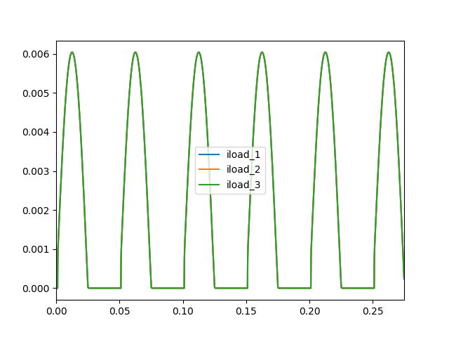

PPE Simulation Files: <https://drive.google.com/drive/folders/1RA0fDDzcEF70HYXHN8ydTsX_pAqjDaHZ?usp=sharing>

**Note for Lecturers**:

1. The lecturers are advised to assess student’s understanding towards the topics included in the assignment.
2. The students will submit their answer in .pdf format through BINUSMAYA.
3. The deadline of this comprehensive assignment is at the end of the semester.