**Gravity and Shock Waves in a**

**Shallow Fluid**

**Introduction**

In this project, we consider the shallow water equations. The shallow water equation is studied to model a shallow, uniform, inviscid fluid mathematically. In this project we will simulate the evolution of a fluid with given initial and boundary condition. For the evolution of a fluid, we consider two models: linear model and non-linear model. The initial and boundary condition are given. And the solutions of both models (linear and non-linear model) is also given in this project. We compare the evolution results with the given solutions, to check whether the created model returns same results. After we get the solutions for the linear and non-linear model, we analysis the conservation properties. For this, we calculate the available energies such as kinetic energy and potential energy as well as fluid mass by using trapezoidal integration method. Based on that, we will consider which model is the better for the conservation properties. In this project, we plot the needed graphs.

1. **Initializing the Model, Loading and Visualizing Solutions**

In section 1, we define the constants to create the linear and non-linear model, load the given data and visualize the given solutions for both of linear and non-linear model.

First, we define the constants according to the requirement of project. We define the following constants in this project.

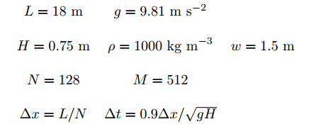

After that, we initialize the model to create in section 2. The variables of the model are u, h, $η$ and $ϕ$. The formula to initialize the above variables is the following.

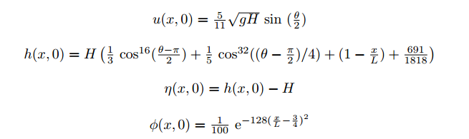

In code, we initialized the initial values of u, h, $η$ and $ϕ$ by the above formula. Next we load ASCII data files “u_lin.dat” and “h_lin.dat” for the linear model and “soln.mat” file for no-linear model. To load those files, we used “load” function in code. The following images show the initialization status of each variable, which will be used in model creation for both of linear and no-linear model, respectively. (Fig1 shows the initial vectors of linear model and Fig2 shows the initial vectors of non-linear model.)

In Fig1, the first row is the initial condition of the linear solution u(x,0) loaded from ASCII file “u_lin.dat”, the second row is the initial condition of the linear solution h(x,0) loaded from ASCII file “h_lin.dat” and the third row is our defined initial condition $ϕ(x,0)$.

In Fig2, the first row is the initial condition of the linear solution u(x,0) loaded from MATLAB file “soln.mat”, the second row is the initial condition of the linear solution h(x,0) loaded from MATLAB file “soln.mat” and the third row is our defined initial condition $ϕ(x,0)$.

Now we can see the solutions from loaded data for linear and non-linear model. The below image shows the surface evaluation h vs x.

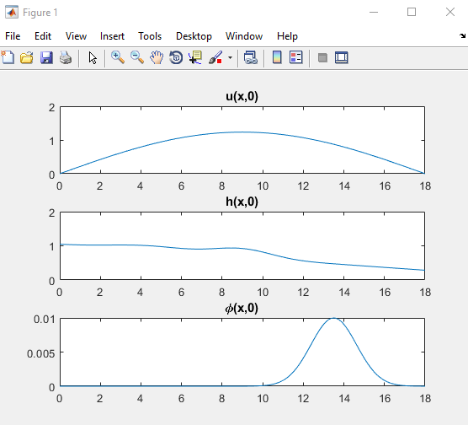

Fig1. The initialization of model variables for the linear model.

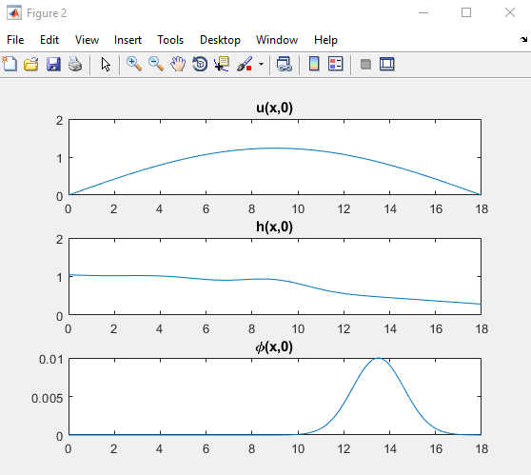

Fig2. The initialization of model variables for the non-linear model.

In Fig3, row 1 : m=1, row 2: m=128, row 3: m=256, row 4: m=384, row 5: m= 512.

We can see the movie for the evolution of surface h by using MATLAB function “getframe”. In movie, we can see the surface is changed continuously initially, and it is rapidly higher in some point. Sometimes, it shows the curve like water wave.

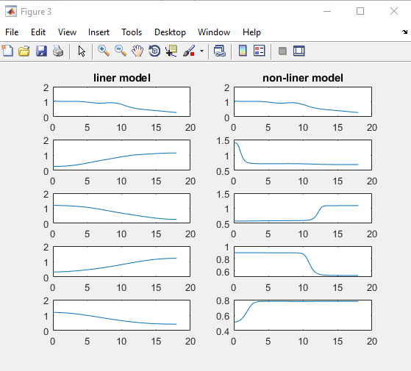

Fig3. The surface evolution h vs x for linear and non-linear model.

1. **Creating the Models and Reproducing Solutions**

In this section, we create two models linear and non-linear model. In first part of this section, we use user prompt. By user prompt, user can select linear model or non-linear model. If user select one, we create non-linear model, if user select zero, then we go into to create linear model.

To create model, we use time loop function. By this loop function, we find solutions of the shallow water equations.

When user select 1, we create non-linear model. To create non-linear model, we use MATLAB script “nonlinear.m”. This function returns next time evolution for previous evolution. As an input, this function has 9 variables: old flow speed, old fluid surface, old fluid depth, old tracer concentration, the number of points, distance between two points, gravity acceleration and mean of fluid depth. Along with time variables, we get new flow speed, new fluid surface and depth and new fluid concentration one by one. After we get the solution for the non-linear model, we compare it with the loaded non-linear solution. By the sum of difference between two solutions, we check whether two solutions is coincided or not.

When user selects zero, we create the linear model. To create the linear model, we use MATLAB script “gravity.m”. This function returns the flow speed, surface elevation and depth elevation, when the flow speed, surface and depth elevation, the number of points, distance between two points, gravity acceleration and mean of fluid depth are inputted. To estimate the transport of the passive tracer, we construct the function “transport.m”. In this function, we check first whether the size of the inputted variables is same or not. If it is not same, code will display error message. If it is same, it constructs the linear system for the passive tracer. After that, we find the solution of the linear model to solve the constructed linear system. By the sum of difference between two solutions, we check whether two solutions is coincided or not.

To show the evolution of the tracer concentration, we plot our tracer concentration for m=1, m=128 and m=184. The below image shows the evolution of the trace concentration.

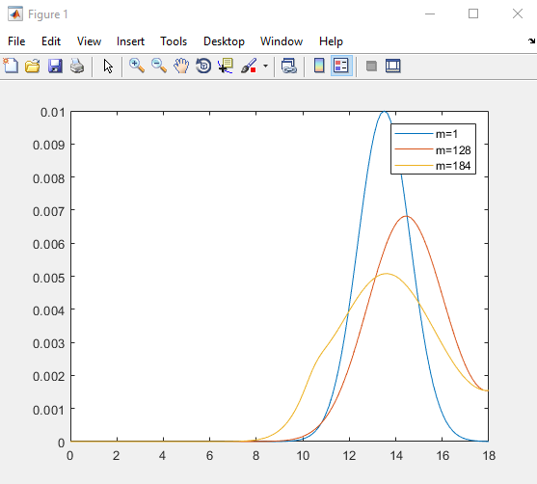

Fig4. The evolution of the trace concentration

1. **Analysis**

In this section, we analyze the conservation properties of the linear and non-linear numerical solutions. To do it, we need to calculate the available energy and fluid mass.

First, we consider the physical formulas. In physical, we get the mass by multiplying of volume and density of fluid. The density of fluid is given. If we integrate the volume in very small interval of fluid width, then we get the volume in the all interval of fluid width. Similarly, to calculate the available energies like kinetic and potential energy, we need to integrate the energy in small interval of fluid width over the full interval. Form this, the physical formulas to calculate the fluid mass and available energies, are the following.

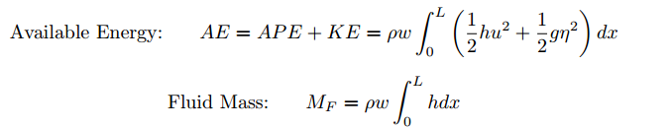

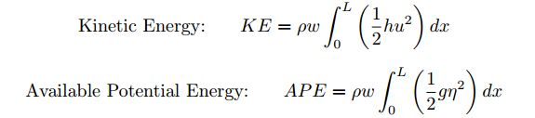

To calculate the integration of the function, we create new function “trapezoidal.m”. This function calculates the integration by trapezoidal method. The input of this function is discrete function value array and output is the one value of integration. Before this function calculates the integration of function, it checks whether the size of the input variable is correct or not. If the size of input variable is correct, this function returns the integration value. The Fig5 shows the change of fluid mass and total energy vs time. And Fig6 shows the change of available energies vs time.

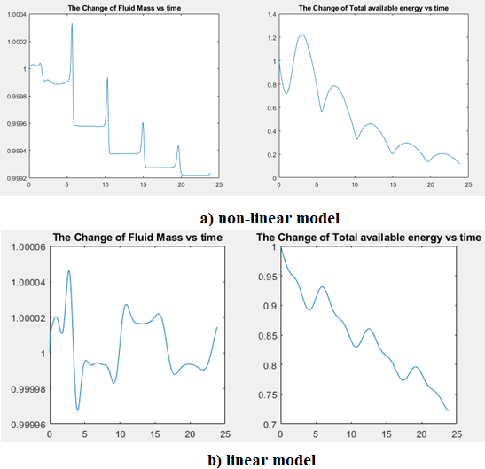

Fig5. The Fluid Mass and total energy vs time

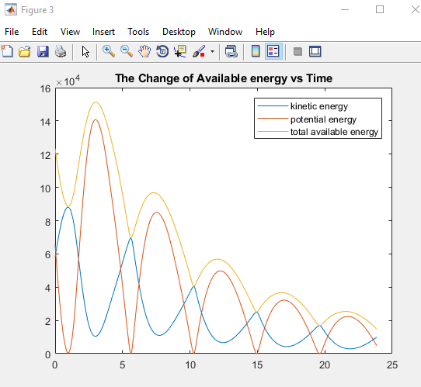

Fig6. The available energies vs time

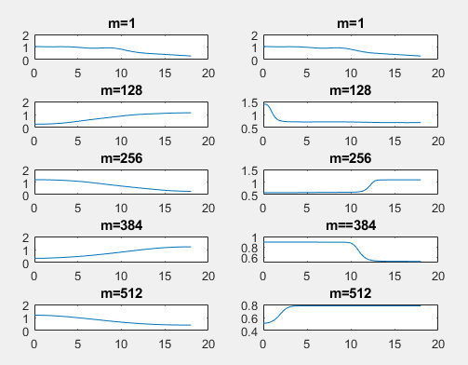

Fig7. The solutions for linear and non-linear model

As we can see in the above images, the change of the fluid mass and energy is more stable than ones of linear model. It means non-linear model conserves energy more efficiently. But for the non-linear model, it has a rapid change in the depth of fluid. As we can see in the above Fig7, the depth of fluid in the linear model is slowly and continuously changed, but the depth of fluid in the non-linear model has a rapid change at the some point. So we can say the non-linear model has a bore or shock wave.

1. **Conclusions**

In this project, we considered the shallow water equations and got the solutions for both of the linear and non-linear. Through this project, we defined model parameters and initialized model variables based on initial and boundary conditions. After that we created two functions. One is transport function to estimate the transport of passive concentration, and another is trapezoidal function to integrate a function, which is used to calculate the fluid mass, total available energy, kinetic and potential available energy. To create non-linear model, we used nonlinear function which is given in this project and we used gravity function and our own transport function to create the linear model. To analyze the conservation properties of the linear and non-linear numerical solutions, we calculated the physical quantities such as fluid mass, kinetic and potential energy and total energy by using our own function trapezoidal.

We plotted the several graphs to visualize the results and considered the evolution of fluid surface by getframe. Through results of this project, we can see the non-linear model conserves energy more efficiently than the linear model, however for the depth of fluid, the non-linear model has a bore or shock wave at some points.

References

[1] Farhadzadeh, A., SUNY Stonybrook, Dept. of Civil Engineering, Coastal and Hydraulic Engineering Research  
Laboratory  
(http://www.stonybrook.edu/commcms/civileng/research/ wavecurrentflumespecification.php)  
[2] Durran, D. R. (1991): Numerical Methods for Wave Equations in Geophysical Fluid Dynamics. Springer, NY  
[3] Sainchera, S. and Banerjeea, J. (2015): Design of a numerical wave tank and wave flume for low steepness waves  
in deep and intermediate water. Proceedings of 8th International Conference on Asian and Pacific Coast.  
[4] Dullemond, C. P., (2008): Lecture on Numerical Fluid Dynamics, Chapter 4  
(http://www2.mpia-hd.mpg.de/~dullemon/lectures/fluiddynamics08/)  
[5] Fishbane, P.M., Gasiorowicz, S., and S.T. Thornton, (1996) Physics for Scientists and Engineers, 2d ed. (Extended), Upper Saddle River, New Jersey: Prentice Hall.