StudentStay Database Design
Tables, rules, security, demo data and how to install them
Product: StudentStay, student accommodation platform for Lusaka universities
Based on: StudentStay PRD v0.9 (FR1 to FR12, section 6 states)
Database: PostgreSQL on Supabase
Version 0.9 draft for review. November 2026.
Status: installed on the StudentStay Supabase project with demo data loaded, and checked there.

Contents
1. What is in the package and what was tested
2. How to install it, step by step
3. Design choices in plain language
4. Entity relationship diagram
5. The 22 tables
6. States and the only allowed changes
7. Rules the database enforces by itself
8. Security: who can see and change what
9. The demo data
10. Error codes the app should handle
11. Coverage of the PRD requirements
12. Test results
13. Defaults used, gaps and next steps
Appendix A. Putting the files in the repository
Appendix B. Giving someone a staff role

1. What is in the package and what was tested
This package turns the data model in the PRD (section 9 and the states in section 6) into a real PostgreSQL database for Supabase. It contains the tables, the rules that keep the data correct, the security rules for the five user roles, the server-side actions, and invented demo data that matches the design prototypes.

1.1 Files
File | What it is
supabase/migrations/20261111000000_initial_schema.sql | The whole database: tables, state rules, triggers, audit log, server-side actions, public views, security policies and permissions. Run once.
supabase/migrations/20261111000001_security_hardening.sql | Small follow-up from Supabase’s security advisor: pins the search path on eight trigger functions and removes eleven helper functions from visitors who are not signed in. Run after the schema.
supabase/seed/demo_data.sql | Invented demo data that matches the prototypes (8 properties, 468 beds, sample applications, tickets, payments). Run once after the schema.
supabase/seed/reset.sql | Deletes every StudentStay table and function so you can start again. Test projects only. Does not delete sign-in users or uploaded files.
supabase/tests/ | The local test suite (optional). Needs a local PostgreSQL. Not needed to use the database.
docs/database-erd.png and docs/database-erd.md | The diagram of the tables and how they connect. The .md version draws itself on GitHub.

1.2 Size of the design
22 tables, 49 relationships, 18 state lists, 69 allowed state changes, 36 triggers, 47 functions, 42 security policies and 51 indexes.

1.3 What was tested, and what was not
The schema and the demo data were run on a local PostgreSQL 16 database, with small stand-ins for the parts Supabase provides (the sign-in tables, the anon and authenticated roles, and file storage). A test suite of 116 checks then acted as a visitor, a student, an owner, an administrator, a technician and a system administrator and tried to break the rules. All 116 pass, including a test where two sessions race for the same bed. Section 12 lists what the checks cover.
Installed and checked on your real Supabase project. The schema and the security hardening were applied to the StudentStay project, the demo data and the demo users were loaded, and 46 key checks were run against the real database inside a transaction that was rolled back, so the demo data was not disturbed. All 46 pass. The counts match the local test database: 22 tables (all with row-level security), 42 policies, 47 functions, 36 triggers, 69 allowed state changes, and the private documents bucket with its two policies. The reset script makes it safe to start again.
Demonstration data only. Every person, property, price and payment is invented. Payments are simulated and the database refuses a payment that is not marked simulated. Do not put real student data into this project until the data protection decisions in the PRD (OD-12, OD-16, OD-19) are settled.

2. How to install it, step by step

2.1 In the Supabase dashboard
- Create the five demo sign-in users. Go to Authentication, then Users, then Add user, then Create new user. Tick Auto Confirm User each time and choose your own passwords (not real ones you use elsewhere). On the StudentStay project these accounts were already created for you with random passwords that nobody knows, so skip this step and see section 2.3 to set a password.
- Run the schema. Open the SQL Editor and create a new query. Paste the whole contents of 20261111000000_initial_schema.sql and click Run. A successful run says "Success. No rows returned". Then run 20261111000001_security_hardening.sql the same way. If this has already been done for you, skip this step.
- Run the demo data. Open a new query, paste demo_data.sql and click Run. It stops with a clear message if a demo user is missing. It also tries to create eight more demo people who never sign in (seven students and a second technician). If it says it could not, add the emails it lists in Authentication, then run it again.
- Check the result. Run select state, count(*) from beds group by state; You should see 468 beds in total: available 67, held 18, pending_approval 9, reserved 31, occupied 335, blocked_for_maintenance 8.
- Check security is on. In the Table Editor every table should show Row Level Security as enabled.
- If anything goes wrong: run reset.sql, then repeat from step 2.

Demo user | Role | Notes
natasha.mwale@example.com | student | UNZA student 108-397. Has the application waiting for approval.
rachael.musongo@example.com | owner | Owns Olympia Park Residence and Northmead Scholars’ Lodge.
johnson.kawemba@example.com | university administrator | UNZA accommodation office. Decides allocations.
joseph.sakala@example.com | technician | Has three assigned tickets.
platform.admin@example.com | system administrator | Platform-wide. Cannot open private documents or decide allocations.

The eight extra people (seven students and a second technician, for example kelvin.sakala@example.com and brian.ngoma@example.com) exist only so the sample applications and tickets have owners. Nobody needs to sign in as them.

2.2 Setting a password for a demo account
The demo accounts on the StudentStay project were created with random passwords so that nobody can sign in to them yet. Their email addresses are written in the public repository, so a guessable password would let anyone sign in as an administrator. To set your own, type the password into the SQL Editor yourself (never into a chat or a file in the repo) and run:
update auth.users
set encrypted_password = extensions.crypt('TYPE-YOUR-PASSWORD-HERE', extensions.gen_salt('bf'))
where email = 'johnson.kawemba@example.com';

Change the email for each person. The example email addresses end in example.com, so they cannot receive messages: password reset emails will not arrive, and that is why the password has to be set this way.

2.3 In the repository
Appendix A shows how to save the files in the repo and merge them through a pull request, the same way the docs and design files were added.

3. Design choices in plain language
- One row, one fact. A listing has rooms, a room has beds, and a booking ties one student to one bed for a period. Nothing is copied between tables. This follows PRD data rule DAT-03.
- State lists are real types. Bed, booking, application, ticket, listing, payment and document states are database types, so a typo such as "aproved" is rejected. The lists match PRD section 6 exactly.
- Allowed changes are data, not code. The 69 allowed state changes sit in one table (state_transitions). A trigger refuses any other change. To allow a new change later you add one row.
- Double booking is impossible, not just unlikely. The booking table has a database rule (bookings_no_overlap) that rejects two live bookings for one bed in overlapping periods. The commit step also locks the bed and rechecks it, so two admins approving at the same moment get one success and one clear error.
- The browser cannot change a status. Application status, ticket status, listing moderation and user role cannot be written from the browser at all. They change only through server-side functions that first check who is asking. This is PRD security rule SEC-02.
- Recommendation and allocation are separate. The engine’s output lives in allocation_runs and allocation_candidates. A booking exists only after an administrator approves (FR6.5, ACC-04).
- Everything important is logged. Triggers write an append-only audit log, and the status trackers (application and ticket timelines) fill in automatically. Nobody, including the service role, can edit or delete audit entries.
- Payments are always simulated. The payments table has a rule that is_simulated must be true. There is no column for a card number or mobile-money PIN (FR8.3).
- Private documents never get a public address. Only the file path is stored in the database. The file sits in a private storage bucket, and owners and reviewers open it through short-lived links made on the server.
- Public pages read from a safe view. Visitors see listing_cards, which shows published listings with bed counts, without being able to read the underlying tables.

4. Entity relationship diagram
Each box is a table. PK marks the primary key and FK a link to another table. A line with a three-pronged end means "many": one listing has many rooms. Only key columns and state columns are shown. Dashed boxes are tables drawn on another page. The diagrams are generated from the real database, so they match the code. A single zoomable picture of all 22 tables is in docs/database-erd.png, and a text version that draws itself on GitHub is in docs/database-erd.md. Colours: blue = people, green = accommodation, purple = admissions, amber = payments, red = maintenance, teal = messages, grey = trust and audit.

4.1 People, properties, rooms and beds
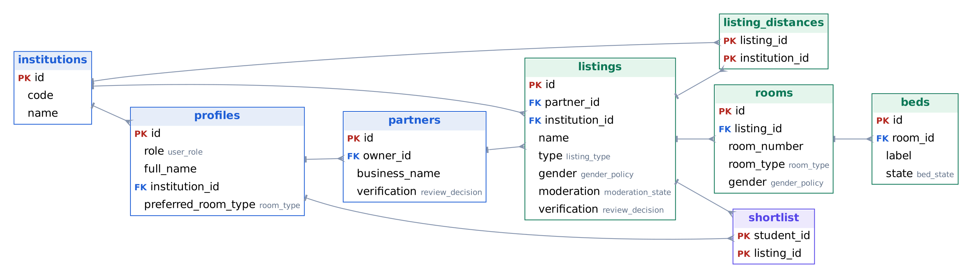

4.2 Applications, allocation, bookings, payments and documents
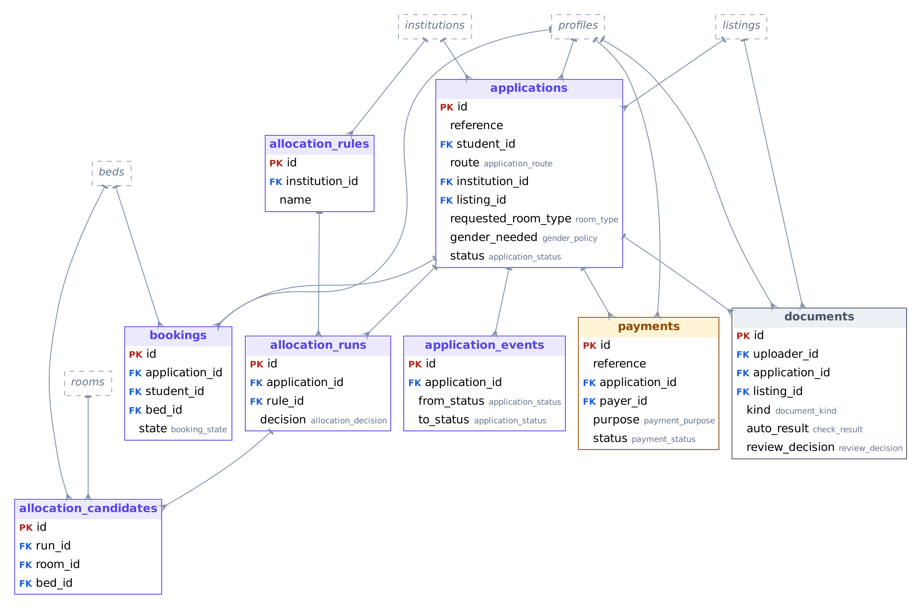

4.3 Maintenance, messages and audit
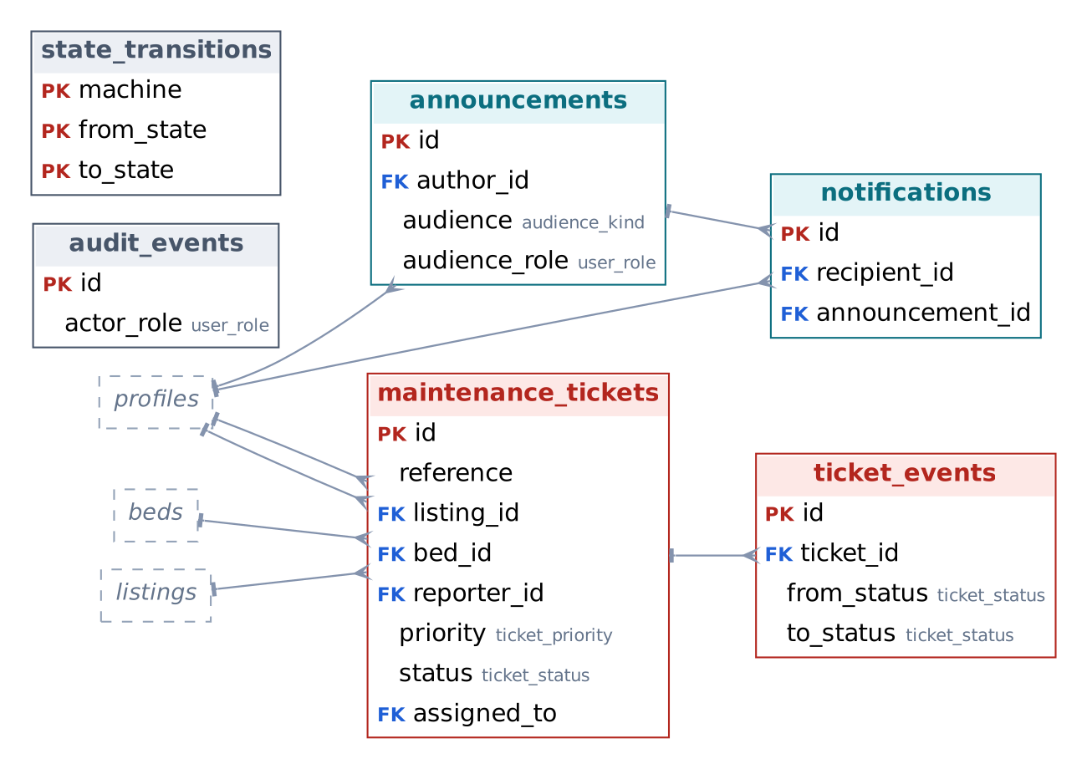

5. The 22 tables
Row counts are after the demo data is loaded. A zero means the table starts empty and fills as people use the app.
Table | What it stores | Columns | Demo rows
institutions | Universities and colleges. Evelyn Hone College is marked validation pending, as in the PRD. | 5 | 5
profiles | One per sign-in account: role, name, institution, student number, preferences and privacy switches. Created automatically at sign-up. | 17 | 13
partners | Property owners and operators. A partner can exist without a login (used for the demo owners). | 7 | 6
listings | A property: type, area, rules, facilities, moderation state, verification badge and last updated time. | 23 | 8
listing_distances | Distance from a listing to each campus, and whether that institution recognises (partners with) the listing. | 4 | 17
rooms | A room with type, capacity and price. Adding a room creates its beds automatically. | 10 | 206
beds | One row per bed with its state, who changed it, when, and when a hold expires. | 10 | 468
shortlist | A student’s saved listings. | 3 | 2
applications | A student’s application, university allocation or private, with its status and reason. | 16 | 8
application_events | The timeline of every application status change. Filled in automatically. | 7 | 29
allocation_rules | An institution’s rule versions: hard constraints and five weights that must total 100. | 13 | 5
allocation_runs | One engine run for one application, plus the administrator’s decision and reason. | 11 | 1
allocation_candidates | The ranked rooms with a score for each factor, and the excluded rooms with their reasons. | 14 | 6
bookings | A student’s claim on one bed for a period. Carries the no-overlap rule. | 10 | 1
payments | Simulated payment records. Always marked simulated. | 13 | 6
maintenance_tickets | Repair requests with priority, assignee, target time and status. | 21 | 6
ticket_events | The timeline of every ticket status change, with notes. Filled in automatically. | 7 | 18
announcements | A message with an audience: everyone, an institution, a property, a role or named users. | 12 | 1
notifications | One row per recipient. Tracks read and unread. | 9 | 4
documents | Uploaded document records with the automated check result and the human review decision. The file itself is in private storage. | 17 | 4
audit_events | Append-only log of who did what. Cannot be edited or deleted. | 10 | 75
state_transitions | The allowed state changes (PRD section 6) as data. | 3 | 69

6. States and the only allowed changes
Each state list below is a database type. A change from one state to another succeeds only if that pair is in state_transitions (69 pairs). Anything else raises the error INVALID_TRANSITION. The lists follow PRD section 6, with three additions marked below.

6.1 State lists
Type | Values
allocation_decision | pending, approved, modified, rejected, rerun
application_route | university_allocation, private
application_status | draft, submitted, profile_incomplete, under_review, recommended, pending_approval, approved, accepted, declined, no_eligible_room, withdrawn, expired
audience_kind | all, institution, listing, role, users
bed_state | available, held, pending_approval, reserved, occupied, blocked_for_maintenance
booking_state | reserved, occupied, cancelled, expired, released
check_result | clear, unclear, possible_duplicate
document_kind | national_id, proof_of_enrolment, ownership_proof
gender_policy | female_only, male_only, mixed
listing_type | university_hostel, recognised_boarding_house, private_rental
moderation_state | draft, awaiting_moderation, published, requires_review, suspended
payment_purpose | application_fee, deposit, rent
payment_status | pending, successful, failed, refunded
review_decision | pending, verified, resubmission_required, requires_review
room_type | single, double, triple, quad
ticket_priority | low, medium, high
ticket_status | pending, assigned, in_progress, completed, reopened, escalated, cancelled
user_role | student, owner, university_admin, technician, system_admin

6.2 Allowed changes

Application
From | Can change to
accepted | expired, withdrawn
approved | expired, withdrawn
draft | submitted, withdrawn
pending_approval | approved, declined, no_eligible_room, submitted, withdrawn
profile_incomplete | expired, submitted, withdrawn
recommended | pending_approval, submitted, withdrawn
submitted | no_eligible_room, profile_incomplete, recommended, under_review, withdrawn
under_review | accepted, declined, withdrawn

Bed
From | Can change to
available | blocked_for_maintenance, held, pending_approval
blocked_for_maintenance | available
held | available, blocked_for_maintenance, reserved
occupied | available
pending_approval | available, reserved
reserved | available, blocked_for_maintenance, occupied

Booking
From | Can change to
occupied | released
reserved | cancelled, expired, occupied

Listing moderation
From | Can change to
awaiting_moderation | published, requires_review, suspended
draft | awaiting_moderation
published | requires_review, suspended
requires_review | awaiting_moderation, suspended
suspended | awaiting_moderation

Payment
From | Can change to
failed | pending
pending | failed, successful

Ticket
From | Can change to
assigned | cancelled, escalated, in_progress, pending
completed | reopened
escalated | assigned, completed, in_progress
in_progress | completed, escalated
pending | assigned, cancelled
reopened | assigned, escalated, in_progress

Three additions to PRD section 6.2. (1) submitted → no_eligible_room: the engine can find no room right after submission. (2) recommended → submitted and pending_approval → submitted: FR6.2 says an administrator can rerun a recommendation, which sends the application back to the engine. Please confirm these with your supervisor and add them to the PRD.
One gap in the PRD. There is no direct available → occupied change, so an owner who moves in a tenant without an online application must go available, held, reserved, occupied. This is workable but clumsy. It is listed as a question in section 13.

7. Rules the database enforces by itself
These hold even if the app has a bug, because the database refuses to break them.
Rule | How it is enforced | PRD
A bed has exactly one state | One state column of a fixed type, one row per bed | FR7.1
Only allowed state changes happen | Trigger plus the state_transitions table | ERR-03, ACC-06
Two live bookings for one bed cannot overlap in time | Exclusion constraint bookings_no_overlap. The commit step also locks the bed and rechecks it | FR7.3, ACC-03
An application has at most one live booking | Partial unique index | FR7
No second open application to the same property by the same student | Partial unique index | FR4.7
Adding a room with capacity 3 creates 3 beds; capacity must match the room type | Trigger plus a check | FR2.2
A hold lasts 48 hours, then the bed is released | Trigger sets the expiry; expire_holds() releases (needs a scheduler) | FR7.2, OD-09
Rule weights total exactly 100 | Check constraint | FR5.3
Only one active rule version per institution | Partial unique index | FR5.7
An excluded room always has a reason; a ranked room always has a rank and a bed | Check constraint | FR5.2
Payments are always simulated; no card or PIN fields exist | Check constraint and schema design | FR8.2, FR8.3
Documents are PDF, JPG or PNG and at most 5 MB | Check constraint | FR11.1
Documents carry a retention date (default 90 days) | Column default. A deletion job is not built yet | FR11.7, OD-12
No application before the email is verified | Insert policy and submit_application | FR1.1
Missing details are flagged, not rejected | submit_application sets profile_incomplete and says what is missing | FR4.2
Changing a student number clears the administrator’s confirmation | Trigger | FR1.7
Only Student or Owner can be chosen at sign-up | Trigger on the sign-in table | FR1.2
Listings not updated for over 30 days are flagged | last_updated_at kept by triggers; the view computes is_stale | FR2.6, OD-05
Ticket target time follows priority (24 h, 3 days, 7 days) | Trigger | FR9.4, OD-10
Audit entries cannot be changed, deleted or truncated | Trigger | FR6.6, FR12.1
A university hostel must belong to an institution | Check constraint | PRD 9

8. Security: who can see and change what
Security works in three layers, as the PRD asks (SEC-02, SEC-03). Row-level security decides which rows a person can see. Column permissions decide which fields they can write. Server-side functions handle the actions that need a decision, and check who is asking before they act.

8.1 The six kinds of visitor
- Visitor (not signed in): published listings, their rooms and bed availability, institutions, and the public listing view.
- Student, Owner, University administrator, Technician, System administrator: the five roles from the PRD. The role is stored on the person’s profile and cannot be changed from the browser.

8.2 Access by role
R means read, W means create or edit, "own" means only their own rows, a dash means no access.
Data | Visitor | Student | Owner | University admin | Technician | System admin
Institutions | R | R | R | R | R | R, W
Profiles | - | own (edit personal fields) | own | own, plus students of their institution (R) | own | all (R)
Partners | - | - | own (R, create, edit) | R | - | R, W
Listings, rooms, beds | published (R) | published (R) | own, any state (R, W) | published and partnered (R); own hostels (W) | published (R) | all (R, W)
Applications | - | own (create, edit drafts) | private ones through the inbox view only | own institution (R) | - | all (R, support)
Allocation rules | - | - | - | own institution (R, W) | - | R, W
Allocation runs and candidates | - | own run, ranked rooms only | - | own institution (R) | - | R
Bookings | - | own | own listings | partnered listings | - | R
Payments | - | own (created by function) | own tenancies (R, mark status) | own institution (R) | - | R
Maintenance tickets | - | own (create if housed) | own listings (R, edit priority and notes) | partnered listings (R, edit) | assigned only (R) | R
Announcements | - | - | own (R, create) | own (R, create) | - | all
Notifications | - | own | own | own | own | own
Documents | - | own uploads | applicants to own listings, own uploads | institution scope (R, review) | - | none (OD-03)
Shortlist | - | own | - | - | - | -
Audit log | - | - | own actions | own institution | - | all
State rules | R | R | R | R | R | R

8.3 What the browser can never write directly
- A user’s role.
- An application’s status and a student number’s confirmed flag.
- A ticket’s status (including completed and reopened).
- A listing’s moderation state and verification badge.
- A document’s automated check result.
- A payment’s amount after it exists (owners can only mark its status).
- Anything in the audit log, the bookings table, or the allocation tables.
These change only through the server-side functions below, or through the service role on the server.

8.4 Server-side actions the browser may call
Function | Who may call it | What it does
submit_application | student | Sends a draft application. Flags missing details. Needs a verified email.
withdraw_application | student (own) | Withdraws and releases every bed set aside. Cancels a reserved booking.
decide_allocation | university administrator of the student’s institution | Approve, modify, reject or rerun. Rechecks the bed, creates the booking, notifies the student, logs the reason.
decide_private_application | owner of that listing | Accept (holds the chosen bed for 48 hours) or decline with a reason.
record_simulated_payment | student (own application) | Records a simulated payment. A deposit on an accepted application confirms the booking.
assign_ticket | owner or administrator of the property | Gives a ticket to a technician and notifies them.
set_ticket_status | technician (assigned), student (reopen), owner, administrator | Technician: start, complete, escalate. Student: reopen within 7 days. Owner: escalate or cancel. Administrator: escalate.
submit_listing_for_moderation | owner, hostel administrator, system administrator | Sends a draft listing for review.
moderate_listing | administrator of a partnered institution, system administrator | Publish, ask for review or suspend. A reason is required for the last two.
confirm_listing_availability | owner, hostel administrator, system administrator | Refreshes "last updated" without changing any bed.
confirm_student_number | university administrator of that institution | Marks a declared student number as confirmed.
publish_announcement | the author | Creates one notification per recipient in the chosen audience.

Two functions are for scheduled jobs and are not callable from the browser: expire_holds() frees beds whose 48-hour hold has run out and expires the linked application, and escalate_overdue_tickets() marks tickets past their target time as escalated. The allocation engine writes allocation_runs and allocation_candidates using the service role, because it runs on the server.

8.5 Private documents
Identity and ownership documents go into a private storage bucket called documents. It has no public address. People can upload and read only inside a folder named after their own user id. Owners and reviewers open files through short-lived signed links that the server creates after checking the person is allowed. The server should also write an audit entry each time it creates one (AUD-06). The system administrator has no access to documents by default (OD-03).

8.6 The service role key
The service role key skips row-level security. It belongs only in server code and in .env.local, never in code that runs in the browser and never in GitHub. The allocation engine, the document checks and the scheduled jobs are the places that need it.

9. The demo data
The demo data reproduces the numbers on the prototype screens, so the app can be built against the same story.
Property | Rooms | Beds | Free beds
Chelston Gardens Rooms | 12 | 24 | 9
Great East Court | 24 | 50 | 9
Kalingalinga Student Homes | 16 | 40 | 6
Northmead Scholars’ Lodge | 28 | 60 | 0
Olympia Park Residence | 30 | 72 | 14
Rhodes Park Annex | 6 | 12 | 3
Riverside Hall | 76 | 180 | 22
Woodlands Student Villas | 14 | 30 | 4

- Bed totals: blocked for maintenance 8, pending approval 9, occupied 335, available 67, held 18, reserved 31. Total 468.
- Natasha’s application (APP-2026-0412) is waiting for approval for Riverside Hall block 3, room 314, bed B. The run lists three ranked rooms (scores shown with a breakdown) and three excluded rooms with reasons: a male-only property, a single room she did not ask for, and a full room.
- Seven more sample applications cover every status on the prototype screens: recommended, under review, no eligible room, accepted, profile incomplete, declined and approved (the approved one has a booking).
- Six tickets, six payments, announcements, notifications and documents match the prototype lists. Two tickets are Natasha’s, so her repairs screen is not empty.
- Rule versions: version 1 (25, 25, 25, 15, 10) is active for UNZA, UNILUS, ZCAS and Cavendish. UNZA also has an inactive draft version 2.
Beds marked reserved or occupied in the demo data do not have booking rows, because only the sample students have bookings. In real use, every reserved or occupied bed has a booking.

10. Error codes the app should handle
Every rule failure starts with a short code followed by a colon, for example BED_UNAVAILABLE: this bed is no longer free. The app should match on the code and show the friendly message, with a reference code (ERR-01, ERR-02). Direct database errors also arrive with standard codes: 42501 (permission denied), 23514 (a check failed) and 23P01 (an overlap).
Code | Meaning | Suggested message | PRD
BED_UNAVAILABLE | The bed was taken, or an overlapping booking exists. | That bed was just taken. Here are other options. | ERR-04
INVALID_TRANSITION | The status change is not in the allowed list. | That change is not possible from the current status. | ERR-03
NOT_ALLOWED / 42501 | The person is not allowed to do this. | You do not have access to do that. | ERR-08
ALREADY_DECIDED | Someone already decided this recommendation or application. | This has already been decided. | FR6
NOTE_REQUIRED | A reason is needed. | Please give a reason. | FR6.2
BED_NOT_ELIGIBLE | The chosen room is not one of the run’s eligible rooms. | Choose one of the eligible rooms. | FR6.2
BED_REQUIRED | An owner accepted without choosing a bed. | Choose the bed to hold. | FR4
EMAIL_NOT_VERIFIED | The email is not verified yet. | Verify your email before applying. | FR1.1
REOPEN_WINDOW_PASSED | More than 7 days since the ticket was completed. | This request can no longer be reopened. Please report a new one. | OD-10
NOT_A_TECHNICIAN | The chosen person is not a technician. | Choose a technician. | FR9.3
ALREADY_SENT | The announcement was sent. | This announcement has already been sent. | FR10
AUDIT_IMMUTABLE | Someone tried to change the audit log. | (Not shown. Treat as a bug.) | FR6.6
BED_NOT_FOUND, RUN_NOT_FOUND, TICKET_NOT_FOUND, BAD_DECISION, BAD_STATE | Bad input. | Something went wrong. Reference code shown. | ERR-01, ERR-02

11. Coverage of the PRD requirements
Requirement | Where it lives in the database | Not covered or needs more work
FR1 Accounts and roles | profiles, sign-up trigger, backfill, role protection, email verification check | Session timeouts are a Supabase Auth setting, not in the database. Staff roles are assigned with SQL (Appendix B).
FR2 Listings | partners, listings, rooms, beds, moderation states, verification badge, last updated | Photos and map data are not modelled yet (both "Should").
FR3 Search and shortlist | listing_cards view, indexes, facilities index, shortlist | Comparison and filtering screens are front-end work reading the view.
FR4 Applications | applications, application_events, submit, withdraw, duplicate rule | None.
FR5 Allocation engine | allocation_rules (weights total 100), allocation_runs, allocation_candidates | The engine itself is application code (slice S5). The database stores and protects its output.
FR6 Approval and audit | decide_allocation, audit_events, append-only rules | None.
FR7 Beds and conflicts | beds, bookings, no-overlap rule, commit step with lock, expire_holds | Needs a scheduler for expire_holds.
FR8 Simulated payments | payments with the simulated-only rule, record_simulated_payment | The 72-hour deposit deadline is stored but not enforced.
FR9 Maintenance | maintenance_tickets, ticket_events, assign_ticket, set_ticket_status, escalate job | Blocking a bed from a ticket is not automated.
FR10 Announcements | announcements, notifications, publish_announcement | Email and SMS are out of scope (OD-11).
FR11 Documents | documents, private bucket, review columns, retention date | Automated checks, signed links and the deletion job are application tasks.
FR12 Audit, reports, errors | audit_events, status timelines, error codes (section 10) | Report queries are written with the report screens.

12. Test results
The suite runs against a fresh database, then again after a reset, a re-install and a re-seed. Both runs give 116 passes and 0 failures. The suite found three genuine bugs while it was being built, all now fixed: students could not create an application because a number sequence was locked too tightly, the "what is missing" message in submit_application mishandled text, and one of my own test helpers was silently switching to the superuser, which made a security test meaningless. That last one is a reminder that tests can be wrong too.
Area | Checks passed | What they prove
data checks | 8 | The demo data matches the prototypes: 468 beds and the exact state counts, timelines recorded automatically, the public listing view shows the right prices, counts and stale flag.
anonymous visitor | 6 | A visitor sees only published listings and cannot read applications, profiles or payments, or call any action.
student Natasha | 14 | A student sees only her own application, payment, tickets, documents, shortlist and notifications. She cannot make herself an administrator, approve her own application, change a bed, add a payment row, or see excluded rooms.
unverified email and application rules | 3 | An unverified email cannot apply. An incomplete draft is flagged with what is missing. A student cannot create an application for someone else.
property owner Rachael | 14 | An owner can hold and release beds in her own property but not in anyone else’s. Invalid moves are refused. She cannot publish her own listing, read the applications table, announce to everyone, or see other people’s documents. Adding a room creates its beds.
private application, accept, deposit confirms booking (FR8.4) | 5 | An accepted private application has a bed held. A simulated deposit confirms the booking and reserves the bed. A payment cannot be marked as real money.
administrator Johnson: allocation decisions | 12 | An administrator sees only her institution. Modify needs a reason and an eligible room. Weights that do not total 100 are refused. Approve creates the booking, reserves the bed, records who decided, notifies the student, and cannot be repeated.
no double booking | 5 | A taken bed cannot be committed for another student. A direct overlapping booking is blocked by the database. A later period is allowed. In a race between two sessions for one free bed, the second waits and then fails with BED_UNAVAILABLE, leaving exactly one booking.
withdraw releases beds | 4 | Withdrawing frees the bed and cancels the booking. A withdrawn or declined application cannot be revived.
maintenance tickets | 11 | A technician sees only his assigned tickets, no profiles or payments, and cannot edit status directly. Status moves follow the rules and are recorded with notes. A student cannot complete a ticket but can reopen one within 7 days.
documents and verification | 7 | An administrator sees and reviews documents in her scope and cannot edit the automated result. The system administrator cannot open private documents but can read all applications for support and cannot decide allocations. An owner cannot see a student’s documents.
announcements | 3 | An announcement reaches exactly the intended people, cannot be sent twice, and an administrator cannot target another institution.
listing moderation and audit | 19 | Moderation respects partnership and needs a reason to suspend. A suspended listing leaves the public view. The audit log records changes and cannot be edited, deleted or truncated. Private applications, the owner inbox and its privacy switch, hold expiry and application expiry all work.
private document storage | 5 | The documents bucket is private. A person can upload and list only inside her own folder. A visitor cannot read any file.

Total: 116 passed, 0 failed on the local PostgreSQL 16 with stand-ins for Supabase.
Run on the real StudentStay project as well. After the data was loaded, the most important checks were repeated against the real database, acting as a visitor, student, owner, administrator, technician and system administrator, inside a transaction that was rolled back at the end. All 46 passed. The first attempt showed 12 failures that came from the way my test was written (it wrapped changes in a form PostgreSQL does not allow), not from the database. The corrected test passed.

13. Defaults used, gaps and next steps

13.1 Defaults used for open PRD decisions
You decided to accept the defaults in PRD section 19. This is what the database does with them.
Decision | What the database does
OD-02 What owners see of an applicant | Owners read a limited view (private_application_inbox): name, institution, requested room, budget and the number of documents. A student can switch off showing her name, and the owner then sees "Applicant".
OD-03 Support access to documents | The system administrator has no policy that opens documents.
OD-05 Stale listings | Flagged after 30 days by the public view. Lowering a stale listing’s score is the engine’s job.
OD-06 University and private applications together | Allowed. Only a second open application to the same property is blocked.
OD-07 Weights and hard constraints | Demo rule: room type 25, budget 25, distance 25, facilities 15, availability 10. Hard constraints are stored as switches in a JSON column for the engine to read.
OD-08 Priority groups | None modelled. Ties are the engine’s concern.
OD-09 Hold times | 48 hours for an accepted private application is enforced. The 72-hour deposit deadline for a university allocation is stored (deposit_due_at) but not enforced.
OD-10 Ticket targets | High 24 hours, medium 3 days, low 7 days, reopen within 7 days. All enforced.
OD-12 Retention | Documents get a retention date 90 days out. No deletion job exists yet and no data controller is recorded.
Not in the PRD | A booking made without dates defaults to 180 days from today. The intake is free text.

13.2 What is not done
- The allocation engine is not in the database. It is TypeScript code (slice S5) that reads rules and beds, then writes a run and its candidates with the service role.
- Automated document checks and the code that makes signed links (and logs each one) are application tasks.
- Scheduled jobs. expire_holds() and escalate_overdue_tickets() exist but nothing calls them yet. The schema ends with two commented cron.schedule lines to use once the pg_cron extension is enabled.
- Deposit deadline and retention deletion are stored but not enforced.
- Blocking a bed from a ticket (FR9.6) is not automated. The blocks_bed flag exists.
- Listing photos (FR2.5) have no table or bucket yet.
- Reports have no views except listing_cards. They are written with the report screens.
- Staff roles are assigned with SQL (Appendix B). There is no admin screen for it yet.
- Realtime is not switched on. The schema has a commented line for it.
- Supabase’s security advisor was run on the real project. After the hardening migration it reports: 2 errors for the views listing_cards and private_application_inbox (they run with the owner’s rights on purpose, and each filters its own rows); 2 warnings for the two helpers visitors need; and 25 warnings that signed-in users can call security definer functions. Twelve of those 25 are the deliberate actions in section 8.4. The other 13 are helpers that the policies call and that only return facts about the caller. A later hardening step is to move the helpers into a schema that is not exposed through the API.
- Free plan limits. A free project pauses after a week without activity and has no automatic backups. Check that it is running before a demo. The migration files in the repo are your backup of the structure.

13.3 Questions for your supervisor
- Do you approve the three additions to the state changes (section 6.2)?
- Should the PRD allow a bed to go straight from available to occupied for tenants who did not apply online?
- Should the 72-hour deposit deadline for university allocations cancel the booking automatically, or only warn?
- What happens to a student’s documents and personal data after the retention period, and who is the data controller (OD-12)?

13.4 Next steps
- Run the install steps in section 2 on your Supabase project and tell me what happens, including any error text.
- Save the files in the repo (Appendix A) and merge the pull request.
- Ask me to write CLAUDE.md from this design, so Claude Code knows the tables, the server-side actions, the error codes and the rules not to break.
- Start slice S1 with Claude Code: sign up and sign in, the five roles, the profile page and the audit log.

Appendix A. Putting the files in the repository
Unzip the package into the project folder so that these paths exist:
supabase/migrations/20261111000000_initial_schema.sql
supabase/migrations/20261111000001_security_hardening.sql
supabase/seed/demo_data.sql
supabase/seed/reset.sql
supabase/tests/ (optional)
docs/StudentStay_Database_Design_v0.9.docx
docs/database-erd.png
docs/database-erd.md

Then, in Git Bash or PowerShell inside the project folder:
git checkout main
git pull
git checkout -b add-database-schema
git add supabase docs
git status
git commit -m "Add database schema, demo data and design document"
git push -u origin add-database-schema

- Run git status before committing. .env.local must not appear.
- The SQL files contain only invented emails and no keys, so they are safe to commit to a public repo.
- Open the pull request from the link in the push output and merge it as before.

Appendix B. Giving someone a staff role
Nobody can pick a staff role at sign-up. Only Student and Owner can be chosen. To make someone a university administrator or technician, create their account in Authentication, then run this in the SQL Editor (it runs with full rights):
update profiles
set role = 'university_admin',
institution_id = (select id from institutions where code = 'UNZA')
where id = (select id from auth.users where email = 'someone@example.com');

For a technician or system administrator use role = 'technician' or role = 'system_admin' and leave the institution out. For an owner who signed up as a student, set role = 'owner'.
When the sign-up page is built, it chooses between student and owner by passing the choice with the new account, for example:
supabase.auth.signUp({
email, password,
options: { data: { full_name: name, signup_role: 'owner' } }
})

The database trigger accepts only 'owner' or treats everything else as a student, so a person cannot sign up as an administrator. Also keep email confirmation switched on in the Authentication settings, because the rule that blocks unverified students relies on a confirmed email.

